Nervous System Cells
Dr. Gary Mumaugh – Campbellsville University

Introduction
- The function of the nervous system, along with the endocrine system, is to communicate
  - Communication makes possible control
  - Control makes possible integration
  - Integration makes possible homeostasis
  - Homeostasis makes possible survival
- The nervous system consists of the brain, spinal cord, and nerves

Overview of Nervous System
- endocrine and nervous system maintain internal coordination
  - endocrine system - communicates by means of chemical messengers (hormones) secreted into to the blood
  - nervous system - employs electrical and chemical means to send messages from cell to cell
- nervous system carries out its task in three basic steps:
  - sense organs receive information about changes in the body and the external environment, and transmits coded messages to the spinal cord and the brain
  - brain and spinal cord processes this information, relates it to past experiences, and determine what response is appropriate to the circumstances
  - brain and spinal cord issue commands to muscles and gland cells to carry out such a response

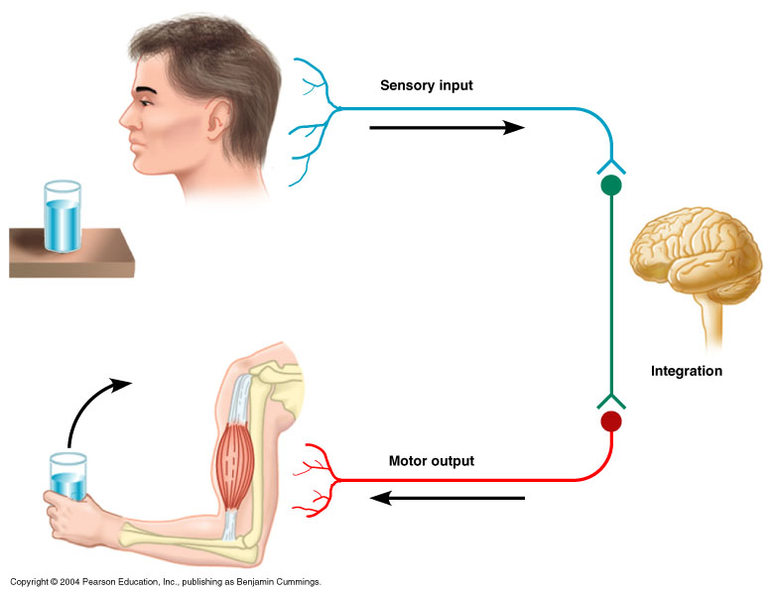
Two Major Anatomical Subdivisions of Nervous System
- central nervous system (CNS)
  - brain and spinal cord enclosed in bony coverings
  - enclosed by cranium and vertebral column
- peripheral nervous system (PNS)
  - all the nervous system outside the brain and spinal cord
  - composed of nerves and ganglia
    - nerve – a bundle of nerve fibers (axons) wrapped in fibrous connective tissue
    - ganglion – a knot-like swelling in a nerve where neuron cell bodies are concentrated

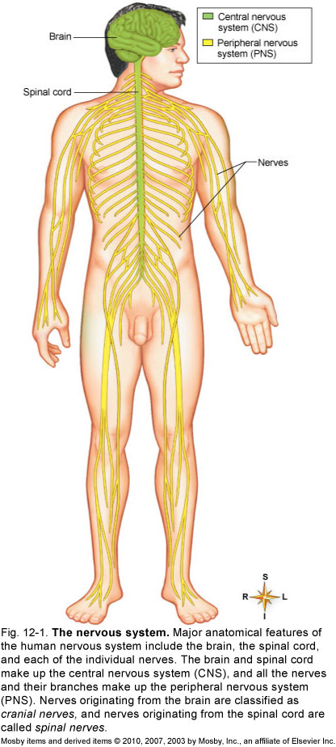

Sensory (afferent) division
- carries sensory signals from various receptors to the CNS
- informs the CNS of stimuli within or around the body
- somatic sensory division – carries signals from receptors in the skin, muscles, bones, and joints
- visceral sensory division – carries signals from the viscera of the thoracic and abdominal cavities
  - heart, lungs, stomach, and urinary bladder

Motor (efferent) division
- carries signals from the CNS to gland and muscle cells that carry out the body’s response
  - effectors – cells and organs that respond to commands from the CNS
- somatic motor division – carries signals to skeletal muscles
  - output produces muscular contraction as well as somatic reflexes – involuntary muscle contractions
- visceral motor division (autonomic nervous system) - carries signals to glands, cardiac muscle, and smooth muscle
  - involuntary, and responses of this system and its receptors are visceral reflexes
  - Visceral Motor Division = Autonomic Nervous System
    - sympathetic division
      - tends to arouse body for action
      - accelerating heart beat and respiration, while inhibiting digestive and urinary systems
    - parasympathetic division
      - tends to have calming effect
      - slows heart rate and breathing
      - stimulates digestive and urinary systems

Organization of the Nervous System
- Organized to detect changes in internal and external environments, evaluate the information, and initiate an appropriate response
- Subdivided into smaller “systems” by location
  - Central nervous system (CNS)
    - Structural and functional center of the entire nervous system
    - Consists of the brain and spinal cord
    - Integrates sensory information, evaluates it, and initiates an outgoing response
  - Peripheral nervous system (PNS)
    - Nerves that lie in the “outer regions” of the nervous system
    - Cranial nerves originate from the brain
    - Spinal nerves originate from the spinal cord

Organization of the Nervous System - continued
- Afferent and efferent divisions
  - Afferent division consists of all incoming sensory pathways
  - Efferent division consists of all outgoing motor pathways
- “Systems” according to organs innervated
  - Somatic nervous system
    - Somatic motor division carries information to the somatic effectors (skeletal muscles)
    - Somatic sensory division carries feedback information to somatic integration centers in the CNS
  - Autonomic nervous system (ANS)
    - Efferent division of ANS carries information to the autonomic or visceral effectors (smooth and cardiac muscles and glands)
      - Sympathetic division: prepares the body to deal with immediate threats to the internal environment; produces fight-or-flight response
      - Parasympathetic division: coordinates the body’s normal resting activities; sometimes called the rest-and-repair division
    - Visceral sensory division carries feedback information to autonomic integrating centers in the CNS

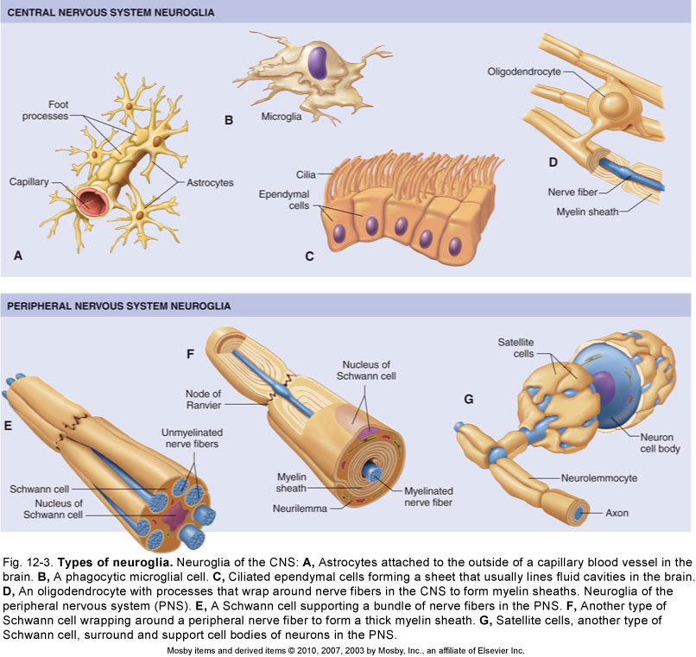

Cells of the Nervous System
- Glia (neuroglia) - Glial cells support the neurons
- Five major types of glia
  - Astrocytes (in CNS)
    - Star shaped; largest and most numerous type of glia
    - Cell extensions connect to both neurons and capillaries
    - Astrocytes transfer nutrients from the blood to the neurons
    - Form tight sheaths around brain capillaries, which, with tight junctions between capillary endothelial cells, constitute the blood-brain barrier
  - Microglia (in CNS)
    - Small, usually stationary cells
    - In inflamed brain tissue, they enlarge, move about, and carry on phagocytosis
  - Ependymal cells (in CNS)
    - Resemble epithelial cells and form thin sheets that line fluid-filled cavities in the CNS
    - Some produce fluid; others aid in circulation of fluid
  - Oligodendrocytes (in CNS)
    - Smaller than astrocytes with fewer processes
    - Hold nerve fibers together and produce the myelin sheath
  - Schwann cells (in PNS)
    - Found only in peripheral neurons
    - Support nerve fibers and form myelin sheaths
    - Myelin sheath gaps are often called nodes of Ranvier
    - Neurilemma is formed by cytoplasm of Schwann cell wrapped around the myelin sheath; essential for nerve regrowth
    - Satellite cells are Schwann cells that cover and support cell bodies in the PNS
- Neurons - Excitable cells that initiate and conduct impulses that make possible all nervous system functions

Components of Neurons
- Cell body (perikaryon)
  - Ribosomes, rough endoplasmic reticulum, Golgi apparatus
    - Provide protein molecules (neurotransmitters) needed for transmission of nerve signals from one neuron to another
    - Neurotransmitters are packaged into vesicles
    - Provide proteins for maintaining and regenerating nerve fibers
    - Mitochondria provide energy (adenosine triphosphate) for neuron; some are transported to end of axon
- Dendrites
  - Each neuron has one or more dendrites, which branch from the cell body
  - Conduct nerve signals to the cell body of the neuron
  - Distal ends of dendrites of sensory neurons are receptors

Components of Neurons - continued
- Axon
  - A single process extending from the axon hillock, sometimes covered by a fatty layer called a myelin sheath
  - Conducts nerve impulses away from the cell body of the neuron
  - Distal tips of axons are telodendria, each of which terminates in a synaptic knob
- Cytoskeleton
  - Microtubules and microfilaments, as well as neurofibrils (bundles of neurofilaments)
  - Allows the rapid transport of small organelles
    - Vesicles (some containing neurotransmitters), mitochondria
    - Motor molecules shuttle organelles to and from the far ends of a neuron

Classification of Neurons
- Structural classification: according to number of processes extending from cell body
  - Multipolar: one axon and several dendrites
  - Bipolar: only one axon and one dendrite; least numerous kind of neuron
  - Unipolar (pseudounipolar): one process comes off neuron cell body but divides almost immediately into two fibers: central fiber and peripheral fiber
- Functional classification
  - Afferent (sensory) neurons: conduct impulses to spinal cord or brain
  - Efferent (motor) neurons: conduct impulses away from spinal cord or brain toward muscles or glandular tissue
- Interneurons

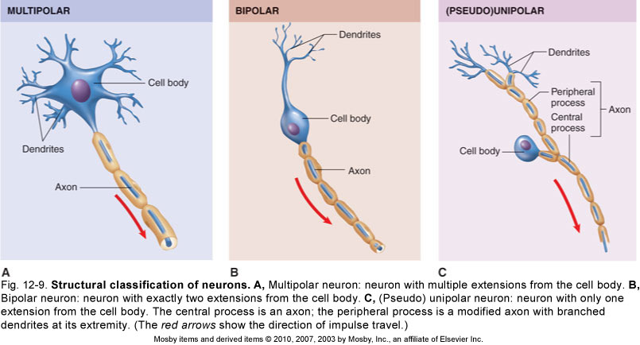

Reflexes
- A reflex is a rapid, predictable motor response to a stimulus
- Reflexes may:
  - Be inborn (intrinsic) or learned (acquired)
  - Involve only peripheral nerves and the spinal cord
  - Involve higher brain centers as well

Reflex Arc
- A signal conduction route to and from the CNS, with the electrical signal beginning in receptors and ending in effectors
- Three-neuron arc most common; consists of afferent neurons, interneurons, and efferent neurons
  - Afferent neurons conduct impulses to the CNS from the receptors
  - Efferent neurons conduct impulses from the CNS to effectors (muscle or glandular tissue)

Reflex Arc - continued
- There are five components of a reflex arc
  - Receptor – site of stimulus
  - Sensory neuron – transmits the afferent impulse to the CNS
  - Integration center – either monosynaptic or polysynaptic region within the CNS
  - Motor neuron – conducts efferent impulses from the integration center to an effector
  - Effector – muscle fiber or gland that responds to the efferent impulse

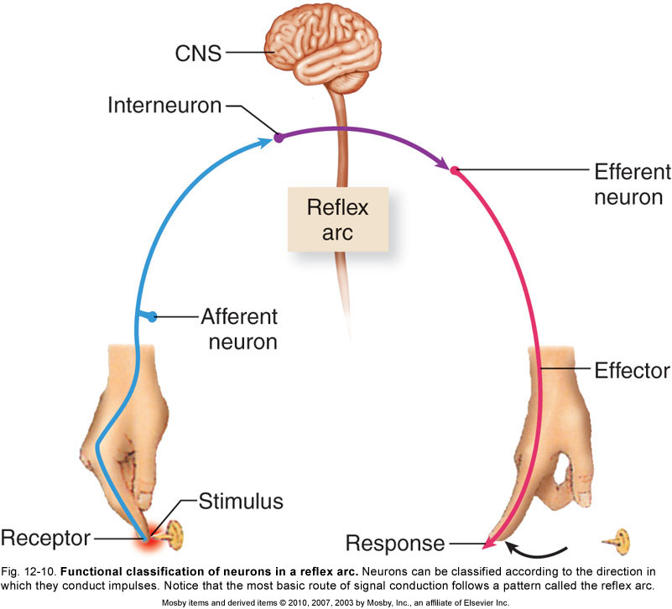

Synapse
- Where nerve signals are transmitted from one neuron to another
  - Two types: electrical and chemical; chemical synapses are typical in the adult
  - Chemical synapses are located at the junction of the synaptic knob of one neuron and the dendrites or cell body of another neuron

Nerves and Tracts
- Nerves: bundles of peripheral nerve fibers held together by several layers of connective tissue
  - Endoneurium: delicate layer of fibrous connective tissue surrounding each nerve fiber
  - Perineurium: connective tissue holding together fascicles (bundles of fibers)
  - Epineurium: fibrous coat surrounding numerous fascicles and blood vessels to form a complete nerve
- Within the CNS, bundles of nerve fibers are called tracts rather than nerves
- A nerve is a group of axons and or dendrites of several neurons, with blood vessels and connective tissue
- Sensory nerves are made of sensory neurons
- Motor nerves are made of motor neurons
- Mixed nerves contain both sensory and motor
- Nerve tracts occur in the CNS traveling up and down carrying information

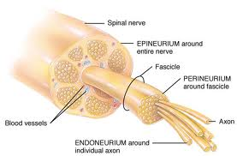

Types of Neurons
- Sensory neurons – afferent neurons
  - Carry impulses from the receptors to the CNS
  - Receptors detect changes in the internal and external environment
  - Sensory neurons
    - Receptors from the skin, skeletal muscles and joints
  - Visceral neurons
    - Receptors from the internal organs
- Motor neurons – efferent neurons
  - Carry impulses from the CNS to the effectors
- Interneurons
  - Found entirely in the CNS

Nerves and Tracts
- White matter
  - PNS: myelinated nerves
  - CNS: myelinated tracts
- Gray matter
  - Composed of cell bodies and unmyelinated fibers
- Mixed nerves
  - Contain sensory and motor neurons
  - Sensory nerves have predominantly sensory neurons
  - Motor nerves have predominantly motor neurons

Repair of Nerve Fibers
- Mature neurons are incapable of cell division; therefore damage to nervous tissue can be permanent
- Neurons have limited capacity to repair themselves
- If the damage is not extensive, the cell body and neurilemma are intact, and scarring has not occurred, nerve fibers can be repaired
- Stages of repair of an axon in a peripheral motor neuron
  - After injury, distal portion of axon and myelin sheath degenerates
  - Macrophages remove the debris
  - Remaining neurilemma and endoneurium form a tunnel from the point of injury to the effector
  - New Schwann cells grow in tunnel to maintain a path for axon regrowth
  - Cell body reorganizes its Nissl bodies to provide the needed proteins to extend the remaining healthy portion of the axon
  - Axon “sprouts” appear
  - When sprout reaches tunnel, its growth rate increases
  - Skeletal muscle cell atrophies until nervous connection is reestablished
- In CNS, similar repair of damaged nerve fibers is unlikely

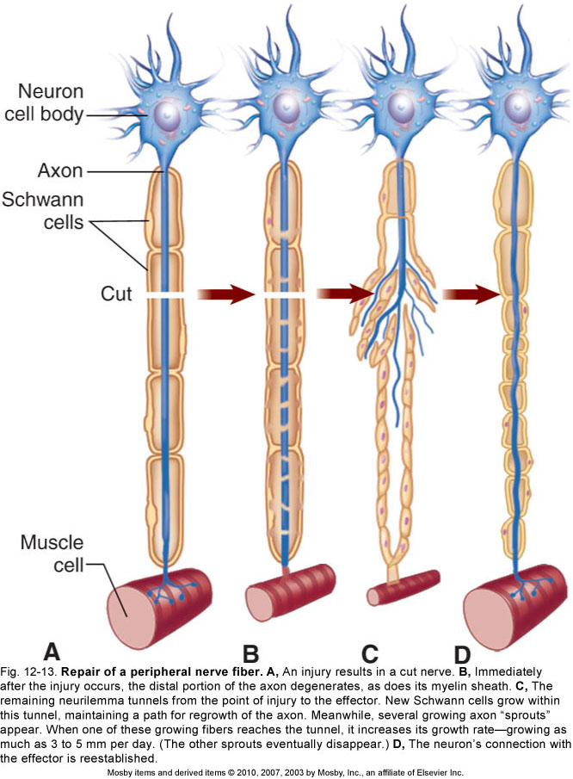

Nerve Impulses
- Membrane potentials
  - All living cells maintain a difference in the concentration of ions across their membranes
  - Membrane potential: slight excess of positively charged ions on the outside of the membrane and slight deficiency of positively charged ions on the inside of the membrane
  - Difference in electrical charge is called potential because it is a type of stored energy
- Resting membrane potential
  - Membrane potential maintained by a non-conducting neuron’s plasma membrane; typically −70 mV
  - The membrane’s selective permeability characteristics help maintain a slight excess of positive ions on the outer surface of the membrane
  - Sodium-potassium pump
    - Active transport mechanism in plasma membrane that transports sodium (Na⁺) and potassium (K⁺) ions in opposite directions and at different rates
    - Maintains an imbalance in the distribution of positive ions, resulting in the inside surface becoming slightly negative compared with its outer surface

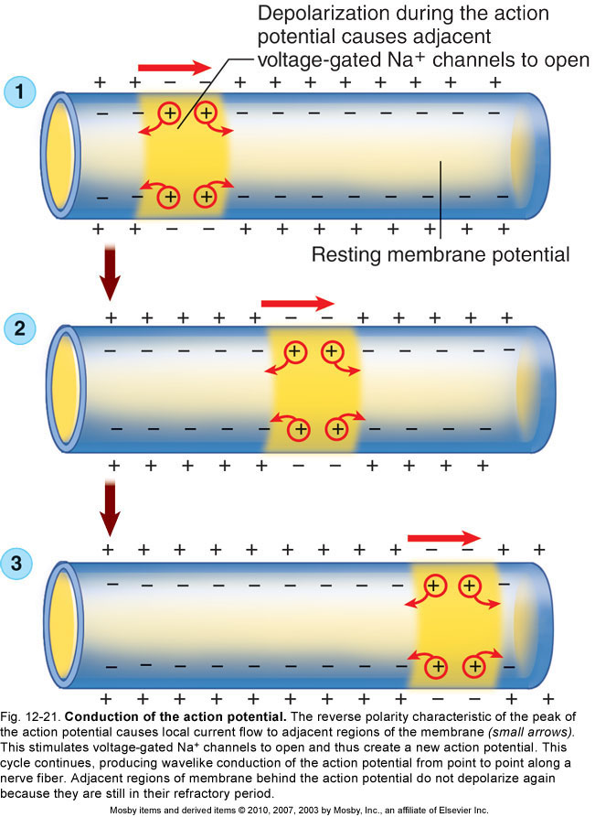

Action Potential
- Action potential: the membrane potential of a neuron conducting an impulse; also known as a nerve impulse
- Mechanism that produces the action potential
  - When an adequate stimulus triggers stimulus-gated Na⁺ channels to open, allowing Na⁺ to diffuse rapidly into the cell, which produces a local depolarization
  - The action potential is an all-or-none response
  - After action potential peaks, membrane begins to move back toward the resting membrane potential, a process is known as repolarization
- Refractory period
  - Absolute refractory period: brief period (lasting approximately 0.5 ms) during which a local area of a neuron’s membrane resists restimulation and will not respond to a stimulus, no matter how strong
  - Relative refractory period: time when the membrane is repolarized and restoring the resting membrane potential; the few milliseconds after the absolute refractory period; will respond only to a very strong stimulus
- Conduction of the action potential
  - At the peak of the action potential, the plasma membrane’s polarity is now the reverse of the resting membrane potential
  - This cycle continues to repeat
  - The action potential never moves backward
  - In myelinated fibers, action potentials in the membrane only occur at the nodes of Ranvier; this type of impulse conduction is called saltatory conduction
  - Speed of nerve conduction depends on diameter and on the presence or absence of a myelin sheath

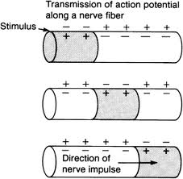
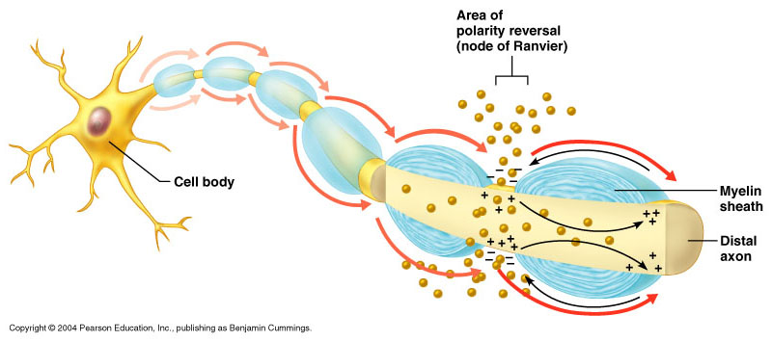

Synaptic Transmission
- Two types of synapses (junctions)
  - Electrical synapses occur where cells joined by gap junctions allow an action potential to simply continue along postsynaptic membrane
  - Chemical synapses occur where presynaptic cells release chemical transmitters (neurotransmitters) across a tiny gap
    - Structure of the chemical synapse
      - Synaptic knob: tiny bulge at the end of a terminal branch of a presynaptic neuron’s axon that contains vesicles housing neurotransmitters
      - Synaptic cleft: space between a synaptic knob and the plasma membrane of a postsynaptic neuron
      - Plasma membrane of a postsynaptic neuron has protein molecules that serve as receptors for the neurotransmitters
- Synapses and memory
  - Memories are stored by facilitating (or inhibiting) synaptic transmission
  - Short-term memories (seconds or minutes)
  - Intermediate long-term memory (minutes to weeks)
  - Long-term memories (months or years)

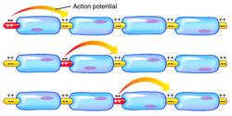
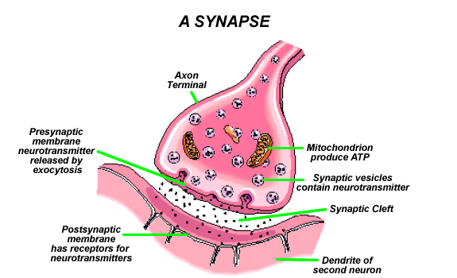

Neurotransmitters
- Neurotransmitters: means by which neurons communicate with one another; more than 30 compounds are known to be neurotransmitters, and dozens of others are suspected
- Common classification of neurotransmitters:
  - Function: determined by the postsynaptic receptor; two major functional classifications are excitatory neurotransmitters and inhibitory neurotransmitters
  - Chemical structure: the mechanism by which neurotransmitters cause a change; four main classes; because the functions of specific neurotransmitters vary by location, usually classified by chemical structure

The Big Picture
- Neurons act as the “wiring” that connects structures needed to maintain homeostasis
- Sensory neurons act as receptors to detect changes in the internal and external environment; relay information to integrator mechanisms in the CNS
- Information is processed and a response is relayed to the appropriate effectors through the motor neurons
- At the effector, neurotransmitter triggers a response to restore homeostasis
- Neurotransmitters released into the bloodstream are called hormones
- Neurons are responsible for more than just responding to stimuli; circuits are capable of remembering or learning new responses and generating thought

