Trauma
Dr. Gary Mumaugh and Dr. Bruce Simat

Overview of Traumatic Injury
- Factors affecting wound production
  - Amount of energy
  - Duration of impact
  - Surface area
  - Tissue Characteristics

Wound Classification
- Wounds caused by mechanical forces
  - Abrasion: epidermis is scraped off, produced by friction, usually minor.
  - Contusion: a bruise—blood loss into tissue spaces, surface is unbroken.
- Hematoma: Focal pooling of blood within a tissue
- Coup injury: blow to brain causes contusion at site of impact.
- Countrecoup injury: contusion on opposite side of brain due to brain moving in skull.

Brain Trauma
- Major head trauma
  - A traumatic insult to the brain possibly producing physical, intellectual, emotional, social, and vocational changes
  - Transportation accidents
  - Falls
  - Sports-related event
  - Violence
- Closed (blunt, nonmissile) trauma
  - Head strikes hard surface or a rapidly moving object strikes the head
  - The dura remains intact and brain tissues are not exposed to the environment
  - Causes focal (local) or diffuse (general) brain injuries
- Open (penetrating, missile) trauma
  - Injury breaks the dura and exposes the cranial contents to the environment
  - Causes primarily focal (local) injuries
- Coup injury
  - Injury directly below the point of impact
- Contrecoup
  - Injury on the pole opposite the site of impact
- Compound fractures
- Basilar skull fracture

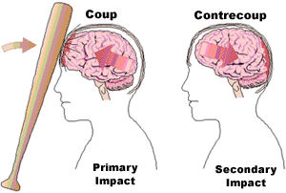

Focal Brain Injury
- Observable brain lesion
- Force of impact typically produces contusions
- Contusions can cause:
  - Extradural (epidural) hemorrhages or hematomas
  - Subdural hematomas
  - Intracerebral hematomas

Wound Classification
- Laceration: caused by tearing or splitting of skin or organ surface.
  - Different than an incision which is a smooth slice
  - Configurations: straight, curved, stellate (star-shaped)
  - Rupture: deep laceration or when hollow organ’s wall tears completely through.
- Penetrating wounds: caused by sharp, long object, causing deep and narrow wound.
- Serious blood loss
- Vital organs may be reached, causing severe hemorrhage or extensive peritonitis.

Bone Fracture
- Many different types, depending on the forces that are applied to the bone.
- Types of Bone Fractures
  - Compound (open) – bone ends penetrate the skin
- Simple (closed) – bone ends do not penetrate the skin
- Greenstick – incomplete fracture where one side of the bone breaks and the other side bends; common in children
- Comminuted – bone fragments into three or more pieces; common in the elderly
- Compression – bone is crushed; common in porous bones

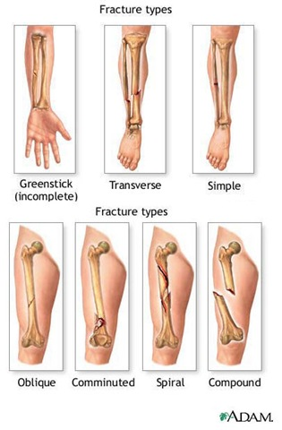

Craniocerebral Trauma
- Primary brain injury: initial trauma causing injury, like a blow to the skull.
- Secondary brain injury: caused by complication of primary injury: infarction, loss of function, epilepsy, etc.
- Types of brain injury:
  - Concussion: period of lost or altered consciousness that follows a brain injury and period of paralysis of nervous function.
  - Coup and Contrecoup Injuries
  - Basal Skull Fracture: when hit hard, the area that is directly hit withstands the pressure, but the opposite side fractures.
  - Closed head injuries: meningeal and vascular protection of brain intact.
  - Open head injuries: protection is broken in some way.

Hematomas:
- Extradural hematoma: artery is blood source.
- Subdural hematoma: bridging vein is usually the blood source.
- Acute: develops over 24-48 hours.
- Subacute: develops in 48 hours to two weeks.
- Chronic: slow leak, initial trauma was minor.

Spinal Cord Trauma
- Most commonly occurs due to vertebral injuries
  - Simple fracture, compressed fracture, and comminuted fracture and dislocation
- Traumatic injury of vertebral and neural tissues as a result of compressing, pulling, or shearing forces
- Spinal cord trauma: caused by hyperextension, crushing, dislocation.
  - Spinal shock: loss of function below site of injury
  - Most common locations: cervical (1, 2, 4-7), and T1-L2 lumbar vertebrae
  - Locations reflect most mobile portions of vertebral column and the locations where the spinal cord occupies most of the vertebral canal
- Spinal shock
  - Normal activity of the spinal cord ceases at and below the level of injury. Sites lack continuous nervous discharges from the brain.
  - Complete loss of reflex function (skeletal, bladder, bowel, sexual function, thermal control, and autonomic control) below level of lesion

Spinal Cord Trauma
- Paraplegia
- Quadriplegia
- Autonomic hyperreflexia (dysreflexia)
  - Autonomic dysreflexia means an over-activity of the Autonomic Nervous System.
- It can occur when an irritating stimulus is introduced to the body below the level of spinal cord injury, such as an overfull bladder.
- The stimulus sends nerve impulses to the spinal cord, where they travel upward until they are blocked by the Lesion at the level of injury.
- Since the impulses cannot reach the brain, a Reflex is activated that increases activity of the sympathetic portion of autonomic nervous system

Thoracic Trauma
- Flail Chest: three or more adjacent ribs are fractured and section can move independently.
  - Can result in hypoxemia and hypercapnia due to hypoventilation.
- Closed pneumothorax: fractured ribs puncture lung and allow air into pleural space, but chest wall is not open to atmospheric air.
- Open pneumothorax: atmospheric air enters pleural space directly through opening.

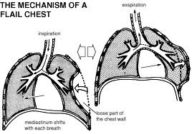
Thoracic Trauma
- Tension pneumothorax: chest wound closes during expiration, causing increased pressure in one pleural cavity.
  - This forces the collapsed lung, heart, and other structures into the other pleural cavity.
- Hemothorax: blood in the pleural space.
- Ruptures in the diaphragm can cause herniation, usually on the left side.
- Cardiac wounds often involve laceration of the aorta or vena cavae.
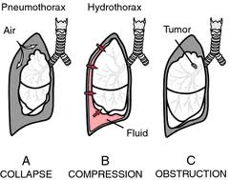

Abdominal Trauma
- Nonpenetrating trauma can cause contusion, laceration, or rupture of abdominal viscera.
- The spleen is the most often damaged organ in cases of blunt trauma.
- Penetrating wounds increase risk of abdominal infection.
- Evisceration: large wall defect allows abdominal organs to escape from abdomen.

Trauma in Athletics
- Stress fracture: overuse injury, load is not enough to cause acute fracture, but exceed that level that the bone can absorb without damage.
- Ligaments: partial or complete tears of ligaments due to excessive stresses.
  - Avulsion fracture: ligament is intact but pulls off a section of bone at its attachment site.
- Joints: injuries involve forces which separate bones in a joint.
  - Sprain (bone return to position)
  - Dislocation (bones remain displaced)
- Tendons: long healing time due to poor vascularization.
- Muscles:
  - Distraction ruptures: caused by high contractile loads or excessive stretching.
  - Compression ruptures: caused by direct impact which forces muscle against bone

Burn Trauma
- Burns caused by thermal energy applied to skin at a rate greater than it can be dissipated.
- Factors affecting skin’s ability to absorb and dissipate heat:
  - Thickness
  - Blood supply
  - Water content
  - Pigmentation
  - Presence of hair and other surface matter (dirt, cosmetics, etc.)
- Classification
  - First-degree burn: damages epidermis only, no significant necrosis. (Sunburn)
  - Second-degree burn: destruction of epidermis and part of dermis, causes blisters.
  - Third-degree burn: damage to epidermis, dermis, and underlying tissue, skin grafting usually needed
- Alternate classification system:
  - Partial-thickness burn: epidermis and some of dermis damage (second-degree).
  - Full-thickness burn: epidermis and whole dermis damage (third-degree).
- Consequences of severe burns:
  - Shock
  - Infection
  - Deformity

