Anatomy and Physiology of Special Senses
Dr. Gary Mumaugh – Campbellsville University

Types of Senses
- General senses
  - receptors over large part of body
  - somatic provide info. about body and environment
  - visceral provide info. about internal organs,
  - pain, pressure, touch, pressure, pain, temp., and itch
- Special senses
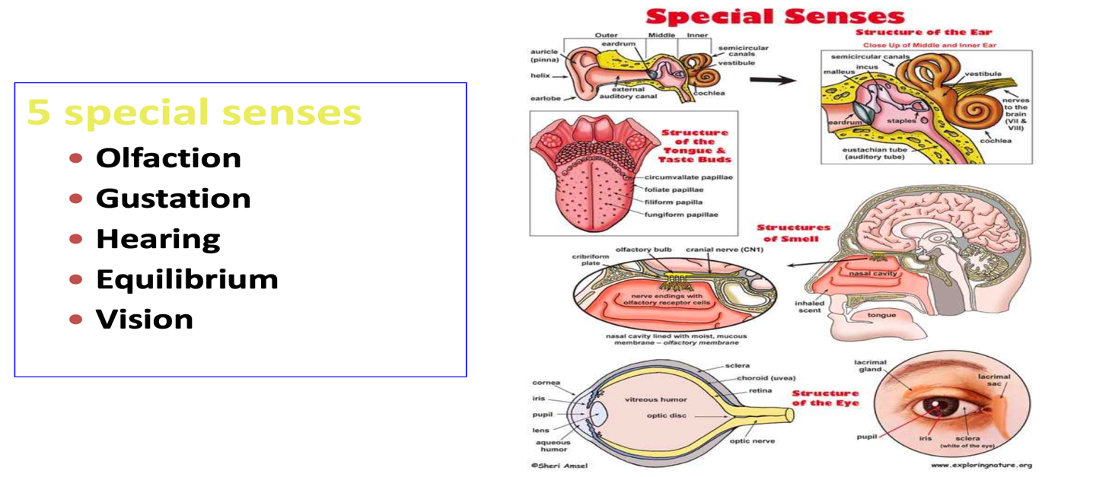
  - smell, taste, sight, hearing, and balance
Sensory Receptors
- Receptor potential
  - The potential that develops when an adequate stimulus acts on a receptor
  - Impulses travel over sensory pathways to the brain and spinal cord
- Adaptation
  - Receptor potential decreases over time in response to a continuous stimulus, which leads to decreased intensity of sensation
- Sensory receptors allow the body to respond to stimuli caused by changes in our internal or external environment
- Receptor response
  - General function: responds to stimuli by converting them to nerve impulses
  - Different types of receptors respond to different stimuli
- Distributions of receptors
  - Receptors for special senses of smell, taste, vision, hearing, and equilibrium are grouped into localized areas or complex organs
  - General sense organs of somatic senses are microscopic receptors widely distributed throughout the body in the skin, mucosa, connective tissue, muscles, tendons, joints, and viscera

Classification of Receptors
- Classification by location
  - Exteroceptors
    - On or near body surface
    - Often called cutaneous receptors (e.g., pressure, touch, pain, temperature)
  - Visceroceptors (interoceptors)
    - Located internally, often within body organs, or viscera
    - Provide body with information about internal environment (e.g., pressure, stretch, chemical changes, hunger, thirst)
  - Proprioceptors: special type of visceroceptor
    - Location limited to skeletal muscle, joint capsules, and tendons
    - Provide information on body movement, orientation in space, and muscle stretch
- Classification by stimulus detected
      - Mechanoreceptors: activated when “deformed”
      - Chemoreceptors: activated by amount or changing concentration of certain chemicals (e.g., taste and smell)
      - Thermoreceptors: activated by changes in temperature
      - Nociceptors: activated by intense stimuli that may damage tissue; sensation produced in pain
      - Photoreceptors: found only in the eye; respond to light stimuli
      - Osmoreceptors: concentrated in the hypothalamus; activated by changes in concentration of electrolytes (osmolarity) in extracellular fluids
- Classification by structure: divides sensory receptors into those with free nerve endings or encapsulated nerve endings
- Free nerve endings
- Most widely distributed sensory receptor
- Include both exteroceptors and visceroceptors
- Called nociceptors; primary receptors for pai
- Primary receptors for heat and cold
- Pain sensations
- Acute fibers mediate sharp, intense, localized pain
- Chronic fibers mediate less intense but more persistent dull or aching pain

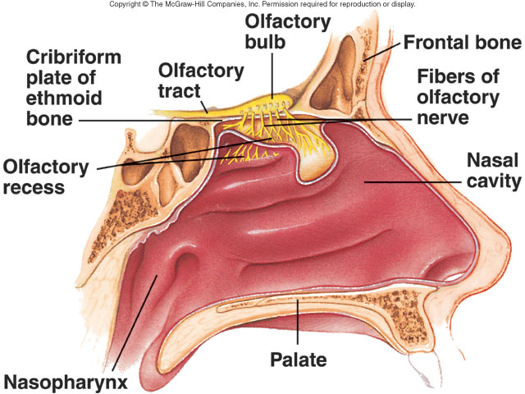
Olfaction
- What is it?
- sense of smell
- occurs in response to odorants
- receptors are located in nasal cavity and hard palate
- we can detected 10,000 different smells

Olfactory Receptors
- Olfactory receptors are located in a layer of support cells; they project their “dendrites” into the mucosa (where odorants are trapped) and their axons through a thin bone to terminate in the olfactory bulb (part of the CNS).
- Different receptors respond to different odors (over 10,000) and these receptors are spatially segregated to some degree on the olfactory epithelium.
- Olfactory receptor axons terminate on mitral cell dendrites in a restricted encapsulated structure called a glomerulus; a glomerulus contains the dendritic bush of one mitral cell but many olfactory receptor axons.
- All the olfactory receptor axons ending in one glomerulus contain are from receptors expressing same olfactory binding protein.

Composition of Olfactory Epithelium
- Each neuron has a thick dendrite with an expanded end called olfactory rod
- From rods cilia project to the mucous surface
- Each receptor neuron has 10-20 cilia
- Axons of olfactory receptor neurons pierce cribriform plate of ethmoid bone and enter olfactory bulbs
- Olfactory neurons have half-time of few weeks.

Mucus Producing Glands
- Olfactory mucous membrane is constantly covered by mucus
- Mucus is produced by Bowman’s glands, placed just under the basal lamina of the membrane

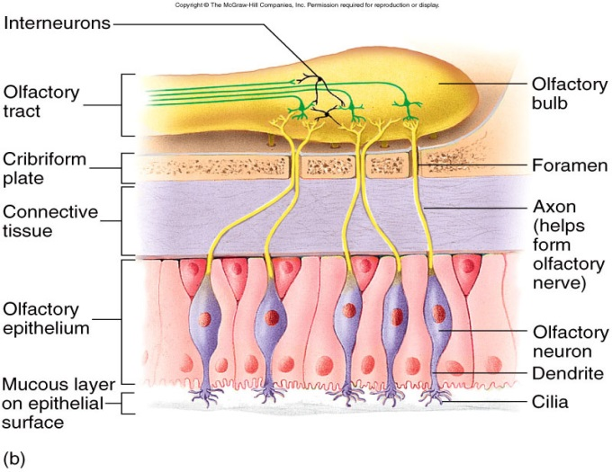
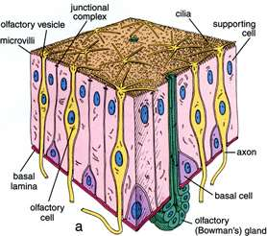

Olfactory Bulbs
- Axons of receptors contact the primary dendrites of mitral cells and tufted cells.
- Forming complex globular synapses called olfactory glomeruli.
- Periglomerular cells are inhibitory neurons connecting one glomerulus to another

Where does smell figure?
• Strong link to sense of taste
• Strong link to emotional states
• Exploited by commercials and marketing
• Used for identification of gender
- Pheromones - signal sexual arousal or a readiness for mating

Vomeronasal Organ
- Organ is not well developed in humans very well developed in animals
- This organ is concerned with perception of odors that act as pheromones
- There is evidence of pheromones in humans and a close relationship between smell and sexual function

Everyone has unique smells as different as fingerprints
- Our bodily scents provide a channel of communication that evolved to help us survive and thrive.
- We have now discovered that each person’s scent is unique – not even identical twins smell exactly alike.
- Each of us also has a one-of-a-kind nose for smells.
- Scents wafting from our bodies and wisping into our nostrils help us to forge family bonds and draw us to partners, divert us from danger, illness and aggression, and even allow us to sniff other people’s happiness.

Role of pain fibers in the nose
- Many trigeminal pain fibers are found in olfactory membrane
- They are stimulated by irritating substances
- Are responsible for initiating sneezing, lacrimation and other reflex responses.

How does olfaction work?
There are two ways we detect odors:
1) In the air we breathe through the front of the nose
2) Through the back of our nose from our mouth, when chewing food.

- This is how we appreciate the flavor of food when it is in our mouth and why many people suffering from a smell disorder believe that there is something wrong with their sense of taste.
- Odor molecules are drawn to the top of the nose, or olfactory cleft, as we breathe in.
- They then dissolve in a layer of mucus membrane known as the olfactory epithelium.
- This ‘drawing in’ of air is aided by the turbinates; which not only help direct the airflow but also warms, humidifies and filters the air.
- Once the odor molecules have dissolved in the mucus, they spread through it and attach cilia.
- The cilia are attached to receptor cells, which generates an Action Potential.
- Bundles of thousands of these axons make up the olfactory nerve.
- They converge on the edges of the olfactory bulb, a structure on the frontal lobe of the brain (there is actually one on each side of the brain, one for each nostril).
- The olfactory bulb processes the signals, and passes this information on to other parts of the brain, including the thalamus, limbic system and the orbitofrontal neocortex

Olfaction Wrap Up
1. Nasal cavity contains a thin film of mucous where odors become dissolved.
2. Olfactory neurons are located in mucous. Dendrites of olfactory neurons are enlarged and contain cilia.
3. Dendrites pick up odor, depolarize, and carry
odor to axons in olfactory bulb (CN I).
4. Frontal and temporal lobes process odor.

Neural Pathway of Olfaction
Olfactory Neurons

Cranial Nerve I – Oculomotor

Olfactory Bulb in Frontal Lobe

Frontal Cortex Hypothalamus Hippocampus of Amygdala
Conscious Perception Emotional Aspects Memory of Smell
of Smell of Smell
Abnormalities
- Anosmia – absence of sense of smell.
  - Olfactory disorder caused by a head injury, nasal cavity inflammation, or age.
  - Major symptom of Covid 19.
  - It can have serious consequences such as loss of appetite and weight.
- Hyposmia – diminished olfactory sensitivity
- Dyssomnia – distorted sense of smell
- More than 75% of humans over the age of 80 have an impaired ability to identify smells

Olfactory Adaptation
- The sense of smell drops about 50% within the first second following stimulation.
- Within 1-2 minutes the receptors become insensitive to given orders.
- Olfactory receptor neurons are the only neurons in direct contact to the outside environment.
- Basal cells along the basement membrane of the olfactory epithelium regularly divide and yield differentiated cells that replace lost neurons.

Taste - Gustation
- Taste buds:
  - Sensory structures that detect taste
  - There are 10,000 taste buds located on papillae on tongue, hard palate, throat
- Inside each taste bud are 40 taste cells
- Each taste cell has taste hairs that extend into taste pores
- Surface of the tongue has papillae, which are the structures for gustatory transduction.
- There are four types of papillae, based on their appearance circumvallate, foliate, filiform, and fungiform.
Taste - Gustation
- Within the structure of the papillae are taste buds that contain specialized gustatory receptor cells for the transduction of taste stimuli.
- These receptor cells are sensitive to the chemicals contained within foods that are ingested, and they release neurotransmitters based on the amount of the chemical in the food.
- Neurotransmitters from the gustatory cells can activate sensory neurons in the facial, glossopharyngeal, and Vagus cranial nerves.

Types of Tastes
- Salty
  - Salty taste is simply the perception Na⁺ ions in the saliva.
  - The presence of Na⁺ into these cells results in the depolarization of the cell membrane and the generation of an action potential.
- Sour
  - Sour taste is the perception of H⁺ ions.
  - Sour flavors are, essentially, the perception of acids in our food.
  - Orange juice—which contains citric acid—will taste sour because it has a pH of 3.
  - The first two tastes (salty and sour) are triggered by Na⁺ and H⁺ Ions.
  - Other tastes result from food molecules binding to a G protein–coupled receptor.
  - A G protein signal ultimately leads to an action potential of the gustatory cell.
- Sweet
  - The sweet taste is the sensitivity of gustatory cells to the presence of glucose dissolved in the saliva.
- Bitter
  - There are a large diversity of bitter-tasting molecules.
  - One major group of bitter-tasting molecules are alkaloids.
  - Alkaloids (contain nitrogen) are found in bitter plant products, such as coffee, hops (in beer), tannins (in wine), tea, and aspirin.
  - Because of this, many bitter foods that are normally ingested are often combined with a sweets to make them more palatable (cream and sugar in coffee, for example)
  - The function of bitter taste may be related to stimulating the gag reflex to avoid ingesting poisons.
  - The highest concentration of bitter receptors appear to be in the posterior tongue, where a gag reflex could still spit out poisonous food.
- Unami
  - Umami is often referred to as the savory taste.
  - This receptor is the amino acid L-glutamate in protein rich foods such as meats.

Cranial Neves and Taste
- Taste buds on the anterior tongue and palate innervated by the Intermediate Nerve (VII)
- Posterior tongue and pharynx innervated by Glossopharyngeal Nerve (IX)
- Epiglottis and larynx innervated by Vagus Nerve (X)
- The afferent fibers of these cranial nerves synapse with many taste cells between single or multiple taste buds
- Intermediate Nerve afferents enter the brain stem at the pontomedullary junction
- Glossopharyngeal and Vagus Nerve afferents enter the brain stem in the rostral medulla

Taste Wrap Up
- Taste buds pick up taste and send it to taste cells.
- Taste cells send taste to taste hairs.
- Taste hairs contain receptors that initiate an action potential which is carried to parietal lobe.
- Brain processes taste.

Neural Pathway of Gustation
Cranial Nerves VII, IX, X
Facial, Glossopharyngeal, Vagus

Solitary Nucleus of Medulla

Thalamus

Gustatory Cortex of Cortex in the Frontal Lobe and Insula
Frontal Lobe - Conscious Perception of Taste
Insula – Emotions and Memory of Taste

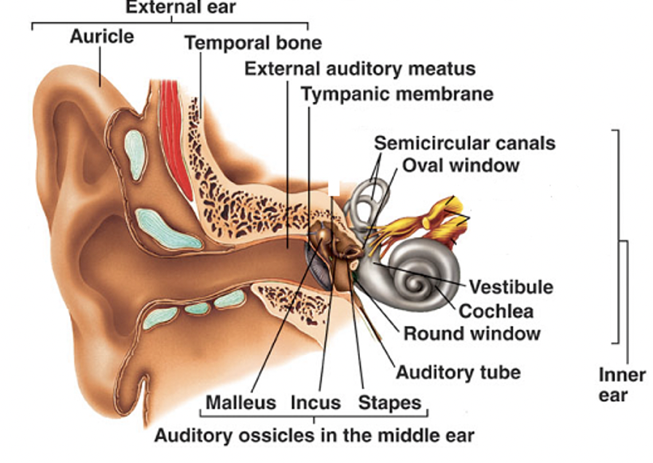
Hearing and Balance
- The ear works with the brain to control your balance.
- The ear is subdivided into three areas:
  - External ear
  - Middle ear
  - Inner ear

External (Outer) Ear
- Extends from outside of head to eardrum
- Auricle (pinna)
  - Fleshy part on outside
- External auditory meatus
  - Canal that leads to eardrum 1” long ¼” wide
- Tympanic membrane (eardrum)
  - Separates external and middle ear
  - Sound waves vibrate the tympanic membrane and pass vibrations to middle ear

Tympanic Membrane
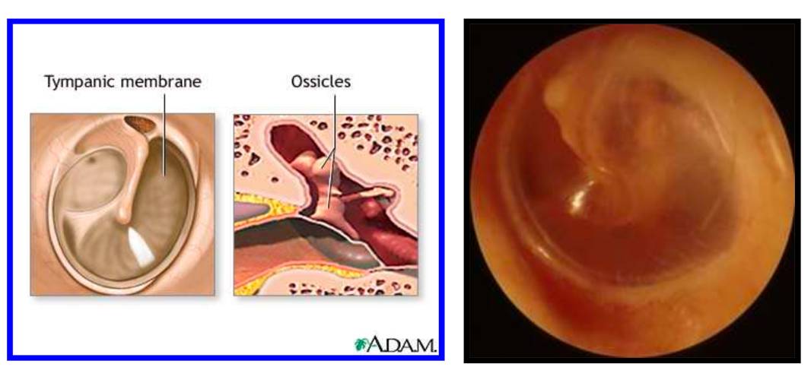
Middle Ear
- Air filled chamber within the temporal bone
- The 3 ossicles amplify the sound waves and vibration against the oval window of the cochlear duct
  - Malleus (hammer) - bone attached to tympanic membrane
  - Incus (anvil) - bone that connects malleus to stapes
  - Stapes (stirrup) - bone located at base of oval window
- Vibrations from eardrum pass on to and through ossicles.
- The last ossicle connects to the oval window, which then passes the vibration on to the fluids in the inner ear.
- Oval window
  - Separates middle and inner ear
- Eustachian or auditory tube
  - Opens into pharynx
  - Equalizes air pressure between outside air and middle ear
Eustachian Tube
Nasopharynx Middle Ear

Air Pressure of Middle Ear = Air Pressure of Outside of Ear

Inner Ear
- Set of fluid filled chambers
- As the stapes vibrates against the oval window, it causes vibrating waves of endolymph fluid of the cochlear canal
- Cochlea
  - Snail-shell shaped structure
  - Where hearing takes place
- Oval Window of the cochlear duct or canal
- Endolymph
  - Fluid in membranous cochlear canal or duct
- Hair cells
  - Attached to sensory neurons that when bent produce an action potential
  - As the fluid mechanically bends the hairs of the cochlear receptors, it activates an Action Potential that is relayed to the brain
  - Higher pitched sounds cause shorter fluid waves to mechanically bend the hairs
  - Lower pitched sounds cause longer fluid waves to bend the hairs

Hearing Wrap Up
- Sound travels in waves through air and is funneled into ear by auricle.
- Auricle through external auditory meatus to tympanic membrane.
- Tympanic membrane vibrates and sound is amplified by malleus, incus, stapes which transmit sound to oval window.
- Oval window produces waves in perilymph of cochlea.
- Vibrations of perilymph cause vestibular membrane and endolymph to vibrate.
6. Endolymph cause displacement of basilar membrane.
7. Movement of basilar membrane is detected by hair hairs in spiral organ.
8. Hair cells become bent and cause action potential is created.

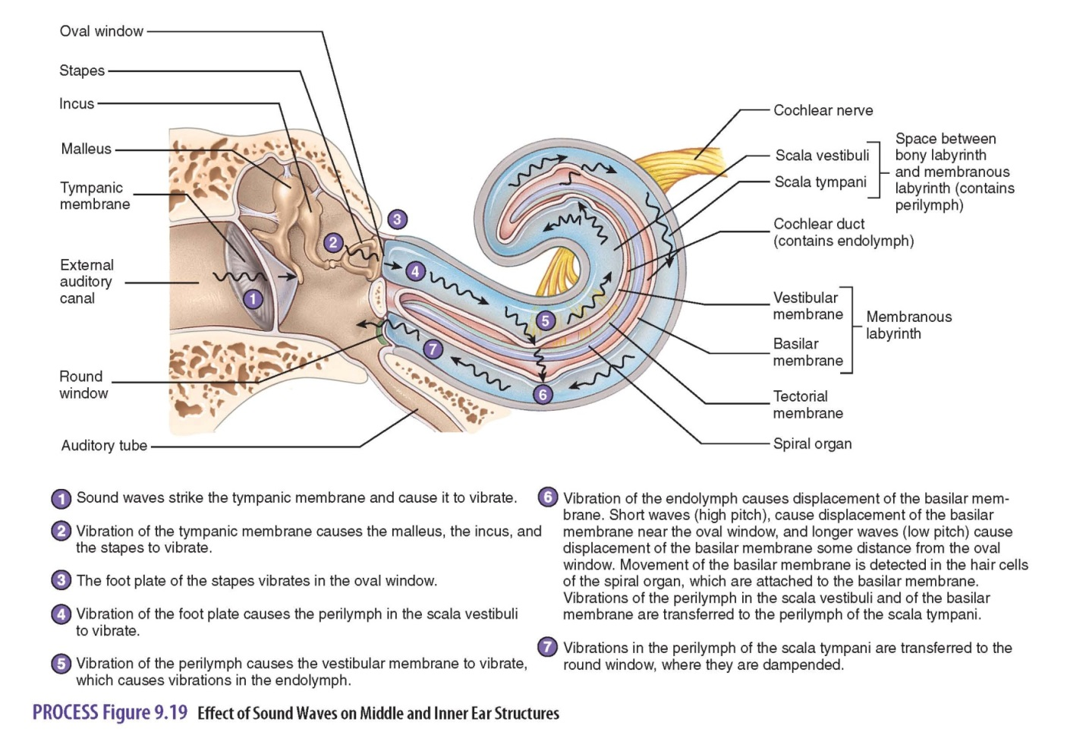
Neural Pathway of Hearing
Cranial Nerves VIII -Vestibulocochlear

Cochlear Nucleus of Medulla
80% decussate and 20% do not

Thalamus
Primary Auditory Area in Cortex in the Frontal Lobe

Balance (Equilibrium)
- Static equilibrium
  - Associated with vestibule
  - Evaluates position of head relative to gravity
- Dynamic equilibrium
  - Associated with semicircular canals
  - Evaluates changes in direction and rate of head movement
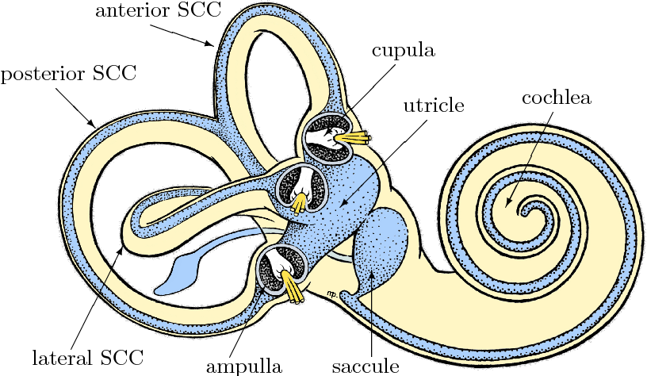
Semicircular Canals
- 3 different canals oriented in three different planes of space
  - Horizontal canal for side to side
  - Vertical canal for up and down
  - Posterior canal for front to back
- Endolymph is in all 3 canals
- Inside of canals are lined with Hair Cells
- When fluid moves in the canals it bends the hair cells which activates and Action Potential to the brain

Utricle and Sacule
- Oriented horizontally and vertically
- They are also lined with Hair Cells with Otolith Organs in the middle.
- When the Otolith Organs mechanically bend the hair cells, it activates and Action Potential to the brain.
- Detects gravity (up and down)
- Detects linear motion (speeding up)
- Detects deceleration (slowing down)

Neural Pathway of Equilibrium
Cranial Nerves VIII - Vestibulocochlear

Vestibular Reflex Center of Medulla

Thalamus

Primary Sensory Area in Cortex in the Parietal Lobe

Vision
- General characteristics
  - It has 130 million sensory receptors in the eye.
  - This is 70 % of all the sensory receptors in your entire body — for touch, taste smell, hearing and sight all put together.
  - Requires the most learning.
  - Easily fooled sense (optical illusions)

Eye - Camera
- The eye functions much like a camera.
- Light passes through the cornea and the lens of the eye and is focused on the retina in much the same way that an image is focused on the film of a camera.
- The eye gathers pictures and sends them to the brain.
- The eyeball is the incredible organ of sight that transmit an external image by the way of the nervous system-the optic nerve to the brain.

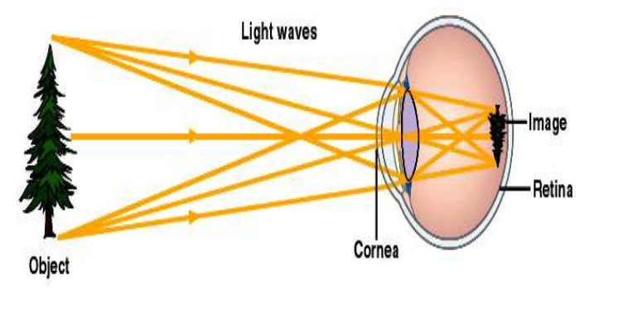

- The actual eyeball is composed of three layers:
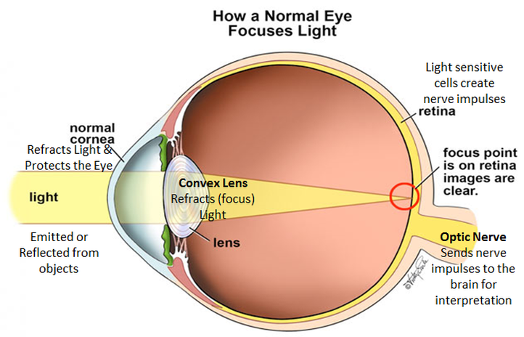
  - Outer Fibrous Tunic
    - Sclera
    - Cornea
  - Middle/Vascular Tunic
    - Choroid
    - Ciliary Body
    - Iris
  - Inner Tunic
    - Retina

Outer 1st Layer - Sclera
- Another term is the “white of the eye”
- The sclera is the outer layer that provides a tough protective coating for the inner structures of the eye.
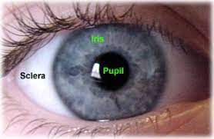
- The anterior portion of the sclera is called the “cornea”.
- This clear transparent area of the sclera allows light to enter the interior of the eyeball.
- The cornea actually bends, or retracts the light rays

Outer 1st Layer – Cornea (AVASCULAR)
- Anterior portion
- Transparent
- Light permission
- Light refraction
- One of the first organs transplanted
- Central part of the cornea receives oxygen from the outside air.
- Soft plastic contact lenses worn for periods must be permeable to air to reach the cornea.

Middle 2nd Layer – Choroid
- The middle layer of the eyeball: the opaque layer provides the blood supply for the eye.
- The anterior portion of the choroid layer consists of the:
  - Iris-colored portion of the eye; contains smooth muscle
  - Pupil-opening in the center of the iris that allows light rays to enter the eyeball.
  - Ciliary Body

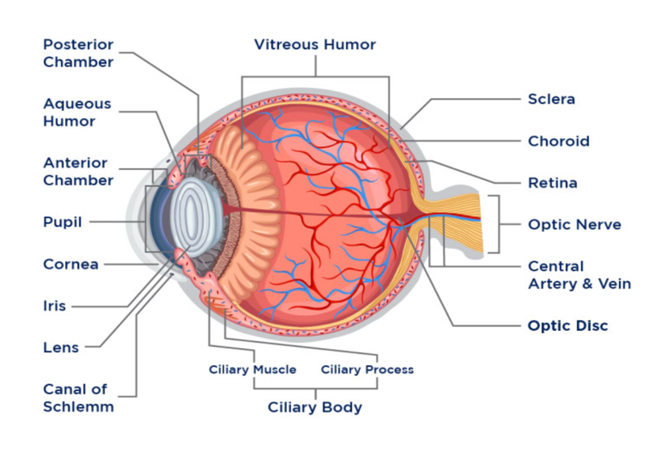
Middle 2nd Layer - Ciliary Body
- Anterior portion
- Pigmented
- Holds lens
- Moves lens for focusing
- Forms internal ring around front of eye
- Ciliary processes-radiating folds
- Ciliary muscles-contract and relax to move lens

Middle 2nd Layer - Iris
- Pigmented anterior portion
- Smooth muscle
- Controls light intensity
- Pupil is the hole in iris
- Dim light stimulates radial muscles and pupil dilates
- Bright light stimulates circular muscles and pupil constricts
  - Blue eyes: decreased melanin
  - Black/brown: increased melanin
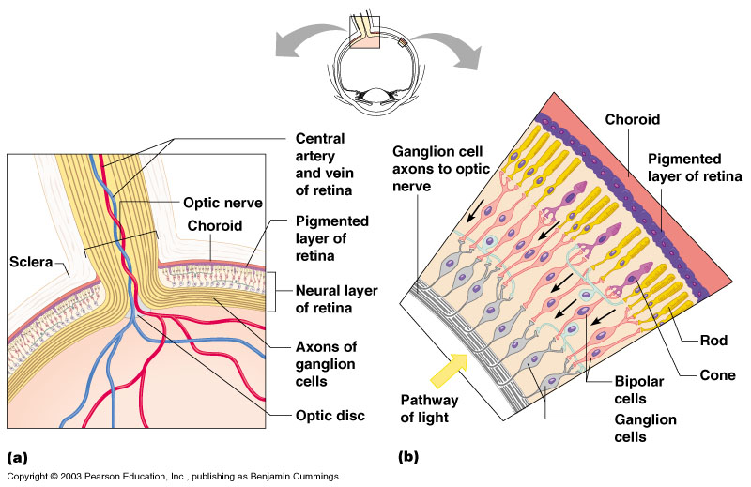
Inner 3rd Layer – Retina
- Innermost layer of the eyeball
- Contains the sensory receptors called:
  - Rods
    - Active in dim light & help us see in gray tones, black and white.
    - 120 million
  - Cones
    - Active only in bright light and responsible for color vision.
    - Sees red, blue, green
    - 6-10 million

Parts of the eye that you can see
- The pupil is the small black opening in the iris.
- The iris controls the size of the pupil with 2 muscles: dilator muscle, which enlarges the pupil and the sphincter muscle, which makes the pupil smaller.
- The iris is the colored disk which is right behind the cornea.
- It’ s color comes from melanin.
- The more melanin there is and the closer it is to the surface, the darker the iris.

The lens is like a magnifying glass
- The lens is transparent and helps to focus light rays onto the retina in the back of the eye.
- The macula is the bull's-eye center of the retina.
- Though the macula makes up only a small part of the retina, it is one hundred times more sensitive to detail than the peripheral retina and allows us to see tiny detail.
Red Eyes
- The "red eye" effect shown is due to light reflection by the retina

Accessory Structures of the Eye
They are all protective
- Eyelids
  - Meets at medial and lateral canthus
- Eyelashes
  - Meibomian glands modified sebacious glands produce an oily secretion to lubricate the eye
- Ciliary glands
  - modified sweat glands between the eyelashes
- Conjunctiva
  - Membrane that lines the eyelids
  - Connects to the surface of the eye
  - Secretes mucus to lubricate the eye

Accessory Structures of the Eye
- Lacrimal apparatus
  - Glands, ducts, (eye), canals, sac, nasolacrimal duct
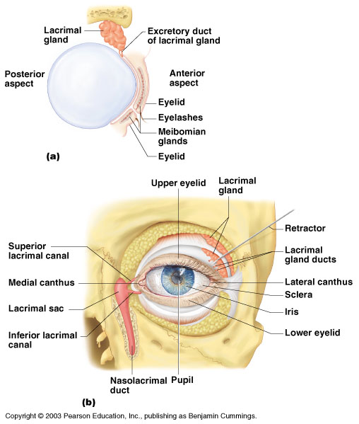
  - Tears: antibodies, lysozymes

Tears and Stress Effects
- Researchers have established that crying releases oxytocin and endogenous opioids, also known as endorphins.
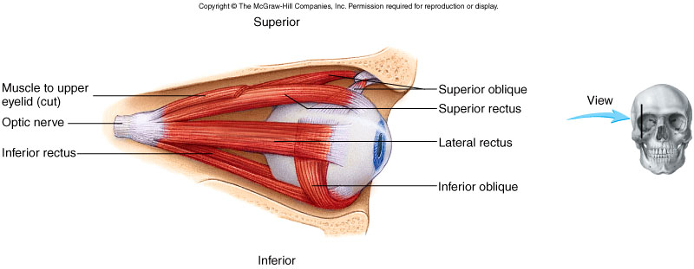
- These feel-good chemicals help ease both physical and emotional pain.
Muscles of Eye
- There are two different types of muscles in your eye -- Intrinsic and Extrinsic!
  - Intrinsic muscles in the eye are the iris and ciliary muscles.
  - Extrinsic muscles are the six muscles that control eye movement and make it possible for the eye to follow a moving object.
Mechanism of visual accommodation
- First light enters the eye through the cornea, which protects the eye and refracts the light.
- From the cornea, the light passes through the pupil. The iris is the colored part of your eye, and it controls the amount of light passing through.
- Next, the light passes through the lens, which works together with the cornea to focus light correctly on the retina.
- Next, light passes through the vitreous humor
- Finally, the light reaches the retina, the nerve layer lining the back of the eye. Here the image is inverted.
- The photoreceptors in the retina trigger an Action Potential.
  - There are 120 million Rods which detect shades, blacks and whites.
  - There are 6 million Cones which detect colors.
- The Optic Nerve is then responsible for carrying the signals to the visual cortex of the brain. The visual cortex turns the signals into images.
Lens Accommodation
- Light must be focused to a point on the retina for optimal vision
- The eye is set for distance vision (over 20 ft. away)
- The lens must change shape to focus for closer objects

Visual Acuity Test
- Normal vision is measured at 20/20
- This means that you can see clearly at 20 feet what should normally be seen at that distance.
- 20/20 vision is not perfect vision, it just indicates the visual acuity
- If you have 20/100 vision, that means that you must be as close as 20 feet to see what a person with normal vision can see at 100 feet
- Other things affecting vision acuity
  - Peripheral vision, eye coordination, depth perception, focusing ability and color vision

Correcting the Eye
- Correct Focus = emmetropia
- Nearsightedness = myopia
  - Focus of light in front of retina
  - Eyeball too long or lens too strong
  - Distant objects are blurry
- Farsightedness = hyperopia
  - Focus of light beyond the retina
  - Short eyeball or lazy lens
  - Near objects are blurry.

Nearsightedness - Myopia
- Affects about 20% of the population
- Is the result of images being focused in front of the retina rather than on it, so distant objects appear blurred.
- A nearsighted person holds a book close to the eyes when reading and has to sit in the front of the classroom or movie theater to see clearly.
- The condition runs in families and affects men and women equally, usually appearing in childhood and stabilizing in the twenties.

Farsightedness - Hyperopia
- The opposite of nearsightedness
- The lens of the eye focuses images slightly behind the retina, making nearby objects appear blurry.
- Children often overcome mild farsightedness as they grow up and the eye muscles contract.
Astigmatism
- Occurs when the eye lacks a single point of focus.
- The condition is a result of an uneven curvature of the cornea or, in some cases, an abnormality in the lens.
- People with astigmatism have a random, inconsistent vision pattern, in which some objects appear clear and others blurry.
Test for Astigmatism
- An irregular curvature of the cornea and/or lens is determined using this type of illustration.
- When using the test card, a person would know if he has astigmatism because some radial lines would be blurred.
Red-Green Colorblindness
- A disorder of the retina's light-sensitive cone cells, which respond to colors.
- People with color blindness see colors normally in bright light but have difficulty distinguishing reds and greens in dim light.
- Color blindness occurs mostly in men, afflicting 8% of the male population.
- It is extremely rare for someone to be totally color-blind -- able to see only shades of gray.

Presbyopia (elder eyes) - Can’t see close-up
- Presbyopia is blurred vision at normal reading distance.
- It typically starts at about age 40 and is the reason many older people use glasses.
Retinal Detachment
- Retinal detachment occurs when a part of one of the layers of the retina is pulled out of place, or when a hole or tear occurs.
- Although a detached retina is not painful, it is definitely a medical emergency.
- If the retina is not reattached to its source of nutrients promptly, the cells die, and blindness can result.
Night Blindness - Nyctalopia
- Night blindness is difficulty seeing in dim light.
- Occurs when the retina's rod cells, which distinguish light from dark, begin to deteriorate.
- The precise cause is unclear, but it may be linked to a liver disorder, a Vitamin-A deficiency, or a disease of the retina, such as retinitis pigmentosa, an inherited disorder.
Vision Loss and Aging
- Losing vision is not a normal part of aging
- As you age, there is a higher risk of developing the following age-related diseases and conditions
  - AMD - Age related macular degeneration
  - Cataracts
  - Diabetic retinopathy
  - Glaucoma
Age-related macular degeneration
- Age-related macular degeneration (AMD) is the top cause of vision loss in people over 50.
- Dry AMD can lead to gradual visual impairment. (90% of cases)
- Wet AMD tends to cause rapid vision loss. (10% of cases)
- People with AMD lose their central vision and can’t see things directly in front of them.
- AMD doesn’t cause total blindness, but it can greatly affect everyday life.
Cataracts
- Cataract is an opacity of the lens.
- Often seen in patients on prolonged corticosteroid therapy.
- Also seen as an age-related phenomenon or in diabetics.
- Cataracts involving the lens cortex may assume a variety of shapes, but most commonly present as wedge-shaped white opacities ,with the apices of the wedge pointing toward the center of the lens.
Diabetic Retinopathy
- Diabetic retinopathy is characterized by numerous microaneurysms, dot hemorrhages and hard exudates, and occasional cotton-wool spots (blue arrow) in the posterior fundus.
- Most of the red dots seen in this picture represent hemorrhages.
- Microaneurysms are more easily seen on angiography.

Glaucoma
- Glaucoma is damage to the retinal nerve fibers associated with an increase in intraocular pressure.
- Glaucoma is a chronic, progressive eye disease caused by damage to the optic nerve, which leads to visual field loss.
- One of the major risk factors is eye pressure.
- An abnormality in the eye’s drainage system can cause fluid to build up, leading to excessive pressure that causes damage to the optic nerve.
- The optic nerve is a bundle of nerve fibers that connects the retina with the brain.
- This damage leads to loss of eyesight.
Flashes and Floaters
- The flashes of light are caused by the tugging of the vitreous where it is attached to the retina.
- As it liquifies and pulls away from the retina, the vitreous becomes somewhat condensed and stringy and forms strands.
- The patient can see these strands and strings; they appear as spots, small circles, or irregular fine threads in the vision.
- They seem to float and are therefore called "floaters".
Neural Pathway of Vision Cranial Nerves II – Optic

½ of the Nerve Fibers cross (decussate) ½ of the Nerve Fibers continue on same side

Nerve Fibers continue to the Optic Tracts with ½ from left and ½ from right

About 25% of the Nerve Fibers synapse in the Oculomotor Reflex Center in the midbrain. This regulates the pupil size and accommodation or focus of the eyes.

The remaining 75% of the Nerve Fibers synapse in the Thalamus

Nerve Fibers in the Optic Radiation Center of the Thalamus travel to

Primary Visual Cortex located in the Occipital Lobe of the Cerebral Cortex

