Brain – Clinical Applications
Dr. Gary Mumaugh – Campbellsville University

Brain Functions
- Sensory Information
- Motor System
- Behavioral State
- Sleep
- Motivation
- Moods
- Learning and Memory
- Language
- Personality

Sensory Information
- Integration of spinal reflexes
- Primary somatic sensory cortex
  - Termination point of pathways from skin, musculoskeletal system, and viscera
  - Somatosensory pathways
    - Touch
    - Temperature
    - Pain
    - Itch

Sensory Information
- Body position
- Special senses have devoted regions
  - Visual cortex
  - Auditory cortex
  - Olfactory cortex
  - Gustatory cortex
- Neural pathways extend from sensory areas to association areas, which integrate stimuli into perception

Motor System
- Three major types
  - Skeletal muscle movement
    - Somatic motor division
  - Neuroendocrine signals
    - Hypothalamus and adrenal medulla
  - Visceral responses
    - Autonomic division
- Voluntary movement
  - Primary motor cortex
  - Motor association areas
- Neuroendocrine and visceral responses are coordinated in the hypothalamus and medulla.

Behavioral State
- Modulator of sensory and cognitive processes
- Neurons collectively known as diffuse modulatory systems
  - Originate in reticular formation in brain stem
  - Project axons to large areas of the brain
- Reticular activating system controls consciousness

Motivation
- Defined as internal signals that shape voluntary behaviors
- Some states known as drives
- Work with autonomic and endocrine responses
- Motivated behaviors stop when a person has reached a certain level of satiety
- Pleasure and addictive behaviors: link to dopamine

Moods
- Similar to emotions but longer-lasting
- Mood disorders
  - Fourth leading cause of illness worldwide today
  - Depression
    - Sleep and appetite disturbances
    - Alterations of mood and libido
    - May affect function at school or work or in personal relationships
    - Antidepressant drugs alter synaptic transmission

Learning and Memory
- Learning has two broad types
- Associative learning
- Non-associative learning
  - Habituation and sensitization
  - Associative & Non-associative Learning
- Memory has several types
  - Short-term and long-term
    - Working memory and consolidation
  - Reflexive and declarative
    - Stored in memory traces
  - Anterograde amnesia is inability to remember new information
    - (Retrograde is past)
  - Memory loss in the elderly can be caused by dementia and Alzheimer’s disease

Language
- Integration of spoken language involves two regions
  - Damage to Wernicke’s area causes receptive aphasia
    - Difficulty understanding written or spoken language
  - Damage to Broca’s area causes expressive aphasia
    - Inability to produce language (written, manual, spoken)

Personality
- Combination of experience and inheritance
- Schizophrenia
  - Both genetic and environmental basis

Brain Stem
- Cerebellum
  - Movement coordination
  - Equilibrium and balance
- Diencephalon
  - Thalamus: relay station and integration of sensory input
  - Hypothalamus: control of homeostasis, hunger, thirst, endocrine function
  - Pituitary – Pineal gland

The Medulla Oblongata
- Location – superior continuation of the cord
- Major clinical note: The medulla is the region of the brain that is least affected by general anesthesia
- Functions
  - Relay station and conduction pathway between the spinal cord and higher levels of the brain for ascending and descending fiber tracts.

Visceral Reflex Centers of Medulla
- Cardiovascular Reflex Center
  - Regulates blood pressure
- Respiratory Reflex Center
  - Regulates O2, CO2, pH levels
- Associated centers that act to modulate breathing patterns
  - Coughing reflex center (forced exhalation)
  - Sneezing reflex center (forced exhalation)
  - Swallowing (deglutition) reflex center
  - Vomiting reflex center (Note: breathing stops in swallowing and vomiting)
- Vestibular reflex center (balance reflexes)
  - Reflexes maintain optimal orientation of the head and body and tracking of the eyes (when spinning or rotating)
  - Sensory inputs
    - Visual information of the eyes
    - Special information from proprioceptors and the vestibular apparatus
  - Principle Influences (outputs)
    - Body posture (via extrapyramidal tracts)
    - Movements of the eyes (via vestibuloocular tracts)
    - Vomiting reflex center
    - Higher brain centers (including cerebellum and cerebral cortex)

Clinical Considerations of Medulla Oblongata
- Vertigo
  - Loss of optimal orientation
  - Sensation of “spinning”
- Motion sickness
- Nystagmus
  - Rhythmic to-and–fro movements of the eyes
  - The eyes drift in the direction of spinning with rapid return in the opposite direction.
The Midbrain
- A relay center for the extrapyramidal tracts
  - Visceral Reflex Center
  - Salivation reflex center
  - Tearing reflex center
  - Oculomotor reflex center
    - Regulates pupil size
    - Controls reflex movement and accommodation of the eyeballs for focusing near and far

The Thalamus
- The waking center
- In the cerebral hemispheres, on each side of the 3rd ventricles
- Functions
  - All sensory information (except olfaction) is processed through the thalamus
  - The thalamus acts as a “sensory filter” that screens relevant information, then relays the information to higher brain centers
  - The amount of information relayed to the cerebral cortex affects one’s level of consciousness (alertness) – Called RAS reticular activating center

Levels of Alertness
- The person’s emotional state affects his level of alertness (via limbic system)
- Clinical considerations
- Action of CNS stimulants
  - Exerts neural activity
  - Epinephrine, caffeine, amphetamines –Actions of hallucinogens
  - Exerts extreme stimulation
  - LSD, psilocybin (mushrooms)
- Actions of CNS depressants
  - Inhibits neural activity
  - Alcohol, sedatives
- Lesions in the thalamus
  - Injury stops transmission of signals from thalamus to the cerebral cortex >>>>>>>>> COMA

Cerebrum
- Is the Site of Higher Brain Functions
- Corpus callosum connects the two hemispheres
- Gray matter
  - Cerebral cortex
  - Basal ganglia: control of movement
  - Limbic system: link between cognitive functions and emotions
    - Amygdala: emotion and memory
    - Hippocampus: learning and memory

The Cerebral Cortex
- Functionally divided into three specializations
  - Sensory areas
    - Sensory input translated into perception (awareness)
  - Motor areas
    - Direct skeletal muscle movement
  - Association areas
    - Integrate information from sensory and motor areas
    - Can direct voluntary behaviors
- Cerebral lateralization 34

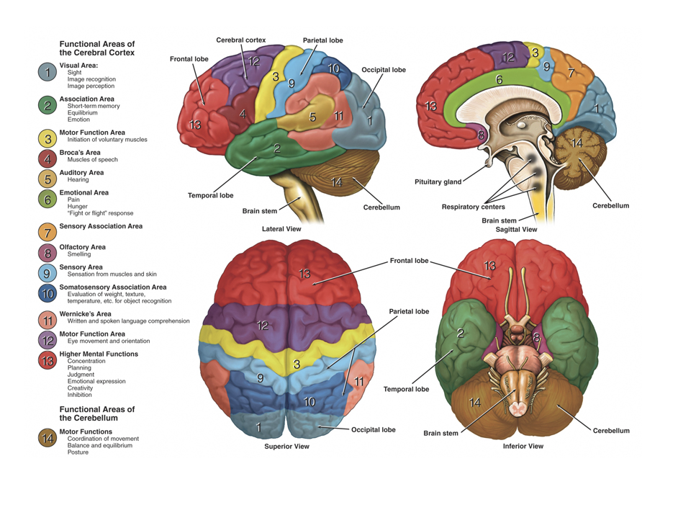

The Cerebral Cortex
- Consists of right and left hemispheres, joined together by 300 million myelinated commissural fibers (Corpus Callosum)
- Cerebral hemispheres show hemisphere specialization
  - The dominant hemisphere (left side of 90% of population) controls:
    - Voluntary movement using the dominant hand (right) and side of the body (primary motor area)
- Sensory discrimination on the dominant (right) side of the body (primary sensory area)

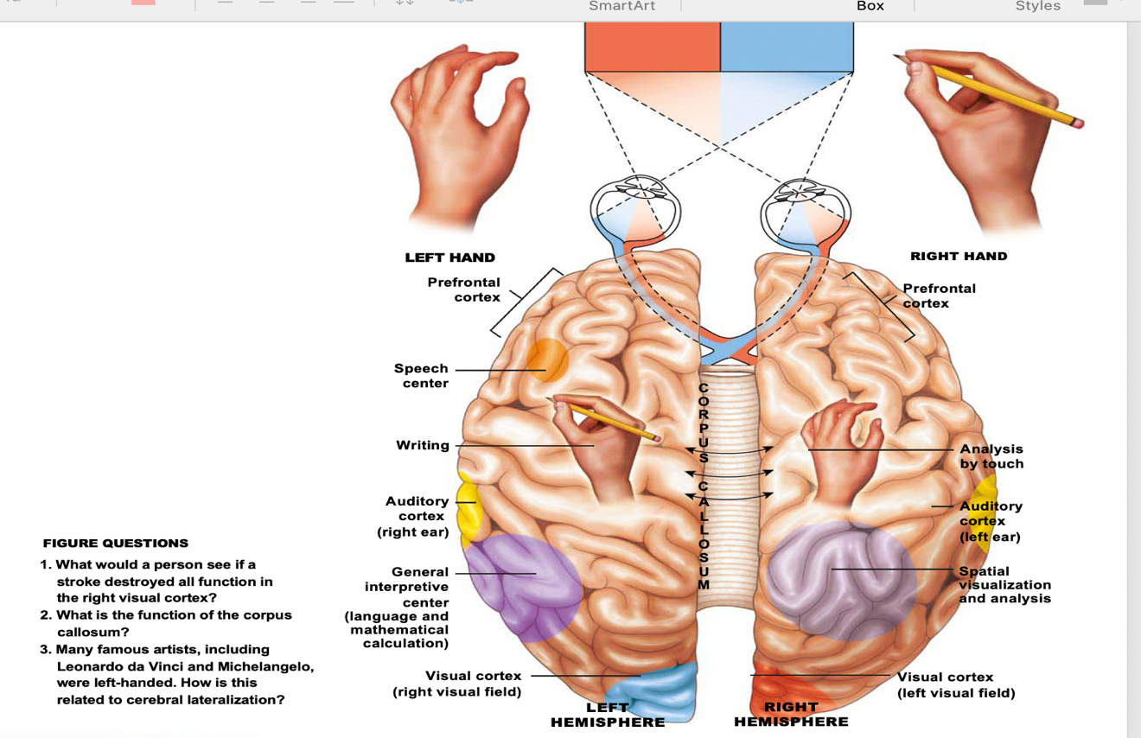

Dominant Hemisphere of Cerebral Cortex
- Stereogenesis using the dominant (right) –Mental construct through touch –Recognizing an object by feeling
  - Understanding of written and oral language
  - Wernicke’s Area is located only in the dominant hemisphere
- Performance of Speech
  - Aphasia – inability to speak because of damage to Brocca’s Speech Center
  - Only in the dominant hemisphere
- Mathematical computations and analytic logic – only in dominant
- Learned reflexes and behaviors
  - Driving a car, doing a task, performing a procedure
  - Only in dominant hemisphere

Subordinate Hemisphere of Cerebral Cortex
- The subordinate hemisphere (right side of 90% of population) controls:
  - Voluntary movement using the weaker hand and weaker side of the body
  - Sensory discrimination on the weaker (left) side of the body
  - Stereogenesis using the weaker (left) hand
  - Spatial relations and tasks
  - Drawing figures, etc.
  - Musical abilities
  - Sense of body posture and balance
  - Example – dancer, surgeon, dentist
  - “Artistic” or intuitive thinking

Other Cerebral Functions
- Not localized
- Involves activity throughout cerebrum
- Consciousness
  - Awareness of the environment (wakefulness)
  - Sensations (perceptions)
  - Self awareness or self cognitions
  - Sensations (perceptions)
  - Self awareness or self cognitions
    - “aware that you are aware”
    - “cognition”
  - Social behaviors
  - Moral and ethical values

Pathologies and Disorders of the Cerebral Cortex
- Viral encephalitis
  - Clinical manifestations depend on which area of the brain has been damaged
- Cerebral palsy
  - Usually damage to a motor area due to cerebral ischemia
- Dyslexia
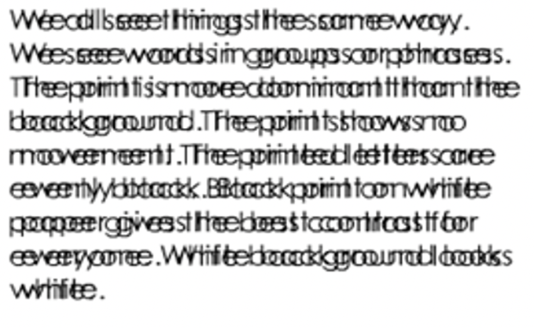
  - Inability to properly read or write words
  - Mistakes “b” for “d” when reading
  - Writes “was when wanted to write “saw”
  - Occurs in up to 15% of schoolchildren
  - 6 times more common in males
  - Hypothesis is a lack of cerebral dominance for understanding language
- Cretinism
  - Retarded brain and body development
  - Caused by a deficiency of thyroxin from birth

Cerebral Vascular Accident
- CVA – Etiology
  - Cerebral thrombus
  - Cerebral hemorrhage
    - Decreased cerebral blood flow >>>>> cerebral ischemia (lack of O2) >>>>> cerebral infarction(death of brain cells)

CVA
- Clinical symptoms may include aphasia, limb paralysis or death
- Neuroplasticity of the cerebral cortex
  - Capacity of the brain to learn new tasks and compensate for the loss of damaged brain areas
- Two pairs of arteries carrying O2 to the brain
  - Right and left internal carotid arteries
  - Right and left vertebral arteries

The Cerebellum (“little brain”
- Located on the dorsal surface of the brainstem
- Functions
  - Unconsciously maintains body posture and balance
  - Unconsciously coordinates voluntary motor activity
  - Unconsciously modulates “set point” of muscle spindles to maintain some degree of muscle tonus (partial contraction)
- Inputs and Outputs
  - The cerebellum receives kinesthetic and proprioceptive information.
  - It evaluates it and subconsciously activates skeletal muscles to maintain posture and balance and coordinate skeletal muscular movements.
- Clinical symptoms associated with cerebellar lesions (injuries)
  - Cerebellar ataxia – loss of coordination
  - Dysarthria – hesitating and slurred speech
  - Hypotonia – (muscle flaccidity) decreased muscle resistance to stretch “limp”
  - Decomposition of voluntary movements
Basal Nuclei
- Located very deep within the white matter of each cerebral hemisphere
- Exerts primarily an inhibitory influence on the somatic motor neurons (via extrapyramidal tracts)
- Functions
  - Generation of mannerisms
  - Stretching, tics and twitches
- Clinical symptoms associated with basal ganglia lesion (injuries)
- Resting muscle tremors
- Hypertonia (muscle rigidity)
- Increased muscle resistance to stretch
- Delay in initiating movement
    - Example – Parkinson’s Disease (“paralysis agitans”)
    - 1st discovered in 1817 by Dr. James Parkinson
    - Associated with decreased dopamine in the basal ganglia
    - Treatment: L-Dopa >>>> increases dopamine level in brain

The Limbic System
- Consists of a complex network of neurons in many associated areas of the brain including:
- Olfactory bulbs
  - Parts of the cerebral cortex
  - Parts of the thalamus
  - Parts of the hypothalamus
  - Amygdeloid nucleus or amygdala
- Functions
  - Generations of emotions
    - Happiness, joy, and euphoria
    - Anger and rage
    - Anxiety, fear, and terror
    - Sadness and depression
  - Emotional state can affect the general level of alertness (via thalamus RAS)

Anxiety, Fear, Excitement, Anger
- Anxiety, Fear, Excitement, Anger >>>>>>>> increased level of alertness
- Depression, sadness >>>>>>>>>>> decreased level of alertness (sedation)
- Motivation (Motivation causes passion)
- Short term memory and learning
  - Motivation and passion are needed for learning
- Sense of smell
  - Odors (like perfumes and aftershave) affect
- Sensitivity to pain (pain is an emotion)
- Sexual behavior

Limbic System – Clinical Considerations
- Rabies – viral infection that damages the limbic system
- Schizophrenia
  - Antisocial
  - Increased dopamine
  - Familial (genetic)

The Medulla Oblongata
- Bipolar Mania and Depression
- Mania (“Hyper”; Impulsive)
  - A form of aggression
  - Increased levels of norepinephrine and serotonin
  - Rx – lithium
- Depression (“sad”; reclusive)
  - Increased catecholamine levels in the brain
  - Decreased norepinephrine and increased serotonin
  - Rx – use anti-depressants and ECS

The Hypothalamus
- Located just below the thalamus and the third ventricle
- Linked to the pituitary gland by
  - Nerve fiber tracts
  - Profuse network of capillaries – (hypothalamic-pituitary portal system)
- Functions
  - Visceral reflex centers
    - Thermoregulatory reflex center
    - Appetite / satiety reflex center
    - Osmoregulatory reflex center
  - Modulates activities of lower visceral reflex centers
    - Cardiovascular reflex center (blood pressure) - in medulla
    - Swelling and vomiting reflex center
    - Micturation reflex center - in spinal cord
    - Defecation reflex center - in spinal cord
- Adjusts the activity of the various visceral organs to match the physical activity and energy requirements of the person
  - –Via descending autonomic fiber tract and the autonomic motor neurons
- Secretes two hormones
  - ADH – vasopressin
  - Oxytocin
- Secretes releasing hormones that affect the anterior lobe of the pituitary
  - These releasing hormones are carried by the anterior pituitary gland via the hypothalamic-pituitary portal veins
  - Different releasing hormones stimulate the release of the anterior pituitary hormones.
    - CRH – Corticotropin Releasing Hormone
    - TRH – Thyrotropin Releasing Hormone
    - GnRH – Gonadotropin Releasing Hormone
    - Growth Hormone Releasing Hormone
    - Growth Hormone Inhibitory Hormone
    - Prolactin Releasing Hormone
    - Prolactin Inhibitory Hormone

CNS Tumors – Pituitary Gland
- Pituitary adenoma – 2 types
  - “Secreting type” (less common) - secretes excess hormones
  - “Null cell”- goes undetected until there is damage
    - Symptoms: “tunnel vision,” cranial nerve compression, hypopituitarism (if blood supply compressed)
    - Treatment - surgery or radiation

