Cerebral Cortex – Occipital Lobe Anatomy and Function
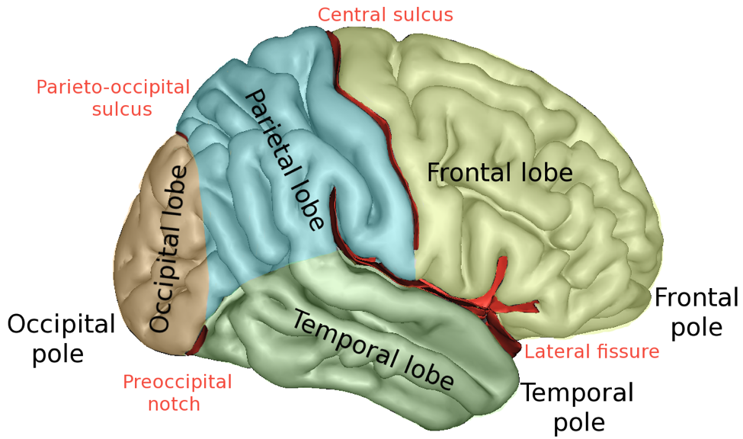
Outline
- Occipital Lobe Anatomy
- Primary Visual Cortex
- Visual Association Cortex
- Summary
- References

OCCIPITAL LOBE ANATOMY
Boundaries of Occipital Lobe
- Parietal-Occipital Sulcus – separates the occipital lobe from the parietal lobe.
- Pre-Occipital Notch - trace an imaginary line between the Pre-occipital notch and the lateral sulcus it’s possible to separate the occipital lobe from the temporal lobe

Divisions and Functions of Occipital Lobe
- Primary Visual Cortex
  - Involved in conscious awareness of visual stimuli
- Visual Association Cortex
  - Involved in analyzing, recognizing, memorizing and understanding a visual stimulus.
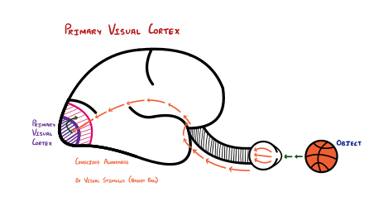
Primary Visual Cortex
- Conscious awareness of a visual stimuli
- The retina sees an image (basketball example). The retina does not know what the image is. It send the image through the optic nerve into a nucleus in the medulla.
- It eventually moves that image forward to primary visual cortex to give the brain a conscious awareness that there is an image.
- The primary visual cortex does not know what the image is. It only knows that there is an image. It send that information forward in the occipital lobe into the visual association cortex to get some meaning and understanding of the image.

- Visual cortex pathway
  - The retina sees an image (basketball) >>>
  - optic nerve >>> optic tracts >>> lateral geniculate nucleus >>> optic radiations >>> primary visual cortex is aware that an object is there.

Visual Association Cortex
- Involved in analyzing, recognizing, memorizing and understanding a visual stimulus.
- The Visual Association Cortex receives the image from the Primary Visual cortex and elaborates its characteristics:
  - Shape
  - Color
  - Size
  - Movement
- Then, compares it to past memories → allows us to recognize the object
- We can recognize that the object is a basketball

Clinical significance of Visual Association Cortex
- A lesion in the Visual Association cortex causes Visual Agnosia
  - The patient is able to see the object, since the visual pathway up to the Primary visual cortex is intact, but can’t recognize it.
  - Example: the patient will see the basketball, and will be able to say that there’s something in front of them, but won’t be able to tell that it’s a basketball.
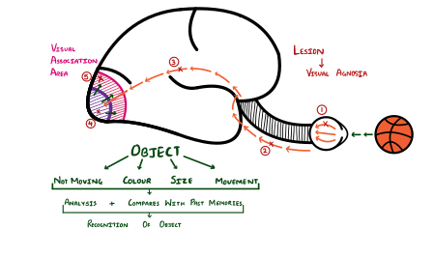

Summary
- The occipital lobe is located in the most posterior portion of the cerebral cortex, between the Parieto-occipital sulcus and pre-occipital notch
- It contains:
  - Primary Visual cortex
    - Responsible for conscious awareness of visual stimuli
    - End point of the visual pathway
  - Visual Association cortex
    - Responsible for understanding and recognizing a visual stimulus
    - Compares the stimulus to past memories
    - If damaged → Visual Agnosia

References
- Marieb EN, Hoehn K. Anatomy & Physiology. Hoboken, NJ: Pearson; 2020.
- Jameson JL, Fauci AS, Kasper DL, Hauser SL, Longo DL, Loscalzo J. Harrison's Principles of Internal Medicine. New York etc.: McGraw-Hill Education; 2018.
- Felten DL, O'Banion MK, Maida ME. Netter's Atlas of Neuroscience. Amsterdam, The Netherlands: Elsevier Health Sciences; 2015
- Hall, John E. Guyton and Hall Textbook of Medical Physiology. 13th ed., W B Saunders, 2015.

