Cerebral Cortex – Parietal Lobe Anatomy and Function
Outline
- Parietal Lobe Anatomy
- Primary Somatosensory Cortex
- Somatosensory Association Area
- Posterior Association Area
- Review Questions
- References

PARIETAL LOBE ANATOMY

Boundaries of Parietal Lobe
- Anteriorly→ Separated from frontal lobe by central sulcus
- Inferiorly→ Separated from temporal lobe by lateral sulcus
- Posteriorly→ Separated from occipital lobe by parieto-occipital sulcus
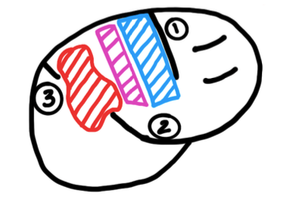
Functional Areas
- Primary Somatosensory Cortex
  - Conscious awareness of somatic sensation (touch, pain, temperature, vibrations, pressure, proprioception)
- Somatosensory Association Cortex
  - Analyzing and recognition of somatic sensations
  - Memory storage of somatic sensations
  - It is providing meaning to what we feel
- Posterior Association Area
  - Overlaps parts of occipital and temporal lobes
  - Integration of somatic, visual and auditory sensations
  - Also called the parietal-occipital-temporal cortex
    - From the parietal lobe it is getting somatic sensations
    - From the occipital lobe it is getting visual sensations
    - From the temporal lobe it is getting auditory sensations
  - All these sensations come together in one area and is giving information on spatial coordination

Primary Somatosensory Cortex
- Also known as Brodmann Area 1,2,3
- It is involved with conscious awareness of somatic sensations
- Receives sensory information through:
  - Dorsal Column Medial Lemniscus Pathway - Information on:
    - Fine Touch and Discriminative Touch
    - Proprioception
    - Vibration
  - Fibers decussate at the medulla and arrive at the contralateral side of the cortex
- Spinothalamic Tract Pathways - Information on:
  - Pain
  - Temperature
  - Crude touch
  - Pressure
  - Fibers decussate at the spinal cord and arrive at the contralateral side of the cortex
- Contributes to 40% of motor function through:
  - Corticobulbar tracts - From the cortex to the pons
  - Corticospinal tracts - From the cortex to the spinal cord

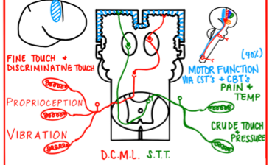

Somatotopy Of Parietal Lobe
- The point-to-point correspondence of an area of the body to a specific point on the central nervous system
- In the somatosensory Homunculus:
  - Medial cortex corresponds to lower extremities
  - Lateral cortex corresponds to upper extremities and face
  - The bigger a structure, the more sensitivity that area has

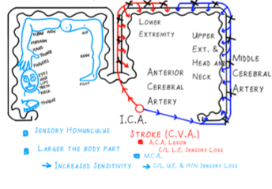
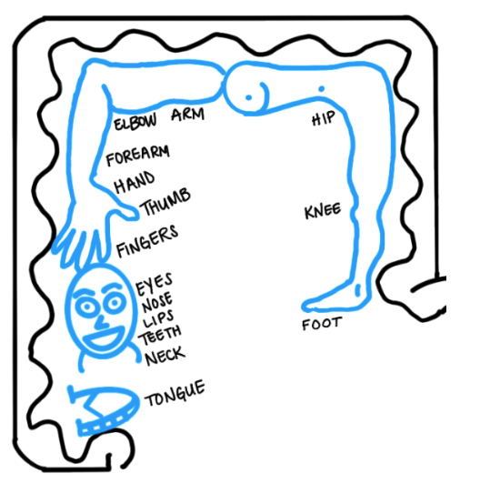
Sensory Homunculus
- Sensations from lower leg goes to medial part of the primary somatosensory cortex
- Sensations from upper extremity to lateral part of the primary somatosensory cortex

The Internal Carotid Artery
- Branches off into an Anterior Cerebral Artery
  - Goes to lower extremities because it is the medial part of the primary somatosensory cortex
- Also branches of into a middle cerebral artery
  - Goes to the upper extremities, head and neck because it is the lateral part of the primary somatosensory cortex

Clinical Correlation- Stroke
- The symptoms of a stroke differ depending on the affected area in the brain:
  - A lesion of the Anterior Cerebral Artery (A.C.A)
    - Reduces blood flow to the medial cortex
    - Results in weakness and loss of sensation of the contralateral lower extremities
  - A lesion of the Middle Cerebral Artery (M.C.A.)
    - Reduces blood flow to the lateral cortex
    - Results in weakness and loss of sensation of the contralateral upper extremities and face

Somatosensory Association Cortex
- Receives somatosensory information from primary association cortex
- Analyzes this information to determine
  - Size of an object
  - Texture
  - Weight of an object
  - Position in 3D space
- Compares this information to previous experiences to determine what you are touching (pattern recognition)
- Stores the new information in memory

Lesions of Somatosensory Association Cortex
- Astereognosis - Inability to identify an object only by touch
- Agraphesthesia - Inability to recognize letters or numbers drawn on the skin
- Astatognosis - Inability to identify body part position
- Abarognosis - Inability to recognize weight differences

Posterior Association Area
- Receives somatosensory information from primary association cortex
- This is a multimodal association area (Integrates stimuli from various areas of your brain)
- Receives information from somatosensory, auditory and visual association cortices
- Puts the information together to:
  - Make sense of the situations around us
  - Develop spatial co-ordination
- Communicates with the Pre-frontal cortex and the Motor cortex
Review Questions
- What artery is most likely to be affected in a stroke that affects sensation to the right leg?
  - Right middle cerebral artery
  - Left anterior cerebral artery
  - Left middle cerebral artery
  - Right anterior cerebral artery
- Which of the following structures/areas is NOT located in the parietal lobe?
  - Post-central gyrus
  - Brodmann Area 1,2,3
  - Motor Cortex
  - Posterior Association Area
- Which of the following somatosensory information is carried to the brain by the spinothalamic tract?
  - Vibration
  - Pain
  - Discriminative Touch
  - Proprioception
References
- Sabatine MS. Pocket Medicine: the Massachusetts General Hospital Handbook of Internal Medicine. Philadelphia: Wolters Kluwer; 2020.
- Papadakis MA, McPhee SJ, Rabow MW. Current Medical Diagnosis & Treatment 2018. New York: McGraw-Hill Education; 2017.
- Jameson JL, Fauci AS, Kasper DL, Hauser SL, Longo DL, Loscalzo J. Harrison's Principles of Internal Medicine, Twentieth Edition (Vol.1 & Vol.2).
- McGraw-Hill Education / Medical; 2018 Marieb EN, Hoehn K. Anatomy & Physiology. Hoboken, NJ: Pearson; 2020.
- Netter FH, Felten DL, Józefowicz Ralph F. Netter's Atlas of Human Neuroscience. Teterboro, NJ: Icon Learning Systems; 2004. Netter FH. Atlas of Human Anatomy.
- Purves, Dale. Neuroscience. Available from: VitalSource Bookshelf, (6th Edition). Oxford University Press Academic US, 2017. University Press (Chapter 32, 33)
- Siegel, Allan, and Hreday N. Sapru. Essential Neuroscience. Available from: VitalSource Bookshelf, (4th Edition). Wolters Kluwer Health, 2018. (Chapter 1, 12)
- Waxman, Stephen G. Clinical Neuroanatomy. Available from: VitalSource Bookshelf, (29th Edition). McGraw-Hill Professional, 2020. (Chapter 21)

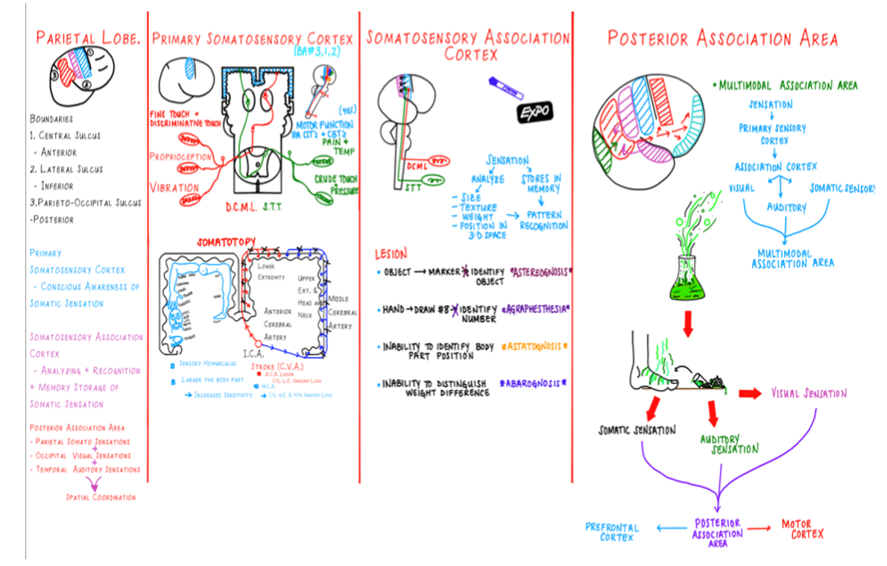
Parietal Lobe Anatomy and Function Wrap Up

