Cerebral Cortex – Temporal Lobe Anatomy and Function
Outline
- Temporay Lobe Anatomy
- Primary Auditory Cortex
- Auditory Association Cortex
- Weirnecke’s Area
- Primary Olfactory Cortex and Association Olfactory Cortex
- Insular Cortex
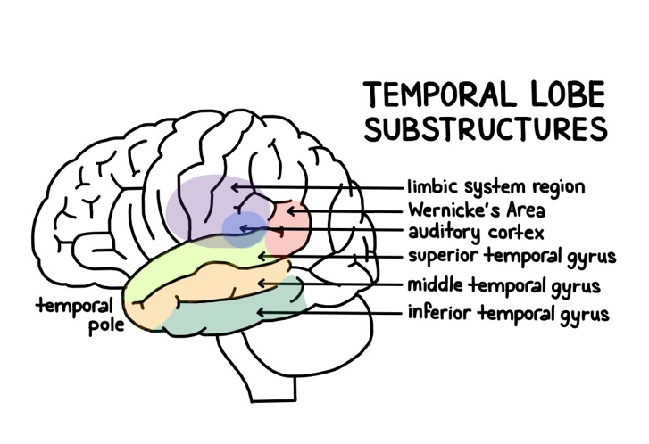
- References
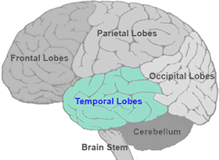

TEMPORAL LOBE ANATOMY
Boundaries of Temporal Lobe
- Lateral sulcus (Sylvian fissure)
  - Separates temporal lobe from frontal and parietal lobes
- Preoccipital notch: an imaginary line that can be drawn between the notch and the Lateral sulcus
  - Separates the temporal lobe from the occipital lobe

Divisions and Functions of Temporal Lobe
- Primary Auditory Cortex
  - Conscious awareness of sound
- Auditory Association Cortex
  - Gives meaning or understanding of sound
- Wernicke’s Area
  - Comphrehensive understanding of written or spoken language
- Primary Olfactory Cortex and Association Olfactory Cortex
  - Conscious awareness of smell
- Insular Cortex
  - Conscious awareness of gustation
  - Visceral sensations & vestibular sensations
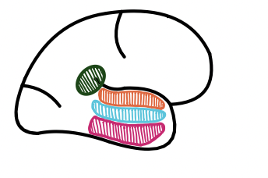
Primary Auditory Cortex Orange in drawing
- The Primary Auditory cortex is Involved in conscious awareness of sound stimuli
- It identifies the 3 characteristics of sound:
  - Frequency
  - Pitch
  - Location

How sound is perceived
- Auditory pathway: → Inner hair cells in cochlea→ carried by vestibulocochlear nerve (CN VIII)→ cochlear nuclei in pontomedullary junction→ decussation at level of trapezoid body→ ascends as lateral lemniscus→ goes to thalamus (medial geniculate body)→ primary auditory cortex
- There is communication between the 2 sides
  - The neurons decussate at the level of the trapezoid body, so the information is received controlaterally (opposite side)
  - Example: a sound stimulus received by the left ear will be heard in the right Primary Auditory cortex

Lesion of Primary Auditory Cortex
- It will cause contralateral loss of sound stimuli
  - Includes difficulty determining the location, pitch and frequency of a sound.

Auditory Association Cortex Blue in drawing above
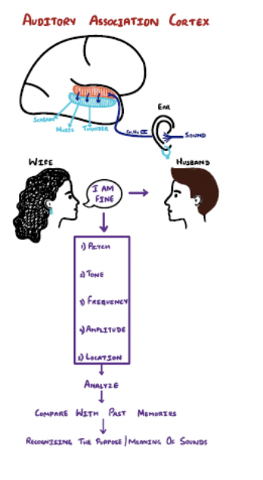
- Once the stimulus has arrived in the Primary Auditory Cortex, it’s sent to Auditory Association cortex
  - Analyzes pitch, localization and amplitude of sound
  - Compares sound characteristics with previous sounds and helps to recognize the meaning and significance of the sound stimulus
    - Example: a wife tells her husband “she's fine” in a loud manner.
- The auditory association cortex will compare that sound characteristics with previous memories and help one recognize she isn't “fine”, instead “she ticked off”.

Wernicke’s Area Green in drawing
- Responsible for comprehension and understanding of written and spoken language
- Receives visual cues from visual association cortex in occipital lobe and auditory information from auditory association cortex in temporal lobe
  - These information are used to help comprehend the language (written or spoken) being presented.
  - Then Wernicke’s area sends impulses to Broca's area (via arcuate fasciculus) which is involved in stimulating muscles of speech production
    - Example:
▪ Wife is talking about various things that happened at work today and you decide to tune her out, because you are listening to a Dr. M podcast. All of a sudden she says frustratingly with her very upset facial expressions “what did I just say, were you even listening?”
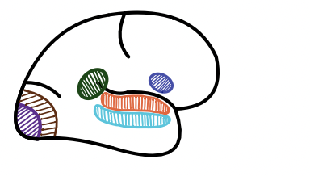
- Your Wernicke’s area will allow you to analyze the angry voice and frustrated face of the wife and then comprehend she is “ticked off”.
- Wernicke's area then sends that information to Broca’s area and then you respond “yeah of course I was listening”.

Wernicke’s Aphasia (Receptive aphasia)
- Caused by damage to Wernicke’s area, usually because of middle cerebral artery stroke.
  - Symptoms:
    - Fluent speech: the patient is able to form words and sentences since Broca’s area isn’t damaged, however the speech will make no sense
- Inability to comprehend the meaning of a word or sentence

Primary Olfactory Cortex and Olfactory Association Area
- Located deep to temporal lobe, at the level of uncus, on medial portion of the brain
- Involved in the awareness of smell and analysis, recognize and identify smell patterns and store these smells in memory pathways
- Olfactory pathway:
  - The smell will activate the receptors located in the nasal activity → activates olfactory nerves (CN I), which cross cribriform plate to reach olfactory bulb → gives rise to olfactory tract→
    - Medial olfactory stria: directed towards primary orbitofrontal cortex in frontal lobe
    - Lateral olfactory stria: directed to primary olfactory cortex
  - From there, the stimulus is sent to Olfactory Association cortex, where it will be stored in our memory
  - The stimulus can also reach the amygdala (limbic system), where that particular smell will be tied to certain emotions

Insular Cortex Pink in drawing below
- Not actually part of the temporal lobe, makes up its own lobe
- Located deep in Lateral fissure
- Functions:
  - Receives visceral sensation: pain and temperature information from lungs, heart and GI tract
    - Information is sent to insula → analyzes, recognizes, and stores memory of visceral sensations
    - Example:
      - Gastroenteritis→ activates visceral sensory neurons of GIT→ sends signals to insula→ Insula remembers visceral pain from gastroenteritis
  - Receives vestibular sensations from inner ear→ Insula
    - This helps us to be more aware of our dynamic and static equilibrium
    - Receives gustation (taste) from taste buds in fungiform papillae and vallate papillae→ Cranial nerves (VII and IX)→ nucleus of tractus solitarius→ insula
    - Insula helps us differentiate between different tastes
      - Sweet
      - Sour
      - Salty
      - Bitter
      - Umami

References
- Purves, Dale. Neuroscience. Available from: VitalSource Bookshelf, (6th Edition). Oxford University Press Academic US, 2017. University Press
- Siegel, Allan, and Hreday N. Sapru. Essential Neuroscience. Available from: VitalSource Bookshelf, (4th Edition). Wolters Kluwer Health, 2018.
- Waxman, Stephen G. Clinical Neuroanatomy. Available from: VitalSource Bookshelf, (29th Edition). McGraw-Hill Professional, 2020.
- Marieb EN, Hoehn K. Anatomy & Physiology. Hoboken, NJ: Pearson; 2020.
- Jameson JL, Fauci AS, Kasper DL, Hauser SL, Longo DL, Loscalzo J. Harrison's Principles of Internal Medicine. New York etc.: McGraw-Hill Education; 2018.
- Felten DL, O'Banion MK, Maida ME. Netter's Atlas of Neuroscience. Amsterdam, The Netherlands: Elsevier Health Sciences; 2015

