Upper Motor Neurons and Lower Motor Neurons Dr. Gary Mumaugh – Campbellsville University

Upper and Lower Motor Neurons
- Upper motor neurons (UMN): have their cell bodies located in the motor cortex and synapse with lower motor neurons
- 2 tracts of UMN:
  - Corticospinal tract - from motor cortex to spinal cord
    - UMNs are located in motor cortex (primary motor cortex, premotor cortex, supplementary motor area)
    - They give off axons that travel through the corona radiata, internal capsule, midbrain, pons, medulla to end up in the
    - Spinal cord: UMN synapse with LMN
  - Corticobulbar tract: from motor cortex to cranial nerves nuclei
    - UMNs are located in the motor cortex (primary motor cortex, premotor cortex, supplementary motor area)
    - They give off axons that travel through the corona radiata, Internal capsule, midbrain, pons and medulla
    - UMNs synapse on LMN located in cranial nerves nuclei
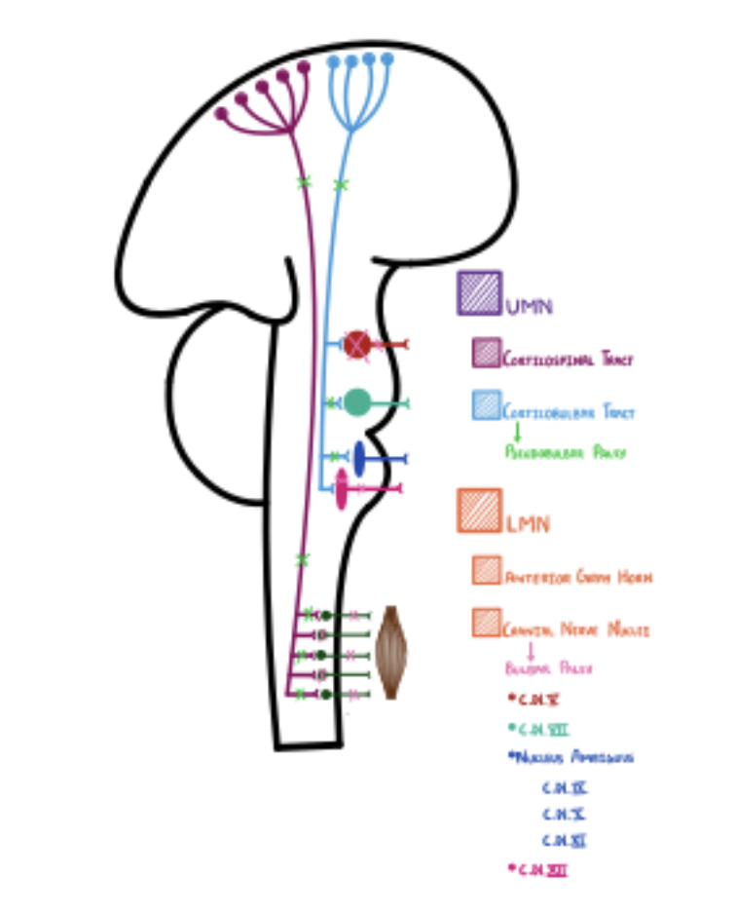
- Lower Motor Neurons (LMN): they have their cell bodies either in the spinal cord or the cranial nerve nuclei, and are directed towards skeletal muscles
- 2 destinations of LMN:
  - Anterior grey horn – continuation of the corticospinal tract
  - LMNs then continue towards skeletal muscles of the body, where they elicit voluntary movements
  - Specific cranial nerves nuclei – continuation of the corticobulbar tract
  - Relevant nuclei
    - Trigeminal (CN V) nucleus – mastication muscles
    - Facial (CN V) nucleus – facial expression muscles (mimetic)
    - Nucleus ambiguous (CN IX, X, XI) – muscles of pharynx, larynx, uvula, palate
    - Relevant for speech, swallowing and articulation
    - Hypoglossal (CN XII) nucleus – tongue muscles
  - Damage to these LMNs leads to bulbar palsy

Causes of UMN and LMN Lesions
- UMN Lesions
  - UMN lesions can be caused by
    - Stroke (CVA) – both ischemic and hemorrhagic
    - Demyelination
    - Multiple sclerosis, Freiderich’s Ataxia, B12 deficiency
    - Amyotrophic Lateral Sclerosis (ALS) – motor neuron disease
  - Damages the cells body of the UMN through free radical accumulation
- LMN Lesions
  - LMN lesions can be caused by
    - Viruses: Poliomyelitis, West Nile Virus
    - Spinal muscle atrophy
    - Cauda equina syndrome – damage to the axon, caused by a disk herniation of the lumbar and sacral portions of the spine
    - Diabetic neuropathy
    - Botulism
    - ALS
Muscle Mass
- Refers to muscle mass changes in different types of lesions
- UMN Lesions
  - Decreased protein synthesis in the muscle cell will cause
    - Disuse Atrophy
    - 15-20% loss of muscle mass
- LMN Lesions
  - Increased protein synthesis in the muscle cell will cause
    - Denervation Atrophy
    - 75-80% loss of muscle mass
UMN Lesions
- UMN lesions can involve damage anywhere from cortex to spinal cord.
- Motor cortex controls voluntary movements:
  - In case of damage: no connection between cortex and spinal cord (where LMNs are located) → no control over skeletal muscles → they start atrophying
  - Disuse Atrophy: decrease of 15-20% in muscle mass
LMN Lesions
- LMNs release Acetylcholine (Ach) at neuromuscular junction → Ach can bind to 2 types of receptors
  - Nicotinic receptors: when activated, elicit AP in muscle cell → contraction
  - Muscarinic receptors: begin intracellular cascade → production of transcription factors → up-regulation of protein synthesis in muscle cell
- In case of damage: decreased Ach release, which has 2 effects
  - No muscle contraction
  - No intracellular pathway for transcription factors
    - Decreased protein synthesis and increased protein degradation
    - Muscles start atrophying
      - Denervation atrophy – decrease of 70-80% of muscle mass
Fasciculations
- Fasciculation are involuntary pathological contractions.
  - A muscle twitch is an involuntary contraction, but it's usually benign.
- Only seen in LMNs lesions: especially evident in the tongue
- LMNs lesions cause reduced Ach release
- In physiological situations:
  - Ach binds to nicotinic receptors → open Ligand- gated Sodium channels → Na+ flows into the cell → depolarization → AP → contraction
- In pathological situations:
  - Decreased Ach reduces receptor binding (the muscle thinks there are not enough receptors on the membrane) > increases receptor production > increases sensitivity to stimuli> they respond to a tapping of the muscle > involuntary muscle contraction - Fasciculation
- Fasciculations can be seen on a EMG: there called fibrillations
UMN Lesions
- In case of UMNs lesions: no stimulation of medullary reticulospinal nuclei which decreases inhibition of LMN
- LMN are more active and has two effects
  - ↑ motor neuron activity: ↑ contractions
    - Increases muscle tone
    - Hypertonia
  - ↑ motor neuron activity: ↑ sensitivity to mechanical stimuli
    - Creates a stronger and bigger reflex - Hyperreflexia
    - Produce spastic paralysis: decrease in strength
      - NOTE: spasticity is very different from rigidity
Spasticity vs. Rigidity
- Spasticity
  - Velocity-dependent: increased resistance with higher velocity
  - Resistance only in one direction
  - Weakness
  - Clasp-knife phenomenon: the muscle makes resistance until eventually it gives out and goes slack
- Rigidity
  - Velocity-independent
  - Resistance in both direction
  - No significant weakness
  - Lead-pipe rigidity: arm is rigid throughout the whole movement
  - Seen in Parkinson’s: characterized by tremors

LMN Lesions
- Decreased motor neuron activity causing decreased stimulation of muscle fibers
- Decreased muscle tone – Hypotonia
- Decreased sensitivity of muscle spindles which causes
  - Decreased reflexive strength and muscle movement
  - Decreased DTR – Hyporeflexia
- Muscle strength is a flacid paralysis

Tests to diagnose UMN vs. LMN lesions
- There are several special test that can be performed to test the presence of damage to motor neurons, however they result positive (pathological) exclusively in UMNs lesions.
- Babinski sign:
  - Run the tip of your reflex hammer of the plantar surface of the foot, from heel to toes, moving laterally to medially
  - In physiological situations, it creates reflex that activates the plantar flexors: the toes curl downwards.
    - At the same time, UMNs send inhibitory signals to dorsiflexor.
  - In pathological situations: decreased inhibition of dorsiflexor → dorsiflexor overcome activity of plantar flexors
    - When stroking the bottom of the foot, the big toe dorsiflex and the other toes fan out
  - Positive Babinski sign is also seen in babies (<1yo):
    - Their corticospinal tract isn’t fully developed, it lacks myelination → the toes dorsiflex and the sign is positive
    - Not pathological, it disappears as they grow older.
- Pronator drift
  - Ask the patient to stand with their arms extended and supinated, their eyes closed. Tap on the arms.
  - If a lesion of UMN is present, there will be an increase in pronators activity and decrease of supinator activity → the arms start drifting downwards and pronate at the same time

Wrap Up of Upper Motor Neuron vs. Lower Motor Neuron Lesions

 | UMN | LMN
Muscle Mass | Decreased muscle mass 15-20% | Decreased muscle mass 75-80%
Type of Atrophy | Disuse Atrophy | Denervation Atrophy
Muscle Strength | Spastic Paralysis | Flacid Paralysis
Muscle Tone | Increased Muscle Tone  Hypertonia | Decreased Muscle Tone  Hypotonia
DTR | Increased - Hyperreflexive | Decreased - Hyporeflexive
Fasciculations | Absent | Present Because of decreased AcH
Fibrillations | Absent | Present Because of decreased AcH
Special Tests | Present - Positive | Absent - Negative

