Spinal Cord – White Matter Dr. Gary Mumaugh
Outline
- White matter structure
- White matter function
- References

White Matter Structure
- White Matter = myelinated axons
  - Made of lipid and protein which is what gives the white appearance
  - Formed by oligodendrocytes (central nervous system) and Schwann cells (peripheral nervous system)
  - Tract = bundle of Axons in the CNS
- Basic Anatomy of White matter
  - Anterior (Ventral) Funiculus or Column
  - Lateral Funiculus or Column
  - Posterior (Dorsal) Funiculus or Column
  - Anterior White Commissure
    - Where fibers Cross
- Ascending Tracts → Sensory
- Descending Tracts → Motor
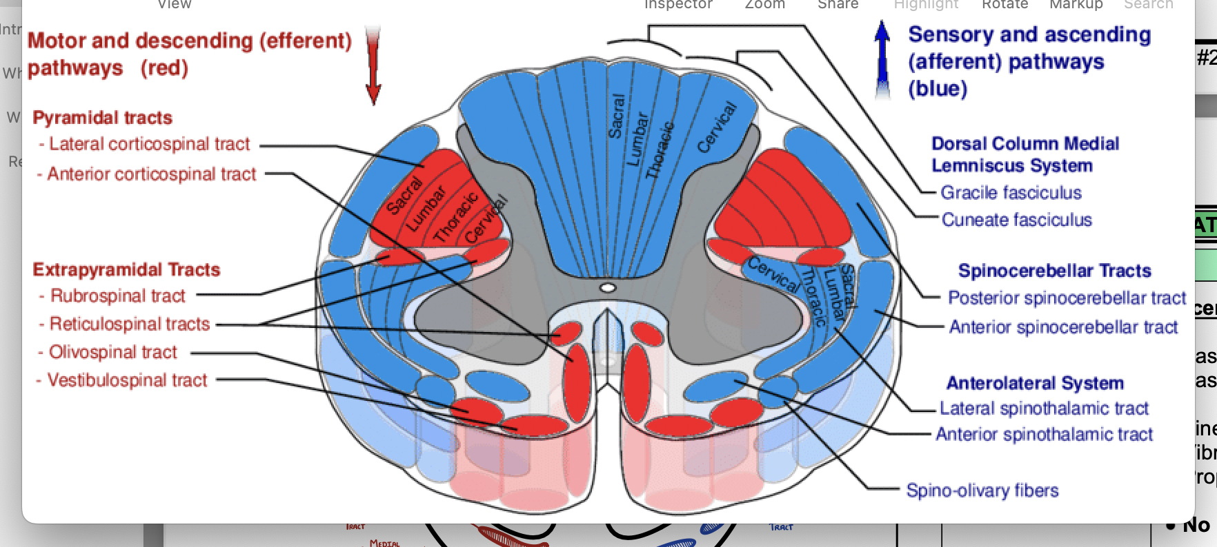

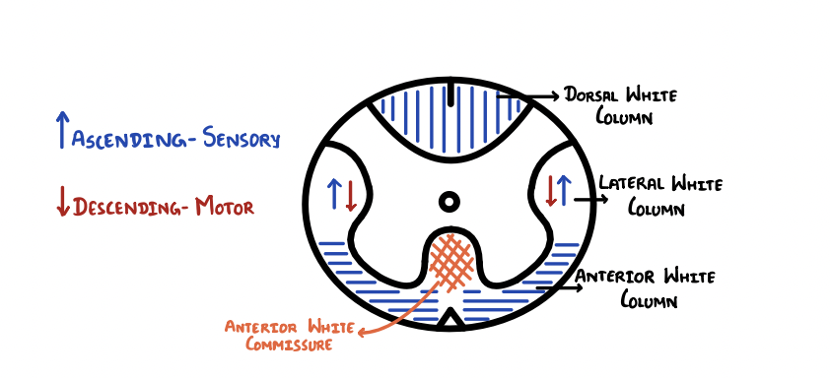

Ascending Sensory Tracts of White Matter Structure
- Dorsal White Column
  - Fasciculus Gracilis
  - Fasciculus Cuneatus
  - There is no descending tract in the Dorsal White Column
- Lateral White Column
  - Dorsal Spinocerebellar Tract Ventral
  - Spinocerebellar Tract
  - Lateral Spinothalamic Tract
  - Spino-Olivary Tract
- Ventral White Column
  - Ventral Spinothalamic Tract

- Somatotopic Arrangement of Lateral Spinothalamic Tract
  - Lower extremity and legs are laterally
  - Upper extremity and arms are medially
  - Dorsal Column
    - Fasciculus Gracilis → Lower extremities
    - Fasciculus Cuneatus→ Upper extremities

Descending Motor Tracts of White Matter Structure
- Lateral White Column
  - Lateral Corticospinal Tract
  - Rubrospinal Tract
- Ventral White Column
  - Lateral Reticulospinal Tract
  - Medial Reticulospinal Tract
  - Vestibulospinal Tract
  - Tectospinal Tract
  - Anterior Corticospinal Tract

- Somatotopic Arrangement of Lateral Corticospinal Tract
  - Lateral Corticospinal Tract going from lateral →→→ medial
    - Sacral → Lumbar →Thoracic →Cervical
  - Fibers that control the upper extremity located medial to those that control the lower extremity

Functions of White Column Tracts

Ascending Tracts | Descending Tracts

 |  | Function
Dorsal Column | Fasciculus Gracilis → T6 and below | Fine Touch, Vibrations, Proprioception
 | Fasciculus Cuneatus → T5 and above | Fine Touch, Vibrations, Proprioception
 | No Descending Tracts
 | Dorsal Spinocerebellar Tract | Proprioception (C8-L2)
 | Ventral Spinocerebellar Tract | Proprioception (L2-Co 1)
 | Spino-Olivary Tract | Proprioception → Inferior Olives →Cerebellum
Lateral Column | Lateral Spinothalamic Tract | Pain, Temperature
 | Lateral Corticospinal Tract | 85% of the fibers of the Pyramidal decussate Stimulate Lower Motor Neurons → Voluntary control of skeletal muscles
 | Rubrospinal Tract | Stimulate Lower Motor Neurons → Flexors
 | Ventral Spinothalamic Tract | Crude Touch and Pressure
 | Lateral Reticulospinal Tract aka Medullary Reticulospinal Tract | Flexors
Ventral Column | Medial Reticulospinal Tract aka Pontine Reticulospinal Tract | Extensors
 | Vestibulospinal Tract | Extensors
 | Tectospinal Tract | Head, Neck and Eye Movements
 | Anterior Corticospinal Tract | Lower Motor Neurons → Voluntary Skeletal Muscle Control

References:
- AMBOSS: medical knowledge platform for doctors and students. (n.d.). Amboss. Retrieved August 22, 2021, from https://www.amboss.com/us/
- Blumenfeld, H. (2010). Neuroanatomy Through Clinical Cases (2nd ed.). Sinauer Associates, Inc.
Answers 1) A 2) C 3) C 4) B 5) D 6) B 7) A 8) A 9) C 10) B 11) C

