Pain, Temperature, Sleep
Pathology 1 - Dr. Gary Mumaugh

Pain
- “Pain is an unpleasant sensory and emotional experience associated with actual or potential tissue damage or described in terms of such damage” International Association for the Study of Pain
- “Pain is whatever the experiencing person says it is, existing whenever he says it does” - McCaffrey

Value of Pain
- Pain is generated as soon as the stimulus is severe enough to cause tissue damage
- The intensity of the pain is related with the rate of the tissue damage.
- Pain is essential for the maintenance of health.
- Pain causes us to behave in a way that we avoid further tissue damage.
- Pain informs us there is a problem.
- Pain promotes immobilization.

Inability to Feel Pain
- The best way to consider the usefulness of pain is seen in individuals who cannot feel pain.
- Seen in diabetes mellitus
- Seen in disorders of neurological deficits
- Hanson’s disease (leprosy)

Components of Pain
- Pain is a complex phenomenon consisting of four basic components.
- Sensory Component
  - This is the feeling of pain experienced.
  - Many different terms are used – sharp, dull, achy, crushing, burning, gnawing, grating, sickening
  - Can vary from irritating to overwhelming to intolerable
- Affective Component
  - Affect means to do with mood or emotion.
  - This is the way pain makes you feel in emotional terms.
  - Pain is upsetting, unpleasant and disturbing and causes anxiety.
- Autonomic Component
  - Pain has an autonomic effect on the ANS
  - Initially pain leads to sympathetic stimulation
- Motor Component
  - The most obvious motor effect is to withdraw the body part to the exposed pain.
  - People in pain usually have a desire to let others know they are suffering.
  - Some people “suffer in silence”, which makes accessing patients on an individual basis.
Clinical Description of Pain
- Pain threshold
  - This is the stimulus that first starts the pain.
  - This does not vary much between individuals or over time.
  - Apparent differences in pain perception between racial groups are probably a result of cultural attitudes and modeling.
  - Biologically, all races of people are identical with pain threshold.
- Perceptual dominance
  - Pain at one location may cause an increase in the threshold in another location.
- Pain tolerance
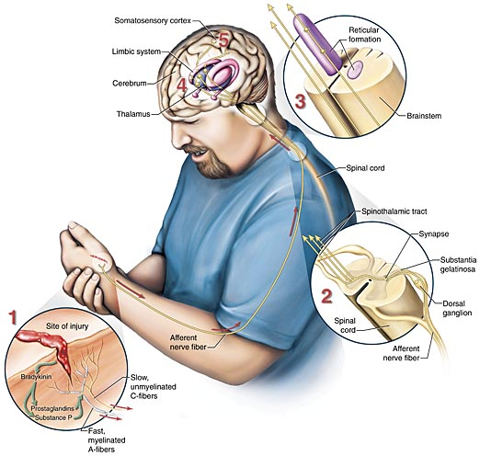
  - Duration of time or the intensity of pain that a person will endure before initiation of pain responses.
  - It is the level of pain intensity which forces the individual to withdraw or ask for the stimulus to be stopped.
- Superficial Pain
  - Pain from the skin or near the body surface
- Deep
  - Deep pain from bones, joints or organs

Acute Pain
- Protective mechanism
- Alerts an individual to a condition or experience that is immediately harmful to the body
- Acute is sudden onset and pain subsides once the cause of the pain is removed.
- Acute pain has a function of preventing further damage.
- Manifestations
  - Fear and anxiety
    - Tachycardia, hypertension, fever, diaphoresis, dilated pupils, outward pain behaviors, elevated blood sugar levels, decreased gastric acid secretion and intestinal motility, and a general decrease in blood flow

Chronic Pain
- Usually defined as lasting at least 3 to 6 months
- Unlike acute pain, chronic pain serves no function.
- The source is often unknown and cannot be treated or stopped.
- Has a very destructive effect on the individual
- May be sudden or develop insidiously
- May be persistent or intermittent
- Response patterns vary
- Produces significant behavior and psychologic changes

Common Types of Chronic Pain
- Myofascial pain syndromes
  - Injury to the muscle and fascia
    - Spasm, tenderness, and stiffness
- Chronic postoperative pain
- Cancer pain

Pain Perception at the Peripheral Level
- Nociceptors
  - Pain originates is specialized with sensory receptors called nociceptors or free nerve endings.
  - They detect noxious stimuli.
  - Tissues which are sensitive to pain have large numbers of nociceptors.
    - Numerous nociceptors in skin, periosteum, arterial walls, joints, cavity membranes
  - Tissues which do not feel pain have no nociceptors.
    - Stomach biopsies cause no pain because there are no nociceptors on the wall.
- Nociception
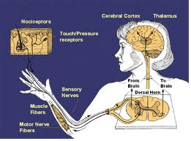
  - There are basically three types of stimuli that stimulate nociceptors and cause pain.
    - Thermal nociception
    - Strong mechanical pressure or stimuli
      - Nociceptors respond strong if torn or cut
    - Chemical nociception
      - Acids and chemicals often associated with inflammation such as histamine and bradykinin
      - Chemical stimulation is why insect stings can be so painful

- Nociceptors only generate a nervous impulse when they are strongly stimulated.
  - It takes a lot of pressure to cause pain.
  - Physiologically, this is because the nociceptors have a very high setting of depolarization threshold.
  - This high threshold prevents us from feeling pain in response to daily wear and tear.
  - Severe pain does not cause a greater degree of depolarization, only the threshold is higher.
  - Like all neuron, the “all or nothing” principle applies.

Local anesthetics
- Cocaine-based preparations work on nociceptor nerve endings and dendrites.
- When injected onto a nerve they work on blocking the sodium ion channels. This blockage prevents the free flow of sodium in and out of the cell.
- This means that the nerve impulse cannot pass along the affected neuron.
- Mixing lidocaine with low dose adrenaline causes an anesthetic effect with local vasoconstriction, which causes the anesthetic to stay at higher concentrations and not be washed away.

Aspirin
- Aspirins and other NSAID work at the peripheral level.
- They inhibit the synthesis of prostaglandins in the tissues.
- Prostaglandins sensitize nociceptors to make them “fire” in inflammation

Sharp and Dull Pain
- Sharp Pain is well localized and tends to be short in duration.
- Shortly after we have sharp pain, we usually become more away of dull pain.
- Dull pain is harder to localize to a precise area of the body.
- Dull pain is often described as being from an area, rather than from an actual location.
- Fast and slow pain neurons
- Myelinated type A –delta fibers transmit sharp pain.
    - These fibers pain transmission is at 15-90 feet per second (35-70 mph)
- Unmyelinated type C fibers transmit dull, achy, hurting pain.
    - These fibers pain transmission is at 1-5 feet per second

Pain Transmission Into and Up the Cord
- All information about the external world and our bodies enters the brain via sensory neurons.
- Nociceptor neurons (and all sensory neurons) enter the spinal cord via the dorsal horn.
- Motor neurons leave via the ventral root.
- Both A and C fibers enter the dorsal horn and synapse with the interneurons or relay neurons.
- The interneuron carries the impulse diagonally across the cord where it synapses upwards and joins with pain neurons in the spinothalamic tracts.

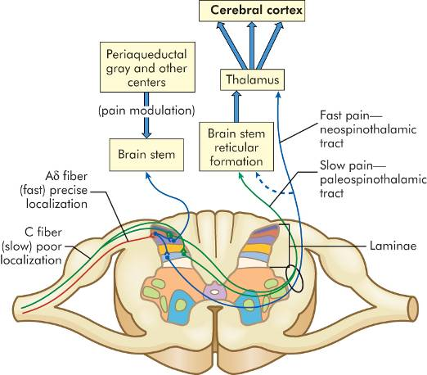
Pain Processing in the Brain
- The right hemisphere provides sensation for the left side of the body and vice versa.
- Unlike other sensory neurons, ascending pain fibers do not cross over in the brain stem because they have already done so in the cord.
- The thalamus with the brain stem generates pain.
- Some of the brain stem and thalamus also generates the arousal system which generates wakefulness.
- This is why it is impossible for people in pain to get to sleep.

Fast Pain Fibers
- From the thalamus the sharp/fast pain neurons synapse with neurons going to the sensory cortex.
- The sensory cortex localizes to a specific part of the body as to where the pain in coming from.
- People who have suffered sensory cortex damage are able to experience pain, but cannot localize the source.

Slow Pain Fibers
- Most of the slow C-fibers stop at the brain stem.
- The C-fibers generate aching and suffering types of pain.
- A few of the C-fibers carry up to the thalamus where there is a little communication with the sensory cortex.
- This is why aches have a more vague nature.
- C-fibers also communicate with the limbic system which generates emotions.

Causes of Acute Pain
- Inflammation
  - Damaged tissue contains chemicals not found in healthy tissues. These act as inflammatory mediators and derive from the damage tissue and mast cells.
    - Histamine, substance P, bradykinin, prostoglandins, potassium and hydrogen ions
  - These chemicals act on local nociceptors to decrease their depolarization threshold which means the nociceptive impulse can fire faster than non-inflamed tissue.
    - Even light touch and nearby arterial pulses can cause throbbing.
  - Inflammation causes hyperalgesia.
- Hypoxia and Ischemia
  - In hypoxia and ischemia the oxygen supply drops greatly. Once the oxygen supply drops below the level to meet metabolic demand, the metabolism changes from aerobic to anerobic.
  - Anerobic metabolism produces lactic acid as a waste product which stimulates nociceptors.
  - Pain as a result of anerobic respiration is seen in vascular disease and angina.
  - This is also why ischemic wounds are more painful than non-ischemic wounds.
- Spasm
  - Spasm in a hollow structure causes colic pain, which is a smooth muscle pain.
  - Spasm is caused by intense muscular contraction of the smooth muscle of organs or skeletal muscles.
  - This increased workload causes anerobic metabolism and lactic acid accumulation.
  - The localized spasm squeezes local blood vessels, reducing blood supply and drainage causing more spasm because of hypoxia.
- Irritation of Internal Membranes
  - Pain may originate from various internal membranes such as those capsules around organs,
  - Pain can arise from these membranes as a result of inflammation, stretching or mechanical insults.
- Pain from the Skin
  - There are no pain fibers in the epidermis, but there are thousands of nociceptors in the dermis.
  - This is why partial thickness injuries (abrasion, burn, graze) are so painful because of the nociceptors.
  - There are few nociceptors in the hypodermis which is why full thickness injuries are less painful.

Neuropathic Pain
- Neuropathy is a general term relating to any disease of peripheral nerves.
- This form of pain is usually sharp or spasm like and follows the nerves anatomical distribution.
- It is usually described as “stabbing pain” or lancinating pain.
  - Tigeminal neuralgia
  - Shingles
  - Tooth pain

Common Causes of Chronic Pain
- Untreated Pathology
  - If there is limited access to care patients may suffer from ongoing conditions such as ulcers, toothache, inflammatory bowel.
- Untreatable Pathologies
  - Some disorders are untreatable or are difficult to treat.
- Musculoskeletal
  - Virtually any disorder of the musculoskeletal system can lead to chronic pain.

Cancer Pain
- Cancer causes pain many ways.
  - Progressive bone destruction affects the periosteum, which is highly pain sensitive
  - Space occupying tumor causing pressure, ischemia or obstruction.
  - Malignancy may lead to inflammation, necrosis and areas of infection.

Stages of Cancer Pain
- Early pain is often caused by exams and treatments.
- Intermediate stage pain is often nerve pressure, post-op contractures, cancer recurrence or metastasis.
- Late stage pain occurs when treatment no longer controls the disease.
    - This pain is chronic and slow and can become intractable.
    - 25% of patients who die from cancer,

Referred Pain
- Pain that is present in an area removed or distant from its point of origin
- Pain originating from an organ or internal structure felt on the body surface
    - Myocardial infarction pain
- The referred pain is according to where the structures were in the embryo, when the nerve tracts where forming and where the structure is now.

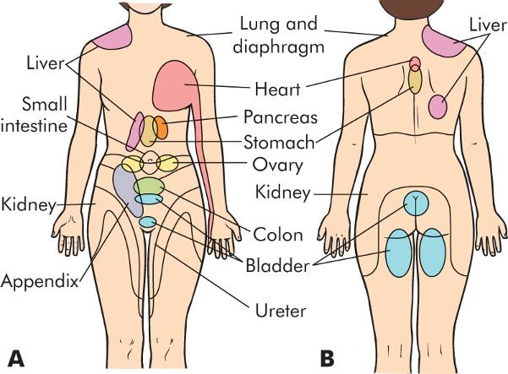

Phantom Pain
- Pain felt in a part of the body that is not present.
- Phantoms occur because the body is mapped out on the sensory cortex, which is unaware of the change and continues to send sensory information.
- 1/3 of phantom limbs can be fixed in an awkward position that the patient cannot alter. This can sometimes be “liberated” by the patient by moving the opposite side of the body in a mirror.

Clinical Features of Pain
- Acute Pain
  - Causes sympathetic ANS reaction.
- Chronic Pain
  - Chronic pain sufferers could be psychosocial
    - Irritability, insomnia, social isolation, depression, helplessness, hopelessness
  - Pain Assessment
    - Borg Scale – 1-10
- PQRST Assessment of Pain
  - P – Provoking factors - What makes is better or worse?
  - Q – Quality of the pain
    - Deep, superficial, crushing, sharp, dull, burning, etc.
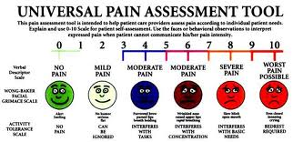
  - R – Region and radiation - Where is the pain and where does it go?
- S – Severity and intensity - Borg pain scale
- T – Time - Onset, duration and frequency

Aging and Pain
- Increase in pain threshold
  - Peripheral neuropathies
  - Skin thickness changes
- Decrease in pain tolerance
- Alteration in metabolism of drugs and metabolites

Fetus Pain
- The fetus has an active CNS at 8 weeks, which means they may feel pain in the first trimester.
  - Evidence of this comes from fetal blood studies with stress hormones present.
  - Many infants scream right after a C-Section under general anesthesia meaning the mom is anesthetized but not the baby.

Pediatrics and Pain
- Pathways and chemicals associated with pain are functional in preterm and newborn infants
- Nociceptor system is functional by 24 weeks’ gestation
- Expressions of pain
  - Facial expression
  - Crying
  - Body language

Pain Inhibition Physiology
- The process of physiologically modifying pain is called modulation.
- Pain modulation occurs in the spinal cord and brain.

Neuromodulation of Pain
- Neuromodulators
  - Located in pathways of nervous system
  - Triggered by tissue injury and or inflammation
  - Excitatory neuromodulation
    - Substance P, glutamate, somatostatin
  - Inhibitory neuromodulation
    - GABA, glycine, serotonin, norepinephrine, endorphins
- Neuromodulation of Pain
  - Endorphins
  - Beta-endorphins
  - Enkephalin
  - Dynorphins
  - Endomorphins

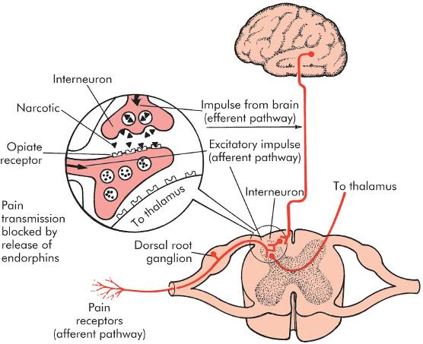

Placebo Effect
- A placebo is an effect that occurs because the patient believes it will happen.
  - This belief has a helpful effect which is independent of any direct physiological action.
  - It is estimated that 30% of the effects of injectable analgesics is due to placebo effect.

Pain Theories
- Specificity theory
  - Amount of pain is related to the amount of tissue injury
  - Accounts for many types of injuries but does not explain cognitive and psychologic contributions
- Gate control theory
  - Developed to explain the complexities of the pain phenomenon

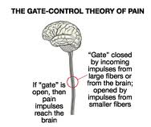
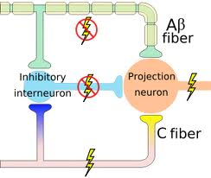

Temperature Regulation
- Varies in response to:
  - Location
  - Activity
  - Environment
  - Circadian rhythm
  - Gender
- Temperature Regulation
  - Peripheral and central thermoreceptors
  - Hypothalamic control
  - Heat production and conservation
  - Chemical reactions of metabolism
  - Skeletal muscle contraction
  - Chemical thermogenesis
  - Vasoconstriction
  - Voluntary mechanisms

Heat Loss
- Radiation
- Conduction
- Convection
- Vasodilation
- Decreased muscle tone
- Evaporation
- Increased respirations
- Voluntary measures
- Adaptation to warmer climates

Temperature Regulation
- Pediatrics
  - Produce sufficient body heat but are unable to conserve heat produced
    - Small body size and high body surface to weight ratio
    - Thin subcutaneous layer
- Aging
  - Slow blood circulation, vasoconstrictive response, and metabolic rate
  - Decreased sweating and perception of heat and cold

Fever
- Resetting of the hypothalamic thermostat
- Activate heat production and conservation measures to a new “set point”
- Exogenous pyrogens
- Endogenous pyrogens

Benefits of Fever
- Kills many microorganisms
- Decreases serum levels of iron, zinc, and copper
- Promotes lysosomal breakdown and autodestruction of cells
- Increases lymphocytic transformation and phagocyte motility
- Augments antiviral interferon production

Hyperthermia
- Not mediated by pyrogens
- No resetting of the hypothalamic set point
- 41º C (105.8º F): nerve damage produces convulsions
- 43º C (109.4º F): death results
- Forms
  - Heat cramps, heat exhaustion, heatstroke

Heat Cramps
- Severe spasmodic cramps in the abdomen and extremities
- Following prolonged sweating and associated sodium loss
- Common in individuals not accustomed to heat or those performing strenuous work in warm climates
- Fever, rapid pulse, and increased blood pressure often accompany the cramps

Heat Exhaustion
- Collapse as a result of prolonged high core or environmental temperatures
- Prolonged vasodilation and profuse sweating
  - Dehydration, depressed plasma volumes, hypotension, decreased cardiac output, tachycardia
- Manifestations
  - Dizziness, weakness, nausea, confusion, and syncope

Heatstroke
- Potentially lethal result of an overstressed thermoregulatory center
- Brain cannot tolerate temperatures >40.5º C (104.9º F)
  - Temperature maintained by blood flow through the veins in the head and face
  - Cardiovascular and thermoregulatory centers may cease functioning with higher temperatures
- Manifestations
  - Cerebral edema, degeneration of the CNS, swollen dendrites, renal tubular necrosis, and death
- Rapid peripheral cooling will cause peripheral vasoconstriction and limit core cooling
- Children are more susceptible
  - Produce more metabolic heat when exercising
  - Greater surface area to mass ratio
  - Sweating capacity is less than in adults
Malignant Hyperthermia
- Complication of inherited muscular disorder
- Precipitated by inhaled anesthetics and neuromuscular blocking agents
- Increased calcium release or decreased calcium uptake with muscle contraction
- Causes sustained muscle contractions
  - Increased oxygen consumption and lactic acid production
- Symptoms include absent reflexes, fixed pupils, apnea, flat ECG

Hypothermia
- Body temperature less than 35º C
- Produces:
  - Vasoconstriction, alterations in the microcirculation, coagulation, and ischemic tissue damage
  - Ice crystals, which form inside the cells, causing them to rupture and die
- Tissue hypothermia
  - Slows the rate of cellular metabolism
  - Increases blood viscosity and slows blood through the microcirculation
  - Facilitates blood coagulation and stimulates vasoconstriction
  - Hypothermia
- Accidental hypothermia
  - Commonly the result of sudden immersion in cold water or prolonged exposure to cold
- Therapeutic hypothermia
  - Used to slow metabolism and preserve ischemic tissue during surgery or limb reimplantation
  - May lead to ventricular fibrillation and cardiac arrest

Trauma and Temperature Change
- “Central fever”
- CNS trauma
  - Inflammation, increased ICP, intracranial bleeding
- Accidental injuries
- Hemorrhagic shock
- Major surgery
- Thermal burns
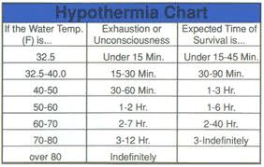

Sleep
- Active, multiphase process
- Hypothalamus is the major sleep center
  - Hypocreatins (ovexins)
    - Promote wakefulness and rapid eye movement (REM) sleep
- Two phases
  - Rapid eye movement (REM) sleep
  - Non-rapid eye movement (NREM) sleep

NREM Sleep
- 75% to 80% of sleep time
- Four stages evaluated by EEG
  - Stage I, Stage II, Stage III, Stage IV

REM Sleep
- 20% to 25% of sleep time
- Also known as paradoxic sleep
- Occurs every 90 minutes beginning after 1 to 2 hours of sleep

Pediatrics and Sleep
- Newborns sleep 16 to 17 hours per day
- 53% of that time is spent in active (REM) sleep
- The infant sleep cycle is about 50 to
  - 60 minutes
- Infants enter REM sleep immediately upon falling asleep

Aging and Sleep
- Total sleep time is decreased
- Older adults take longer to fall asleep, and awaken more frequently during the night
- Amount of time in stage IV sleep decreases
- Potential causes
  - Physical ailments, lack of daily routine, circadian rhythm changes, medications

Sleep Disorders - Four classifications
- Dyssomnias
  - Insomnia, obstructive sleep apnea, primary and secondary hypersomnia, disorders of sleep-wake cycle
- Parasomnias
  - Somnambulism, night terrors, restless legs syndrome, eating, and violent behaviors
- Association with medical/psychiatric disorders
- Proposed sleep disorder

Sleep and Disease
- Secondary sleep disorders
  - Alterations in the quality and/or quantity of sleep caused by primary diseases
  - Depression, pain, sleep apnea syndromes, and alterations in thyroid hormone secretion
- Sleep-provoked disorders
  - Sleep stage alterations produced in certain disease states

