Alterations of Neurologic Function
Pathology 1 - Dr. Gary Mumaugh

Brain Trauma
- Major head trauma
  - A traumatic insult to the brain possibly producing physical, intellectual, emotional, social, and vocational changes
  - Transportation accidents
  - Falls
  - Sports-related event
  - Violence
- Closed (blunt, nonmissile) trauma
  - Head strikes hard surface or a rapidly moving object strikes the head
  - The dura remains intact and brain tissues are not exposed to the environment
  - Causes focal (local) or diffuse (general) brain injuries
- Open (penetrating, missile) trauma
  - Injury breaks the dura and exposes the cranial contents to the environment
  - Causes primarily focal (local) injuries
- Coup injury
  - Injury directly below the point of impact
- Contrecoup
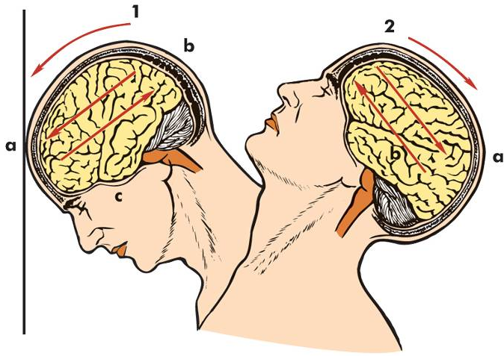
  - Injury on the pole opposite the site of impact
- Compound fractures
- Basilar skull fracture

Focal Brain Injury
- Observable brain lesion
- Force of impact typically produces contusions
- Contusions can cause:
  - Extradural (epidural) hemorrhages or hematomas
  - Subdural hematomas
  - Intracerebral hematomas

Hematomas
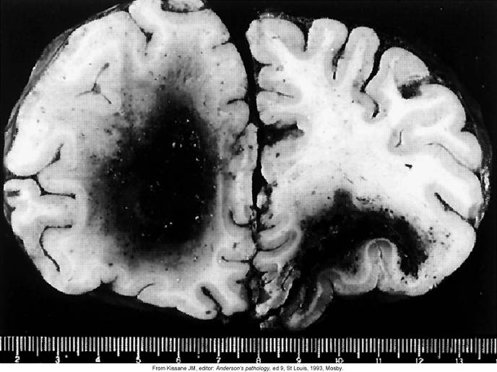

Subdural (Epidural) Hematomas
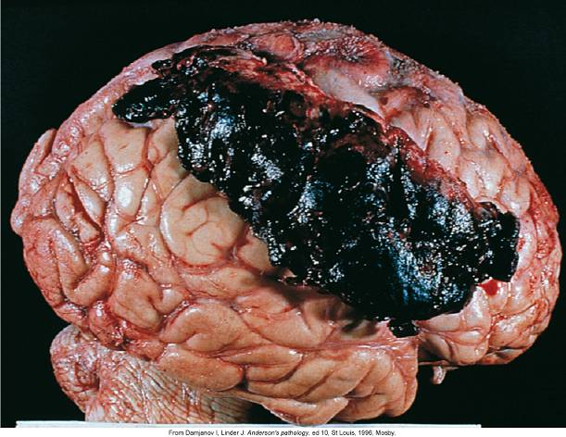

Diffuse Brain Injury
- Diffuse axonal injury (DAI)
  - Shaking, inertial effect
  - Acceleration/deceleration
  - Axonal damage
    - Shearing, tearing, or stretching of nerve fibers
  - Severity corresponds to the amount of shearing force applied to the brain and brain stem
- Categories:
  - Mild concussion
  - Classical concussion
  - Mild, moderate, and severe diffuse axonal injuries (DAI)

Mild Concussion
- Temporary axonal disturbance causing attention and memory deficits but no loss of consciousness
  - I: confusion, disorientation, and momentary amnesia
  - II: momentary confusion and retrograde amnesia
  - III: confusion with retrograde and anterograde amnesia

Classic Cerebral Concussion
- Grade IV
  - Disconnection of cerebral systems from the brain stem and reticular activating system
  - Physiologic and neurologic dysfunction without substantial anatomic disruption
  - Loss of consciousness (<6 hours)
  - Anterograde and retrograde amnesia
  - Post-concussive syndrome

Diffuse Axonal Injury
- Produces a traumatic coma lasting more than 6 hours because of axonal disruption
  - Mild
  - Moderate
  - Severe

Spinal Cord Trauma
- Most commonly occurs due to vertebral injuries
  - Simple fracture, compressed fracture, and comminuted fracture and dislocation
- Traumatic injury of vertebral and neural tissues as a result of compressing, pulling, or shearing forces
- Most common locations: cervical (1, 2, 4-7), and T1-L2 lumbar vertebrae
  - Locations reflect most mobile portions of vertebral column and the locations where the spinal cord occupies most of the vertebral canal
- Spinal shock
  - Normal activity of the spinal cord ceases at and below the level of injury. Sites lack continuous nervous discharges from the brain.
  - Complete loss of reflex function (skeletal, bladder, bowel, sexual function, thermal control, and autonomic control) below level of lesion
- Paraplegia
- Quadriplegia
- Autonomic hyperreflexia (dysreflexia)

Autonomic hyperreflexia (dysreflexia)
- Autonomic dysreflexia means an over-activity of the Autonomic Nervous System.
- Stimulation of the sensory receptors below the level of the cord lesion.
- It can occur when an irritating stimulus is introduced to the body below the level of spinal cord injury, such as an overfull bladder. The stimulus sends nerve impulses to the spinal cord, where they travel upward until they are blocked by the Lesion at the level of injury. Since the impulses cannot reach the brain, a Reflex is activated that increases activity of the sympathetic portion of autonomic nervous system.
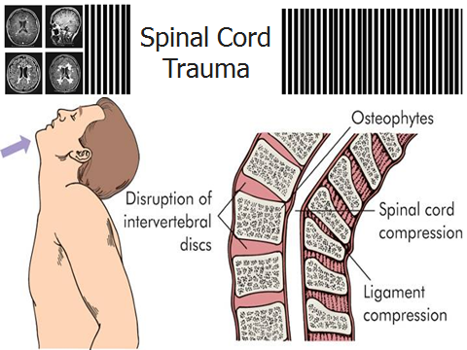
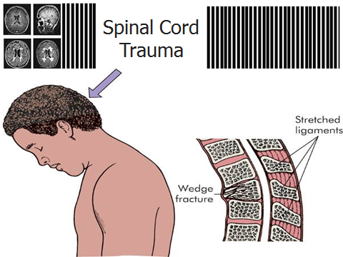
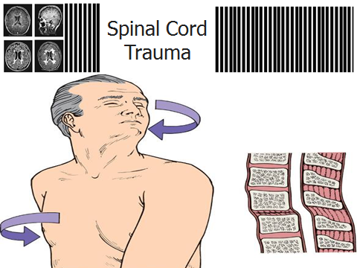
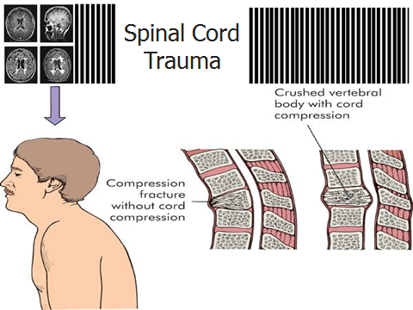
Degenerative Disorders of the Spine
- Degenerative disk disease (DDD)
  - Spondylolysis
  - Spondylolisthesis
  - Spinal stenosis
- Low back pain
- Herniated intervertebral disk

Cerebrovascular Disorders
- Cerebrovascular accident
  - Leading cause of disability
  - Third leading cause of death in United States
  - Classified
    - Global hypoperfusion
    - Ischemia (thrombotic, embolic)
    - Hemorrhagic

Cerebrovascular accidents (CVAs)
- Thrombotic stroke
  - Arterial occlusions caused by thrombi formed in arteries supplying the brain or in the intracranial vessels
  - Transient ischemic attacks (TIAs)
- Embolic stroke
  - Fragments that break from a thrombus formed outside the brain
- Hemorrhagic stroke -Intracranial hemorrhage
- Lacunar stroke - Smaller than 1 cm
- Cerebral infarction
- Cerebral hemorrhage

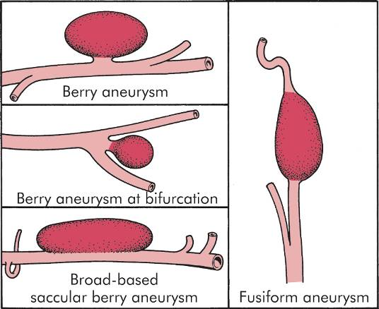
Cerebrovascular Disorders
- Intracranial aneurysm
  - Saccular (berry) aneurysms
  - Fusiform (giant) aneurysms
- Vascular malformations
  - Cavernous angiomas
  - Capillary telangiectasis
  - Venous angioma
  - Arteriovenous malformation
- Subarachnoid hemorrhage
  - Blood escapes from defective or injured vasculature into the subarachnoid space
- Manifestations
  - Kernig sign
    - Straightening knee with flexed hip caused back and neck pain
  - Brudzinski sign
    - Passive neck flexion causes pain and rigidity

Infection and Inflammation of the CNS
- Meningitis
  - Bacterial meningitis
  - Aseptic (viral, nonpurulent, lymphocytic) meningitis
  - Fungal meningitis
  - Tubercular (TB) meningitis
- Encephalitis
  - Acute febrile illness, usually of viral origin with nervous system involvement
  - Most common forms of encephalitis are caused by arthropod-borne viruses and herpes simplex virus

Neurologic Complications of AIDS
- Human immunodeficiency-associated cognitive dysfunction
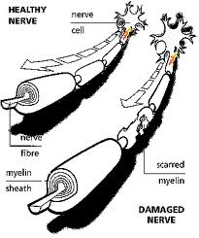
- HIV myelopathy
- HIV neuropathy
- Aseptic viral meningitis
- Opportunistic infections
- CNS neoplasms

Demyelinating Disorders
- Multiple sclerosis (MS)
  - MS is a progressive, inflammatory, demyelinating disorder of the CNS
  - Types
    - Mixed (general), Spinal, Cerebellar

Peripheral Nervous System Disorders
- Amyotrophic lateral sclerosis (ALS)
  - Classic ALS—“Lou Gehrig disease”
  - Diffusely affects upper and lower motor neurons of the cerebral cortex, brain stem, and spinal cord (corticospinal tracts and anterior roots)
  - Disease leads to progressive weakness leading to respiratory failure and death
  - Patient has normal intellectual and sensory function until death
- Neuropathies
  - Generalized symmetrical polyneuropathies
    - Distal axonal polyneuropathy
    - Demyelinating polyneuropathy
  - Generalized neuropathies
    - Sensory neuropathies
  - Focal or multifocal neuropathies
- Guillain-Barré syndrome
  - Acquired inflammatory disease causing demyelination of the peripheral nerves with relative sparing of axons
  - Acute onset, ascending motor paralysis
  - Humoral and cellular immunologic reaction
- Myopathies
  - Primary muscle disorder
  - Marked weakness
    - Symmetrical and proximal
- Radiculopathies
  - Radiculitis
    - Inflammation of the spinal nerve roots
  - Radicular pain
- Plexus injures
  - Involves the nerve plexus distal to the spinal roots but proximal to the formation of the peripheral nerves

Neuromuscular Junction Disorders
- Myasthenia Gravis
  - Chronic autoimmune disease
  - An IgG antibody is produced against acetylcholine receptors (antiacetylcholine receptor antibodies)
  - Weakness and fatigue of muscles of the eyes and the throat causing diplopia, difficulty chewing, talking, swallowing
- Myasthenia Gravis Classification
  - Neonatal myasthenia
  - Congenital myasthenia
  - Juvenile myasthenia
  - Ocular myasthenia
  - Generalized autoimmune myasthenia

Central Nervous System Tumors
- Cranial tumors
  - Primary intracerebral tumors (gliomas)
    - Astrocytoma
    - Oligodendroglioma
    - Ependymoma
  - Primary extracerebral tumors
    - Meningioma
    - Nerve sheath tumors
    - Metastatic carcinoma
- Spinal cord tumors
  - Intramedullary tumors
  - Extramedullary tumors
    - Intradural
    - Extradural
  - Manifestations
    - Compressive syndrome
    - Irritative syndrome
    - Syringomyelic syndrome

