Hematology Pathology
Pathology 1 - Dr. Gary Mumaugh

Anemia
- Reduction in the total number of erythrocytes in the circulating blood or in the quality or quantity of hemoglobin
  - Impaired erythrocyte production
  - Acute or chronic blood loss
  - Increased erythrocyte destruction
  - Combination of the above
- Classifications:
  - Etiology
  - Morphology
    - Size
      - Identified by terms that end in -cytic
      - Macrocytic, microcytic, normocytic
    - Hemoglobin content
      - Identified by terms that end in -chromic
      - Normochromic and hypochromic
- Physiologic manifestation
  - Reduced oxygen-carrying capacity-hypoxemia
- Variable symptoms based on severity and the ability for the body to compensate
- Classic anemia symptoms:
  - Fatigue
  - Weakness
  - Dyspnea
  - Pallor

Megaloblastic Anemia
- Macrocytic-Normochromic Anemia
- Characterized by defective DNA synthesis
  - Caused by deficiencies in vitamin B₁₂ or folate
    - Coenzymes for nuclear maturation and the DNA synthesis pathway
- Ribonucleic acid (RNA) processes occur at a normal rate
  - Results in the unequal growth of the nucleus and cytoplasm

Pernicious Anemia
- Macrocytic-Normochromic Anemia
- Caused by a lack of intrinsic factor from the gastric parietal cells
- Required for vitamin B₁₂ absorption
- Results in vitamin B₁₂ deficiency
- Typical anemia symptoms
- Neurologic manifestations:
  - Nerve demyelination
  - Absence of intrinsic factor
Pernicious Anemia (cont’d)
- Other Symptoms:
  - Loss of appetite
  - Abdominal pain
  - Beefy red tongue (atrophic glossitis)
  - Icterus
  - Splenic enlargement
- Treatment
  - Parenteral or high oral doses of vitamin B₁₂

Folate Deficiency Anemia
- Macrocytic-Normochromic Anemia
- Absorption of folate occurs in the upper small intestine
- Similar symptoms to pernicious anemia except neurologic manifestations generally not seen
- Treatment requires daily oral administration of folate

Microcytic-Hypochromic Anemias
- Characterized by red cells that are abnormally small and contain reduced amounts of hemoglobin
- Related to:
  - Disorders of iron metabolism
  - Disorders of porphyrin and heme synthesis
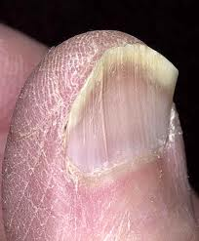
  - Disorders of globin synthesis

Iron deficiency anemia
- Most common type of anemia worldwide
- Nutritional iron deficiency
- Metabolic or functional deficiency
- Manifestations when serum Hgb decreased to 7 or 8 gm/dl
  - Early: fatigue; weakness; shortness of breath; pale ear lobes, palms, conjunctiva
  - Progression of iron deficiency causes:
    - Brittle, thin, coarsely ridged, and spoon-shaped nails (koilonychia)
    - A red, sore, and painful tongue
    - Dry, sore corners of mouth (angular stomatitis)
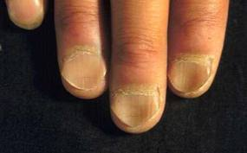
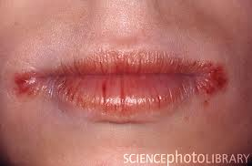

Hemolytic Anemia
- Normocytic-Normochromic Anemia
- Accelerated destruction of red blood cells
- Autoimmune hemolytic anemias
- Immunohemolytic anemia
- Warm antibody immunohemolytic anemia
- Drug-induced hemolytic anemia
- Cold agglutinin immunohemolytic anemia
- Cold hemolysin hemolytic anemia
- Sickle cell anemia

Anemia of chronic inflammation
- Mild to moderate anemia seen in:
  - AIDS
  - Rheumatoid arthritis
  - Lupus erythematosus
  - Hepatitis
  - Renal failure
  - Malignancies
- Pathologic mechanisms:
  - Decreased erythrocyte life span
  - Ineffective bone marrow response to erythropoietin
  - Altered iron metabolism

Myeloproliferative RBC Disorders
- Polycythemia
  - Overproduction of red blood cells
- Relative polycythemia
  - Result of dehydration
  - Fluid loss results in relative increases of red cell counts and Hgb and Hct values
- Absolute polycythemia
  - Primary absolute
    - Abnormality of stem cells in the bone marrow
    - Polycythemia vera (PV)
  - Secondary absolute
    - Increase in erythropoietin as a normal response to chronic hypoxia or an inappropriate response to erythropoietin-secreting tumors

Alterations of Leukocyte Function
- Quantitative disorders:
  - Increases or decreases in cell numbers
  - Bone marrow disorders or premature destruction of cells
  - Response to infectious microorganism invasion
- Qualitative disorders:
  - Disruption of cellular function
Quantitative Alterations of Leukocytes
- Leukocytosis
  - Leukocytosis is a normal protective physiologic response to physiologic stressors
- Leukopenia
  - Leukopenia is not normal and not beneficial
  - A low white count predisposes a patient to infections
- Granulocytosis (Neutrophilia)
  - Neutrophilia is evident in the first stages of an infection or inflammation
  - If the need for neutrophils increases beyond the supply, immature neutrophils are released into the blood
  - This premature release is detected in the manual WBC differential and is termed a shift to the left
  - When the population returns to normal, it is termed a shift to the right
- Neutropenia
  - Reduction in circulating neutrophils
  - Causes:
    - Prolonged severe infection
    - Decreased production
    - Reduced survival
    - Abnormal neutrophil distribution and sequestration
- Eosinophilia
  - Hypersensitivity reactions trigger the release of eosinophilic chemotactic factor of anaphylaxis from mast cells
  - Increased in allergic disorders
  - Increased in parasitic invasions
- Eosinopenia
  - Decrease in circulation numbers of eosinophils
  - Usually caused by migration of cells to inflammatory sites
  - Other causes:
    - Surgery
    - Shock
    - Trauma
    - Burns
    - Mental distress
- Basophils
  - Basophils account for only 0% to 1% of the circulating WBCs
  - Basophilia
    - Response to inflammation and hypersensitivity reactions
  - Basopenia
    - Occurs in acute infections, hyperthyroidism, and long-term steroid therapy
- Monocytes
  - Monocytosis
    - Usually occurs with neutropenia in later stages of infections
    - Monocytes are needed to phagocytize organisms and debris
- Lymphocytes
  - Lymphocytosis
    - Acute viral infections - Epstein-Barr virus
- Lymphocytopenia
  - Immune deficiencies
  - Drug destruction
  - Viral destruction

Infectious Mononucleosis
- Acute, self-limiting infection of B lymphocytes transmitted by saliva through personal contact
- Commonly caused by the Epstein-Barr virus (EBV)—85%
  - B cells have an EBV receptor site
  - Others viral agents resembling IM:
    - Cytomegalovirus (CMV)
    - Hepatitis
    - Influenza
    - HIV
- Symptoms:
  - Fever
  - Sore throat
  - Swollen cervical lymph nodes
  - Increased lymphocyte count
  - Atypical (activated) lymphocytes
- Serious complications are infrequent (<5%)
  - Splenic rupture is the most common cause of death
- >50% lymphocytes and at least 10% atypical lymphocytes
- Diagnostic test
  - Monospot qualitative test for heterophilic antibodies
- Treatment: symptomatic

Leukemias
- Malignant disorder of the blood and blood-forming organs
- Excessive accumulation of leukemic cells
- Pancytopenia if cells crowd bone marrow
- Acute leukemia
  - Presence of undifferentiated or immature cells, usually blast cells
- Chronic leukemia
  - Predominant cell is mature but does not function normally
- Leukemia Types
  - Acute lymphocytic leukemia (ALL)
  - Acute myelogenous leukemia (AML)
  - Chronic myelogenous leukemia (CML)
  - Chronic lymphocytic leukemia (CLL)

- Signs and symptoms of leukemia
  - Anemia
  - Bleeding purpura B-lymphocytes
  - Petechiae
  - Ecchymosis
  - Thrombosis
  - Hemorrhage
  - DIC
  - Infection
  - Weight loss
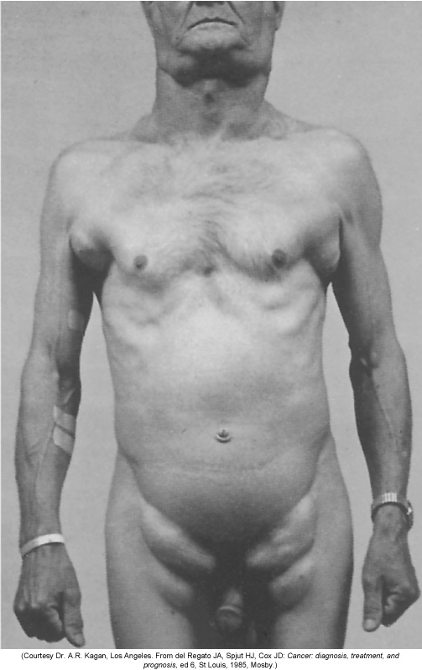
  - Bone pain
  - Elevated uric acid
  - Liver, spleen, and lymph node enlargement

Lymphadenopathy
- Enlarged lymph nodes that become palpable and tender
- Local lymphadenopathy
  - Drainage of an inflammatory lesion located near the enlarged node
- General lymphadenopathy
  - Occurs in the presence of malignant or nonmalignant disease

Malignant Lymphomas
- Malignant transformation of a lymphocyte and proliferation of lymphocytes, histiocytes, their precursors, and derivatives in lymphoid tissues
- Two major categories:
  - Hodgkin lymphoma
  - Non-Hodgkin lymphoma
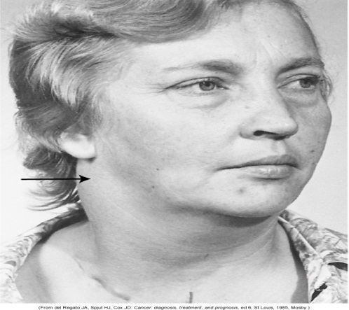
Hodgkin Lymphoma
- Characterized by the presence of Reed-Sternberg cells in the lymph nodes
  - Reed-Sternberg cells are necessary for diagnosis, but they are not specific to Hodgkin lymphoma
  - Classical Hodgkin lymphoma
  - Nodular lymphocyte predominant Hodgkin lymphoma

Hodgkin Lymphoma
- Physical findings
  - Adenopathy, mediastinal mass, splenomegaly, and abdominal mass
- Symptoms
  - Fever, weight loss, night sweats, pruritus
- Laboratory findings
  - Thrombocytosis, leukocytosis, eosinophilia, elevated ESR, and elevated alkaline phosphatase

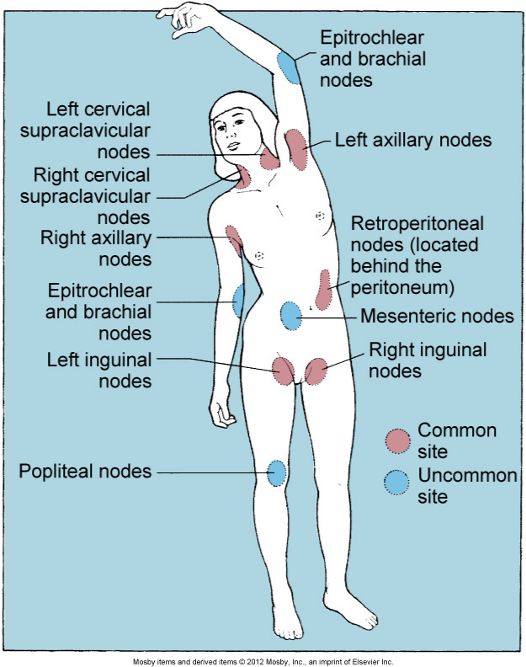

Non-Hodgkin Lymphoma
- Generic term for a diverse group of lymphomas
- Differentiated based on etiology, unique features, and response to therapies
- Non-Hodgkin lymphomas are linked to chromosome translocations, viral and bacterial infections, environmental agents, immunodeficiencies, and autoimmune disorders

Multiple Myeloma
- Malignant proliferation of plasma cells
- Infiltrate bone marrow and aggregate into tumor masses in skeletal system
- Bence Jones protein
- Hypercalcemia, renal failure, bone lesions
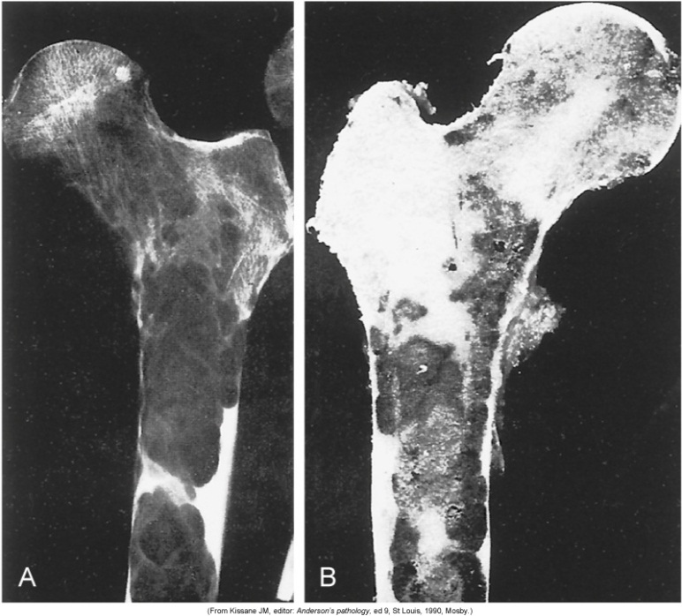

Disorders of Platelets
- Thrombocytopenia
  - Platelet count <150,000/mm³
    - <50,000/mm³: hemorrhage from minor trauma
    - <15,000/mm³: spontaneous bleeding
    - <10,000/mm³: severe bleeding
  - Causes:
    - Hypersplenism
    - Autoimmune disease
    - Hypothermia
    - Viral or bacterial infections that cause disseminated intravascular coagulation (DIC)
- Immune (ideopathic) thrombocytopenic purpura (ITP)
  - IgG antibody that targets platelet glycoproteins
  - Antibody-coated platelets are sequestered and removed from the circulation
  - The acute form of ITP that often develops after a viral infection is one of the most common childhood bleeding disorders
- Immune (ideopathic) thrombocytopenic purpura (ITP) (cont’d)
  - Manifestations:
    - Petechiae and purpura
    - Progressing to major hemorrhage
- Thrombotic thrombocytopenic purpura (TTP)
  - A thrombotic microangiopathy
    - Platelets aggregate, form microthrombi, and cause occlusion of arterioles and capillaries
  - Chronic relapsing TTP
  - Acute idiopathic TTP
- Essential (primary) thrombocythemia (thrombocytosis)
  - Thrombocythemia is characterized by platelet counts >600,000/mm³
  - Myeloproliferative disorder of platelet precursor cells
    - Megakaryocytes in the bone marrow are produced in excess
  - Microvasculature thrombosis occurs

Alterations of Platelet Function
- Qualitative alterations in platelet function demonstrate an increased bleeding time in the presence of a normal platelet count
- Platelet function disorders result from platelet membrane glycoprotein and von Willebrand factor deficiencies
- Manifestations:
  - Petechiae
  - Purpura
  - Mucosal bleeding
  - Gingival bleeding
  - Spontaneous bruising
- Disorders can be congenital or acquired

Alterations of Coagulation
- Vitamin K deficiency
  - Vitamin K is necessary for synthesis and regulation of prothrombin, the prothrombin factors
- Liver disease
  - Liver disease causes a broad range of hemostasis disorders:
    - Defects in coagulation
    - Fibrinolysis
    - Platelet number and function

