Skeletal and Muscular Pathophysiology
Dr. Gary Mumaugh – UNW St. Paul

Bone Physiology - Bone Basics:
- Function: structure and reservoir for calcium
- Ossification - bone formation
- Osteoblasts - cells involved in bone deposition
- Osteoclasts - cells involved in bone breakdown
- Bone Metabolism:
  - PTH activates osteoclasts; promotes renal retention of Ca²⁺; promotes intestinal Ca²⁺ absorption indirectly with Vit. D
  - Calcitriol (Vit. D activated to act as a hormone) promotes active absorption of Ca²⁺ from intestine
  - Calcitonin lowers blood calcium levels by suppressing osteoclast activity

Bone Pathophysiology
- Bone disorders are derived from infection, tumor growth, abnormal ossification, or imbalance in bone remodeling
  - Osteopenia - net loss of bone
  - Hyperostosis - excessive, irregular, or inappropriate bone formation
  - 2 Types of Bone disorders
    - Genetic
    - Acquired

Genetic Bone Disorders
- Osteopetrosis (Marble Bone disease)
  - Osteoclasts are functionally deficient resulting in defective ossification
  - Excessive deposition of bone tissue that is brittle and easily fractured
  - Therapy includes bone marrow transplants and calcitrol
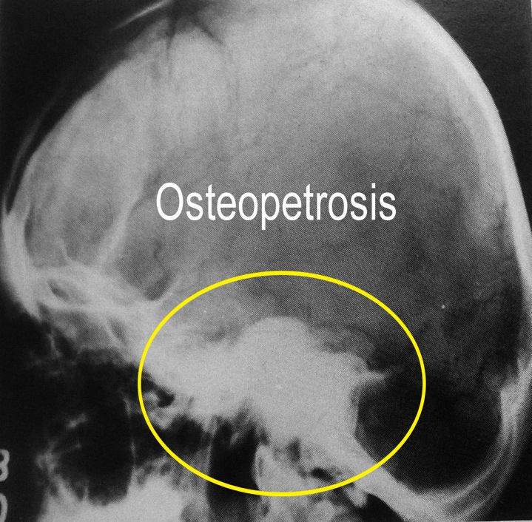
  - Deformalities in floor of brain can lead to blindness, deafness, paralysis of facial muscles from intracranial pressure
  - Mild cases display short stature and weakened bones
  - Severe cases have little change of survival

Genetic Bone Disorders
- Osteogenesis Imperfecta
- “Brittle bone disease”
- Defect in type I collagen production
  - Bone and vessel collagen
  - Several conditions related to defect in collagen synthesis leading to osteopenia and brittle bones
- Clinical manifestations:
  - Osteopenia
  - Increased rate of fractures
  - Bone deformity (bowing)
  - Short stature
  - Blue sclera and poor dentition
  - Aortic aneurysm
- Clinical management:
  - Surgical
    - Intramedullary and telescoping rod placement
  - Medical
    - Increased calcium and vitamin D
    - Biphosphates

Achondroplasia
  - Defect in normal cartilage development resulting in skeletal disproportion
  - Lack of cartilage development at epiphyseal plates of long bones with causes ossification to seal the plates early preventing further elongation

Acquired Bone Disorders
- Paget’s Disease (Epithelial tumor)
  - Excessive deposition of coarsely structured bone
  - Osteolytic Phase (initial stage)
    - Occurs during middle age
    - Bone reabsorption dominates and newly formed bone is abnormal
- Mixed Phase
    - Bone reabsorption and abnormal new bones continues
    - Pagetic bone- coarse structures and crude organization forming dense, focal masses
- Osteosclerotic Phase
  - Reabsorption declines and harder, more dense bone tissue is formed
  - In extreme cases, heavy skull can cause compression fractures
  - Hearing disorders result from thickening ossicles
  - Pain caused by microfractures of pagetic bone and nerve compression
  - Osteogenic or other sarcomas can arise in affected bones and are resistant to therapy
  - Often asymptomatic, therefore undiagnosed

- Osteoporosis
- Gradual and progressive loss of bone mass leading to fractures and pain
- Idiopathic
- Primary Osteoporosis
  - Critical point: bone is too weak to resist fracturing
  - Bone tissue rate of loss is 0.5% per year
  - Twice as common in women
- Secondary Osteoporosis
  - Bone loss due to some identifiable derangement such as a nutritional deficiency, genetic abnormality, or a tumor
  - No cure Therapy aims to slow the rate of bone loss and promote new deposition of bone to prevent fracture
      - Calcium supplements, Vitamin D, Hormone replacement

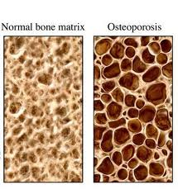

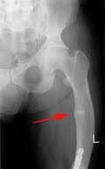
Acquired Bone Disorders
- Rickets
- Inadequate mineralization and Vitamin D deficiency in children
- Deformity of developing skeleton (ex. bowed legs)
- Bones of children are inadequately mineralized causing softened, weakened bones
- Bowed legs and deformities of the pelvis, skull, and rib cage are common
- Caused by insufficient calcium in the diet, or by vitamin D deficiency

- Osteomalacia
- Inadequate bone mineralization in the adult
- Pain, muscle weakness, predisposition to fractures

- Osteomyelitis
- Bone inflammation in response to infection by a pyogenic (pus-producing) bacterium
- Osteocytes respond to damage by forming new segments of reactive bone that can form walls and isolate the infection from phagocytes
- A permanent epithelium-lined tract called a sinus may form where pus and necrotic bone fragments drain to the surface

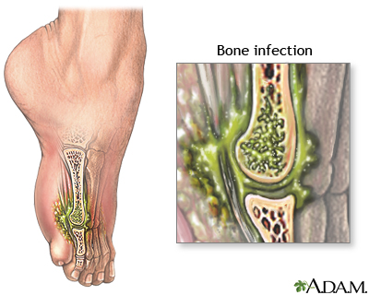
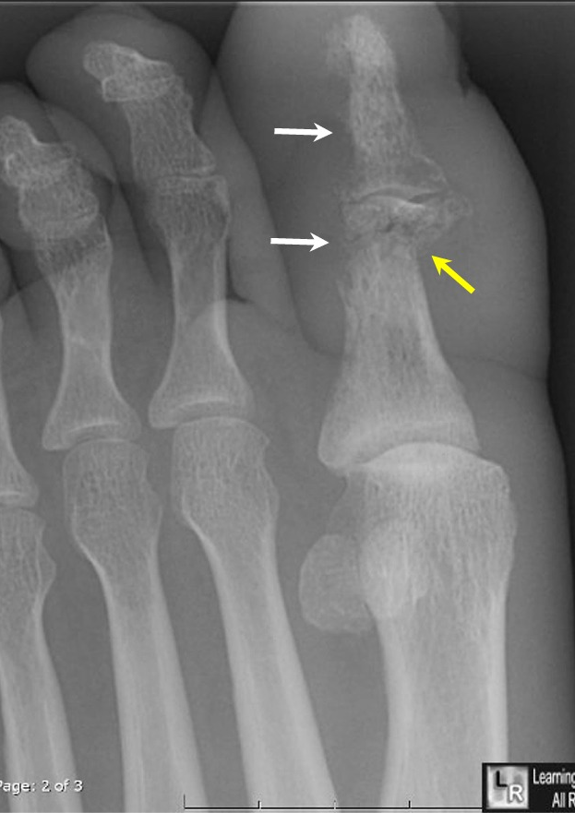

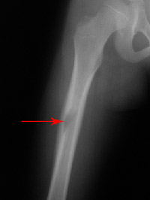
Acquired Bone Disorders
- Bone Tumors
  - Disrupt organization of osseous tissue by inducing osteolysis or new bone formation
  - Primary Bone Tumors
- 1/3 are benign and can be surgically removed
- Osteogenic Sarcoma - most common malignant tumor, affects 10-20 year old and has great predisposition to blood-borne metastasis to the lungs
- Other types: Chondrosarcoma, Ewing’s tumor, Giant cell tumor
  - Secondary Bone Tumors
  - Most common
  - A carcinoma is usually the primary tumor and most often arises from the prostate, breast, thyroid, lung or kidney

Joint Disorders
- Osteoarthritis or Degenerative Joint Disease
  - Most common joint disorder
  - Articular cartilage becomes thin, irregular, and frayed
    - Results in cracks and fissures leading to microfractures
    - Causes pain and loss of mobility associated with aging process
    - Osteophytes or bone spurs may form (bony projections)
  - Primary OA - idiopathic
  - Secondary OA- contributing factor to joint stress can be identified
- Degenerative arthritis - “wear and tear” arthritis
- Incidence
  - Most prevalent form of arthritis in the United States with 20-30 million cases
  - Affecting more than 70% of adults between 55 and 78
  - 90% over 45 have some OA symptoms
  - Women are affected more than men
  - Common in 20-30 year old athletes with silent symptoms
- Pathophysiology
  - With aging, the water content of the cartilage increases, and the protein makeup of cartilage degenerates.
  - Eventually, cartilage begins to degenerate by flaking or forming tiny crevasses.
  - In advanced cases, there is a total loss of cartilage cushion between the bones of the joints.
  - Repetitive use of the worn joints over the years can irritate and inflame the cartilage, causing joint pain and swelling.

Joint Disorders
- Osteoarthritis or Degenerative Joint Disease
  - Loss of the cartilage cushion causes friction between the bones, leading to pain and limitation of joint mobility.
  - Inflammation of the cartilage can also stimulate new bone outgrowths.
- Symptoms
    - Develop gradually (RA is fast onset)
    - Usually starts in 1-2 joints
    - Starts with weight bearing joint pain that is better with rest
    - Eventually joint ROM decreases
- Diagnosis
    - By history with tender joints, decreased ROM, osteophytes
    - No signs of inflammatory changes
    - Joint fluid usually WINL
    - X-rays show decreased joint spaces and osteophytes
    - Usually x-rays appear worse than the level of symptoms
- Treatment of OA
    - Gentle exercise, pool therapy
    - PT and OT
    - Appliances (heating pads, orthotics, walkers, braces, supports, etc.)
    - Weight control
    - TENS units
    - MEDS Tylenol and NSAIDs, COX2 inhibitors
Glucosamine and chondroitin sulfate
Steroids used short term but not very helpful
Joint injections helpful at times
OTC rubefacients helpful
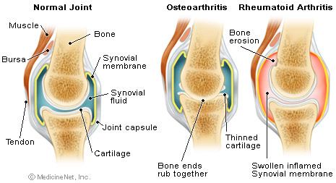
  - Surgery reserved for very severe and incapicating form only
Joint Disorders
- Rheumatoid Arthritis
- Systemic disease with prominent involvement of the joints
- Inflammatory condition affecting the joints in hands, wrists, ankles, and feet; also affects heart, lungs, and skin
- Variable clinical pattern with remission and exacerbation
- Rheumatoid Nodules - regions of focal subcutaneous swelling found of elbow, heel, and dorsal surface of head
- Etiology- idiopathic, characterized by immune-mediated destruction of joints; genetic component
  - Rheumatoid factor (RF) - antibody against immunogloublin G
- Therapy - no cure; relieve pain and reduce swelling through anti-inflammatory drugs and stress reduction to joints
- An autoimmune disease causing chronic joint inflammation
- A progressive illness that has the potential to cause joint destruction and functional disability
- Affecting approximately 1.3 million people in USA
- Three times more common in women as in men
- It afflicts people of all races equally
- Can begin at any age, but it most often starts after age 40 and before 60
- In some families, multiple members can be affected, suggesting a genetic basis for the disorder
- Symptoms
  - Come and go, depending on the degree of inflammation
  - When body tissues are inflamed, the disease is active
  - The course of rheumatoid arthritis varies from patient to patient, and periods of flares and remissions are typical
  - Inflammation usually symmetrical and of the small joints
  - Pronounced morning stiffness – “morning gel”
- Rheumatoid arthritis and inflammation of organs - can affect organs and areas of the body other than the joints
  - Sjogren's syndrome is inflammation of the glands of the eyes and mouth and causes dryness of these areas
  - Rheumatoid inflammation of the pleura
  - Pericarditis
  - Can have lowered RBC (anemia) and WBC
  - Felty’s Syndrome (lowered WBC and spleenomegaly)
- Diagnosis
- Positive RF (rheumatoid factor) and RF titer, ASO titer
- WBC changes
- Joint fluid with WBC and proteins
- X-ray changes
- Treatment
- Supportive and appliance measures (Hot and cold packs, walkers, etc.)
- NSAIDs and COX2 inhibitors - Steroids are the main treatment
  - Rest and mild ROM exercises

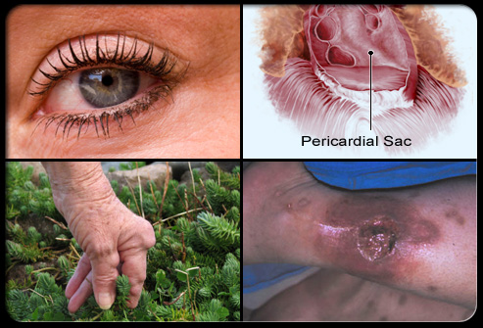

Joint Disorders
- Gout
- High levels of urate ions in the plasma produce hyperuricemia from nucleic acid metabolism
- Deposition of monosodium urate (MSU) crystals in joints - of foot
- Tophus- local inflammation resembling rheumatoid nodules
- Most common in adult males

- Gouty Arthritis
- Familial disease affects men 90% of time
- Usually starts in 30s due to uric acid crystals being laid down in certain joints
  - By product of nucleic acid metabolism
  - Body also forms uric acid from high purine foods
    - Anchovies, sardines, asparagus, mushrooms, meat gravies and broth, all organ meats
    - Alcohol increases uric acid production and decreases excretion
- Usually involve great toe, can also affect ankle, knee, wrist or elbow
- Signs and symptoms
- Episodes come on suddenly with severe excruciating pain
- Attacks are worse with emotional stress, drinking, fatigue, surgery, eating and eating high purine foods
- 25% of patients will develop nephrolithiasis
- Diagnosis with a history of typical monoarthritis with elevated uric acids on joint aspiration

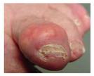
Joint Disorders
- Gout
  - Treatment
    - Treated with Colchicine hourly for pain
    - NSAIDs and COX2 inhibitors
    - Codeine, demerol and morphine
    - Steroids – oral and injectables
    - Foot cradle for sleeping

- Ankylosing Spondylitis
- Fusion of vertebral column starting in sacroiliac joints and proceeds slowly up the spinal column
- Genetic defect that causes autoimmune attack on joint structures following infection
- Joint structures become destroyed and replaced by fibrous cartilage and bone
- Bone resorption increases reducing bone mass
  - Thinning of bone resembles bamboo, called bamboo spine

- Systemic Lupus Erythematosus (SLE)
- Autoimmune condition
- Widespread deposition of immune complexes in various tissues, especially joints

Skeletal Muscle Pathophysiology
- Skeletal muscles are remarkably resistant to disturbances - adapt to change with hypertrophy and atrophy
- Disorders develop from inadequate contraction stimulus caused by neurological defects
- Myositis - inflammation arises in response to systemic infections from viruses, bacteria, fungi, or parasites
- Polymyositis - condition in which signs and symptoms derive from muscle damage
- Dermatomyositis - occurs in about 30% of polymyositis cases
  - Skin rash present from dermal immune complex deposition
- Polymyositis & Dermatomyositis
- Polymyositis – disabling muscle weakness
- Dermatomyositis – hyper-pigmentation rashes
- Both occur in 40-60 year olds
- S & S
  - Affects large muscles in shoulders and hips
- Diagnosis
  - Muscle weakness of shoulders and hips in middle age is suggestive, characteristic skin rash
  - EMG, muscle biopsy
- Treatment
  - Steroids and immunosuppressive drugs
Muscular Dystrophy
  - Group of rare diseases characterized by genetic etiology and progressive degeneration of skeletal muscle
  - Duchenne Muscular Dystrophy
    - Most common
    - X-linked recessive defect
    - Diagnosed on basis of high serum levels of creatine kinnase (CK)- enzyme released from damaged muscle fibers
    - Underlying defect condition in deficiency of muscle protein dystrophin
    - Results in muscle weakness and delayed motor development
- Myotonic Dystrophy
      - Genetic defect produces abnormal membrane ion channels
      - Muscle atrophy, loss of strength, and myotonia
      - Muscles of face, neck, and distal limbs are most affected
      - Defects in heart can lead to serious dysrhythmias

