Cardiovascular Structure and Function
Pathology 2 - Dr. Gary Mumaugh

Circulatory System - Heart
- Right heart
  - Pulmonary circulation - Pumps blood through the lungs
- Left heart
  - Systemic circulation - Pumps blood through the body
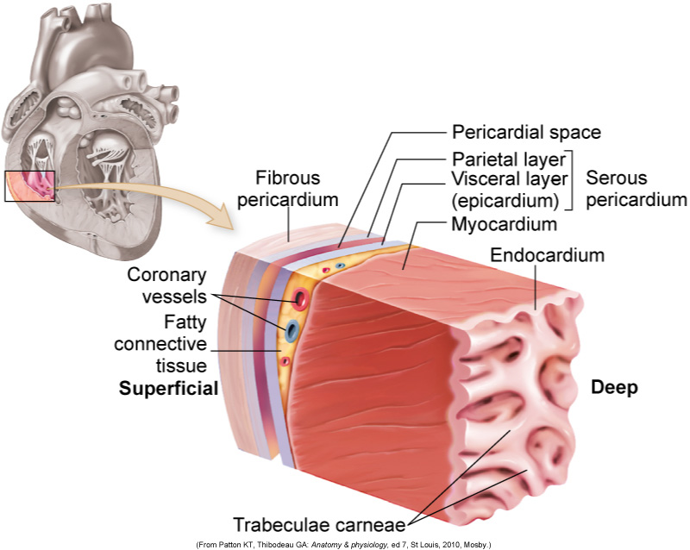
- Mediastinum
- Heart wall
  - Pericardium
    - Parietal and visceral
    - Pericardial cavity and fluid
  - Myocardium
  - Endocardium

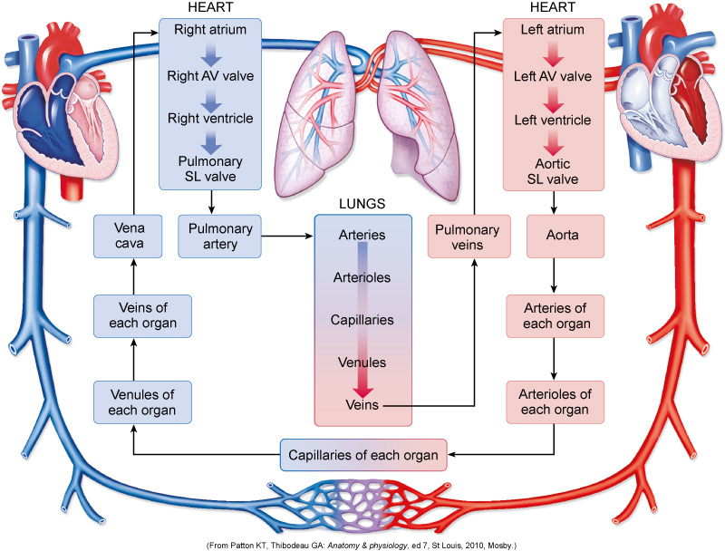

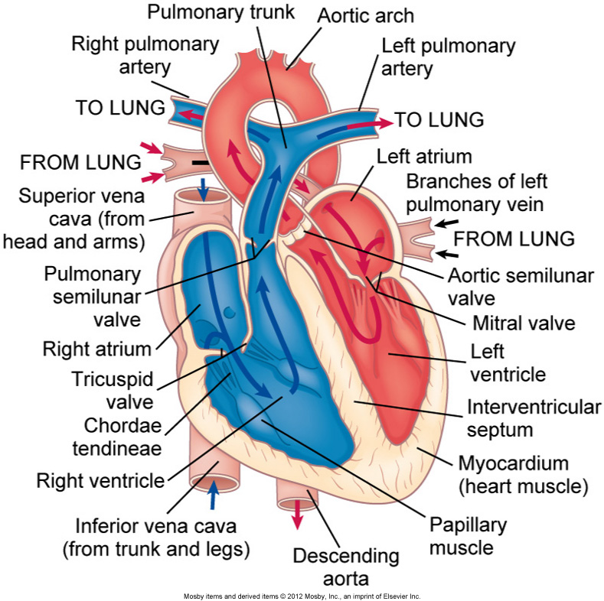
The Valves of the Heart
- Atrioventricular valves:
  - Tricuspid valve
  - Mitral valve
- Semilunar valves:
  - Pulmonic semilunar valve
  - Aortic semilunar valve

The Great Vessels
- Superior and inferior venae cavae
- Pulmonary artery (trunk)
  - Right and left pulmonary arteries
- Pulmonary veins
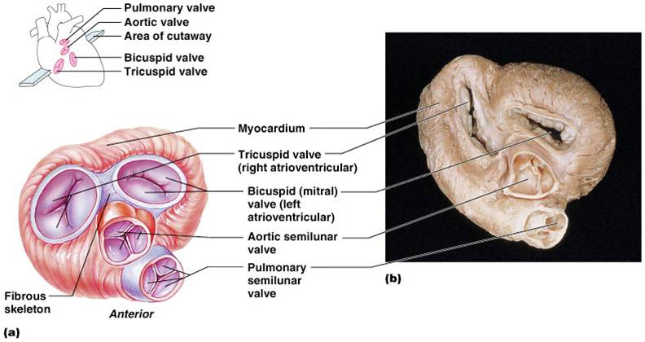
- Aorta

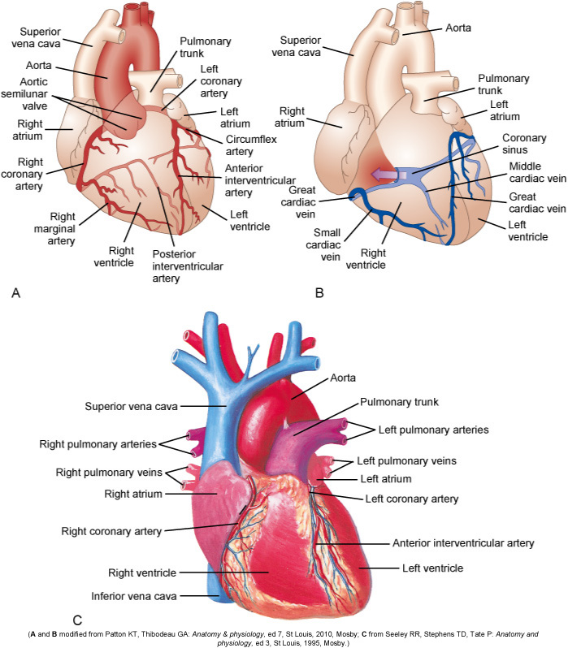

The Coronary Vessels
- Right coronary artery
  - Right marginal branch
  - Posterior descending branch
- Left coronary artery
  - Left anterior descending artery
  - Circumflex artery
- The Coronary Vessels
- Coronary capillaries
- Coronary veins:
  - Coronary sinus
  - Great cardiac vein
  - Posterior vein of the left ventricle
- Coronary lymphatic vessels

Structures That Control Heart Action
- Cardiac action potentials
- Conduction system
  - Sinoatrial node (SA)
  - Atrioventricular node (AV)
  - Bundle of His (AV bundle)
  - Right and left bundle branches
  - Purkinje fibers

Structures That Control Heart Action
- Propagation of cardiac action potentials
  - Resting membrane potential
  - Depolarization
  - Repolarization
  - Hyperpolarization
  - Refractory period
- Electrocardiogram
- Automaticity
- Rhythmicity

Structures That Control Heart Action
- Cardiac innervation
  - Sympathetic nerves
  - Parasympathetic nerves
- Adrenergic receptor function
  - Beta-adrenergic receptors
  - Norepinephrine or epinephrine

Cardiac Performance
- Cardiac output
  - Preload
    - Left ventricular end-diastolic volume
    - Laplace law
    - Frank-Starling law of the heart
  - Afterload
    - Load muscle must move after it starts to contract
    - Determined by system vascular resistance in aorta, arteries, and arterioles

Heart rate
- Cardiovascular control center
  - Cardioexcitatory and cardioinhibitory centers
- Neural reflexes
  - Bainbridge and baroreceptor reflexes
- Atrial receptors
- Hormones and biochemicals
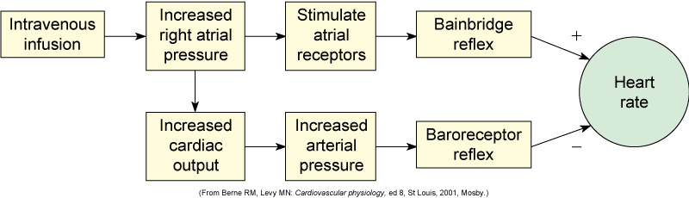

Cardiac Performance
- Myocardial contractility
  - Stroke volume
  - Inotropic agents
  - Oxygen and carbon dioxide levels
- Cardiac output
  - Volume of blood flowing through either the systemic or pulmonary circuit in liters per minute
- Ejection fraction
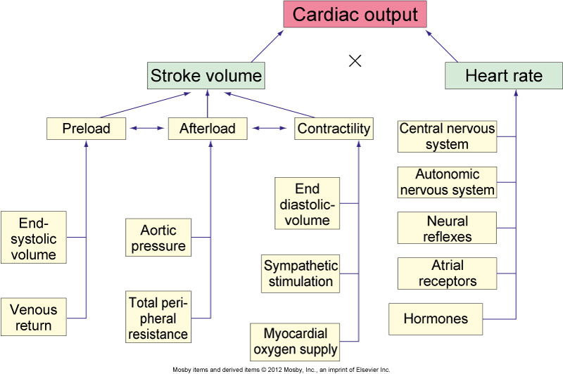

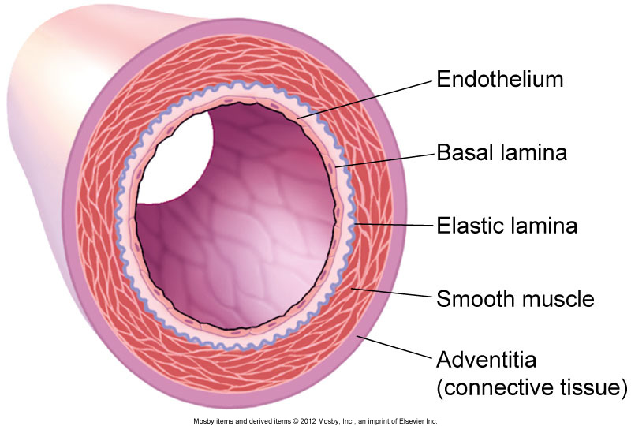
Systemic Circulation
- Arteries
- Arterioles
- Capillaries
- Venules
- Veins

Structure of Blood Vessels
- Lumen
- Tunica intima
- Tunica media
- Tunica externa (adventitia)

Factors Affecting Blood Flow
- Pressure
  - Force exerted on a liquid per unit area
- Resistance
  - Opposition to force
  - Diameter and length of the blood vessels contribute to resistance
- Poiseuille law
- Factors Affecting Blood Flow
- Neural control of total peripheral resistance
  - Change in diameter of the vessels
  - Baroreceptors
  - Arterial chemoreceptors
- Velocity
- Laminar vs. turbulent flow
- Vascular compliance

Laminar vs. Turbulent Flow
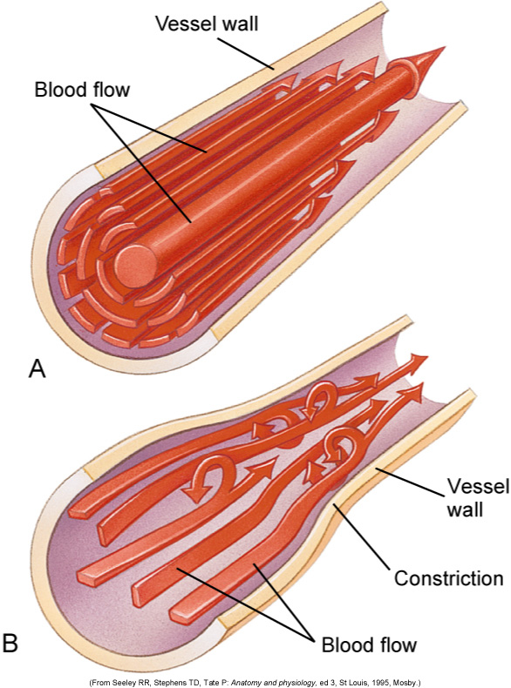

Regulation of Blood Pressure
- Arterial pressure
  - Mean arterial pressure (MAP)
  - Effects of cardiac output
  - Effects of total peripheral resistance
  - Effect of hyperemia
  - Effects of hormones
    - Epinephrine and norepinephrine
    - Antidiuretic hormone, renin-angiotensin system, and natriuretic peptides

Regulation of Blood Pressure
- Adrenomedullin
- Insulin
- Venous pressure

Regulation of Coronary Circulation
- Coronary perfusion pressure
- Autoregulation
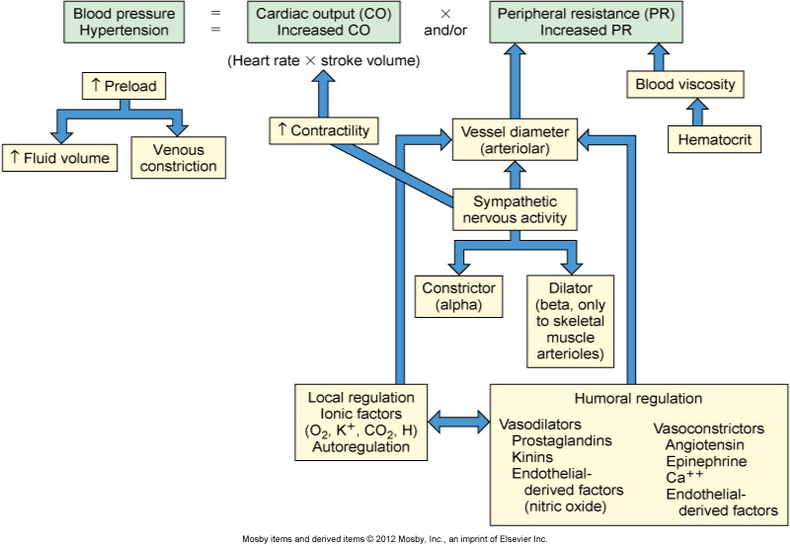
- Autonomic regulation
Lymphatic System
- Special vascular system that picks up excess fluid and returns it to the bloodstream
- Lymphatic fluid
- Lymphatic veins and venules
- Right lymphatic duct
- Thoracic duct
- Afferent and efferent lymphatic vessels

