Pediatric Orthopedic Pathology
Dr. Gary Mumaugh – UNW St. Paul

Congenital Defects - Clubfoot (congenital equinovarus)
- Forefoot is adducted and supinated
  - Positional equinovarus
  - Idiopathic congenital equinovarus
  - Teratologic equinovarus

Congenital Defects - Developmental Dysplasia of the Hip (DDH)
- Abnormality of the hip that can affect the femoral head, acetabulum, or both
  - Risk factors:
    - Female sex
    - Positive family history
    - Breech presentation
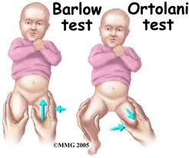
  - The hip can present as subluxated, dislocated, or acetabular dysplasia
  - Manifestations:
    - Asymmetry of skinfolds at groin crease
    - Galeazzi sign
    - Limitation of hip abduction
    - Positive Ortolani sign
    - Positive Barlow test
  - Clinical management
    - Outcome becomes poorer with age
    - Pavlik harness
    - Closed reduction with spica casting
    - Surgery

Osteogenesis Imperfecta - “Brittle bone disease”
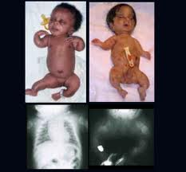
- Defect in type I collagen production
  - Bone and vessel collagen
- Clinical manifestations:
  - Osteopenia
  - Increased rate of fractures
  - Bone deformity (bowing)
  - Short stature
  - Blue sclera and poor dentition
  - Aortic aneurysm

- Clinical management:
  - Surgical
    - Intramedullary and telescoping rod placement
  - Medical
    - Increased calcium and vitamin D
    - Biphosphates

Osteomyelitis
- Bone infection from bacteria or tuberculosis (granulomatous)
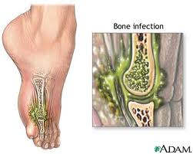
- Acute hematogenous osteomyelitis in children frequently begins as a blood abscess in the metaphysis of the bone
- The abscess ruptures under the periosteum and spreads along the bone shaft or into the bone marrow
- Clinical manifestations:
  - Pain, swelling, warmth, fever
  - Elevated white blood cells, C-reactive protein, and erythrocyte sedimentation rate
- Clinical management:
  - Antibiotics for 6-week regimen
  - Surgical debridement

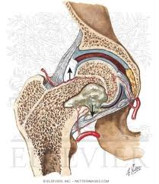
Septic Arthritis
- Caused by bacteria or granulomatous
- Surgical emergency
- Occurs primarily or secondary to osteomyelitis
- Lysosomes destroy articular cartilage and interrupt blood supply
- Clinical manifestations:
  - Pseudoparalysis
  - Inability to bear weight
  - Guarded motion of the joint
  - Malaise
  - Anorexia
- Clinical management:
  - Staphylococcus aureus most common bacteria
  - Surgical debridement
  - Antibiotic therapy
  - Long-term follow-up

Juvenile Rheumatoid Arthritis (JRA)
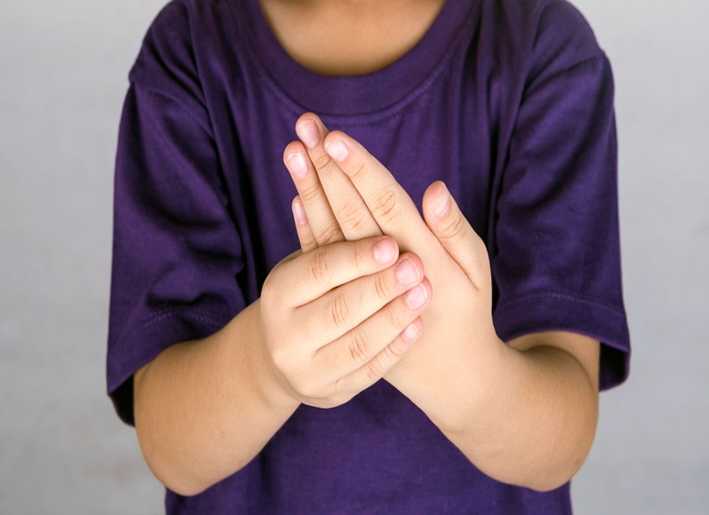
- Childhood form of rheumatoid arthritis
- The basic pathophysiology of JRA is the same as the adult form
- Three distinct modes of onset:
  - Oligoarthritis
  - Polyarthritis
  - Stills disease
- Differences in JRA and adult RA:
  - Large joints are affected
  - Chronic uveitis
  - Low detection of rheumatoid factor
  - Subluxation and ankylosis of the cervical spine
- Treatment
  - Supportive with anti-inflammatories and methotrexate

Osteochondrosis
- Avascular diseases of the bone
- Decrease blood supply
  - Trauma
  - Change in clotting sensitivity
  - Vascular injury
- Legg-Calvé-Perthes disease
  - Interrupted blood supply to the femoral head
  - Deformation due to ischemia is permanent
  - Clinical manifestations:
    - Spasm on rotation of hip
    - Limited internal rotation or abduction of hip
    - Trendelenburg gait
  - Clinical management:
    - Anti-inflammatories
    - Serial radiographs
    - Surgery

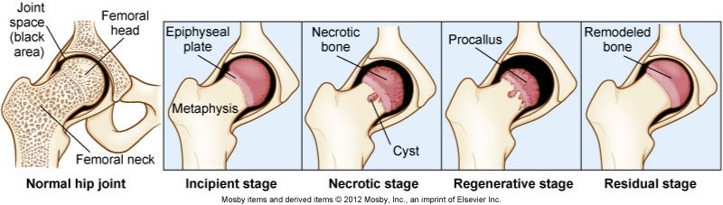

Osgood-Schlatter Disease
- Tendinitis of the anterior patellar tendon and osteochondrosis of the tubercle of the tibia
- One of the most common ailments in children involved in sports
- Clinical manifestations:
  - Pain
  - Swelling
- Clinical management:
  - Restricted activity
  - Bracing and knee immobilizer
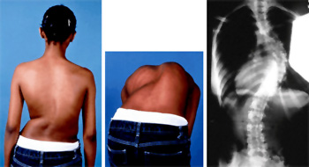
Scoliosis
- Scoliosis is a curvature of the spine that involves both lateral curvature and rotation
  - Idiopathic (80% of cases)
  - Congenital
  - Teratogen
- Medical management:
  - Bracing
  - Surgery

Muscular Dystrophies
- Group of inherited disorders that cause degeneration of skeletal muscle fibers
- The muscular dystrophies cause progressive, symmetric weakness and wasting of skeletal muscle groups

Duchenne Muscular Dystrophy
- Most common of the muscular dystrophies
- X-linked recessive inheritance
  - Deletion of a segment of DNA or a single gene defect on the short arm of the X-chromosome
- Generally affects boys
- Duchenne muscular dystrophy gene
  - Encodes for the dystrophin protein
  - Dystrophin maintains the structural integrity of the cytoskeleton
- Manifestations of the disorder begin to appear by approximately 3 years of age:
  - Slow motor development
  - Progressive weakness
  - Muscle wasting
  - Sitting and standing are delayed
  - The child is clumsy, falls frequently, and has difficulty climbing stairs

Musculoskeletal Tumors
- Benign bone tumors
- Osteochondroma
  - Inherited syndrome of hereditary multiple exostoses
- Nonossifying fibroma
  - Sharply demarcated, cortically based lesions of fibrocytes
- Musculoskeletal Tumors

Malignant bone tumors
- Osteosarcoma
  - Most common tumor in childhood
  - Originates in mesenchymal cells - Linked to deletion of genetic material
  - Bulky tumor extending into soft tissue
  - Clinical manifestations:
    - Night pain, swelling, warmth,
    - Cough, dyspnea, and chest pain if lung metastasis
  - Clinical management:
    - Graded according to malignancy
    - Surgery and chemotherapy
- Ewing sarcoma
  - Most lethal bone tumor
  - Translocation of chromosome
  - Breaks through bone to form soft tissue mass
  - Metastasizes to nearly every organ
  - Clinical manifestations:
    - Pain that increases in severity
    - Fever, Malaise, Anorexia
  - Clinical management:
    - Radiation and chemotherapy
    - Surgical debridement

Nonaccidental Trauma
- “Corner” metaphyseal fractures
  - Long bone fractures caused by a twisting force
  - Transverse tibial fractures are the most common
  - Associated with child abuse, but osteogenesis imperfecta must be ruled out
- Legally mandated to report child abuse

