Alterations of Cardiovascular Function
Pathology 2 - Dr. Gary Mumaugh

Diseases of the Veins
Varicose veins
- A vein in which blood has pooled
- Distended, tortuous, and palpable veins
- Caused by trauma or gradual venous distention
- Risk factors:
  - Age, Female gender , Family history, Obesity
  - Pregnancy, Deep Vein Thrombosis, Prior leg injury

Chronic venous insufficiency
- Inadequate venous return over a long period due to varicose veins or valvular incompetence
- Venous stasis ulcers

Deep venous thrombosis
- Obstruction of venous flow leading to increased venous pressure
- Factors:
  - Triad of Virchow
    - Venous stasis
    - Venous endothelial damage
    - Hypercoagulable states
  - Other (cancer, orthopedic surgery/trauma, heart failure, immobility)

Superior vena cava syndrome
- Progressive occlusion of the superior vena cava that leads to venous distention of upper extremities and head
- Oncologic emergency
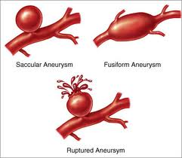

Diseases of the Arteries and Veins
Hypertension
- Isolated systolic hypertension—becoming prevalent in all age groups
  - Elevations of systolic pressure are caused by increases in cardiac output, total peripheral vascular resistance, or both

Primary hypertension
- Essential or idiopathic hypertension
- Genetic and environmental factors
- Affects 92% to 95% of individuals with hypertension
- Risk factors:
  - High sodium intake
  - Obesity
  - Insulin resistance

Secondary hypertension
- Caused by a systemic disease process that raises peripheral vascular resistance or cardiac output
- Renal artery stenosis, renal parenchymal disease, pheochromocytosis, drugs

Complicated hypertension
- Chronic hypertensive damage to the walls of systemic blood vessels
- Smooth muscle cells undergo hypertrophy and hyperplasia with fibrosis of the tunica intima and media
- Affects heart, kidneys, retina
- Can result in transient ischemic attack/stroke, cerebral thrombosis, aneurysm, dementi

Malignant hypertension
- Rapidly progressive hypertension
- Diastolic pressure is usually >140 mm Hg
- Life-threatening organ damage

Orthostatic (postural) hypotension
- Decrease in both systolic and diastolic blood pressure upon standing
- Lack of normal blood pressure compensation in response to gravitational changes on the circulation
- Acute orthostatic hypotension
- Chronic orthostatic hypotension

Aneurysm
- Local dilation or outpouching of a vessel wall or cardiac chamber
- True aneurysms
  - Fusiform aneurysms
  - Circumferential aneurysms
- False aneurysms
  - Saccular aneurysms
- Aorta most susceptible, especially abdominal
  - Causes include atherosclerosis, hypertension
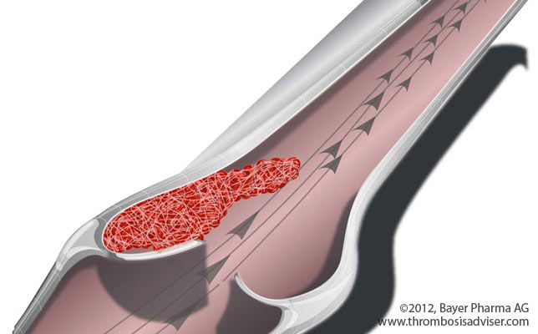
  - Can lead to aortic dissection or rupture

Thrombus formation
- Blood clot that remains attached to the vessel wall
- Risk factors include intimal injury/inflammation, obstruction of flow, pooling (stasis)
- Thromboembolus
- Thrombophlebitis
- Arterial thrombi
- Venous thrombi

Embolism
- Bolus of matter that is circulating in the bloodstream
  - Dislodged thrombus
  - Air bubble
  - Amniotic fluid
  - Aggregate of fat
  - Bacteria
  - Cancer cells
  - Foreign substance
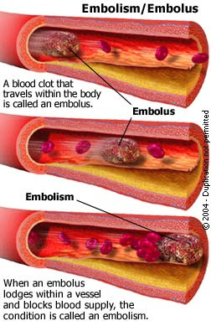

Thromboangiitis obliterans (Buerger disease)
- Occurs mainly in young men who smoke
- Inflammatory disease of peripheral arteries resulting in the formation of nonatherosclerotic lesions
  - Digital, tibial, plantar, ulnar, and palmar arteries
- Obliterates the small and medium-sized arteries
- Causes pain, tenderness, and hair loss in the affected area
- Symptoms are caused by slow, sluggish blood flow
- Can often lead to gangrenous lesions

Raynaud phenomenon and Raynaud disease
- Episodic vasospasm in arteries and arterioles of the fingers, less commonly the toes
- Raynaud disease is a primary vasospastic disorder of unknown origin
- Raynaud phenomenon is secondary to other systemic diseases or conditions:
  - Collagen vascular disease
  - Smoking
  - Pulmonary hypertension
  - Myxedema
  - Cold environment
- Manifestations include pallor, cyanosis, cold, pain

Arteriosclerosis
- Chronic disease of the arterial system
  - Abnormal thickening and hardening of the vessel walls
  - Smooth muscle cells and collagen fibers migrate to the tunica intima
- Form of arteriosclerosis
- Thickening and hardening caused by accumulation of lipid-laden macrophages in the arterial wall
- Plaque development
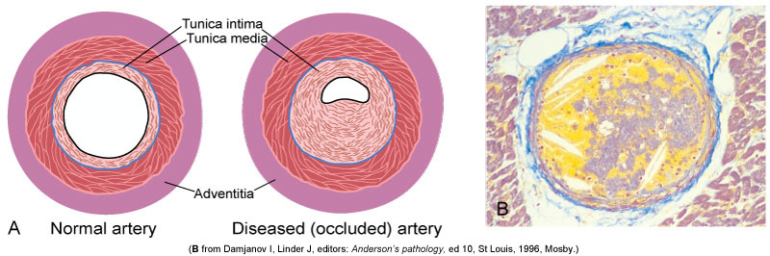
- Progression
  - Inflammation of endothelium
  - Cellular proliferation
  - Macrophage migration and adherence
  - LDL oxidation (foam cell formation)
  - Fatty streak
  - Fibrous plaque
  - Complicated plaque
- Risk factors include hyperlipidemia/dyslipidemia, diabetes, smoking, hypertension
- Result in—inadequate perfusion, ischemia, necrosis

Peripheral Arterial Disease
- Atherosclerotic disease of arteries that perfuse limbs
- Intermittent claudication

Coronary Artery Disease
- Any vascular disorder that narrows or occludes the coronary arteries leading to myocardial ischemia
- Atherosclerosis is the most common cause
- Risk Factors
  - Major:
    - Increased age
    - Family history
    - Male gender or female gender post menopause
  - Modifiable:
    - Dyslipidemia
    - Hypertension
    - Cigarette smoking
    - Diabetes mellitus
    - Obesity/sedentary lifestyle
    - Atherogenic diet
  - Nontraditional risk factors:
    - Markers of inflammation and thrombosis
      - High density C-reactive protein, erythrocyte sedimentation rate, von Willebrand factor concentration, interleukin-6, interleukin-18, tumor necrosis factor, fibrinogen, and CD 40 ligand
      - Hyperhomocysteinemia
      - Adipokines
      - Infection

Myocardial ischemia
- Local, temporary deprivation of the coronary blood supply
- Stable angina
- Prinzmetal angina
- Silent ischemia

Acute coronary syndromes:
- Transient ischemia
- Unstable angina
- Sustained ischemia
- Myocardial infarction
  - STEMI or non-STEMI
- Myocardial inflammation and necrosis

Myocardial infarction
- Sudden and extended obstruction of the myocardial blood supply
- Subendocardial infarction
- Transmural infarction
- Cellular injury
- Cellular death
- Structural and functional changes:
  - Myocardial stunning
  - Hibernating myocardium
  - Myocardial remodeling
  - Repair
- Manifestations:
  - Sudden severe chest pain; may radiate
  - Nausea, vomiting
  - Diaphoresis
  - Dyspnea
- Complications:
  - Sudden cardiac arrest due to ischemia, left ventricular dysfunction, and electrical instability

Disorders of the Heart Wall
Disorders of the Pericardium:
- Acute pericarditis
- Pericardial effusion
  - Tamponade
- Constrictive pericarditis

Disorders of the Myocardium
- Cardiomyopathies:
  - Dilated cardiomyopathy (congestive cardiomyopathy)
  - Hypertrophic cardiomyopathy
    - Asymmetrical septal hypertrophy
    - Hypertensive (valvular hypertrophic) cardiomyopathy
  - Restrictive cardiomyopathy

Disorders of the Endocardium
- Valvular dysfunctions:
  - Valvular stenosis
    - Aortic stenosis
    - Mitral stenosis
  - Valvular regurgitation
    - Aortic regurgitation
    - Mitral regurgitation
    - Tricuspid regurgitation
  - Mitral valve prolapse syndrome (MVPS)

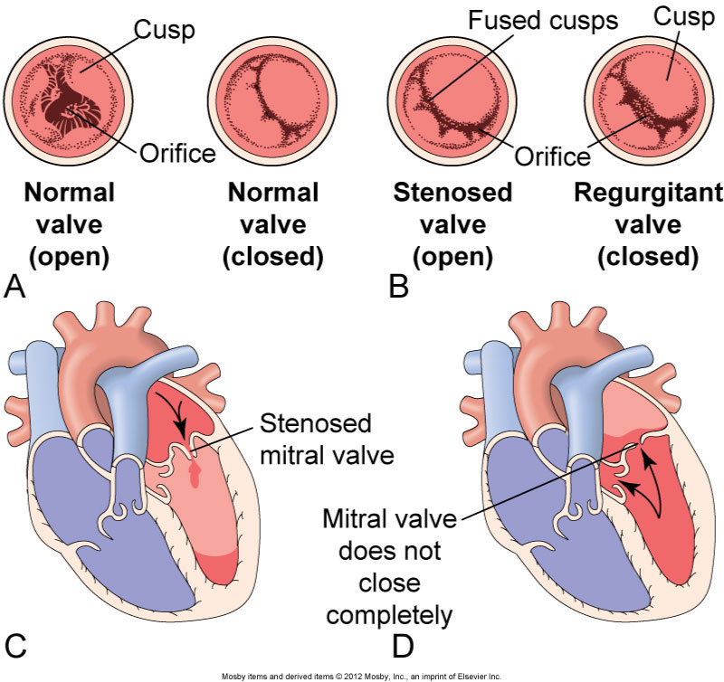

Acute Rheumatic Fever and Rheumatic Heart Disease
Rheumatic fever
- Systemic, inflammatory disease caused by a delayed immune response to pharyngeal infection by the group A beta-hemolytic streptococci
- Febrile illness
  - Inflammation of the joints, skin, nervous system, and heart
- If left untreated, rheumatic fever causes rheumatic heart disease

Acute Rheumatic Fever and Rheumatic Heart Disease
- Common manifestations:
  - Fever
  - Lymphadenopathy
  - Arthralgia
  - Nausea/vomiting
  - Tachycardia
  - Abdominal pain
  - Epistaxis
- Major clinical manifestations:
  - Carditis
  - Polyarthritis
  - Chorea
  - Erythema marginatum

Infective Endocarditis
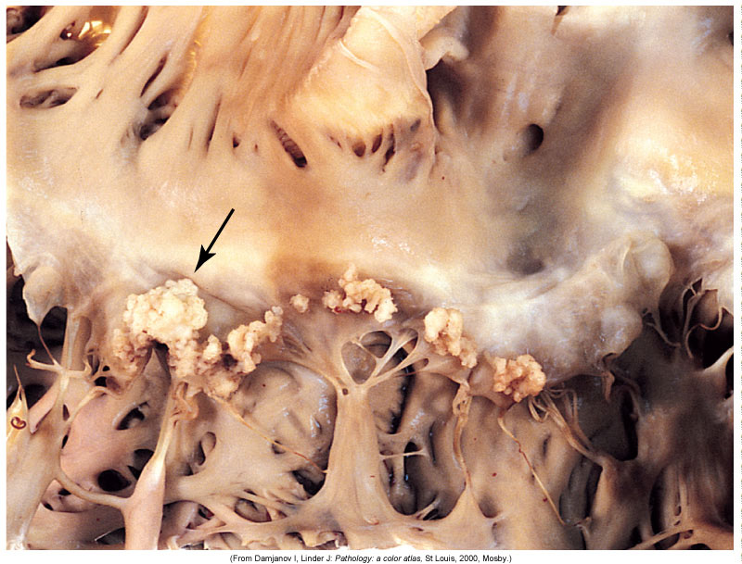
- Inflammation of the endocardium
- Agents:
  - Bacteria, Viruses, Fungi, Rickettsiae, Parasites
- Pathogenesis
  - Damaged (prepared) endocardium
  - Blood-borne microorganism adherence
  - Proliferation of the microorganism (vegetations)
- Manifestations:
  - Classic finding:s
    - Fever
    - New or changed cardiac murmur
    - Petechial lesions of the skin, conjunctiva, and oral mucosa
  - Characteristic physical findings:
    - Osler nodes (painful erythematous nodules on the pads of the fingers and toes)
    - Janeway lesions (nonpainful hemorrhagic lesions on the palms and soles)
  - Other: weight loss, back pain, night sweats, and heart failure

Cardiac Complications of AIDS
- Myocarditis
- Endocarditis
- Pericarditis
- Cardiomyopathy
- Pericardial effusion
- Pulmonary hypertension
- Antiviral drug-related cardiotoxicity

Dysrhythmias (Arrhythmias)
- Disturbance of the heart rhythm
- Range from occasional “missed” or rapid beats to severe disturbances that affect the pumping ability of the heart
- Can be caused by an abnormal rate of impulse generation or abnormal impulse conduction
- Examples:
  - Tachycardia
  - Flutter
  - Fibrillation
  - Bradycardia
  - Premature ventricular contractions (PVCs)
  - Premature atrial contractions (PACs)
  - Asystole

Heart Failure
- General term used to describe several types of cardiac dysfunction that result in inadequate perfusion of tissues with blood-borne nutrients

Left heart failure (Congestive heart failure)
- Systolic heart failure
  - Inability of the heart to generate adequate cardiac output to perfuse tissues
  - Ventricular remodeling
  - Causes include myocardial infarction, myocarditis, cardiomyopathy
- Diastolic heart failure
  - Pulmonary congestion despite normal stroke volume and cardiac output
  - Causes include myocardial hypertrophy and ischemia, diabetes, valvular and pericardial disease
- Manifestations of left heart failure:
  - Result of pulmonary vascular congestion and inadequate perfusion of the systemic circulation
  - Include dyspnea, orthopnea, cough of frothy sputum, fatigue, decreased urine output, and edema
  - Physical examination often reveals pulmonary edema (cyanosis, inspiratory crackles, pleural effusions), hypotension or hypertension, an S₃ gallop, and evidence of underlying CAD or hypertension

Right heart failure
- Most commonly caused by a diffuse hypoxic pulmonary disease
- Can result from an increase in left ventricular filling pressure that is reflected back into the pulmonary circulation

High-output failure
- Inability of the heart to supply the body with blood-borne nutrients, despite adequate blood volume and normal or elevated myocardial contractility
- Causes include anemia, hyperthyroidism, septicemia

Shock
- Cardiovascular system fails to perfuse the tissues adequately
- Leads to impaired cellular metabolism
  - Impaired oxygen use
  - Impaired glucose use
- Manifestations vary based on stage but often include hypotension, tachycardia, increased respiratory rate
- Types of Shock
  - Cardiogenic
  - Hypovolemic
  - Neurogenic
  - Anaphylactic
  - Septic

Multiple Organ Dysfunction Syndrome
- Causes:
  - Most common: sepsis, septic shock
  - Other: any severe injury (trauma, burns, major surgery)
- Manifestations:
  - Respiratory
  - Hepatic
  - Renal
  - GI
  - Myocardial failure

