Introduction to Anatomy
Dr. Gary Mumaugh – Bethel University

Overview of Anatomy
- Anatomy – the study of the structure of body parts and their relationships to one another
  - Gross or macroscopic
  - Microscopic
- Physiology – the study of the function of the body’s structural machinery

Gross Anatomy
- Regional – all structures in one part of the body
(such as the abdomen or leg)
- Systemic – gross anatomy of the body studied by system
- Surface – study of internal structures as they relate to the overlying skin

Microscopic Anatomy
- Cytology – study of the cell
- Histology – study of tissues

Other Branches of Anatomy

Developmental anatomy

Embryology

Pathological anatomy (pathology)

Radiographic anatomy

Functional morphology

Levels of Structural Organization
- Chemical – atoms combined to form molecules
- Cellular – cells are made of molecules
- Tissue – consists of similar types of cells
- Organ – made up of different types of tissues
- Organ system – consists of different organs that work closely together
- Organism – made up of the organ systems

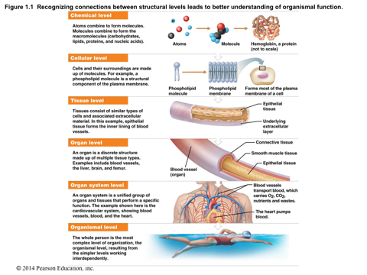

Characteristics of Life
- Movement – locomotion, propulsion (peristalsis), and contractility
- Responsiveness – ability to sense changes in the environment and respond to them
- Growth – increase in size of a body part or of the organism
- Reproduction – cellular and organism levels
- Cellular – an original cell divides and produces two identical daughter cells
- Organism – sperm and egg unite to make a whole new person
- Respiration – O2 and CO2 exchange
- Digestion – breakdown of ingested foodstuffs
- Absorption – passage of substances through membrane
- Assimilation – changing absorbed substances into different chemical forms
- Excretion – removal of wastes from the body
- Maintaining boundaries – the internal environment remains distinct from the external
  - Cellular level – accomplished by plasma membranes
  - Organism level – accomplished by the skin

Homeostasis
- Homeostasis is the ability to maintain a relatively stable internal environment in an ever-changing outside world
- The internal environment of the body is in a dynamic state of equilibrium
- Chemical, thermal, and neural factors interact to maintain homeostasis

Homeostatic Control Mechanisms
- The variable produces a change in the body
- The three interdependent components of control mechanisms are:
  - Receptor – monitors the environments and responds to changes (stimuli)
  - Control center – determines the set point at which the variable is maintained
  - Effector – provides the means to respond to the stimulus
- Negative Feedback
  - In negative feedback systems, the output shuts off the original stimulus
  - If the receptors measure deviations from a set point, effectors are activated to return things to normal
  - Examples
    - Thermostatic controls of body
    - Regulation of blood glucose levels
- Positive Feedback
  - In positive feedback systems, the output enhances or exaggerates the original stimulus
  - Example: Regulation of blood clotting
  - Positive Feedback Loops
    - Normal way of producing rapid changes occurs with childbirth, blood clotting, protein digestion, fever, and generation of nerve signals

Homeostatic Imbalance
- Disturbance of homeostasis or the body’s normal equilibrium
- Overwhelming of negative feedback mechanisms allowing destructive positive feedback mechanisms to take over
  - Disease = Dis ease

Organ Systems of the Body
- Integumentary system
  - Forms the external body covering
  - Composed of the skin, sweat glands, oil glands, hair, and nails
  - Protects deep tissues from injury and synthesizes vitamin D
- Skeletal system
  - Composed of bone, cartilage, and ligaments
  - Protects and supports body organs
  - Provides the framework for muscles
  - Site of blood cell formation
  - Stores minerals

Organ Systems of the Body – continued
- Muscular system
  - Composed of muscles and tendons
  - Allows manipulation of the environment, locomotion, and facial expression
  - Maintains posture
  - Produces heat
- Nervous system
  - Composed of the brain, spinal column, and nerves
  - Is the fast-acting control system of the body
  - Responds to stimuli by activating muscles and glands
- Cardiovascular system
  - Composed of the heart and blood vessels
  - The heart pumps blood
  - The blood vessels transport blood throughout the body
- Lymphatic system
  - Composed of red bone marrow, thymus, spleen, lymph nodes, and lymphatic vessels
  - Picks up fluid leaked from blood vessels and returns it to blood
  - Disposes of debris in the lymphatic stream
  - Houses white blood cells involved with immunity
- Respiratory system
  - Composed of the nasal cavity, pharynx, trachea, bronchi, and lungs
  - Keeps blood supplied with oxygen and removes carbon dioxide
- Digestive system
  - Composed of the oral cavity, esophagus, stomach, small intestine, large intestine, rectum, anus, and liver
  - Breaks down food into absorbable units that enter the blood
  - Eliminates indigestible foodstuffs as feces
- Urinary system
  - Composed of kidneys, ureters, urinary bladder, and urethra
  - Eliminates nitrogenous wastes from the body
  - Regulates water, electrolyte, and pH balance of the blood
- Male reproductive system
  - Composed of prostate gland, penis, testes, scrotum, and ductus deferens
  - Main function is the production of offspring
  - Testes produce sperm and male sex hormones
  - Ducts and glands deliver sperm to the female reproductive tract
- Female reproductive system
  - Composed of mammary glands, ovaries, uterine tubes, uterus, and vagina
  - Main function is the production of offspring
  - Ovaries produce eggs and female sex hormones
  - Remaining structures serve as sites for fertilization and development of the fetus
  - Mammary glands produce milk to nourish the newborn

What systems do which function?
- Body covering
- Control - integration and coordination
- Transportation
- Absorption
- Excretion
- Reproduction

Anatomical Position
- Body erect, feet slightly apart, palms facing forward, thumbs point away from body

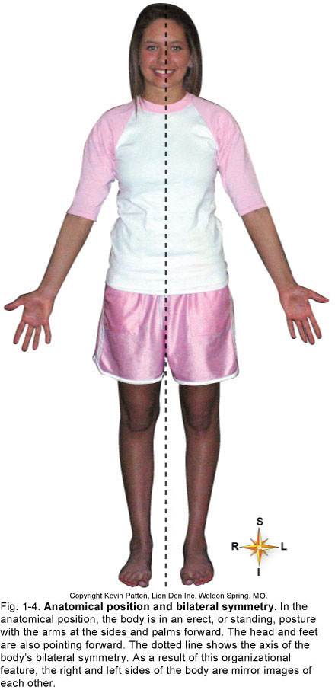

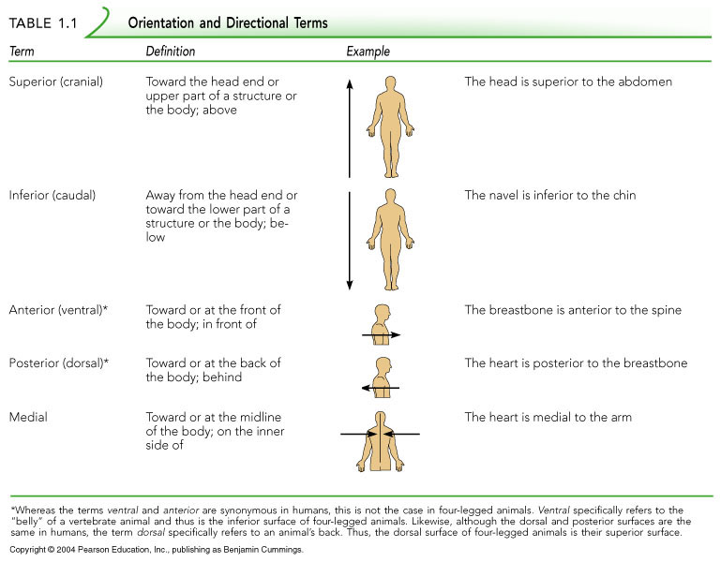

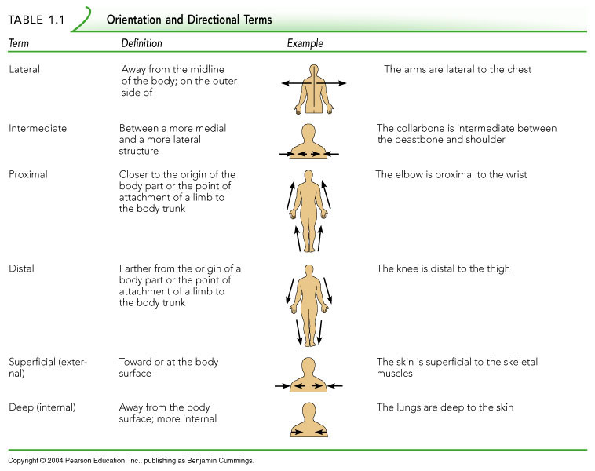

Regional Terms
- Axial – head, neck, and trunk
- Appendicular – appendages or limbs
- Specific regional terminology

Body Planes
- Sagittal – divides the body into right and left parts
- Midsagittal or medial – sagittal plane that lies on the midline
- Frontal or coronal – divides the body into anterior and posterior parts
- Transverse or horizontal (cross section) – divides the body into superior and inferior parts
- Oblique section – cuts made diagonally

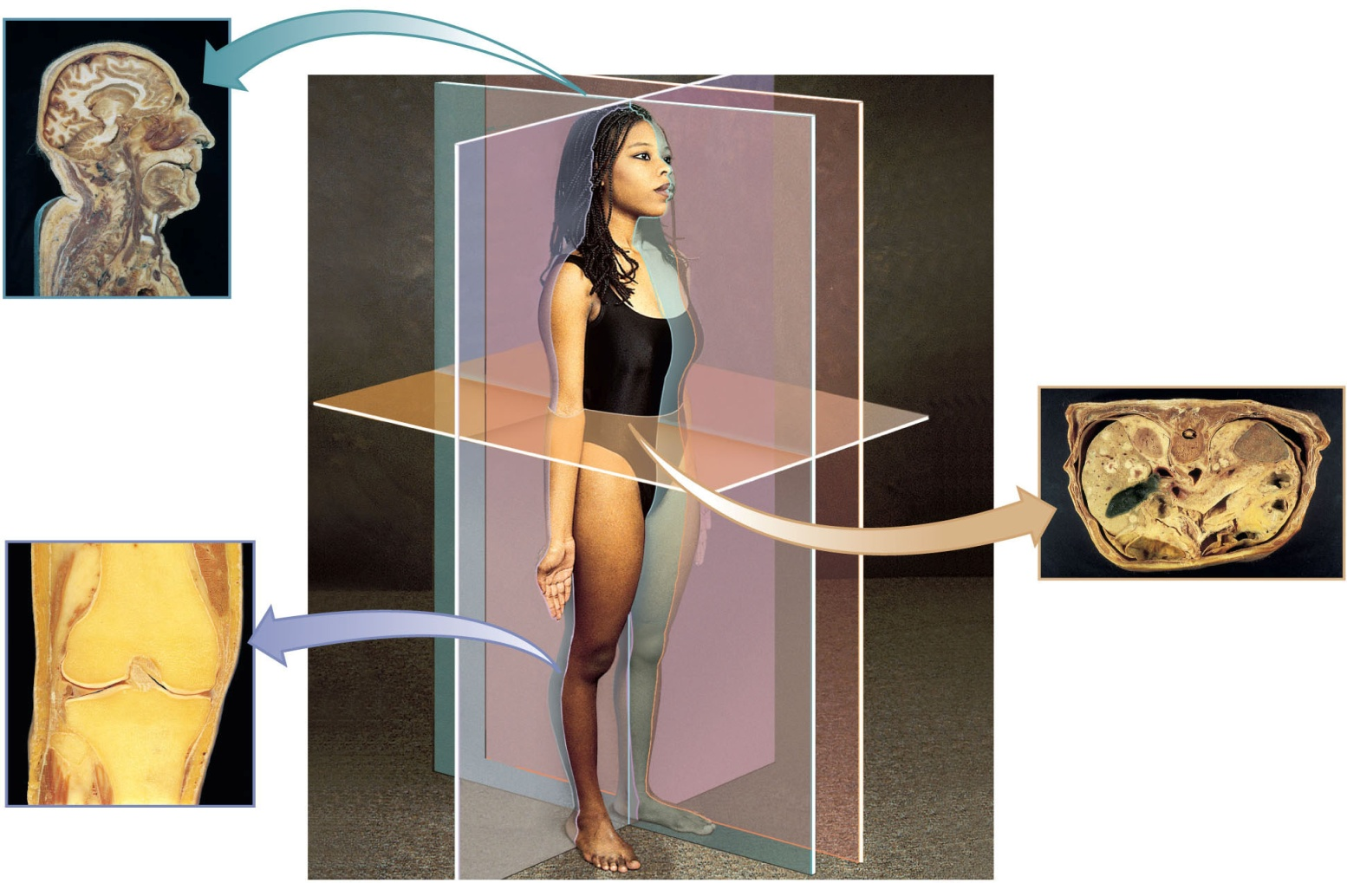

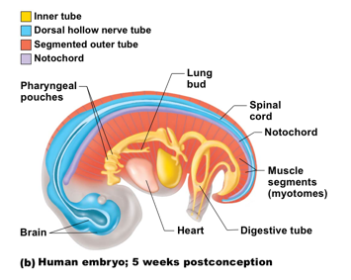
The Human Body Plan

Tube-within-a-tube

Bilateral symmetry

Dorsal hollow nerve cord

Notochord and vertebrae

Segmentation

Pharyngeal pouches

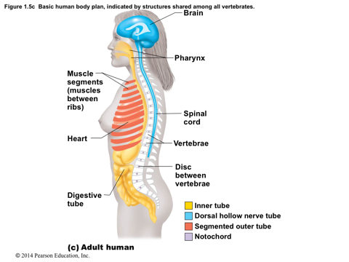

Body Cavities
- Dorsal cavity protects the nervous system, and is divided into two subdivisions
  - Cranial cavity is within the skull and encases the brain
  - Vertebral cavity runs within the vertebral column and encases the spinal cord
- Ventral cavity houses the internal organs (viscera), and is divided into two subdivisions: thoracic and abdominopelvic
  - Thoracic cavity is subdivided into pleural cavities, the mediastinum, and the pericardial cavity
    - Pleural cavities – each houses a lung
    - Mediastinum – contains the pericardial cavity, and surrounds the remaining thoracic organs
    - Pericardial cavity – encloses the heart
  - The abdominopelvic cavity is separated from the superior thoracic cavity by the dome-shaped diaphragm - It is composed of two subdivisions
    - Abdominal cavity – contains the stomach, intestines, spleen, liver, and other organs
    - Pelvic cavity – lies within the pelvis and contains the bladder, reproductive organs, and rectum
- Other Body Cavities
  - Oral and digestive – mouth and cavities of the digestive organs
  - Nasal –located within and posterior to the nose
  - Orbital – house the eyes
  - Middle ear – contain bones (ossicles) that transmit sound vibrations
  - Synovial – joint cavities

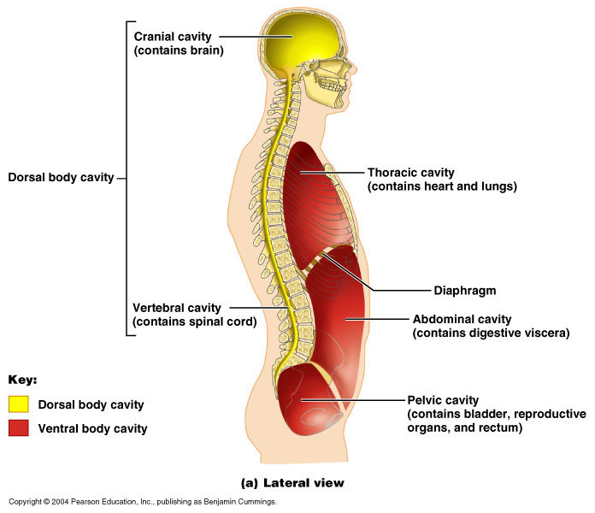

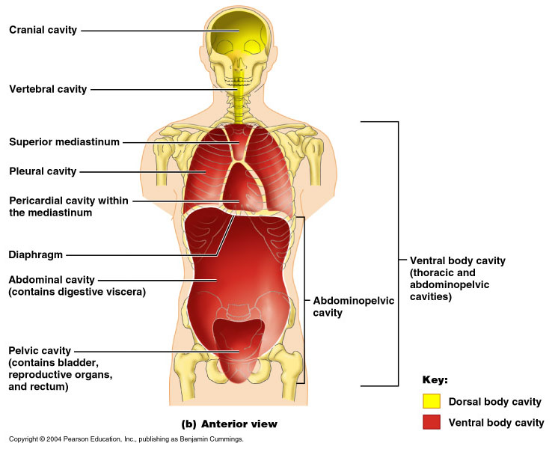

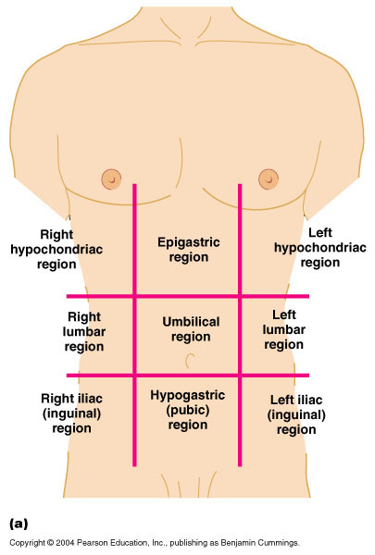

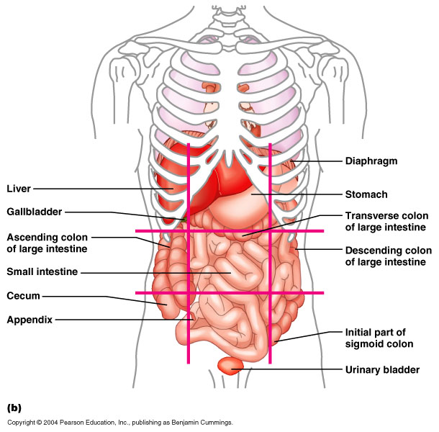

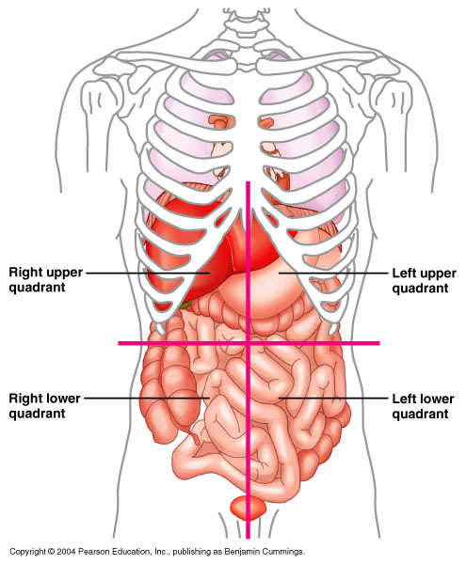

Microscopic Anatomy

Microscopy—examining small structures through a microscope

Light microscopy illuminates tissue with a beam of light (lower magnification)

Electron microscopy uses beams of electrons (higher magnification)

Scanning electron microscopy

Heavy metal salt stain—deflects electrons in the beam to different extents

Artifacts

Minor distortions of preserved tissues

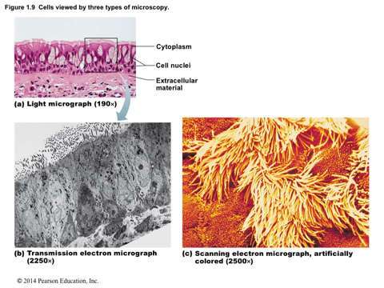
Not exactly like living tissues and organs

Clinical Anatomy—An Introduction to Medical Imaging Techniques

X ray—electromagnetic waves of very short length

Best for visualizing bones and abnormal dense structures

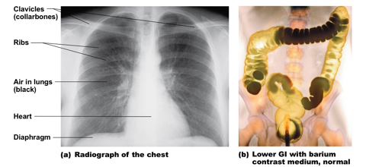

Advanced X-Ray Techniques

Computed (axial) tomography (CT or CAT)

Takes successive X rays around a person’s full circumference

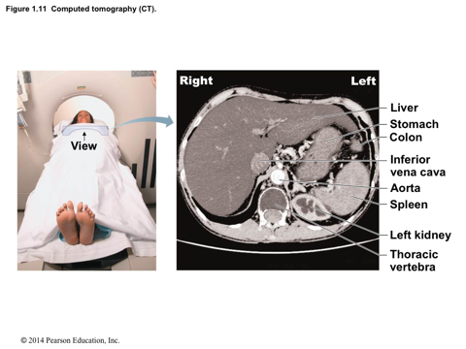
Computer translates recorded information into a detailed picture of the body section

Advanced X-Ray Techniques

Angiography

Contrast medium highlights vessel structure

Digital subtraction angiography (DSA)

Images taken before and after contrast medium injection

Computer subtracts “before” from “after” to identify blockage of arteries to heart wall and brain

Positron emission tomography (PET)—forms images by detecting radioactive isotopes injected into the body

Sonography (ultrasound imaging)—body is probed with pulses of high-frequency sound waves that echo off the body’s tissues

Imaging technique used to determine the age of a developing fetus

Magnetic resonance imaging (MRI)—produces high-quality images of soft tissues

Distinguishes body tissues based on relative water content

