Basic Cancer Genetics
Dr. Gary Mumaugh – Bethel University

“Anything found to be true of E.coli must also be true of elephants.”
Jacques Monrod, pioneer molecular biologist, 1954
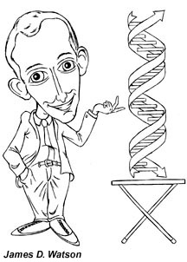
20th century biological revolution
- The biological revolution of the 20th century reshaped all fields of biomedical study, including cancer research.
- This began with Watson and Crick’s discovery of the DNA double helix.
- After this the field of molecular biology grew by asking “how does the genetic makeup of a cell and organism determine it’s appearance and function?”
- Watson and Crick made a model of the DNA molecule and proved that genes determine heredity
- Without this molecular foundation, cancer research would not be possible.

Gregory Mendel was the father of genetic research.
- Though farmers had known for centuries that crossbreeding of animals and plants could favor certain desirable traits, Mendel's pea plant experiments conducted between 1856 and 1863 established many of the rules of heredity , now referred to as the laws of Mendelian inheritance.
- To explain this phenomenon, Mendel coined the terms “recessive” and “dominant” in reference to certain traits.
- He published his work in 1866, demonstrating the actions of invisible “factors”— now called genes —in providing for visible traits in predictable ways.
- The profound significance of Mendel's work was not recognized until the turn of the 20th century.
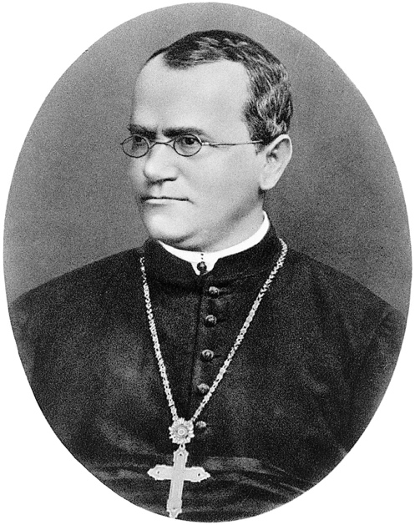
- Mendel’s work was actually based upon the prior writings off Charles Darwin.

Mendel established the basic rules of genetics
- Mendel’s work focused on the genetics of pea plants and his results and conclusions were soon forgotten, only to be discovered in the early 1900’s by other researchers.
- Mendel’s most fundamental insight came from realizing that genetic information is passed on to an offspring.
- He called this information discrete separate information packets, which latter became known as genes.

Human genome
- Now we have studied the human genome, which states that we have 22,000 genes.
  - Barely more than the 19,000 of a fruit fly !!!
- Basically, each observable trait can be directly traced to a separate gene that is the blueprint.
- Mendel’s research implied that the genetic information – genotype – could be divided into thousands of packets.
- Phenotypes came to be described as the outward appearance of physical and chemical traits.

Medelian genetics governs how both genes and chromosomes behave
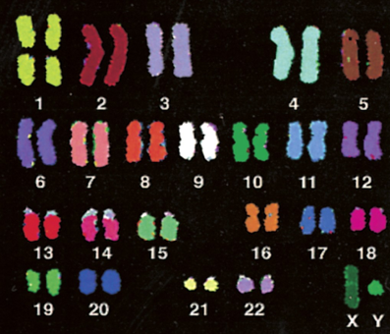
- Individual genes are to small to be seen with a light microscope, thus most cancer mutations cannot be visualized.
- Normal chromosomes are euploid karyotype, which means they are normally in structured pairs.
- The picture to the right shows normal chromosome pairs or euploidity.

Cancer cells often have altered chromosome structure, such as to many or to few chromosomes, or extra arms or fusions.
- Deviation from a normal euploid karyotype is called aneuploidy.
  - Single or with extra arms or off by themselves
  - This weird genetic configuration benefits the cancer cell and its agenda of runaway growth.

- Check out the breast cancer chromosomes in the picture below and compare them to the normal chromosome.

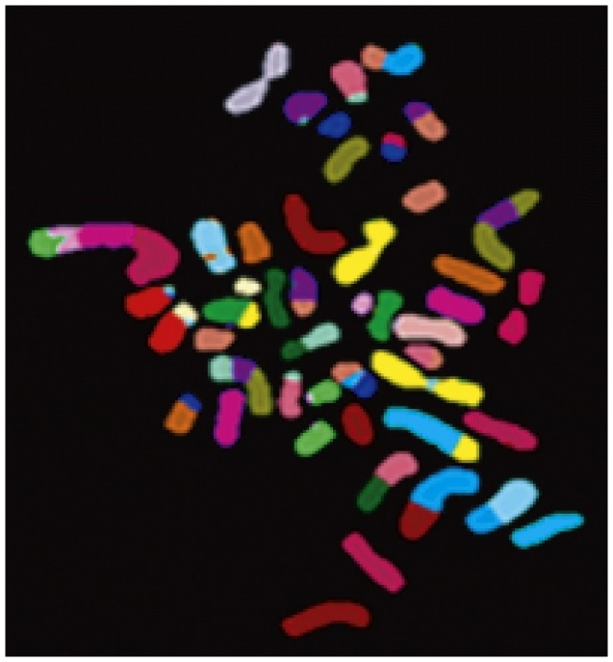
Carcinogens are mutagenic and can mutate genes.
- An abiding theme in cancer research is the notion that carcinogens - cancer causing agents – act through their ability to enter the tissues and to damage specific genes inside previously normal cells.
- Basic concept is that cancer cells have mutated genomes.
- Examples of carcinogens that could could mutagenesis
  - Obviously we get the connection with smoking and lung cancer, although 10% of lung cancers are in people who never smoked.

The truth is that the vast majority of cancers are NOT caused by specific mutagenic chemicals that enter the body.
- Most of the carcinogens do not act as agent as that are mutagenic, but they can act through other mechanisms to provoke cancer.
  - For example, certain viral infections, such a Hepatitis B, produce a very high incidence of liver cancer.

There are two basic types of genetic mutations:
- Acquired mutations
  - These occur from damage to genes during a person’s life.
- They are the most common cause of cancer.
  - They are not passed from parent to child.
  - Factors such as tobacco, ultraviolet (UV) radiation, viruses, and age cause these mutations.
  - Cancer that occurs because of acquired mutations is called sporadic cancer.

- Germline mutations
- Passed directly from a parent to a child.
- Germline mutations are less common.
  - In these situations, the mutation can be found in every cell of a person’s body, including the reproductive sperm cells in a boy’s body and egg cells in a girl’s body.
  - Because the mutation affects reproductive cells, it passes from generation to generation.
  - Cancer caused by germline mutations is called inherited cancer, and it makes up about 5% to 10% of all cancers.

Mutations and cancer
- Mutations happen often, and the human body is normally able to correct most of them.
- One mutation alone is unlikely to lead to cancer.
- Usually, it takes multiple mutations over a lifetime to cause cancer.
- This is why cancer occurs more often in older people who have had more opportunities for mutations to build up.

Types of genes linked to cancer
- Tumor suppressor genes are protective genes.
  - They limit cell growth by monitoring how quickly cells divide into new cells, repairing mismatched DNA, and controlling when a cell dies.
  - When a tumor suppressor gene is mutated, cells grow uncontrollably and may eventually form a mass called a tumor.
  - BRCA1, BRCA2, and p53 are examples of tumor suppressor genes.
    - BRCA1 or BRCA2 genes (which are germline mutations) increase a woman’s risk of developing hereditary breast or ovarian cancers.
  - The most commonly mutated gene in people who have cancer is p53.
    - More than 50% of all cancers involve a missing or damaged p53 gene
    - Most p53 gene mutations are acquired mutations.
    - P53 is often referred to as the “guardian of the genome.”

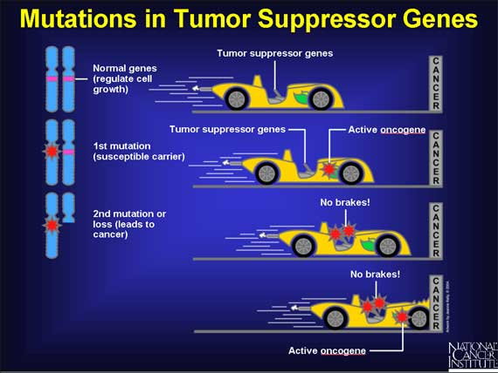

Types of genes linked to cancer
- Oncogenes turn a healthy cell into a cancerous cell.
- Mutations in these genes are not inherited.
- Two common oncogenes are:
  - HER2, which is a specialized protein that controls cancer growth and spread, and it is found on some cancer cells, such as breast and ovarian cancer cells.
  - The ras family of genes, which make proteins involved in cell communication pathways, cell growth, and cell death
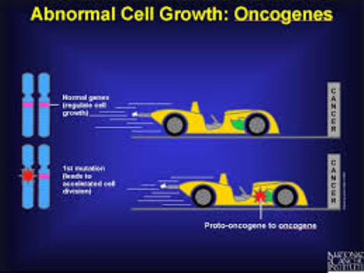

Types of genes linked to cancer
- DNA repair genes fix mistakes made when DNA is copied.
  - If a person has an error in a DNA repair gene, these mistakes are not corrected.
  - Then they become mutations, which may eventually lead to cancer.
  - This is especially true if the mutation occurs in a tumor suppressor gene or oncogene.

Despite all that is known about the different ways cancer genes work, many cancers cannot be linked to a specific gene.

Cancer likely involves multiple gene mutations.

