Family Processes and Chronic Illness
Dr. Gary Mumaugh – Bethel University

Past Research
- In 1962, two pediatricians published the first paper from a study examining the relationship between family stress and the susceptibility to streptococcal infections.
- They found that an acute crisis was four times more likely to have occurred during the pre-illness period period.
- It was called the family stress study and it was alerting doctors to the fact that a person’s social environment might be a determinant of the clinical incidence of disease.
- Another study 25 years latter in 1986 at George Washington University studied the relationship between family factors and dynamics and medical issues.
  - This study focused on three family factors
    - The family’s problem solving style
    - The strength of the family’s extended network
    - The family’s level of accomplishment as measured by income and educational level
  - This study was able to predict the early death of patients and it was very startling. It was startling because it was able to predict early patient’s death with 100% accuracy.
  - The thing that made this study so startling was that a few of the findings were the exact opposite to what you would think.
    - It turned out that meaningful contact of family members across three generations (family network) predicted early death.
    - The also found that the more highly coordinated the family was with its problem-solving style (usually considered a positive trait),the greater the likelihood the patient would be dead at the time they did a two yea follow-up.
    - And they found out that the higher the level of accomplishment, the more likely the patient would have died before the two year follow-up.
    - At the same time, physicians ratings of the disease severity proved useless as predictors of the course of the illness.
  - There have been a few studies that have tried to disprove the 1986 Reis study, but they have been inconclusive.
  - Nearly every study since then have essentially ignored or at best tolerated families in many medical settings.
  - Although many hospitals and clinical settings have improved family support, but rarely are these settings and programs ever administered by staff trained in family system dynamics.

A Brief Overview of the Family and Illness
- The “Deficit” Perspective
  - This approach focuses on family pathology.
  - The idea is that the family is a potential negative force in medical illness situations, in that dysfunctional family behavior psychologically and physically debilitates the family members.
  - This increases the risk foe physical illness.
  - Possibly the best known of these “deficit” models is the “psychosomatic family.”
    - Families in which there is a chronically ill member, it is thought that this renders individual family members susceptible to disease.
- The Family as a Resource
  - In this approach the focus is on the family as a potential resource for coping with chronic illness.
  - This basic argument is that the family serves either as a protective or preventative role in strengthening individual resistance to illness.
  - These families tend to educate and reinforce healthy behaviors such as diet, exercise, tobacco and alcohol abuse.
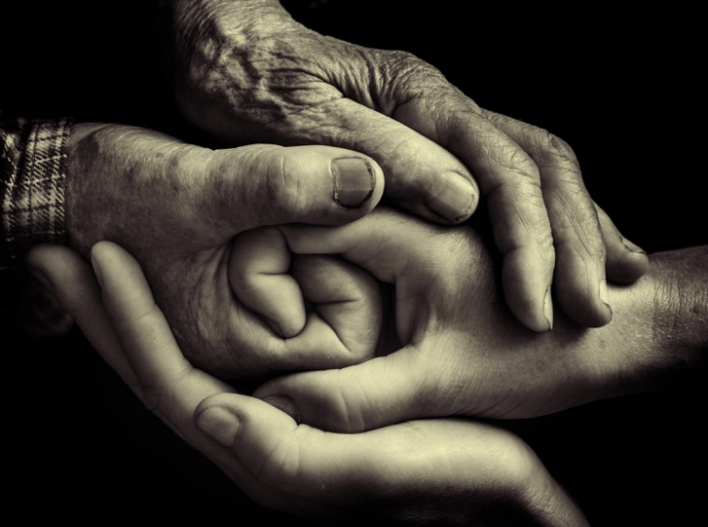
- The Clinical Course Perspective
  - The third perspective looks at how the family influences the course of chronic illness, and argues that because different illness characteristics and phases place different demands on the family.
  - The research and clinical work from this perspective looks at the interface between family behavior and illness characteristics, and asks questions about how a family can reinforce one another as the illness becomes more chronic and critical.
  - In this perspective, as an illness moves into its chronic phase, family members come to reorganize their daily lives around the illness demands.
    - For example, daily routines such as sleep-wake cycles, mealtime schedules, etc. are reorganized to accommodate the illness.
    - Space within the home us reorganized to accommodate treatment needs.
- The Impact Perspective
  - This fourth perspective focuses not on the family influence on the course of the medical condition, but it focuses on the impact of the illness on the family members.

Concluding Comments
- There is vast research and clinical literature suggesting an impact of illness on all the family members.
- In chronic illness situations, it is the family rather than the individual alone who should be seen as needing care.
- There is vast research and clinical literature suggesting an impact of illness on all the family members.
- In chronic illness situations, it is the family rather than the individual alone who should be seen as needing care.
- Current trends need to be addressed of the importance of the family in the medical treatment environment for the next decade:
  - Aging population
  - Conditions that used to be acute and possibly terminal are now increasingly becoming chronic. (Examples: ESRD, HIV, cancer)
  - Impact of high-technology treatments on the family
  - Increasing use of family members as an extension of the health care team in home treatment
  - Growing appreciation of the importance of health behaviors in the prevention of illness
  - Death and dying decision-making
  - Genetic predisposition to illness, and the current implications of genetic testing for the family.

