Muscular Tissue
Dr. Gary Mumaugh

Muscle Overview
- The three types of muscle tissue are skeletal, cardiac, and smooth
- These types differ in structure, location, function, and means of activation

Functional Characteristics of Muscle Tissue
- Excitability, or irritability – the ability to receive and respond to stimuli
- Contractility – the ability to shorten forcibly
- Extensibility – the ability to be stretched or extended
- Elasticity – the ability to recoil and resume the original resting length

Muscle Function
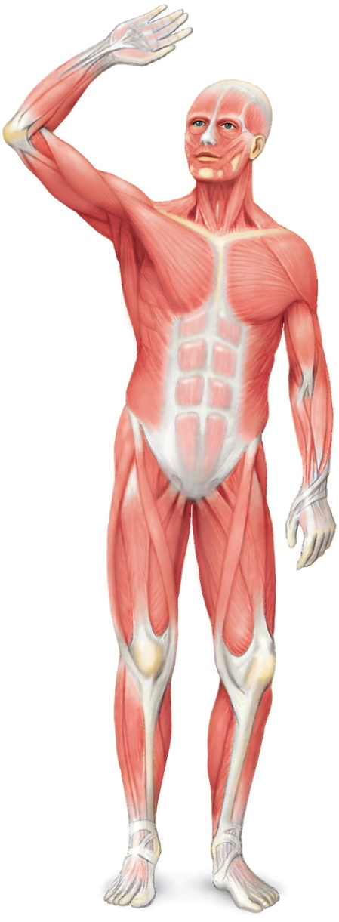
- Skeletal muscles are responsible for all movement
- Cardiac muscle is responsible for the movement of blood through the body
- Smooth muscle helps maintain blood pressure, and squeezes or propels substances (i.e., food, feces) through organs
- Muscles also maintain posture, stabilize joints, and generate heat

Three Types of Muscle
- Skeletal
  - Voluntary or somatic
  - Usually attaches to bones
  - Striated
- Cardiac
  - Involuntary or autonomic
  - Walls of Heart
  - Striated
- Smooth
  - Involuntary or autonomic
  - Walls of viscera, blood vessels and skin
  - Not striated

Structure of Skeletal Muscle
- Organ of the muscular system
- Skeletal muscle tissue
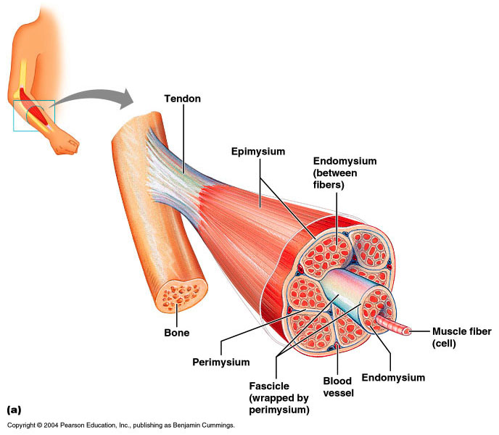
- Nervous tissue
- Blood
- Connective tissue
    - Fascia
    - Tendons
    - Aponeurosis

Muscle Coverings
- Epimysium
- Perimysium
- Endomysium
- Muscle organ
- Fascicles
- Muscle cells or fibers
- Myofibrils
- Thick and thin myofilaments
  - Actin and myosin proteins
  - Titin is an elastic myofilament

Skeletal Muscle Attachments
- Most skeletal muscles span joints and are attached to bone in at least two places
- When muscles contract the movable bone, the muscle’s insertion moves toward the immovable bone, the muscle’s origin

Myofibrils
- Myofibrils are densely packed, rodlike contractile elements
- Hundreds to thousands of myofibrils are in a single muscle fiber
- They make up most of the muscle volume
- The arrangement of myofibrils within a fiber is such that a perfectly aligned repeating series of dark A bands and light I bands is evident

Skeletal Muscle Contraction
- Movement within the myofilaments
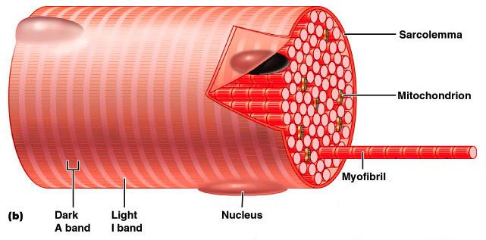
- I band (thin)
- A band (thick and thin)
- H zone (thick)
- Z line (or disc)
- M line

Myofilaments
- Thick myofilaments
  - Composed of myosin protein
  - Form the cross-bridges
- Thin myofilaments
  - Composed of actin protein
  - Associated with troponin and tropomyosin proteins

Neuromuscular Junction
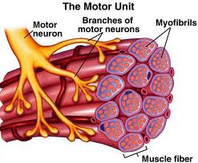
- Also known as NMJ or myoneural junction
- Site where an axon and muscle fiber meet
- Parts
- Motor neuron
- Motor end plate
- Synapse
- Synaptic cleft
- Synaptic vesicles
- Neurotransmitters

Motor Unit
- Single motor neuron
- All muscle fibers controlled by motor neuron
- As few as four fibers
- As many as 1000’s of muscle fibers

Skeletal Muscle Physiology
- The brain initiates an impulse for the muscles to contract
- It only takes 2 neurons to tell the skeletal muscle to contract
  - In brain to cord
  - Cord to muscle
- Motor neuron sends an impulse to the muscle cells to contract the motor neuron and the muscle cells that innervate it
- The neuron action potential continues down the neuron to muscle cells (motor unit) and the action potential continues into muscle cells
- As the action potential goes down the muscle cell along the sarcolema and the T Tubules
- When the action potential passes over the T Tubules, it releases calcium to contract the muscle

Ratchet Theory or Sliding Filament Mechanism
- Denotes the idea of how the myosin cross-bridge pull on the action filament in a ratchet-like manner.
  - A ratchet wrench puts tension on a bolt, then lets go of the tension as you swing it back, then exerts the tension again
- Similarly, a myosin cross-bridge pulls on the actin filament exerting tension, then it relaxes by letting go, exerts tension once again and then relaxes.

Muscle Tone
- Is the constant, slightly contracted state of all muscles, which does not produce active movements
  - Keeps the muscles firm, healthy, and ready to respond to stimulus
- Spinal reflexes account for muscle tone by:
  - Activating one motor unit and then another
  - Responding to activation of stretch receptors in muscles and tendons

Isotonic Contractions
- In isotonic contractions, the muscle changes in length and moves the load
- The two types of isotonic contractions are concentric and eccentric
  - Concentric contractions – the muscle shortens and does work
  - Eccentric contractions – the muscle contracts as it lengthens

Isometric Contractions
- Tension increases to the muscle’s capacity, but the muscle neither shortens nor lengthens

Concentric Eccentric Isometric
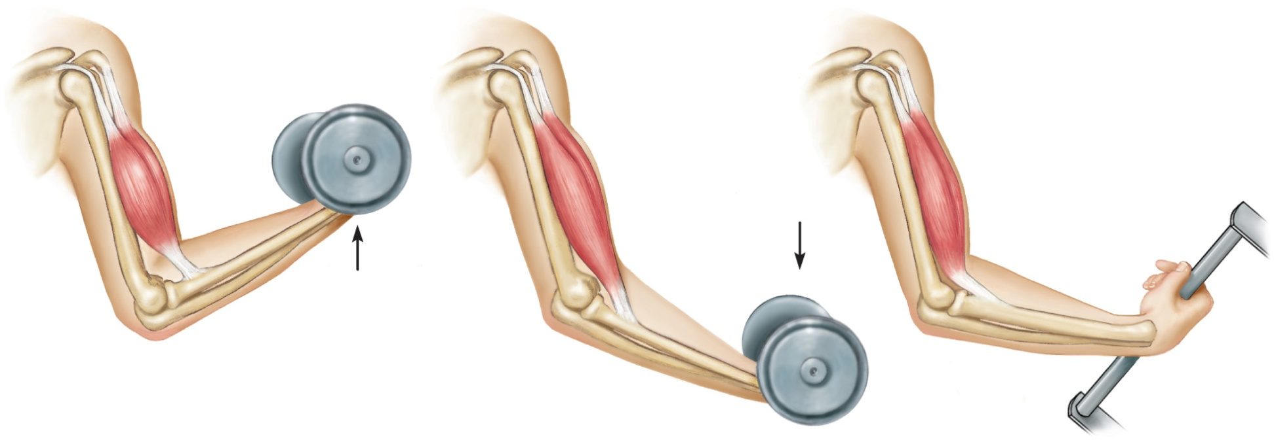

Muscle Metabolism: Energy for Contraction
- ATP is the only source used directly for contractile activity
- As soon as available stores of ATP are hydrolyzed (4-6 seconds), they are regenerated by:
  - The interaction of ADP with creatine phosphate (CP)
  - Anaerobic glycolysis
  - Aerobic respiration

Muscle Fatigue
- Muscle fatigue – the muscle is in a state of physiological inability to contract
- Muscle fatigue occurs when:
  - ATP production fails to keep pace with ATP use
  - The deficit of ATP causes contractures
  - Lactic acid accumulates in the muscle

Recruitment of Motor Units
- Recruitment - increase in the number of motor units activated
- Whole muscle composed of many motor units
- More precise movements are produced with fewer muscle fibers within a motor unit
- As intensity of stimulation increases, recruitment of motor units continues until all motor units are activated

Sustained Contractions
- Smaller motor units (smaller diameter axons) - recruited first
- Larger motor units (larger diameter axons) - recruited later
- Produce smooth movements
- Muscle tone – continuous state of partial contraction

Fast Twitch and Slow Twitch Muscle Fibers
- Slow-twitch fibers
  - Always oxidative
  - Resistant to fatigue
  - Red fibers
  - Most myoglobin
  - Good blood supply
- Fast-twitch fibers
  - White fibers
  - Poorer blood supply
  - Susceptible to fatigue
- Fast-twitch fatigue-resistant fibers
  - Intermediate fibers
  - Oxidative
  - Pink to red in color
  - Resistant to fatigue

Force of Muscle Contraction
- The force of contraction is affected by
  - The number of muscle fibers contracting – the more motor fibers in a muscle, the stronger the contraction
  - The relative size of the muscle – the bulkier the muscle, the greater its strength
  - Degree of muscle stretch – muscles contract strongest when muscle fibers are 80-120% of their normal resting length

Skeletal Muscle – The Big Picture
- A skeletal muscle attaches to two bones and crosses the joints between the bones
- The big picture is that when the muscles contract, it shortens it’s center
- The contraction creates a pulling force on the boney attachments
- If the pulling force is strong enough, one or both of the bones that attaches to the muscle will be pulled toward the center of the muscle
- Because bones are located within body parts, movements of a bone results in movement of a body part

Interactions of Skeletal Muscles
- Skeletal muscles work together or in opposition
- Muscles only pull (never push)
- As muscles shorten, the insertion generally moves toward the origin
- Whatever a muscle (or group of muscles) does, another muscle (or group) “undoes”

Naming Skeletal Muscles
- Number of origins – e.g., biceps (two origins) and triceps (three origins)
- Location of attachments – named according to point of origin or insertion
- Action – e.g., flexor or extensor, as in the names of muscles that flex or extend, respectively
- Location of muscle – bone or body region associated with the muscle
- Shape of muscle – e.g., the deltoid muscle (deltoid = triangle)
- Relative size – e.g., maximus (largest), minimus (smallest), longus (long)
- Direction of fibers – e.g., rectus (fibers run straight), transversus, and oblique (fibers run at angles to an imaginary defined axis)

Smooth Muscle
- Found in walls of hollow organs (except the heart)
- Have essentially the same contractile mechanisms as skeletal muscle

Peristalsis
- When the longitudinal layer contracts, the organ dilates and contracts
- When the circular layer contracts, the organ elongates
- Peristalsis – alternating contractions and relaxations of smooth muscles that mix and squeeze substances through the lumen of hollow organs

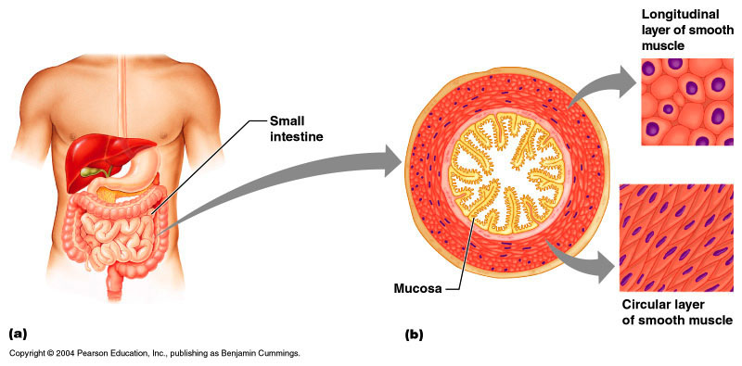

Developmental Aspects: Male and Female
- There is a biological basis for greater strength in men than in women
- Women’s skeletal muscle makes up 36% of their body mass
- Men’s skeletal muscle makes up 42% of their body mass

Developmental Aspects: Age Related
- With age, connective tissue increases and muscle fibers decrease
- Muscles become stringier and less elastic
- By age 80, 50% of muscle mass is lost (sarcopenia)
- Regular exercise reverses sarcopenia
- Aging of the cardiovascular system affects every organ in the body

