Muscular System
Dr. Gary Mumaugh

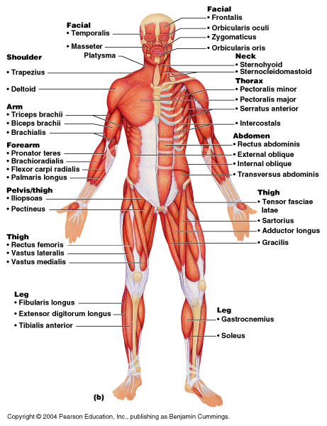

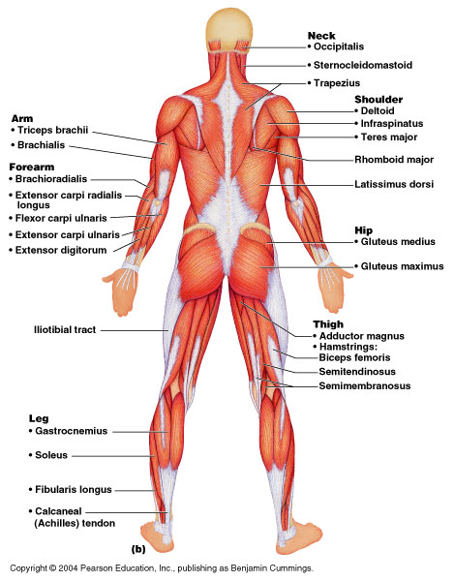

Organization of Muscles
- about 600 human skeletal muscles
- constitute about half of our body weight
- three kinds of muscle tissue
  - skeletal, cardiac, smooth
- specialized for one major purpose
  - converting the chemical energy in ATP into the mechanical energy of motion
- myology – the study of the muscular system

The Functions of Muscles
- Movement
  - move from place to place, movement of body parts and body contents in breathing, circulation, feeding and digestion, defecation, urination, and childbirth
  - role in communication – speech, writing, and nonverbal communications
- Stability
  - Maintain posture by preventing unwanted movements
  - antigravity muscles – resist the pull of gravity and prevent us from falling or slumping over
  - stabilize joints
- Control of openings and passageways
  - sphincters – internal muscular rings that control the movement of food, bile, blood, and other materials
- Heat production by skeletal muscles
  - as much as 85% of our body heat

Connective Tissues of a Muscle
- endomysium
  - thin sleeve of loose connective tissue surrounding each muscle fiber
  - allows room for capillaries and nerve fibers to reach each muscle fiber
- perimysium
  - slightly thicker layer of connective tissue
  - fascicles – bundles of muscle fibers wrapped in perimysium
  - carry larger nerves and blood vessels, and stretch receptors
- epimysium
  - fibrous sheath surrounding the entire muscle
  - outer surface grades into the fascia
  - inner surface sends projections between fascicles to form perimysium
- fascia
  - sheet of connective tissue that separates neighboring muscles or muscle groups from each other and the subcutaneous tissue

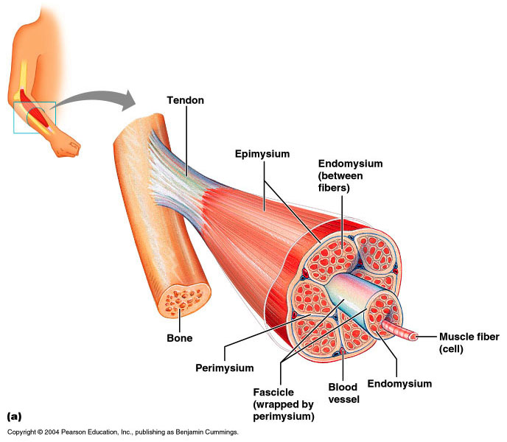

Fascicle Orientation of Muscles

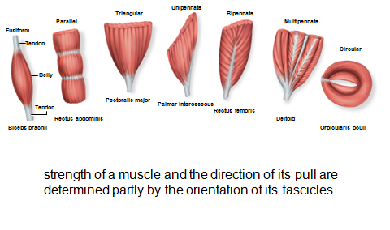

Muscle Attachments
- indirect attachment to bone
  - tendons bridge the gap between muscle ends and bony attachment
    - the collagen fibers of the endo-, peri-, and epimysium continue into the tendon
    - from there into the periosteum and the matrix of bone
    - very strong structural continuity from muscle to bone
    - aponeurosis – tendon is a broad, flat sheet (palmar aponeurosis
- direct (fleshy) attachment to bone
  - little separation between muscle and bone
  - muscle seems to immerge directly from bone
  - margins of brachialis, lateral head of triceps brachii
- some skeletal muscles do not insert on bone, but in dermis of the skin – muscles of facial expression
- Origin
  - bony attachment at stationary end of muscle
- Belly
  - thicker, middle region of muscle between origin and insertion
- Insertion
  - bony attachment to mobile end of muscle

Functional Groups of Muscles
- action – the effects produced by a muscle
  - to produce or prevent movement
- prime mover (agonist) - muscle that produces most of force during a joint action
- synergist - muscle that aids the prime mover
  - stabilizes the nearby joint
  - modifies the direction of movement
- antagonist - opposes the prime mover
  - relaxes to give prime mover control over an action
  - preventing excessive movement and injury

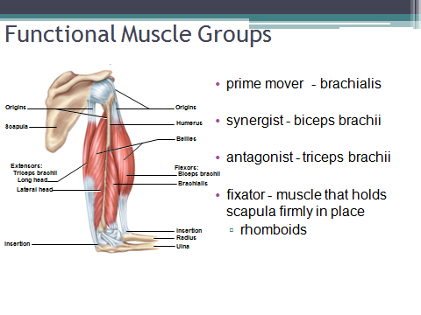
Intrinsic and Extrinsic Muscles
- intrinsic muscles – entirely contained within a region, such as the hand
  - both its origin and insertion there
- extrinsic muscles – act on a designated region, but has its origin elsewhere
  - fingers – extrinsic muscles in the forearm

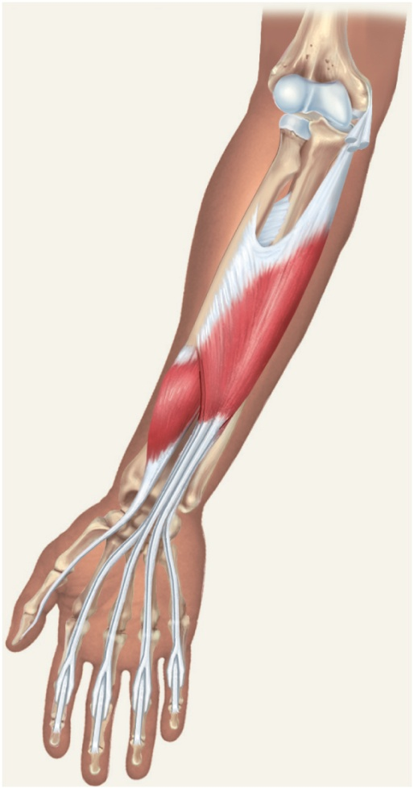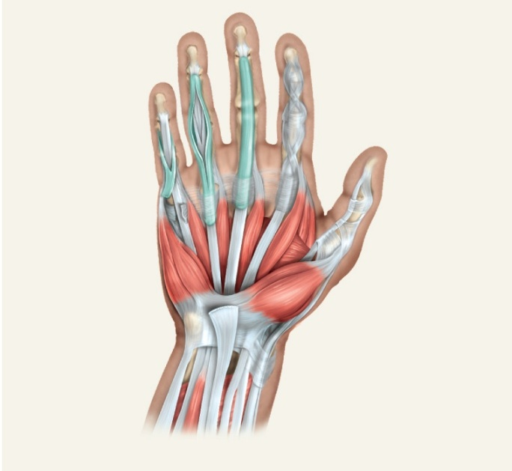

Muscle Innervation
- innervation of a muscle – refers to the identity of the nerve that stimulates it
  - enables the diagnosis of nerve, spinal cord, and brainstem injuries from their effects on muscle function
- spinal nerves arise from the spinal cord
  - emerge through intervertebral foramina
  - immediately branch into a posterior and anterior ramus
  - innervate muscles below the neck
- cranial nerves arise from the base of the brain
  - emerge through skull foramina
  - innervate the muscles of the head and neck
  - numbered I to XII

Muscles of Facial Expression
- muscles that insert in the dermis and subcutaneous tissues
- tense the skin and produce facial expressions
- innervated by facial nerve (CN VII)
- paralysis causes face to sag
- found in scalp, forehead, around the eyes, nose and mouth, and in the neck

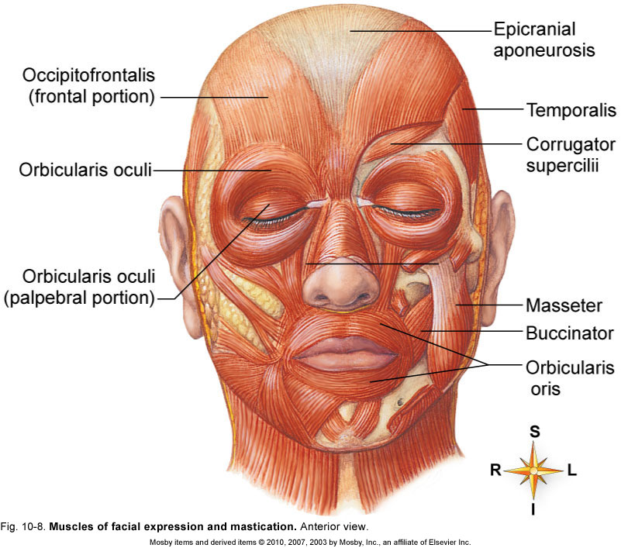

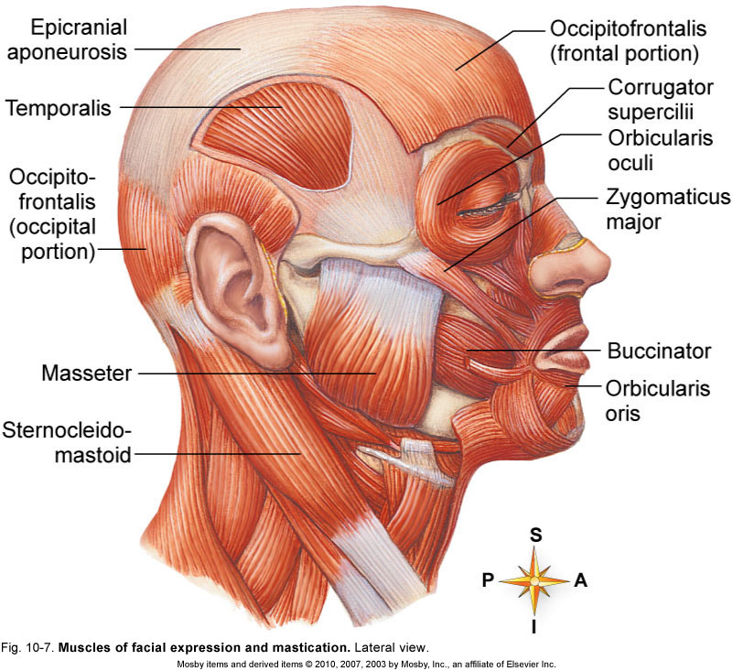

Muscles of Chewing and Swallowing
- extrinsic muscles of the tongue
  - tongue is very agile organ
  - pushes food between molars for chewing (mastication)
  - forces food into the pharynx for swallowing (deglutition)
  - crucial importance to speech
- intrinsic muscles of tongue
  - vertical, transverse, and longitudinal fascicles

Muscles of Chewing
- four pairs of muscles produce the biting and chewing movements of the mandible
  - depression – to open mouth
  - elevation – biting and grinding
  - protraction – incisors can cut
  - retraction – make rear teeth meet
  - lateral and medial excursion – grind food
- temporalis, masseter, medial pterygoid, lateral pterygoid
- innervated by mandibular nerve which is a branch of the trigeminal (V)

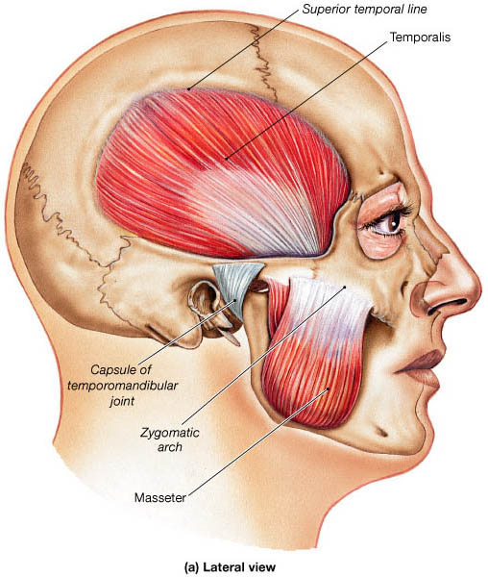

Muscles Acting on the Head
- originate on the vertebral column, thoracic cage, and pectoral girdle
- insert on the cranial bones
- actions
  - flexion (tipping head forward)
    - sternocleidomastoid
    - scalenes
  - extension (holding the head erect)
    - trapezius
    - splenius capitis
    - semispinalis capitis
- Actions
  - lateral flexion (tipping head to one side)
  - rotation (turning the head to the left and right)
  - may cause contralateral movement – movement of the head toward the opposite side
  - may cause ipsilateral movement – movement of the head toward the same side

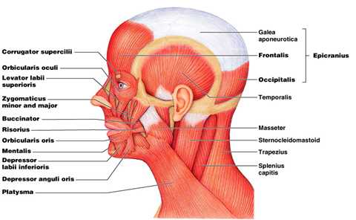

Muscles of the Trunk
- three functional groups
  - muscles of respiration
  - muscles that support abdominal wall and pelvic floor
  - movement of vertebral column

Muscles of Respiration
- breathing requires the use of muscles enclosing thoracic cavity
  - diaphragm, external and internal intercostal,
- inspiration – air intake
- expiration – expelling air
- other muscles of chest and abdomen that contribute to breathing
  - sternocleidomastoid, scalenes of neck
  - pectoralis major and serratus anterior of chest
  - latissimus dorsi of back
  - abdominal muscles – internal and external obliques, and transverse abdominis
  - some anal muscles

Muscles of Respiration - Intercostals
- external intercostals
  - elevates ribs
  - expand thoracic cavity
  - create partial vacuum causing inflow of air
- internal intercostals
  - depresses and retracts ribs
  - compresses thoracic cavity
  - expelling air
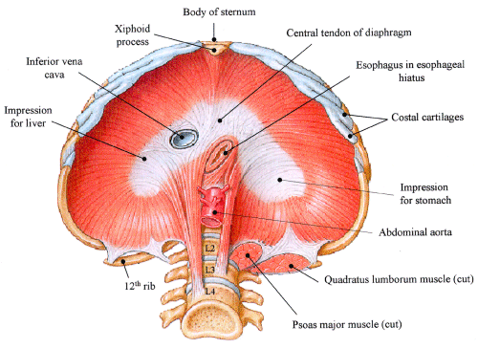

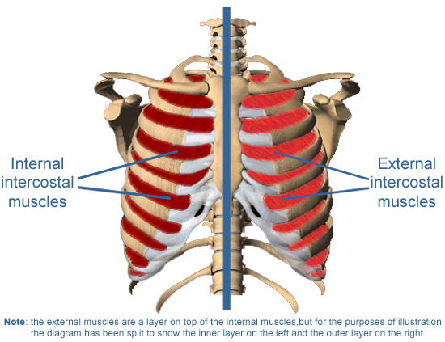

Muscles of the Anterior Abdominal Wall
- four pairs of sheetlike muscles
  - external abdominal oblique
  - internal abdominal oblique
  - transverse abdominal
  - rectus abdominis
- strengthen abdominal wall

External Abdominal Oblique
- most superficial of lateral abdominal muscles
- supports abdominal viscera against pull of gravity
- stabilizes vertebral column during heavy lifting
- maintains posture
- compresses abdominal organs
- aids in forced expiration
- rotation at waist

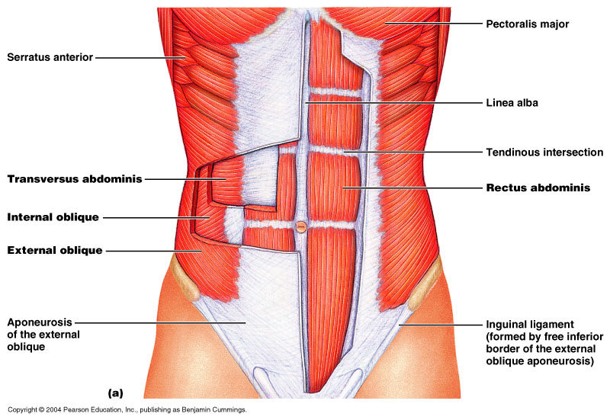

Internal Abdominal Oblique
- intermediate layer of lateral abdominal muscles
- unilateral contraction causes ipsilateral rotation of waist
- aponeurosis – tendons of oblique and transverse muscles –broad, fibrous sheets

Transverse Abdominal
- deepest of lateral abdominal muscles
- horizontal fibers
- compresses abdominal contents
- contributes to movements of vertebral column

Rectus Abdominis
- flexes lumbar region of vertebral column
- produces forward bending at the waist
- extends from sternum to pubis
- rectus sheath encloses muscle
- three transverse tendinous intersections divide rectus abdominis into segments – “six pack”

Superficial Back Muscles

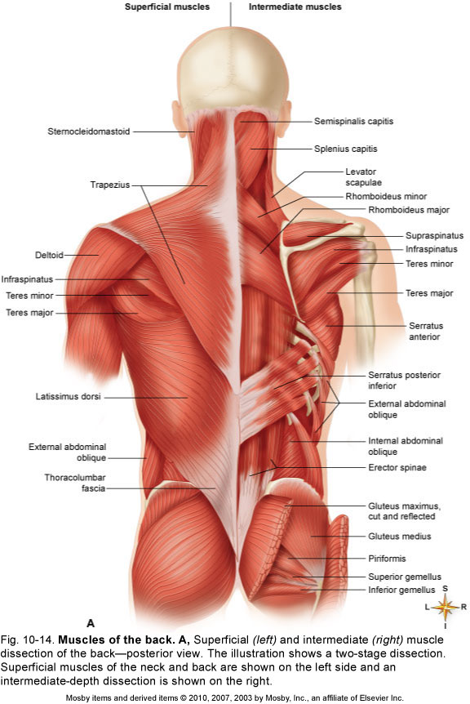

Deep Muscles of the Back
- erector spinae
  - iliocostalis, longissimus, spinalis
  - from cranium to sacrum
  - extension and lateral flexion of vertebral column
- semispinalis thoracis
  - extension and contralateral rotation of vertebral column
- quadratus lumborum
  - aids respiration
  - ipsilateral flexion of lumbar vertebral column
- multifidus
  - stabilizes adjacent vertebrae
  - maintains posture

Deep Muscles of the Back

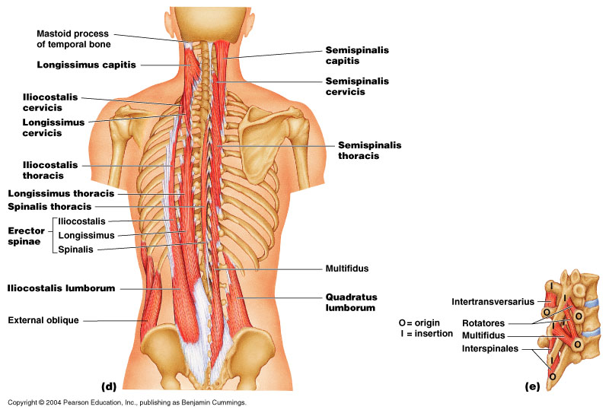

Muscles of the Pelvic Floor
- three layers of muscles and fasciae that span pelvic outlet
  - penetrated by anal canal, urethra, and vagina
- perineum – diamond-shaped region between the thighs
  - bordered by four bony landmarks
  - urogenital triangle – anterior half of perineum
  - anal triangle – posterior half of perineum
- three layers or compartments of the perineum
  - superficial perineal space – three muscles
- ischiocavernosus, bulbospongiosus, superficial transverse peritoneal
  - middle compartment - spanned by urogenital diaphragm
    - composed of a fibrous membrane and two or three muscles
    - deep transverse perineal muscle, external urethral and anal sphincters
    - compressor urethrae in females only
  - pelvic diaphragm – deepest layer consists of two muscle pairs
    - levator ani and coccygeus

Superficial Perineal Space
- muscles found just deep to the skin
- ischiocavernosus – maintains erection
- bulbospongiosus – aids in erection, expels remaining urine

Muscles of Pelvic Diaphragm
- deepest compartment of the perineum
- pelvic diaphragm – two muscle pairs
  - levator ani - supports viscera and defecation
  - coccygeus - supports and elevates pelvic floor

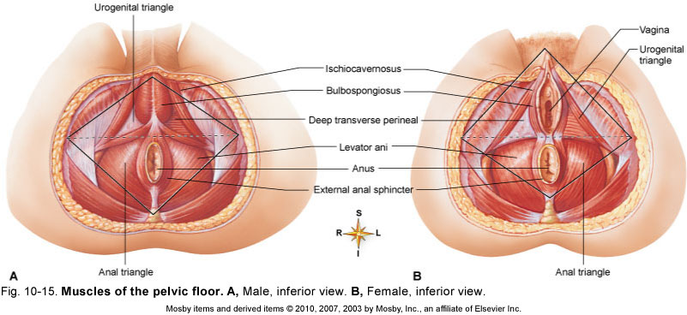

Hernias
- hernia – any condition in which the viscera protrudes through a weak point in the muscular wall of the abdominopelvic cavity
- inguinal hernia
  - most common type of hernia (rare in women)
  - viscera enter inguinal canal or even the scrotum
- hiatal hernia
  - stomach protrudes through diaphragm into thorax
  - overweight people over 40
- umbilical hernia
  - viscera protrude through the nave

Muscles Acting on Shoulder and Upper Limb
- compartments – spaces in which muscles are organized and are separated by fibrous connective tissue sheets (fasciae)
  - each compartment contains one or more functionally related muscles along with their nerve and blood supplies
- muscles of upper limbs divided into anterior and posterior compartments
- muscles of lower limbs divided into anterior, posterior, medial, and lateral compartments
- compartment syndrome – one of the muscles or blood vessels in a compartment is injured

Compartment Syndrome
- fasciae of arms and legs enclose muscle compartments very snugly
- if a blood vessel in a compartment is damaged, blood and tissue fluid accumulate in the compartment
- fasciae prevent compartment from expanding with increasing pressure
- compartment syndrome – mounting pressure on the muscles, nerves and blood vessel triggers a sequence of degenerative events
  - blood flow to compartment is obstructed by pressure
  - if ischemia (poor blood flow) persists for more than 2 – 4 hours, nerves begin to die
  - after 6 hours, muscles begin to die
- nerves can regenerate after pressure relieved, but muscle damage is permanent
- myoglobin in urine indicates compartment syndrome
- treatment – immobilization of limb and fasciotomy – incision to relieve compartment pressure

Muscles Acting on the Shoulder
- originate on the axial skeleton
- insert on clavicle and scapula
- scapula loosely attached to thoracic cage
  - capable of great movement
  - rotation, elevation, depression, protraction, retraction
- clavicle braces the shoulder and moderates movements

Anterior Muscles of Pectoral Girdle
- pectoralis minor
  - ribs 3-5 to coracoid process of scapula
  - draws scapula laterally
- serratus anterior
  - ribs 1-9 to medial border of scapula
  - abducts and rotates or depresses scapula

Movement of the Scapula

Posterior Muscles of Pectoral Girdle
- four muscles of posterior group
  - trapezius – superficial
  - levator scapulae, rhomboideus minor, and rhomboideus major – deep
- trapezius
  - stabilizes scapula and shoulder
  - elevates and depresses shoulder apex
- levator scapulae
  - elevates scapula
  - flexes neck laterally
- rhomboideus minor
  - retracts scapula and braces shoulder
- rhomboideus major
  - same as rhomboideus minor

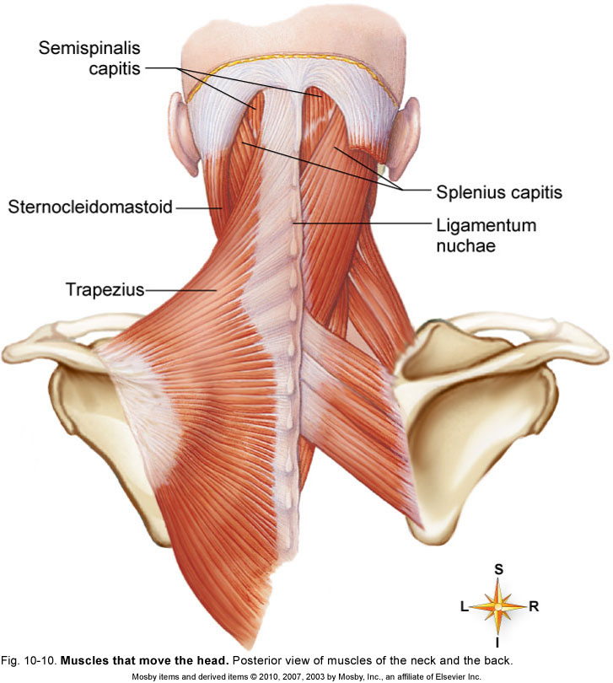

Muscles Acting on Arm
- nine muscles cross the shoulder joint and insert on humerus
  - two are axial muscles because they originate on axial skeleton
    - pectoralis major – flexes, adducts, and medially rotates humerus
    - latissimus dorsi – adducts and medially rotated humerus
- seven scapular muscles
  - originate on scapula
    - deltoid
      - rotates and abducts arm
      - intramuscular injection site
    - teres major
      - extension and medial rotation of humerus
    - coracobrachialis
      - flexes and medially rotates arm
    - remaining four form the rotator cuff that reinforce the shoulder joint
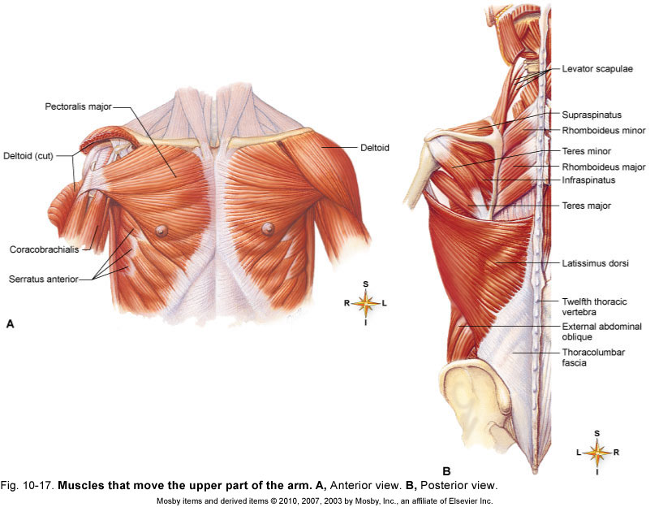

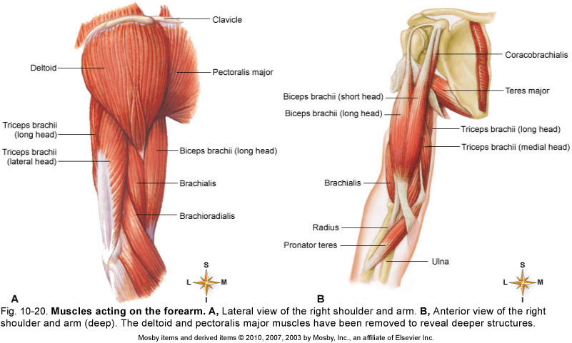

Rotator Cuff Muscles
- tendons of the remaining four scapular muscles form the rotator cuff
- “SITS” muscles – for the first letter of their names
  - Supraspinatus
  - Infraspinatus
  - teres minor
  - subscapularis
- tendons of these muscles merge with the joint capsule of the shoulder as they cross it in route to the humerus
- holds head of humerus into glenoid cavity
- supraspinatus tendon most easily damaged

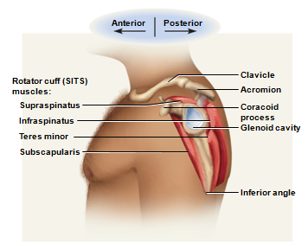

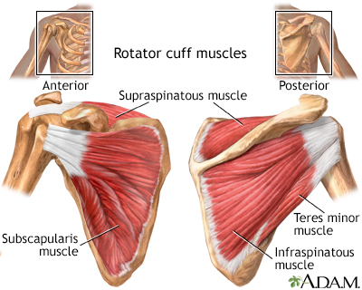

Muscles Acting on Forearm
- elbow and forearm capable of flexion, extension, pronation, and supination
  - carried out by muscles in both brachium (arm) and antebrachium (forearm)
- muscles with bellies in the arm (brachium)
  - principal elbow flexors – anterior compartment
    - brachialis and biceps brachii
    - brachialis produces 50% more power than biceps brachii
    - brachialis is prime mover of elbow flexion
  - principal elbow extensor – posterior compartment
    - triceps brachii - prime mover of elbow extension
- muscles with bellies in the forearm (antebrachium)
  - most forearm muscles act on the hand and wrist
    - brachioradialis – flexes elbow
    - anconeus – extends elbow
    - pronator quadratus – prime mover in forearm pronation
    - pronator teres – assists pronator quadratus in pronation
    - supinator – supinates the forearm

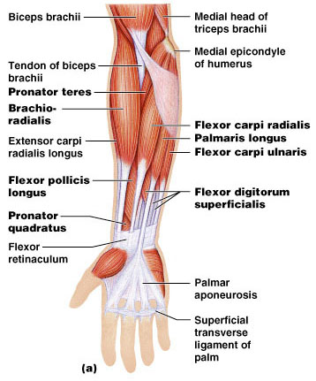

Muscles Acting on Forearm
- principal flexor
  - brachialis
- synergistic flexors
  - biceps brachii
  - brachioradialis
- principal extensor
  - triceps brachii
- Supination and Pronation
  - Supination
    - supinator muscle
    - palm facing anteriorly or superiorly
  - Pronation
    - pronator quadratus and pronator teres
    - palm faces posteriorly or inferiorly

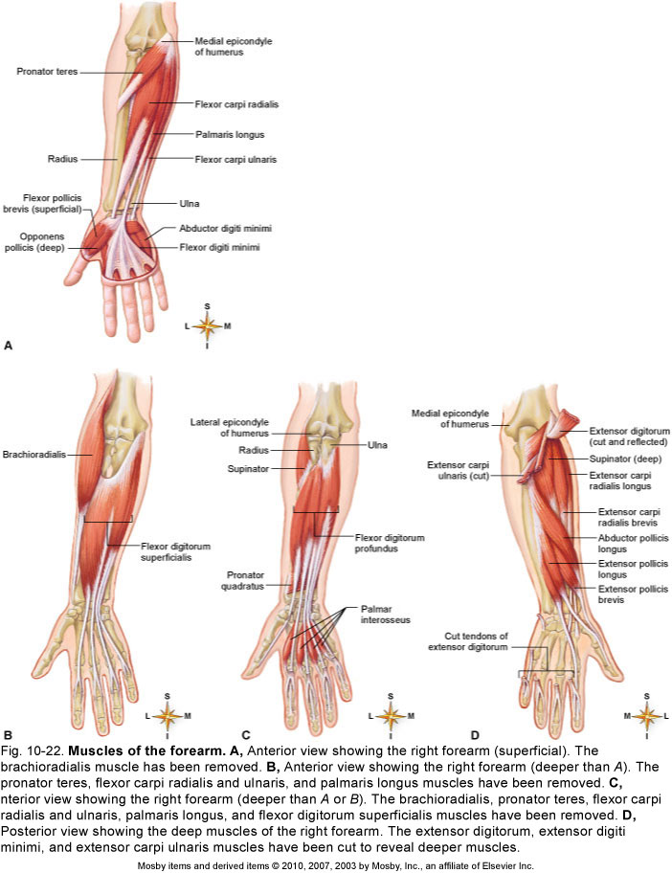
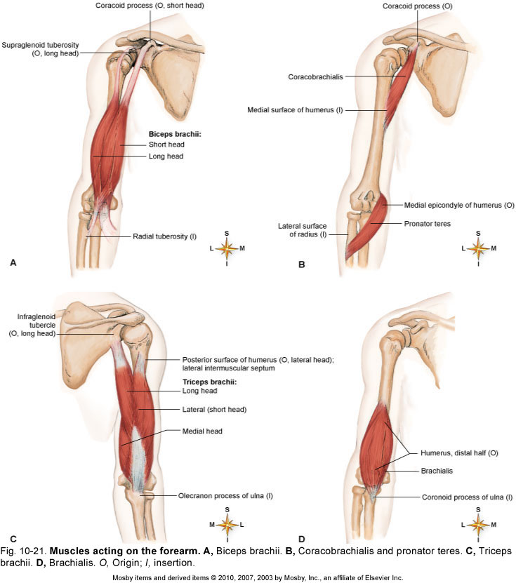

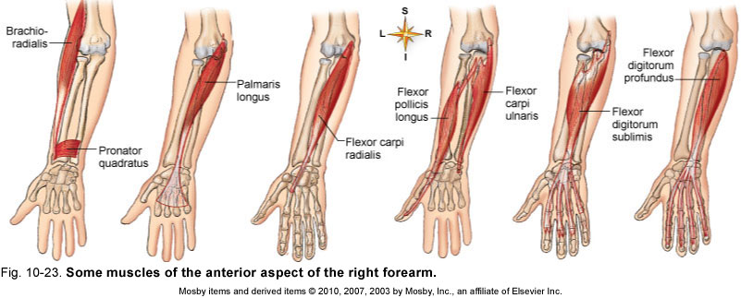

Anterior Muscles on Wrist and Hand
- extrinsic muscles of the forearm
- intrinsic muscles in the hand itself
- extrinsic muscle actions
  - flexion and extension of wrist and digits
  - radial and ulnar flexion
  - finger abduction and adduction
  - thumb opposition
- Anterior (Flexor) Compartment – superficial layer
  - flexor carpi radialis
  - flexor carpi ulnaris
  - flexor digitorum superficialis
  - palmaris longus
- Anterior (Flexor) Compartment – deep layer
  - flexor digitorum profundus
  - flexor pollicis longus
- extension of wrist and fingers, adduct / abduct wrist
- extension and abduction of thumb (pollicis)
- brevis - short, ulnaris - on ulna side of forearm

Posterior Muscles on Wrist and Hand
- Posterior (Extensor) Compartment – superficial layer
  - extensor carpi radialis longus
  - extensor carpi radialis brevis
  - extensor digitorum
  - extensor digiti minimi
  - extensor carpi ulnaris
- Posterior (Extensor) Compartment – deep layer
  - abductor pollicis longus
  - extensor pollicis brevis
  - extensor pollicis longus
  - extensor indicis

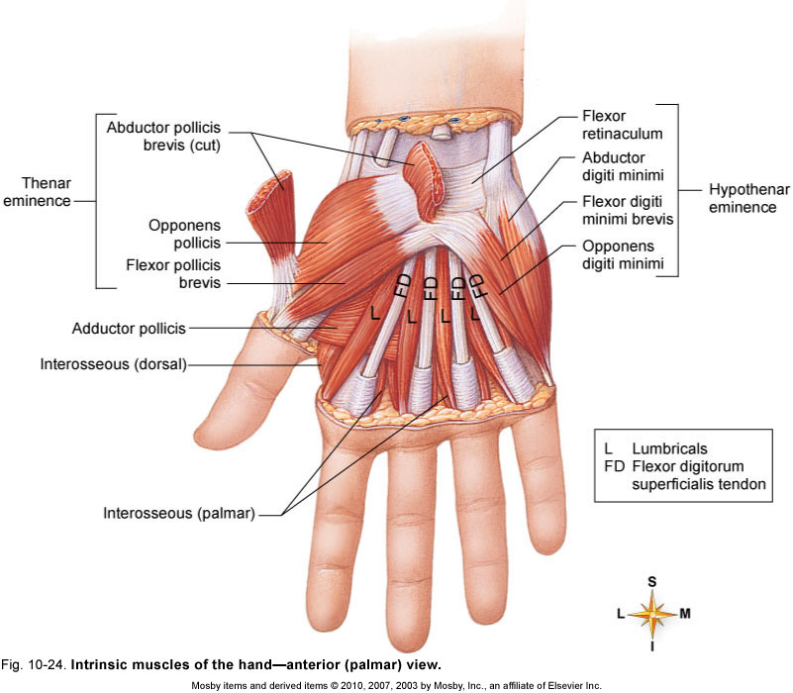
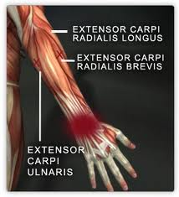

Carpal Tunnel Syndrome
- flexor retinaculum – bracelet-like fibrous sheet that the flexor tendons of the extrinsic muscles that flex the wrist pass on their way to their insertions
- carpal tunnel – tight space between the flexor retinaculum and the carpal bones
  - flexor tendons passing through the tunnel are enclosed in tendon sheaths
  - enable tendons to slide back and forth quite easily
- carpal tunnel syndrome - prolonged, repetitive motions of wrist and fingers can cause tissues in the carpal tunnel to become inflamed, swollen, or fibrotic
  - puts pressure on the median nerve of the wrist that passes through the carpal tunnel along with the flexor tendons
  - tingling and muscular weakness in the palm and medial side of the hand
  - pain may radiate to arm and shoulder
  - treatment – anti-inflammatory drugs, immobilization of the wrist, and sometimes surgery to remove part or all of flexor retinaculum

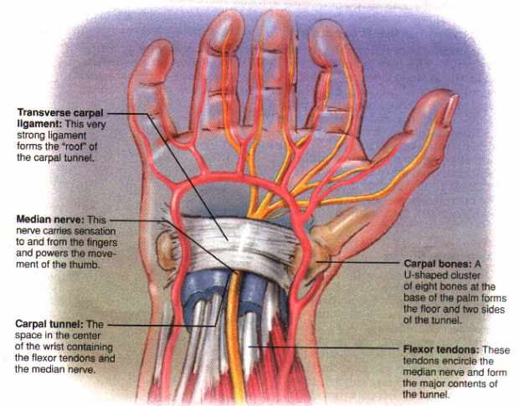

Intrinsic Hand Muscles
- thenar group – form thick, fleshy mass at base of thumb
  - adductor pollicis
  - abductor pollicis brevis
  - flexor pollicis brevis
  - opponens pollicis
- Hypothenar group - fleshy base of the little finger
  - abductor digiti minimi
  - flexor digiti minimi brevis
  - opponens digiti minimi
- Midpalmar group – hollow of palm
  - dorsal interosseous muscles (4)
  - palmar interosseous muscles (3)
  - lumbricals (4 muscles)

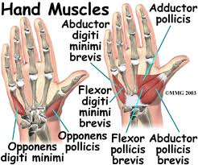

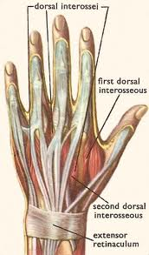

Muscles on the Hip and Lower Limb
- largest muscles found in lower limb
- less for precision, more for strength needed to stand, maintain balance, walk, and run
- several cross and act on two or more joints
- leg – the part of the limb between the knee and ankle
- foot – includes tarsal region (ankle), metatarsal region, and the toes

Muscles Acting on the Hip and Femur
- Anterior muscles of the hip
  - iliacus
    - flexes thigh at hip
    - iliacus portion arises from iliac crest and fossa
  - psoas major
    - flexes thigh at hip
    - arises from lumbar vertebrae
  - they share a common tendon on the femur
- Posterior Muscles on Hip and Femur
- Lateral and posterior muscles of the hip
  - tensor fasciae latae
    - extends knee, laterally rotates knee
  - gluteus maximus
    - forms mass of the buttock
    - prime hip extensor
    - provides most of lift when you climb stairs
  - gluteus medius and minimus
    - abduct and medially rotate thigh

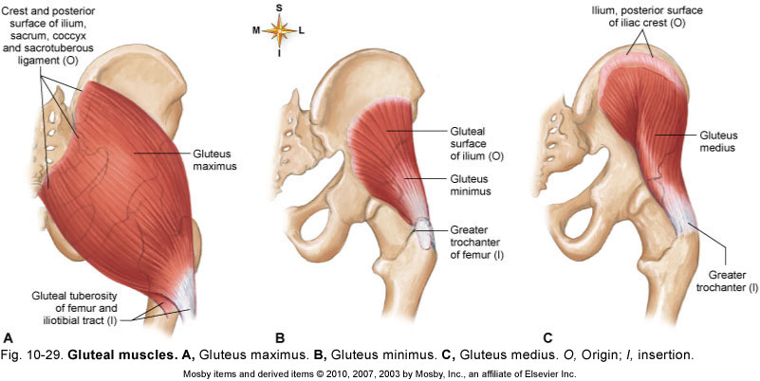
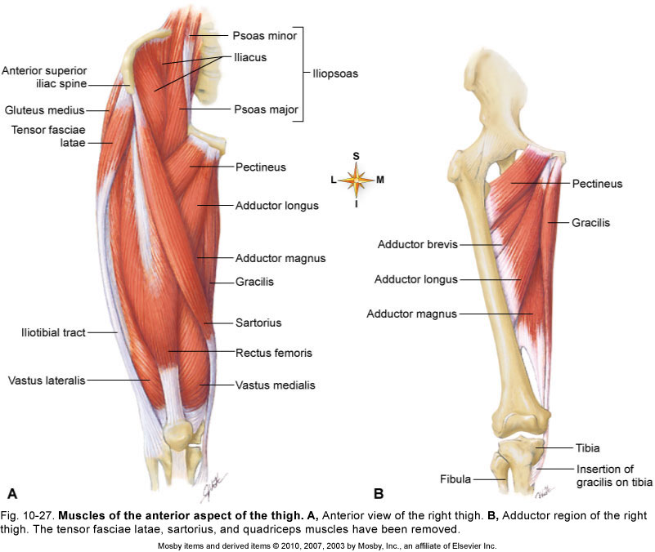

Posterior Muscles on Hip and Femur
- lateral rotators - six muscles inferior to gluteus minimus
- deep to the two other gluteal muscles
  - gemellus superior
  - gemellus inferior
  - obturator externus
  - obturator internus
  - piriformis
  - quadratus femoris

Muscles Acting on Hip and Femur
- medial (adductor) compartment of thigh
- five muscles act as primary adductors of the thigh
  - adductor brevis
  - adductor longus
  - adductor magnus
  - gracilis
  - pectineus

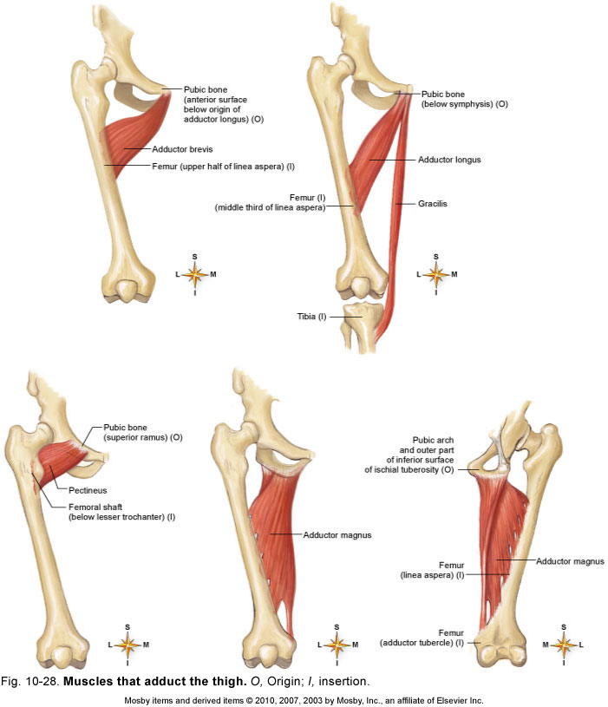

Muscles on the Knee and Leg
- anterior (extensor) compartment of the thigh
  - contains large quadriceps femoris muscle
    - prime mover of knee extension
    - most powerful muscle in the body
    - has four heads – rectus femoris, vastus lateralis, vastus medialis, and vastus intermedius
      - all converge on single quadriceps (patellar) tendon
      - extends to patella
      - then continues as patellar ligament
      - inserts on tibial tuberosity
  - sartorius – longest muscle in the body
    - tailor’s muscle

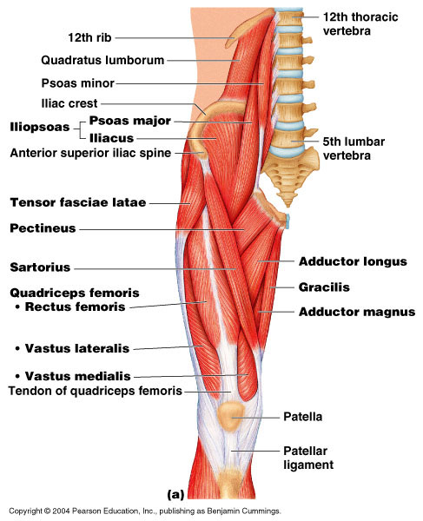

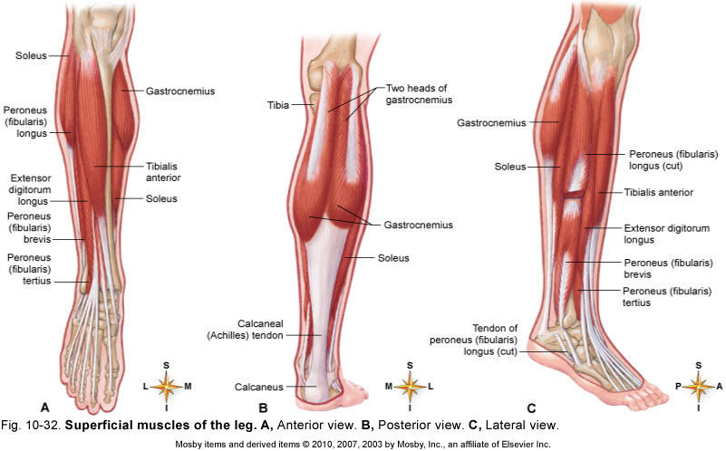

Muscles Acting on the Knee and Leg
- Posterior (flexor) compartment of the thigh
  - contains hamstring muscles
    - from lateral to medial; biceps femoris, semitendinosus, semimembranosus
- Anterior Compartment of Leg
  - anterior (extensor) compartment of the leg
    - dorsiflex the ankle
    - prevent toes from scuffing when walking
    - fibularis (peroneus) tertius
    - extensor digitorum longus
    - extensor hallucis longus
    - tibialis anterior
- Posterior Compartment of Leg - Superficial Group
  - three muscles of the superficial group
    - gastrocnemius - plantar flexes foot, flexes knee
    - soleus – plantar flexes foot
    - plantaris - weak synergist of triceps
Muscles Acting on the Knee and Leg
- Posterior Compartment of Leg - Deep Group
  - four muscles in the deep group
    - flexor digitorum longus – flexes phalanges
    - flexor hallucis longus – flexes great toe
    - tibialis posterior – inverts foot
    - popliteus – acts on knee
- Lateral (Fibular) Compartment of the Leg
  - two muscles in this compartment
    - fibularis longus
    - fibularis brevis
    - both plantar flex and evert the foot
    - provides lift and forward thrust

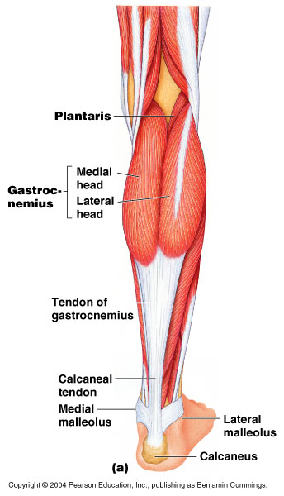

Intrinsic Muscles of Foot
- support for arches
  - abduct and adduct the toes
  - flex the toes
- one dorsal muscle
  - extensor digitorum brevis extends toes

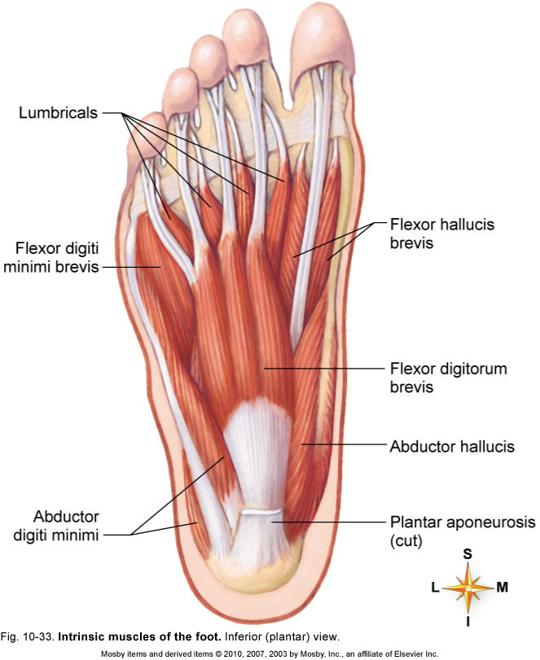

Athletic Injuries
- muscles and tendons are vulnerable to sudden and intense stress
- proper conditioning and warm-up needed
- common injuries;
  - compartment syndrome
  - shinsplints
  - pulled hamstrings
  - tennis elbow
  - pulled groin
  - rotator cuff injury
- treat with rest, ice, compression and elevation
- “no pain, no gain” is a dangerous misconception

