Cardiovascular Anatomy
Dr. Gary Mumaugh

Location of Heart
- Approximately the size of your fist
- Location
  - Superior surface of diaphragm
  - Left of the midline in mediastinum
  - Anterior to the vertebral column, posterior to the sternum
  - Posteriorly the heart rests on the bodies of vertebrae T5-T8
  - Apex lies on the diaphragm, pointing to the left
  - Base lies just below the second rib
- PMI – point of maximal intensity is the place where you feel and hear the heart the best
  - It is located between the 5th and 6th rib on the left.

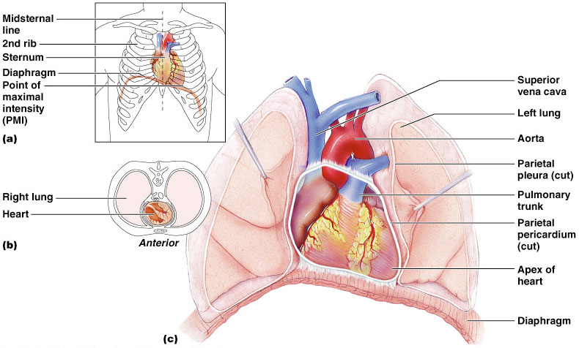

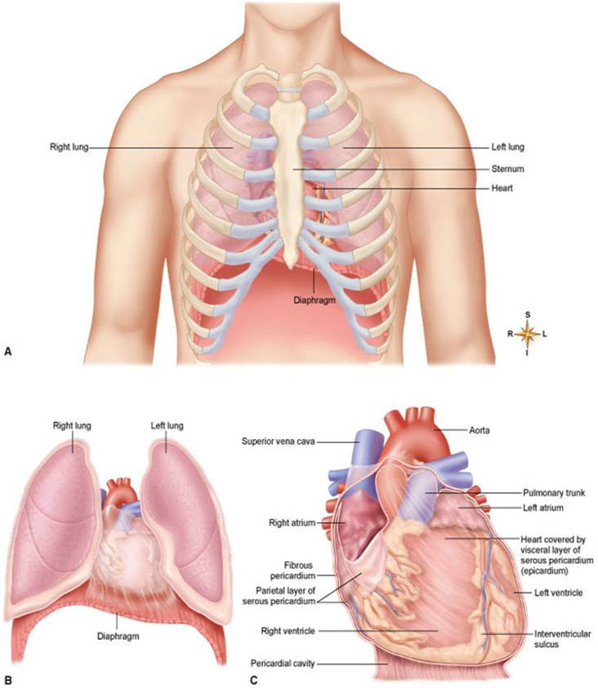
Coverings of the Heart: Anatomy
- Pericardium – a double-walled sac around the heart composed of:
- A superficial fibrous pericardium
- A deep two-layer serous pericardium
  - The parietal layer lines the internal surface of the fibrous pericardium
  - The visceral layer or epicardium lines the surface of the heart
  - They are separated by the fluid-filled pericardial cavity

Coverings of the Heart: Physiology
- The pericardium:
  - Protects and anchors the heart
  - Prevents overfilling of the heart with blood
  - Allows for the heart to work in a relatively friction-free environment
- Pericarditis – Inflammation of the Pericardium
  - The serous membrane is roughened up
  - When the heart beats, it rubs against the pericardial sac, creating a “grating” sound
  - Characterized by deep pain
  - In severe cases a large amount of inflammatory fluid seeps into the pericardial cavity causing a compression when the heart beats
    - Cardiac Tamponade

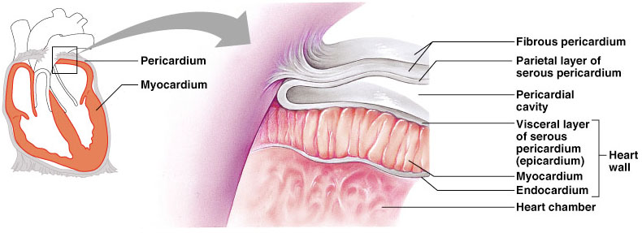
Wall of the Heart
- Structure of the heart
- Wall of the heart: composed of three distinct layers
  - Epicardium: outer layer of heart wall
  - Myocardium: thick, contractile middle layer of heart wall; compresses the heart cavities, and the blood within them, with great force
  - Endocardium: delicate inner layer of endothelial tissue

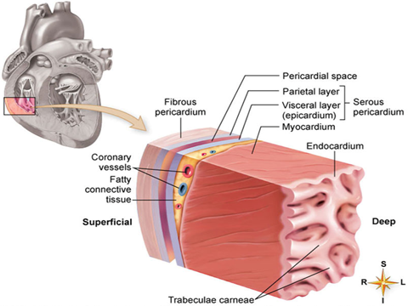

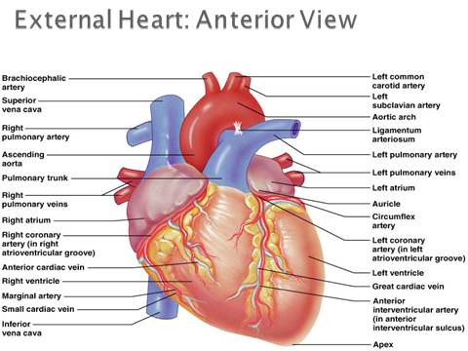
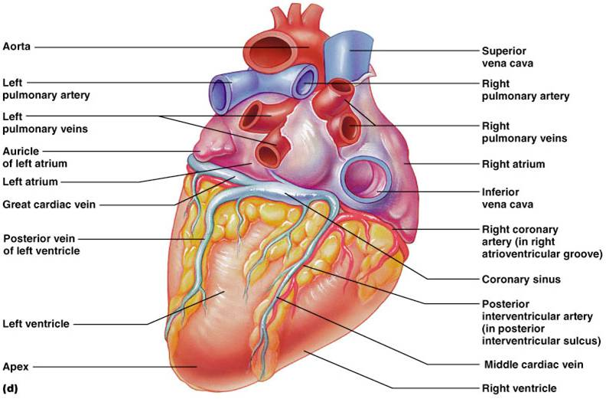

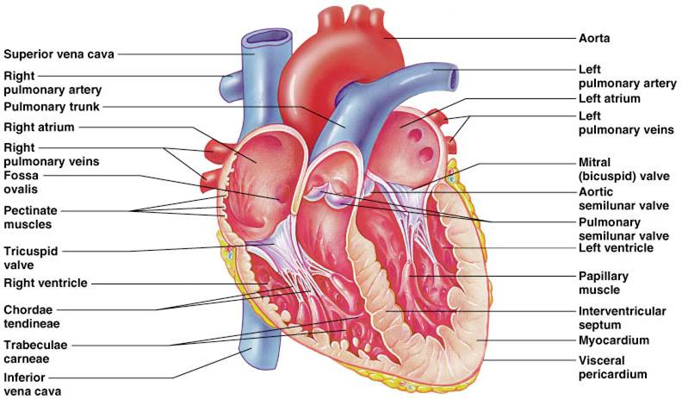

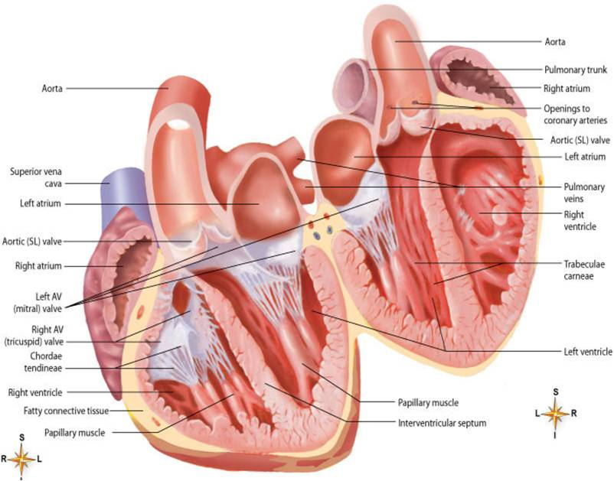
Heart Chambers
- Heart is divided into four cavities with the right and left chambers separated by the septum
- Atria of the Heart - Receiving Vessels
  - Superior chambers
  - Are the receiving chambers of the heart
  - Atria alternately contract and relax to receive blood and then push it into ventricles
  - Only a minimal contraction is needed to push the blood “downstairs” to the ventricles.
  - Each atrium has a protruding auricle
  - Blood enters right atria from superior and inferior venae cavae and coronary sinus
  - Blood enters left atria from pulmonary veins
- Ventricles of the Heart - Discharging Chambers
  - Inferior chambers
  - Ventricles are the discharging chambers of the heart – The actual heart pumps
  - The ventricles make up most of the volume of the heart
  - Right ventricle pumps blood into the pulmonary trunk
  - Left ventricle pumps blood into the aorta

Heart Valves
- Heart valves ensure unidirectional blood flow through the heart
- Atrioventricular (AV) valves lie between the atria and the ventricles
  - Tricuspid and bicuspid
- Semilunar valve lies between the ventricles and the great vessels
  - Aortic and pulmonary

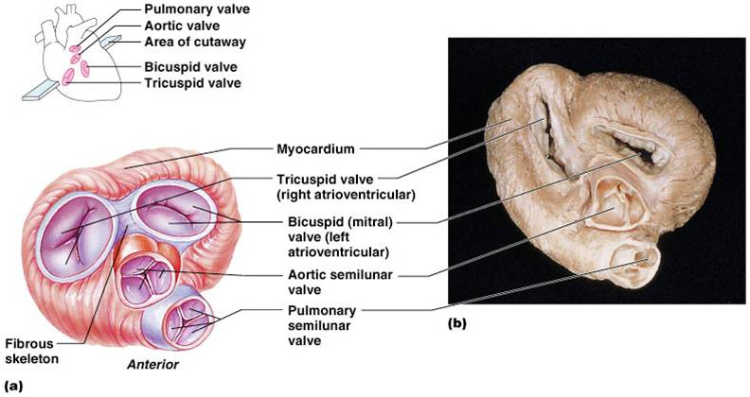

Atrioventricular (AV) Valves
- Atrioventricular (AV) valves: prevent blood from flowing back into the atria from the ventricles when the ventricles contract
  - Tricuspid valve (right AV valve): guards the right atrioventricular orifice; free edges of three flaps of endocardium are attached to papillary muscles by chordae tendineae
  - Bicuspid, or mitral, valve (left AV valve): similar in structure to tricuspid valve except has only two flaps

Semilunar (SL) Valves
- Semilunar valves: half-moon–shaped flaps growing out from the lining of the pulmonary artery and aorta; prevent blood from flowing back into the ventricles from the aorta and pulmonary artery
  - Pulmonary valve: valve at entrance of the pulmonary artery
  - Aortic valve: valve at entrance of the aorta
- Skeleton of the heart
  - Set of connected rings that serve as a semirigid support for the heart valves and the attachment of cardiac muscle of the myocardium
  - Serves as an electrical barrier between the myocardium of the atria and that of the ventricles

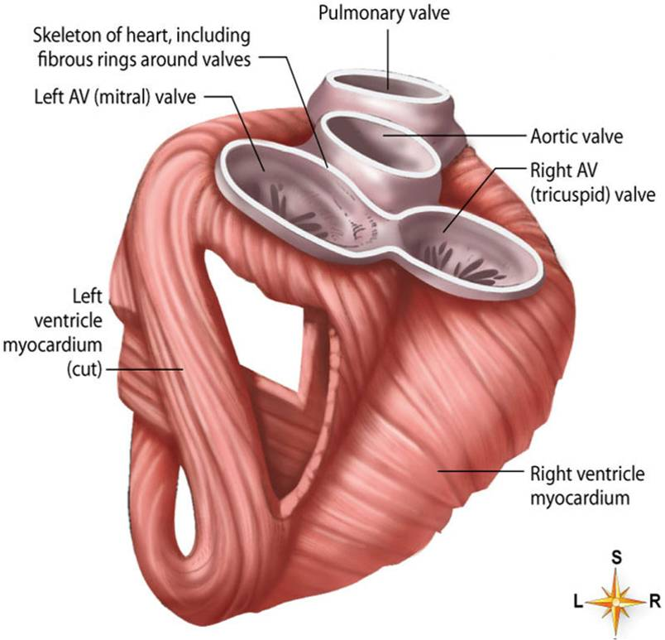

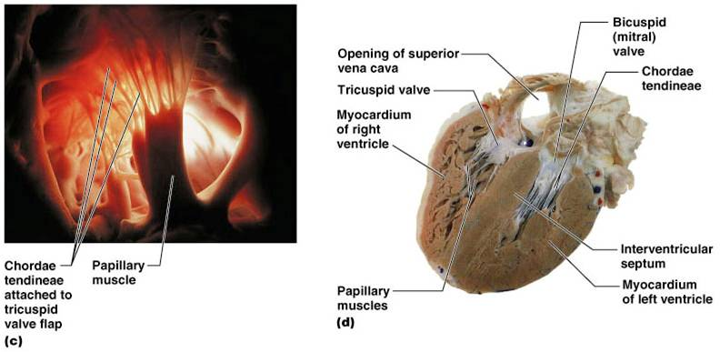Coronary Circulation
- Coronary circulation is the functional blood supply to the heart muscle itself
- Collateral routes ensure blood delivery to heart even if major vessels are occluded
- Angina pectoris – thoracic pain caused by blood deficiency to the heart
- MI is caused by prolonged blockage
- Blockage of the coronary artery can be fatal

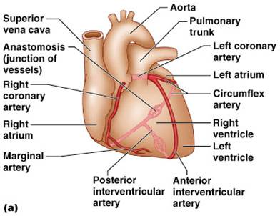
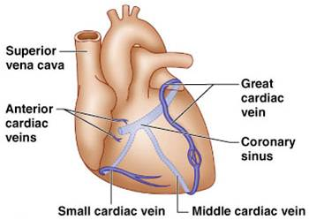
Blood supply of heart tissue
- Coronary arteries: Myocardial cells receive blood from the right and left coronary arteries
- Veins of Coronary Circulation : As a rule, veins follow a course that closely parallels that of coronary arteries

Nerve Supply of the Heart
- Conduction system of the heart: composed of modified cardiac muscle, it generates and distributes the heart’s own rhythmic contractions; can be regulated by afferent nerves
- Most fibers end in the SA node, but some end in the AV node and in the atrial myocardium; the nodes are the heart’s pacemakers
- Sympathetic nerves: accelerator nerves
- Vagus fibers: inhibitory, or depressor, nerves
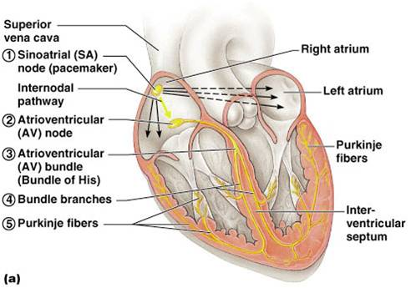
Blood Vessels
- Blood is carried in a closed system of vessels that begins and ends at the heart
- The three major types of vessels are arteries, capillaries, and veins
- Arteries carry blood away from the heart, veins carry blood toward the heart
- Capillaries contact tissue cells and directly serve cellular needs

Generalized Structure of Blood Vessels
- Layers
  - Tunica externa: found in arteries and veins (tunica adventitia)
  - Tunica media: found in arteries and veins
  - Tunica intima: found in all blood vessels
    - Lining endothelial cells
      - Only lining found in capillary
      - Line entire vascular tree
      - Provide a smooth luminal surface; protect against intravascular coagulation
- Lumen – central blood-containing space surrounded by tunics
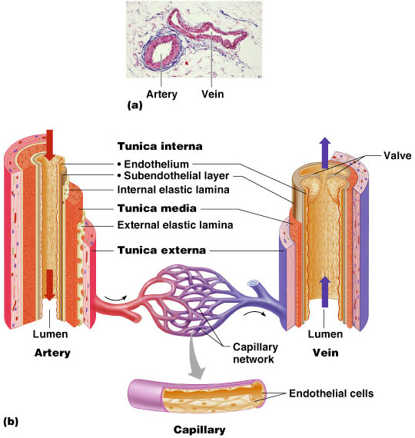
Blood vessels
- Collagen fibers
  - Exhibit woven appearance
  - Have only a limited ability to stretch (2% to 3%) under physiological conditions
  - Strengthen and keep lumen of vessel open
- Elastic fibers
  - Form highly elastic networks
  - Fibers can stretch more than 100% under physiological conditions
  - Play important role in creating passive tension to help regulate blood pressure throughout the cardiac cycle
- Smooth muscle fibers
  - Most numerous in elastic and muscular arteries
  - Exert active tension in vessels when contracting
Capillaries are the smallest blood vessels
- Capillaries
  - Primary exchange vessels
  - Microscopic vessels
  - Carry blood from arterioles to venules; together, arterioles, capillaries, and venules constitute the microcirculation
  - Not evenly distributed; highest numbers in tissues with high metabolic rate; may be absent in some “avascular” tissues, such as cartilage
  - Walls consisting of a thin tunica interna, one cell thick
  - Allow only a single RBC to pass at a time

Capillary Beds
- A microcirculation of interwoven networks of capillaries.
- Precapillary sphincters control blood flow through the capillary beds
  - Cuff of smooth muscle that surrounds each true capillary
  - Regulates blood flow into the capillary
- Blood flow is regulated by vasomotor nerves and local chemical conditions, so it can either bypass or flood the capillary bed

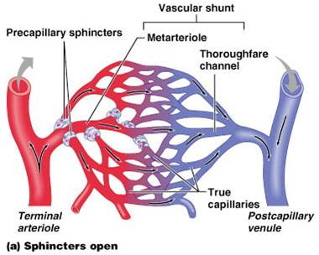

Venous System: Veins
- Veins are capacitance vessels (blood reservoirs) that contain 65% of the blood supply
- Veins have much lower blood pressure and thinner walls than arteries
- To return blood to the heart, veins have special adaptations
  - Large-diameter lumens, which offer little resistance to flow
  - Valves which prevent backflow of blood
- Varicose veins
  - Varicose veins are veins that are tortuous and dilated because of leaky valves
  - 15% of adult population
  - Heredity, prolonged standing, obesity, pregnancy

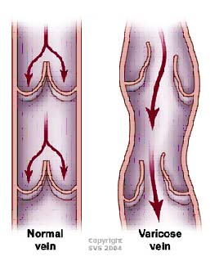

Circulatory Pathways
- The vascular system has two distinct circulations
  - Pulmonary circulation – short loop that runs from the heart to the lungs and back to the heart
  - Systemic circulation – routes blood through a long loop to all parts of the body and returns to the heart

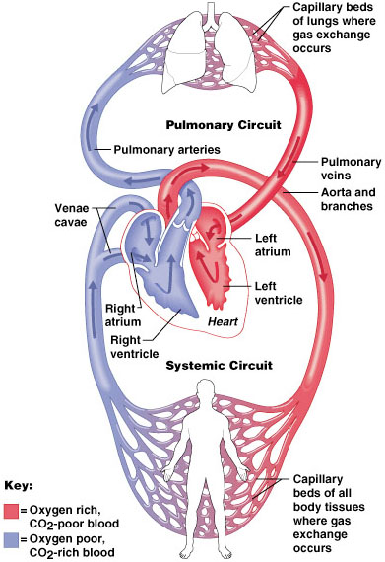
Circulatory routes
- Systemic circulation: blood flows from the left ventricle of the heart through blood vessels to all parts of the body (except gas exchange tissues of lungs) and back to the right atrium
- Pulmonary circulation: venous blood moves from right atrium to right ventricle to pulmonary artery to lung arterioles and capillaries, where gases are exchanged; oxygenated blood returns to left atrium by pulmonary veins; from left atrium, blood enters the left ventricle
- Systemic arteries
  - Main arteries give off branches, which continue to rebranch, forming arterioles and then capillaries
  - End arteries: arteries that eventually diverge into capillaries
  - Arterial anastomoses: arteries that open into other branches of the same or other arteries; incidence of arterial anastomoses increases as distance from the heart increases
  - Arteriovenous anastomoses, or shunts, occur when blood flows from an artery directly into a vein

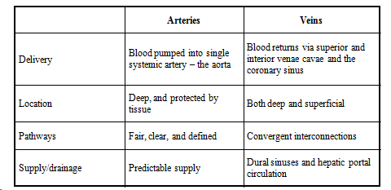

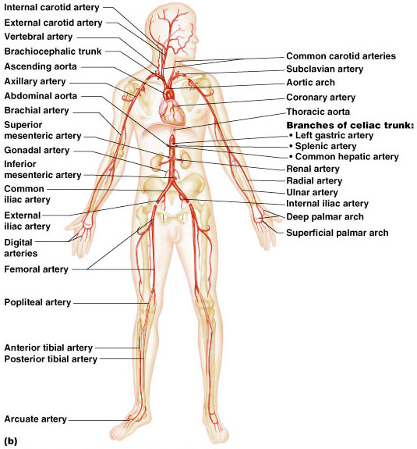
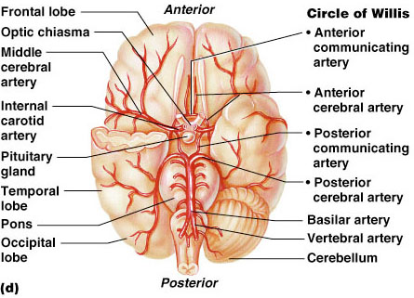

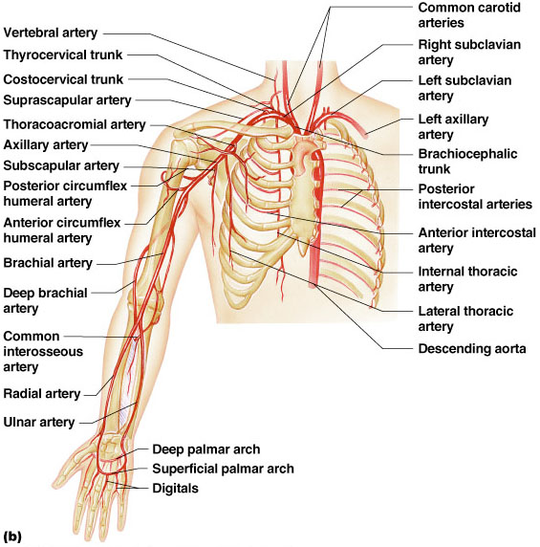

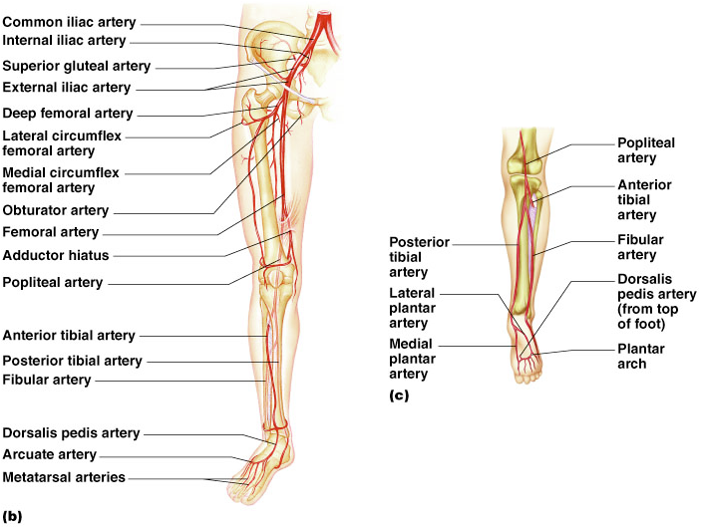
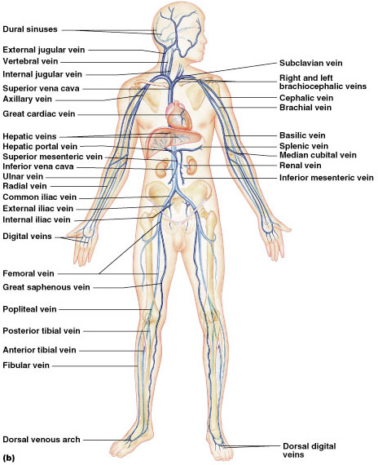

Fetal Circulation
- Placenta: where exchange of oxygen and other substances between the separate maternal and fetal blood occurs; attached to uterine wall
- Umbilical vein: returns oxygenated blood from the placenta to the fetus
- Ductus venosus: continuation of the umbilical vein; drains into inferior vena cava
- Foramen ovale: opening in septum between the right and left atria
- Ductus arteriosus: small vessel connecting the pulmonary artery with the descending thoracic aorta

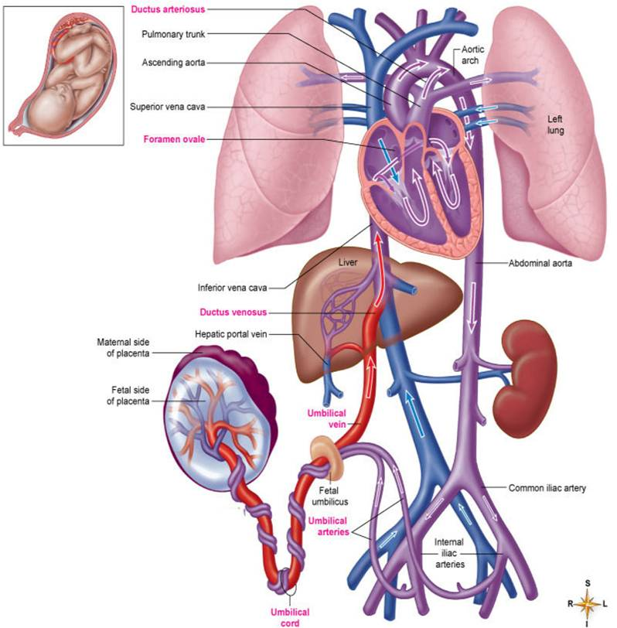
Cycle of Life : Cardiovascular Anatomy
- Birth: change from placenta-dependent system
- Heart and blood vessels maintain basic structure and function from childhood through adulthood
- Exercise thickens myocardium and increases the supply of blood vessels in skeletal muscle tissue
- Adulthood through later adulthood: degenerative changes
- Atherosclerosis: blockage or weakening of critical arteries
- Heart valves and myocardial tissue degenerate, reducing pumping efficiency

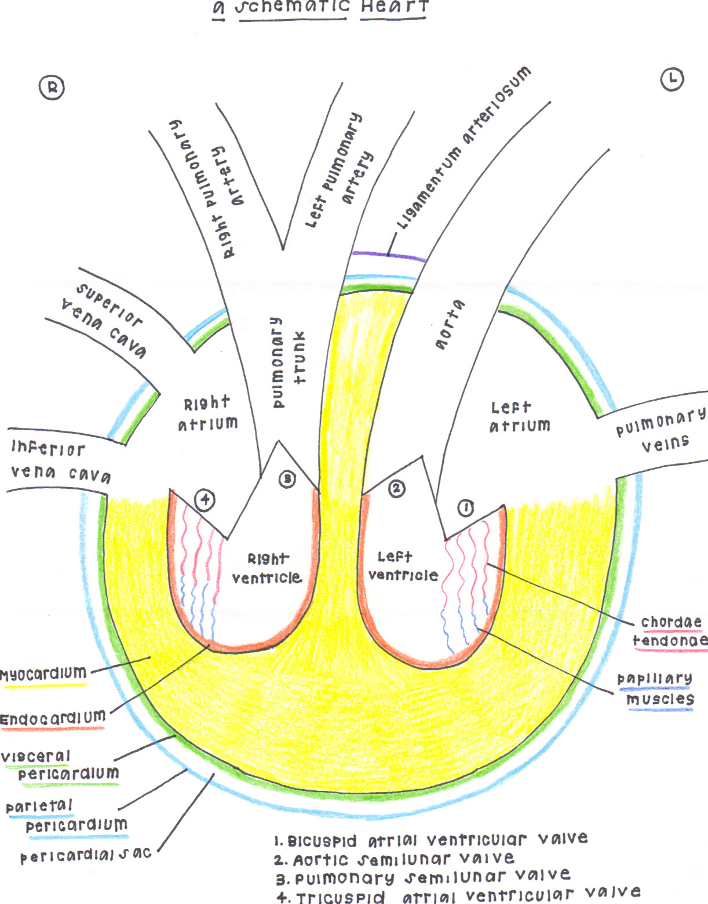

By Kyla Kern – OTA Student

