Cardiac Physiology
Dr. Gary Mumaugh

Introduction
- Vital role of the cardiovascular system in maintaining homeostasis depends on the continuous and controlled movement of blood through the capillaries
- Numerous control mechanisms help regulate and integrate the diverse functions and component parts of the cardiovascular system to supply blood in response to specific body area needs

Cardiac Muscle Contraction
- Heart muscle:
  - Is stimulated by nerves and is self-excitable (automaticity)
  - Sympathetic increases heart rate
  - Parasympathetic decreases heart rate
  - Contracts as a unit
- Cardiac muscle contraction is similar to skeletal muscle contraction

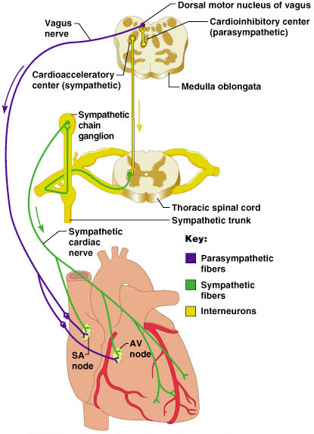
Extrinsic Innervation of the Heart
- Heart is stimulated by the sympathetic cardioaccelerator center
- Heart is inhibited by the parasympathetic cardioinhibitory center

Heart Physiology: Sequence of Excitation
- Sinoatrial (SA) node generates impulses about 75 times/minute
- Atrioventricular (AV) node delays the impulse approximately 0.1 second
- Impulse passes from atria to ventricles via the atrioventricular bundle (bundle of His)
- Heart Block - the only route for impulse transmission from the atria to the ventricles is through the AV node, and damage to the AV node is called heart block

Defects in the Intrinsic Conduction System
- Arrhythmias
  - Irregular heart rhythms
  - Uncoordinated atrial and ventricular contractions
- Fibrillation
  - A condition of rapid and irregular or out of phase contractions
  - The heart rhythm is taken away from the SA node by fast activity in other heart regions

Heart Physiology: Sequence of Excitation
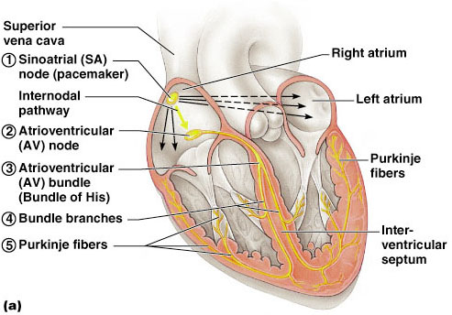

Electrocardiogram (ECG)
- Graphic record of the heart’s electrical activity, its conduction of impulses
- A record of the electrical events that precede the contractions of the heart
- Producing an ECG
- Electrodes of an electrocardiograph are attached to the subject
- Changes in voltage are recorded that represent changes in the heart’s electrical activity

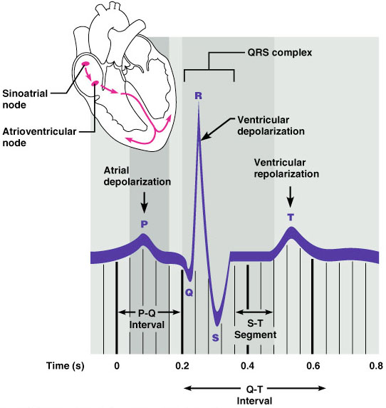
Cardiac Cycle
- Cardiac cycle: a complete heartbeat consisting of contraction (systole) and relaxation (diastole) of both atria and both ventricles
- When the heart muscle contracts (pushes in) it is called systole
- When the heart muscle relaxes (stops pushing in), this is called diastole
- Both atria do systole together
- Both ventricles do systole together
- But the atria do systole before the ventricles
- Even though the atrial systole comes before ventricular systole, all four chambers do diastole at the same time
  - This is called cardiac diastole
- The order is: atrial systole > ventricular systole >cardiac diastole
- When this happens one time, it is called a cardiac cycle

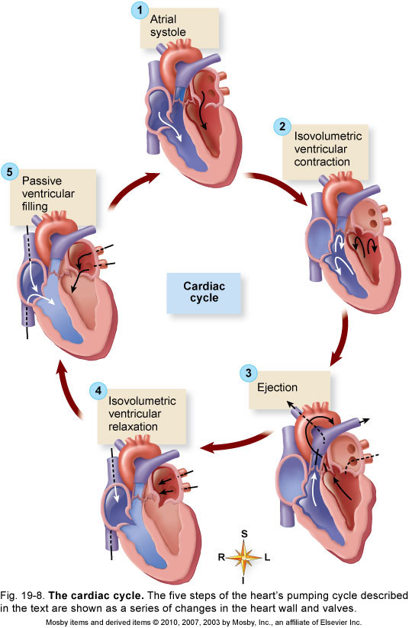
Heart Sounds
- Heart sounds (lub-dup) are associated with closing of heart valves
  - First sound occurs as AV valves close and signifies beginning of systole (start of the heart contraction)
  - Second sound occurs when SL valves close at the beginning of ventricular diastole (relaxation of the heart muscle)
  - Clinically significant because they provide information about the functioning of the heart valves
Heart Murmurs
- Abnormal heart sounds are called murmurs
- Blood flows silently as long as the flow is smooth and interrupted
- If there is an obstruction, the flow becomes turbulent and generates a detectable sound
- Common in young children and some elderly
  - Probably because the heart walls are thinner and vibrate more

Arterial Blood Pressure
- Primary determinant of arterial blood pressure is the volume of blood in the arteries
- A direct relation exists between arterial blood volume and arterial pressure
- Cardiac output (CO) is the amount of blood pumped by each ventricle in one minute
- CO is the product of heart rate (HR) and stroke volume (SV) – Normal adult volume is 5L/min
- Heart rate (HR) is the number of heart beats per minute
- Stroke volume (SV) is the amount of blood pumped out by a ventricle with each beat

Starling’s Law of the Heart
- States that the force of contraction depends on the length of muscle fibers of the heart wall
- The greater the stretch of cardiac muscle, the greater the force of contraction
- This means that when there is an unusual increase in volume of blood entering the heart, the ventricular wall stretches causing the cardiac muscle to contract more forcefully
- Since there is an increase of the load experienced by each muscle fiber the result is greater heart contraction and beat

Factors That Affect Heart Rate
- Cardiac pressor receptors
  - Aortic baroreceptors & carotid baroreceptors affect the autonomic cardiac control center
- Other factors
  - Anxiety, fear, and anger often increase heart rate
  - Exercise normally increases heart rate
  - Grief tends to decrease heart rate
  - Emotions produce changes in heart rate
  - Increased blood temperature or stimulation of skin heat receptors increases heart rate
  - Decreased blood temperature or stimulation of skin cold receptors decreases heart rate
- Peripheral resistance
  - Resistance to blood flow imposed by the force of friction between blood and the walls of its vessels
  - Factors that influence peripheral resistance
    - Blood viscosity: the thickness of blood as a fluid
      - High hematocrit (percentage of red blood cells) can increase blood viscosity
      - Anemia, hemorrhage, or other abnormal conditions may also affect blood viscosity
    - Diameter of arterioles
      - Muscles in walls of arteriole may constrict
      - Small changes in blood vessel diameter

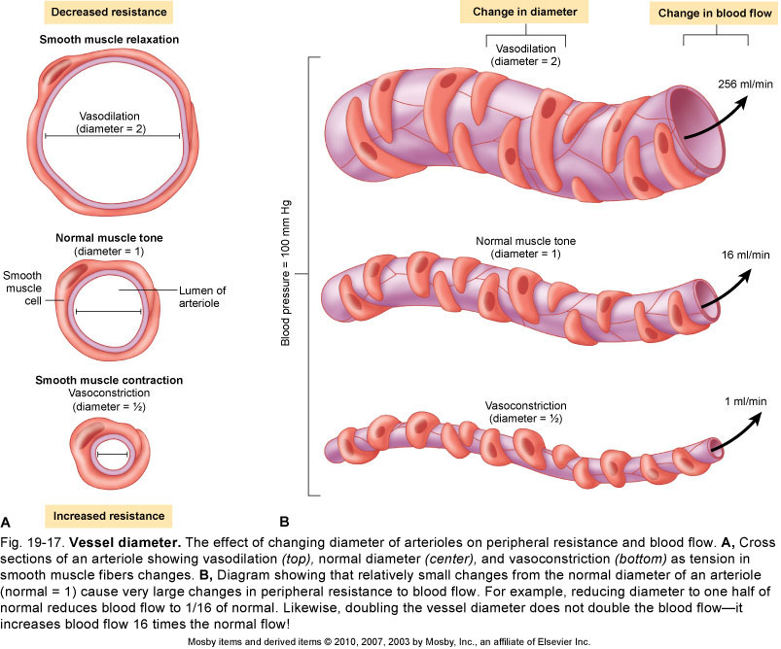
Arterial Blood Pressure
- Systolic pressure – pressure exerted on arterial walls during ventricular contraction
- Diastolic pressure – lowest level of arterial pressure during a ventricular cycle
- Pulse pressure – the difference between systolic and diastolic pressure

Capillary Blood Pressure
- Capillary BP ranges from 20 to 40 mm Hg
- Low capillary pressure is desirable because high BP would rupture fragile, thin-walled capillaries
- Low BP is sufficient to force filtrate out into interstitial space and distribute nutrients, gases, and hormones between blood and tissues

Maintaining Blood Pressure
- Maintaining blood pressure requires:
  - Cooperation of the heart, blood vessels, and kidneys
- Supervision of the brain
- The main factors influencing blood pressure are:
  - Cardiac output (CO)
  - Peripheral resistance (PR)
  - Blood volume

Venous Return to the Heart
- Venous return: amount of blood returned to the heart by the veins
- Gravity: the pull of gravity on venous blood while sitting or standing tends to cause a decrease in venous return (orthostatic effect)
- Venous pumps: blood-pumping action of respirations and skeletal muscle contractions facilitate venous return by increasing pressure gradient between peripheral veins and venae cavae
- Three main mechanisms of venous return to the heart:
  - Respiratory pump mechanism- pressure changes occur in the thoracic and abdominal cavities during inspiration and expiration. This compresses veins and assists blood return to the heart.
  - Skeletal muscle contractions: promote venous return by squeezing veins through a contracting muscle and milking the blood toward the heart
  - One-way valves in veins prevent backflow

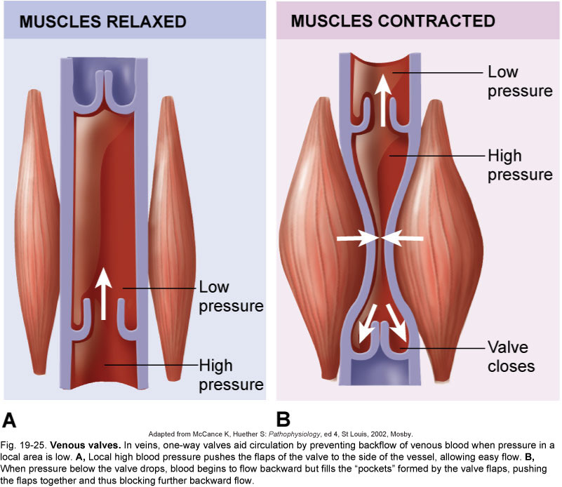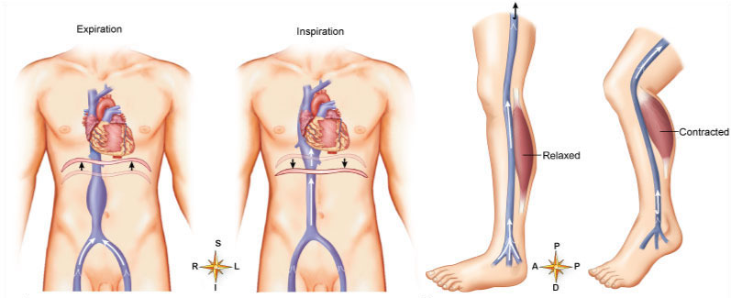
Localized Blood Flow
- Blood flow to skeletal muscle
  - When muscles become active, hyperemia is directly proportional to greater metabolic activity of the muscle (active or exercise hyperemia)
  - Muscle blood flow can increase tenfold or more during physical activity as vasodilation occurs
- Blood flow to skin
  - Helps maintain body temperature
  - Provides a blood reservoir
- Blood flow to the brain
  - Is constant, as neurons are intolerant of ischemia
  - Brain is extremely sensitive to declines in pH
  - The brain can regulate its own blood flow in certain circumstances, such as ischemia caused by a tumor
  - The brain is vulnerable under extreme systemic pressure changes
    - MAP below 60mm Hg can cause syncope (fainting)
    - MAP above 160 can result in cerebral edema
- Blood flow to the lungs
  - Blood flow in the pulmonary circulation is unusual in that:
    - The pathway is short
    - Arteries/arterioles are more like veins/venules (thin-walled, with large lumens)

Measuring Blood Pressure
- Arterial blood pressure
  - Measured with a sphygmomanometer and stethoscope; listen for Korotkoff sounds as the pressure in the cuff is gradually decreased
  - Systolic blood pressure: force of the blood pushing against the artery walls while ventricles are contracting
  - Diastolic blood pressure: force of the blood pushing against the artery walls when ventricles are relaxed
  - Pulse pressure: difference between systolic and diastolic blood pressure
- The first sound heard is recorded as the systolic pressure
- The pressure when sound disappears is recorded as the diastolic pressure

Variations in Blood Pressure
- Blood pressure cycles over a 24-hour period
- BP peaks in the morning due to waxing and waning levels of retinoic acid
- Extrinsic factors such as age, sex, weight, race, mood, posture, socioeconomic status, and physical activity may also cause BP to vary
- Alterations in Blood Pressure
  - Hypotension – low BP in which systolic pressure is below 100 mm Hg
  - Hypertension – condition of sustained elevated arterial pressure of 140/90 or higher

Hypertension
- Hypertension maybe transient or persistent
- Primary or essential hypertension – risk factors in primary hypertension include diet, obesity, age, race, heredity, stress, and smoking
- Secondary hypertension – due to identifiable disorders, including excessive renin secretion, arteriosclerosis, and endocrine disorders

Developmental Aspects
- Blood vessels are trouble-free during youth
- Vessel formation occurs:
  - As needed to support body growth
  - For wound healing
  - To rebuild vessels lost during menstrual cycles
- With aging, varicose veins, atherosclerosis, and increased blood pressure may arise

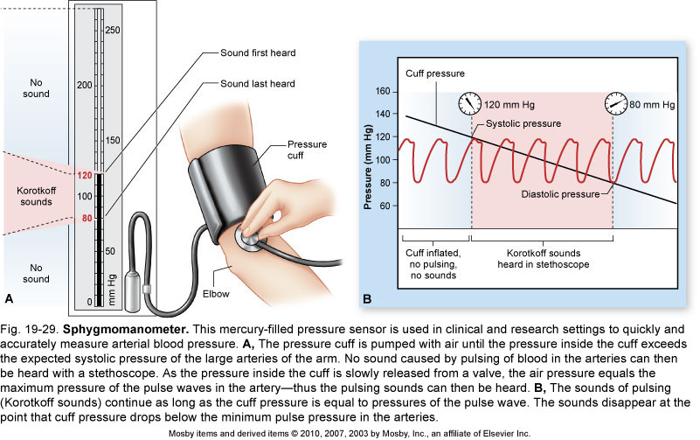
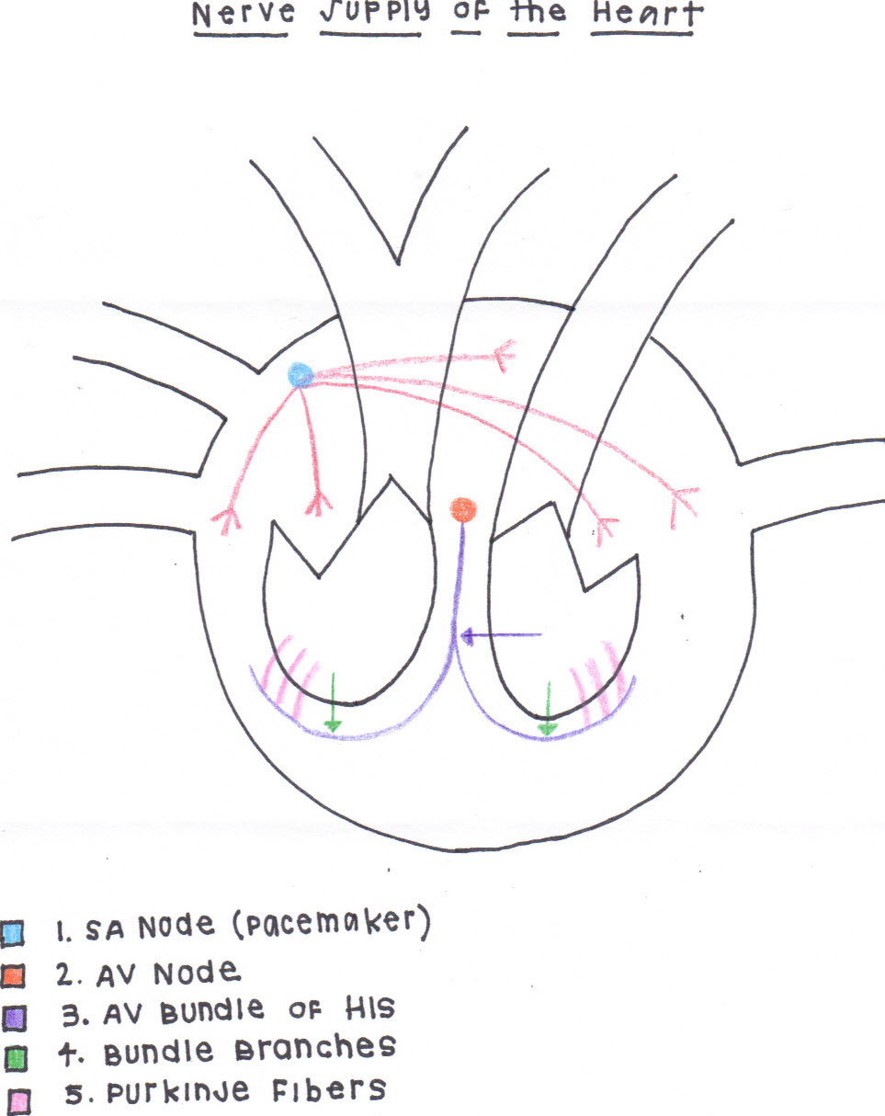

By Kyla Kern – OTA Student

