Clinical Cardiac A & P
Dr. Gary Mumaugh

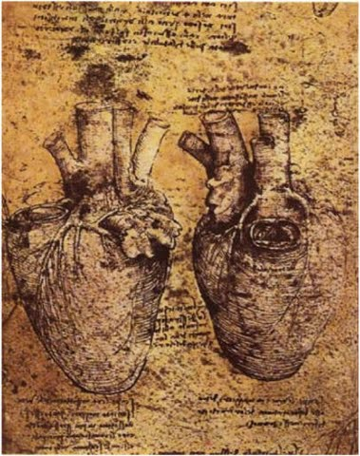
Coronary Artery Disease
- Pathophysiology
  - Atherosclerotic disease and coronary artery disease accounts for 45% of all USA deaths
  - 50% of female deaths are cardiovascular
  - Etiology includes the presence of plaques lining the coronary arteries with plaque rupture and coronary artery spasm
  - Result is ischemia, angina or MI, cell death and or electrical dysfunction
  - 3 Elements of atherogenesis is plaque formation, plaque rupture, vasoregulation creating atherosclerotic disease

- CAD risk factors
  - Older age
- Family history
- Socioeconomic factors
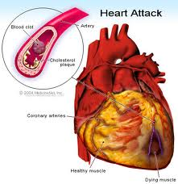
- Overweight with trunk fat depostition
- Blood pressure
- Smoking
- Personality and psychological factors
- Glycemic control
- Increased LDL and triglycerides
- Poor dental hygeine
- Chronic infections
- With several risk factors the risk could be up to 20X

- Preventative therapy to reduce heart attacks
  - Specific therapy for those with pre-clinical CAD
    - Lovastatin and strict diet control
    - Proper diabetic control
    - Antihypertensives
    - Folic acid for high homocysteine
    - Temporary antibiotics
    - Maintenance of good oral hygiene
  - General therapy for all adults
    - Low dose ASA
    - Smoking cessation & stress management
    - Folic acid, Vitamin C and E, omega-3 fatty acids
    - Increasing aerobic exercise

Coronary Artery Occlusion with MI
- Incidence
  - 1,100,000 American had MI, with 650,000 being the first attack and 450,000 instant deaths

- S & S
  - Crushing chest pain with diaphoresis, dyspnea, weakness, palpitations, vomiting

- Diagnosis
  - Patient presentation with ECG and blood tests

- Treatment
  - Admission to CCU has best survival
  - Oxygen, beta blockers, heparin, tPa
  - Pacemaker insertion or CABG surgery

- Famous Cardiac Caveats
  - In all men or older women with acute physical distress of any kind, always think, “Is this a myocardial infarction?”
  - When a young man complains of pain in his heart, it is usually his stomach. When an old man complains of pain in his stomach, it is usually his heart.
  - Such thought has saved thousands of lives

Hypertension
- Up to 50 million in the USA
- 95% diagnosed as essential
  - Essential means preventable or likely due to diet, obesity, inactivity, stress and alcohol

- Conventional treatment with lifestyle modifications work well with integrative care
  - According to the 6th Joints Commission of Hypertension, even with a BP of 140/90, the main intervention is lifestyle intervention before starting medication.
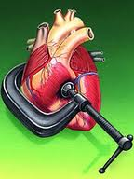
  - This includes weight loss, decrease sodium and alcohol and moderate exercise for one year before starting medication.

- Causes of essential hypertension
  - Heredity
  - Obesity
  - Salt intake
  - Stress
  - Alcohol

- Three diagnostic components of essential HTN
  - Careful history, family history, organ system review, lifestyle evaluation
  - Thorough physical examination
  - Lab studies
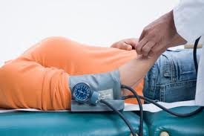
- Treatment of essential HTN
  - Lifestyle changes
    - Weight, exercise, smoking, salt restriction, stress reduction, DASH diet
  - Medication (only after lifestyle modification)
    - Diuretics
    - Calcium channel blockers
    - ACE inhibitors
    - Alpha blockers
    - Beta-blockers
    - Angiotensin II receptor blockers

- Causes of secondary hypertension
  - “white coat hypertension”
  - Medical noncompliance
  - Exogenous drug usage
    - Oral contraceptives, weight control drugs, NSAIDs, steroids, sympathomimetic cold remedies
  - Renal disease
  - Aldosteronism
  - Endocrine diseases
  - Sleep apnea
  - Congenital stenosis of the aorta

- Treatment of secondary HTN
  - Remove the cause and the HTN is gone
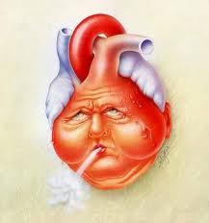
Congestive Heart Failure
- CHF Incidence
  - In the USA, 3 million hospitalizations per year
  - 30-40% are readmitted with six months
  - 4-5 millions current cases
  - 500,000 – 600,000 new cases per year
  - 250,000 deaths per year
  - Half of all CHF diagnosis die within 5 years
    - 10% die in year one
  - Twice as common in African-Americans
  - USA yearly treatment cost - $21 billion

- Causes of CHF
  - Coronary artery disease
  - Hypertension
  - Aortic stenosis and insufficiency
  - Mitral regurgitation
  - Atrial fibrillation, flutter or tachycardia
  - Viral myocarditis
  - Septicemia
  - Hyperthyroidism or hypothyroidism
  - Alcohol abuse
  - Chemotherapy
  - Congenital or rheumatic heart disease
  - Chagas’ disease – parasitic heart infection

- Pathophysiology of CHF
  - The pumping action of the heart becomes less and less powerful
  - Despite its misleading name, in heart failure the heart doesn't suddenly stop working
  - Heart failure develops slowly as the heart muscle gradually weakens
  - The "failure" refers to the heart's inability to pump enough blood.
  - Blood and fluid do not move efficiently through the circulatory system, and starts to "back up“
  - Eventually, parts of your body (lungs, abdomen, and lower limbs) hold blood and fluid that your heart isn't circulating very well
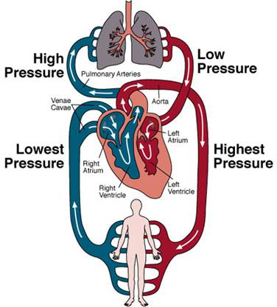
  - This is called "becoming congested," and is why this condition is called "congestive heart failure"

- Left sided vs. Right sided Heart Failure
  - Can involve the heart's left side, right side or both sides, though CHF much more affects the left heart
  - Left-sided heart failure
    - Fluid collects in the lungs - this extra fluid in the lungs ("congestion") makes it more difficult for the airways to expand as you inhale
    - Presents with dyspnea, pulmonary edema, and orthopnea
  - Right-sided heart failure
    - Due to failure of the right ventricle
    - Fluid collects in other body tissues especially the lower extremities – pitting edema, liver enlargement

Left Sided Congestive Heart Failure
- LVF will eventually lead to RVF and vice versa
- Because the Stroke Volume (SV) is weak, all of the blood is NOT pumped out of the ventricle
- This causes a backward damming of blood into the lungs which reduces the volume of blood which pass through the lungs
- This causes less blood being able to enter the lungs and an increase of pulmonary pressure which leads to increased right ventricular workload and eventually hypertrophy

Right Sided Congestive Heart Failure

- RVF will eventually lead to LVF and vice versa
- Because the Stroke Volume (SV) of the ventricle is weak, all of the blood is NOT pumped out of the ventricle
- This causes a backward damming of the blood into the superior and inferior vena cava causing congestion of the venous system
- In essence the heart is a “bottle neck” of the circulatory system
- If the backward damming is in the SVC, there will be distention of the neck veins
- If the backward damming is in the IVC, there will be congestion of the major organs with blood affecting the liver, spleen, guts, GI tract, kidneys and legs

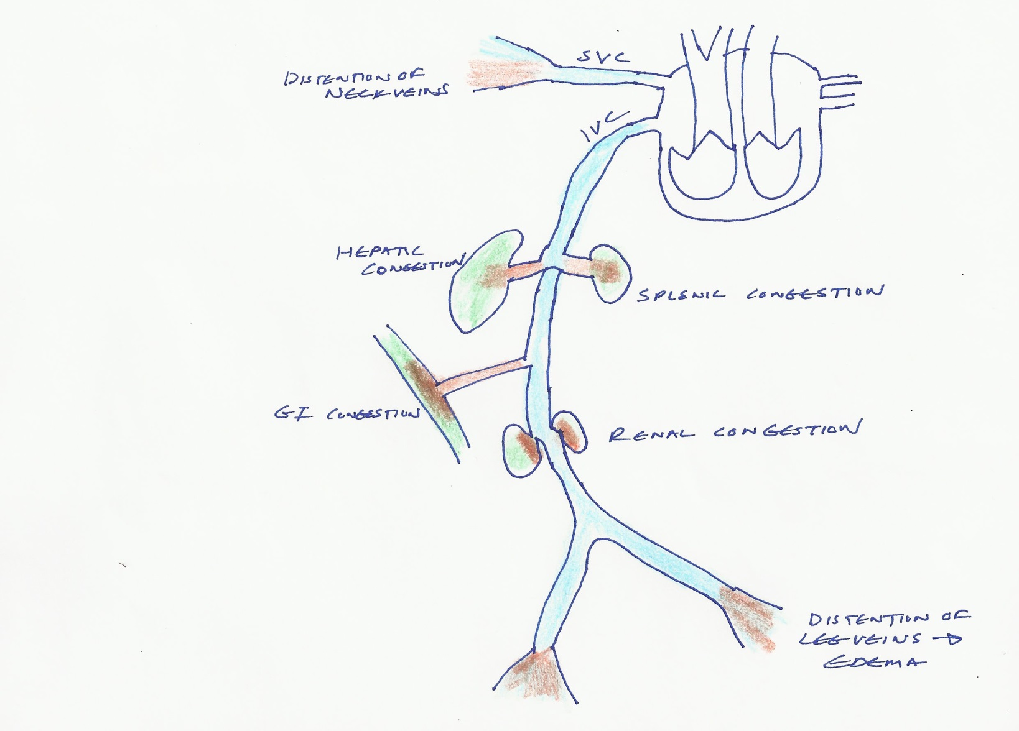

- CHF Symptoms
  - Three cardinal symptoms are dyspnea, fatigue and fluid retention
  - Sudden weight gain, despite loss of appetite
  - Swelling in legs, ankles, feet, or abdomen
  - Tired and short of breath when doing things that are normally easy, such as walking
  - Breathing difficulty when lying flat in bed or may wake up with a choking feeling
    - May need to sleep with your head raised up on several pillows
  - Persistent cough, more at night
  - Less frequent urination during the day
  - Irregular heartbeats, feeling of heart pounding
  - Chest pain, pressure or chest discomfort
  - Loss of appetite
  - Dizziness or lightheadedness, inability to concentrate

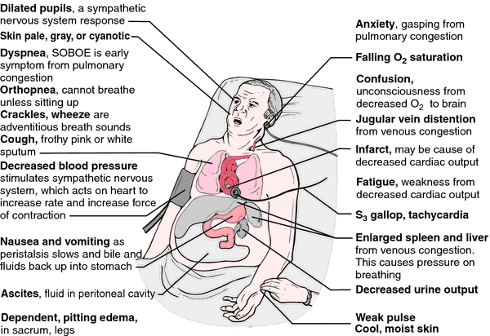

- Four Stages of CHF - New York Heart Association Guidelines
  - Class I (Mild) 35%
    - No limitation of physical activity
    - Ordinary physical activity does not cause symptoms fatigue
  - Class II (Mild) 35%
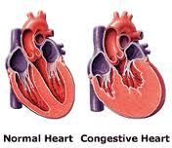
    - Slight limitation of physical activity
    - Comfortable at rest, but ordinary physical activity results in fatigue, palpitation, or dyspnea
  - Class III (Moderate) 25%
    - Marked limitation of physical activity
    - Comfortable at rest, but less than any activity causes fatigue, palpitation, or dyspnea
  - Class IV (Severe) 5%
    - Unable to carry out any physical activity without discomfort
    - Symptoms of cardiac insufficiency at rest
    - If any physical activity is undertaken, discomfort is increased

- CHF Diagnosis
  - Family history
  - Medical history
  - HTN, angina, diabetes, high cholesterol, valve disease, PVD, rheumatic disease, chest radiation
  - Life style
  - Health habits
  - Physical exam
  - Peripheral edema, hepatomegaly, ascites, pallor, tachycardia, jugular venous distension
  - Chest x-ray
  - EKG
  - Echocardiogram
  - Blood work

- CHF treatment
  - Aldosterone antagonists
    - Reduce the stress to the heart
    - Weak diuretic effect
  - Angiotensin converting enzyme (ACE) inhibitors
    - Help reduce the stress on your heart
  - Beta blockers
    - Help decrease the heart’s need for blood and oxygen by reducing its workload
    - Help the heart to beat more regularly
  - Digoxin (Lanoxin®)
    - Help increases the strength of the pumping action
  - Diuretics (water pills)
    - Help reduce the amount of fluid in your body

Extrinsic Innervation of the Heart
- Heart is stimulated by the sympathetic cardioaccelerator center
- Heart is inhibited by the parasympathetic cardioinhibitory center
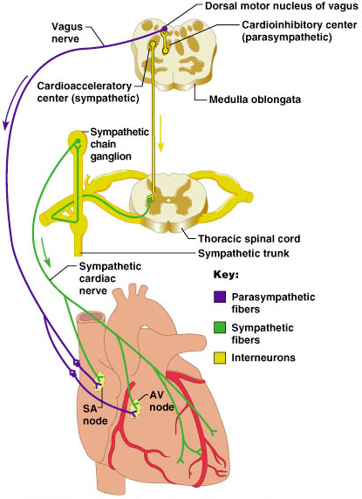
- Heart Physiology: Sequence of Excitation
  - Sinoatrial (SA) node generates impulses about 75 times/minute
  - Atrioventricular (AV) node delays the impulse approximately 0.1 second
  - Impulse passes from atria to ventricles via the atrioventricular bundle (bundle of His)
  - Heart Block - the only route for impulse transmission from the atria to the ventricles is through the AV node, and damage to the AV node is called heart block

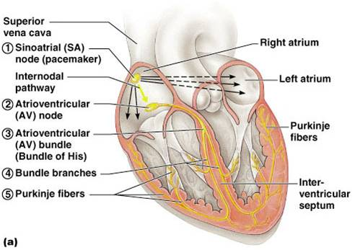

Cardiac Arrhythmias
- Premature atrial contractions (PAC)
  - Seen in normal people with to much caffeine, anxiety, alcohol, electrolytes, vomiting or diarrhea

- Premature ventricular contractions (PVC)
  - Often seen in middle age and of no concern
  - Can also occur with MI, CHF, hypoxia

- Paroxysmal atrial tachycardia (PAT)
  - Usually in women 20-25
  - May be congenital and start in first year of life
    - Called Wolf Parkinson White Syndrome which requires a catheter radio-ablation

Cardiac Arrhythmias - continued

- Atrial fibrillation and flutter (AF)
  - Not life-threatening, yet it is a common cause of hospitilization
  - Causes the heart to be sporadically with no rhythmic pattern
  - May be caused by COPD, alcohol, cardiac surgery, hyperthyroidism, or idiopathic
  - The inefficiency of the atrial contraction leads to a potential buildup of clots in the wall of the atria
  - Treated with electrical cardioversion with anticoagulation meds
  - Some are resistant to cardioversion which puts them at risk for strokes, ventricular fibrillation and sudden death

- Ventricular tachycardia (VT)
  - A normal response to exercise, stress reactions and sexual activity causing the heart to elevate up to 200/minute
  - In patient’s with structural heart disease, VT can occur without provocation
  - S & S – pounding heart and lightheadedness
  - Treated with electrical cardioversion and beta blockers

- Bradycardia
  - Pulse less than 60/min or 46/min for athletes
  - Extrinsic causes by drugs, hypothyroidism, CNS disorders
  - Intrinsic causes by SA or AV node dysfunction
  - Treat the cause, such as a pacemaker

- Heart block
  - Often caused by ischemia due to CAD or may be idiopathic
  - Three degrees possible
    - 1st degree – impulses reach the ventricles and slow in the AV node – no treatment needed
    - 2nd degree – impulse slows so that not all beats get through the ventricle, causing bradycardia – may or may not need a pacemaker
    - 3rd degree (complete) – all impulses from the atria to the ventricles are blocked at the AV node – all need external pacemaker
  - Sick sinus syndrome - a wide variety of alternate bradycardia and tachycardia

Cardiac Valve Disease
- Heart valve malfunction comes in two forms:
  - Valves that do not open well
    - This constricts the flow and is called stenosis
  - Valves that do not close well
    - This causes backwards leakage and is called regurgitation or insufficiency

- Four most common valve problems
  - Mitral regurgitation (insufficiency)
    - In the past, was caused by rheumatic fever
  - Mitral stenosis
    - Caused by rheumatic fever, congenital abnormalities, lupus, or tumor
  - Aortic regurgitation (insufficiency)
    - The 3 cusps leak after contraction
    - Caused by rheumatic heart disease, congenital defects, endocarditis or degeneration
    - Causes ventricular enlargement
  - Aortic stenosis
    - Most common valve problem in adults
    - Most caused by arteriosclerosis of flaps – normal aging

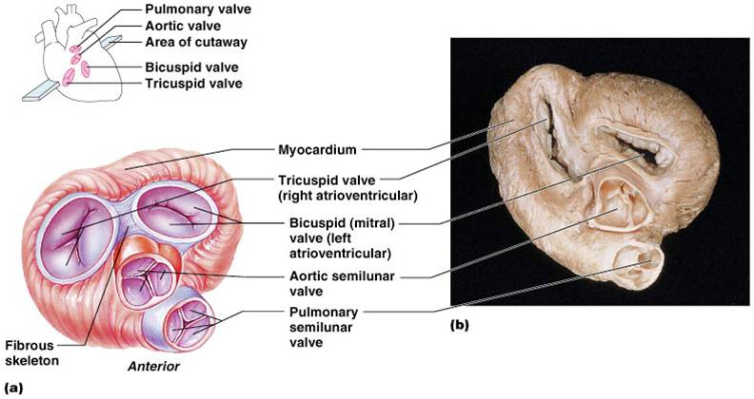

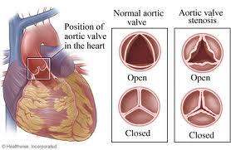

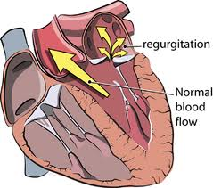

Pericarditis
- Has a triad of chest pain, ECG changes and pericardial friction rub – the patient must have 2 of the 3 to make the diagnosis
- Major causes
  - Viral infections, myocardial infarction, drug side effect, connective tissue disorders, blunt or penetrating trauma

- S & S
  - Chest pain radiating to back or left shoulder
  - Fatigue or dyspnea

- Diagnosis
  - High intensity friction rub and ECHO

- Treatment
  - NSAIDs and steroids
  - Pericardiocentesis to avoid cardiac tamponade from effusion
    - Tamponade is fatal it not relieved
- Prognosis
  - Most resolve in four weeks
  - Some cases become chronic which require surgery to remove the thickened constrictive heart layer

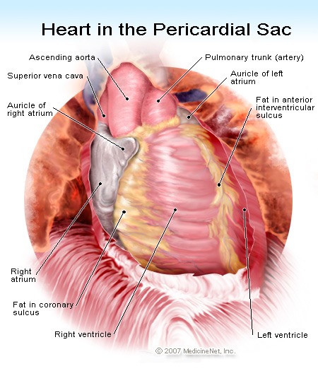
Endocarditis
- Infection of inner heart lining, usually bacterial
  - Can be acute or subacute
  - Usually occur on damaged valves in which the bacteria accumulates and forms blood clots on the valves
    - Bacteria in the bloodstream comes from mouth, dental work, gingivitis, skin infections, medical procedures (Streptococcus, staphlococcus, enterococcus)
  - Heart valve vegetations can and easily embolize throughout the body causing satellite abscesses
  - Diagnosis with ECHO and blood culture
    - Consider in any patient with fever heart murmur
  - Treatment – IV antibiotics and possible valve replacement

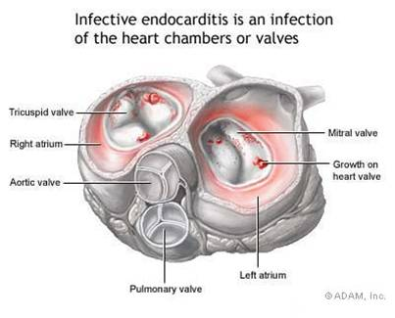

Aortic Artery Disease
- Ruptured aortic aneurysms are responsible for 15,000 deaths per year (half die in surgery)
  - (> 4 cm diameter with normal at 2.5 to 3 cm)
- S & S
  - Often no symptoms when they are small
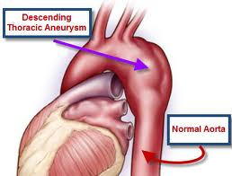
  - When they enlarge, they cause low back pain and powerful abdominal pulse sensation
- Diagnosis
  - Pulsating aneurysm palpated and seen on ultrasound
- Treatment
  - Surgical resection > 5 cm diameter

Peripheral Artery Disease
- Arteriosclerosis
  - Generalized narrowing and stiffening of arteries occurring over 65 years old
- Atherosclerosis
  - The process of plaque formations over the age of 35
  - Plaques build up where vessels split and can lead to strokes, gangrene and heart attacks
  - Very common in diabetes
  - Risk factors
    - Tobacco (3-4X), age, HTN, diabetes, cholesterol, sedentary lifestyle, high homocysteine

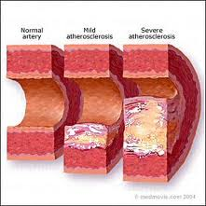

Aortic Artery Disease
- Ruptured aortic aneurysms are responsible for 15,000 deaths per year (half die in surgery)
  - (> 4 cm diameter with normal at 2.5 to 3 cm)
- S & S
  - Blood flow restricted to lower extremities
  - Severe claudication
  - Sharp pain with exercise that stops with lack of movement
- Diagnosis
  - Diminished or absent peripheral pulses
  - Doppler flowmeter changes
  - Ischemic limbs have purple-red color
  - Glove-like distribution of nerve loss
- Treatment
  - Vasodilators
  - Vascular surgery

