The Lymphatic System
Dr. Gary Mumaugh

Lymphatic System: Overview
- Consists of two semi-independent parts
  - A meandering network of lymphatic vessels
  - Lymphoid tissues and organs scattered throughout the body
- Returns interstitial fluid and leaked plasma proteins back to the blood
- Lymph – interstitial fluid once it has entered lymphatic vessels

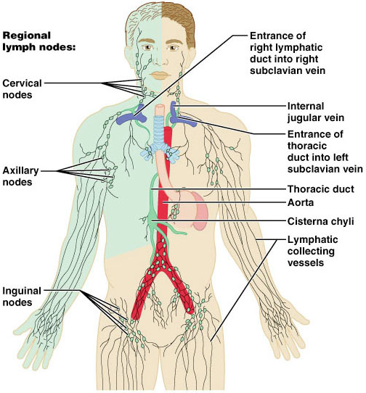
Where is the lymph going?
- As blood circulates through the body, nutrients, wastes and gases are exchanged between the blood and interstitial fluid
  - Interstitial fluid – extracellular fluid derived from blood
- The pressure of the capillary beds force fluid out of the blood
- The fluid that remains behind in the tissue spaces becomes interstitial fluid
  - Up to 3 liters per day
  - Once interstitial fluid enters the lymphatic's, it is called lymph
Lymphatic Vessels
- A one-way system in which lymph flows toward the heart
- Lymph vessels include:
  - Microscopic, permeable, blind-ended capillaries
  - Lymphatic collecting vessels
  - Trunks and ducts

Lymphatic Capillaries
- Similar to blood capillaries, with modifications
  - Remarkably permeable
  - Loosely joined endothelial minivalves
  - The minivalves function as one-way gates
- During inflammation, lymph capillaries can absorb:
  - Cell debris
  - Pathogens
  - Cancer cells
- Cells in the lymph nodes:
  - Cleanse and “examine” this debris
- Lacteals – specialized lymph capillaries present in intestinal mucosa
  - Absorb digested fat and deliver chyle to the blood

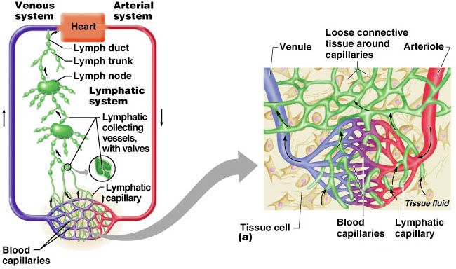

Lymphatic Trunks
- Lymphatic trunks are formed by the union of the largest collecting ducts
- Lymph is delivered into one of two large trunks
  - Right lymphatic duct – drains the right upper arm and the right side of the head and thorax
  - Thoracic duct – arises from the cisterna chyli and drains the rest of the body

Lymph Transport
- The lymphatic system lacks an organ that acts as a pump
- Vessels are low-pressure conduits
- Uses the same methods as veins to propel lymph
  - Pulsations of nearby arteries
  - Contractions of smooth muscle in the walls of the lymphatics
  - Respiratory movements

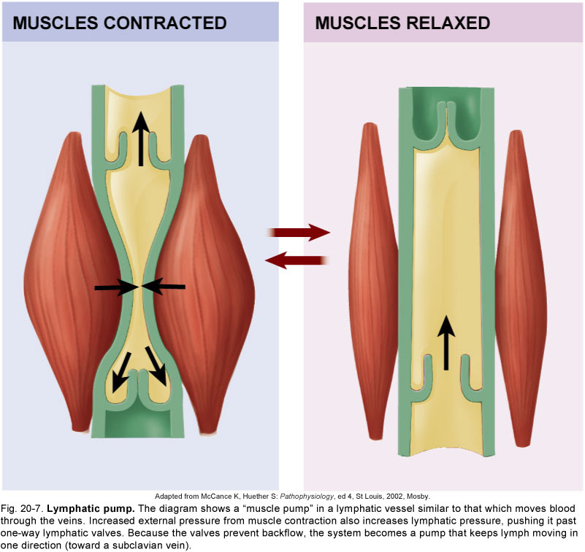
Lymphoid Cells
- Lymphocytes are the main cells involved in the immune response
- Infectious microorganisms manage to penetrate the body are encountered by a fight from the phagocytes and the lymphocytes
- The phagoctyic macrophages are crucial in protection

Lymphoid Tissue
- Lymphoid (lymphatic tissue) is an important component of the immune system, mainly because it
  - Houses and provides a proliferation site for phagocytes
  - Furnishes a great surveillance point for lymphocytes and macrophages

Lymph Nodes
- Lymph nodes are the principal lymphoid organs of the body
- Nodes are imbedded in connective tissue and clustered along lymphatic vessels
- Aggregations of these nodes occur near the body surface in inguinal, axillary, and cervical regions of the body
- Their two basic functions are:
  - Filtration – macrophages destroy microorganisms and debris
  - Immune system activation – monitor for antigens and mount an attack against them

Structure of a Lymph Node

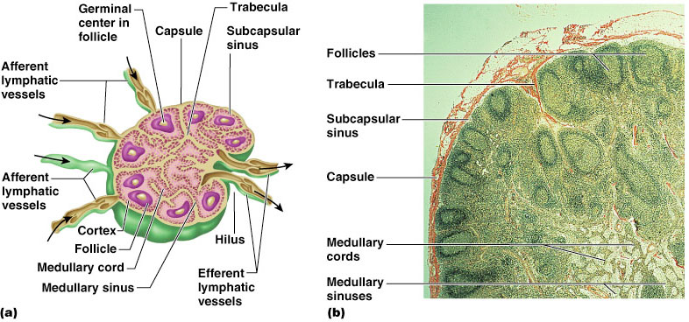

Circulation in the Lymph Nodes
- There are fewer efferent vessels draining the node then afferent vessels feeding it
- Because there are fewer efferent vessels, lymph stagnates and pools somewhat in the node
- This allows lymphocytes and macrophages time to carry out their protective functions
- Nodes often become secondary cancer sites in metastasizing cancers

Other Lymphoid Organs
- The spleen, thymus gland, and tonsils
- Peyer’s patches in the small intestines
- Appendix in the large intestine
- Lymphoid tiisue in the walls of the bronchi
- Lymphatic tissue scattered in connective tissue
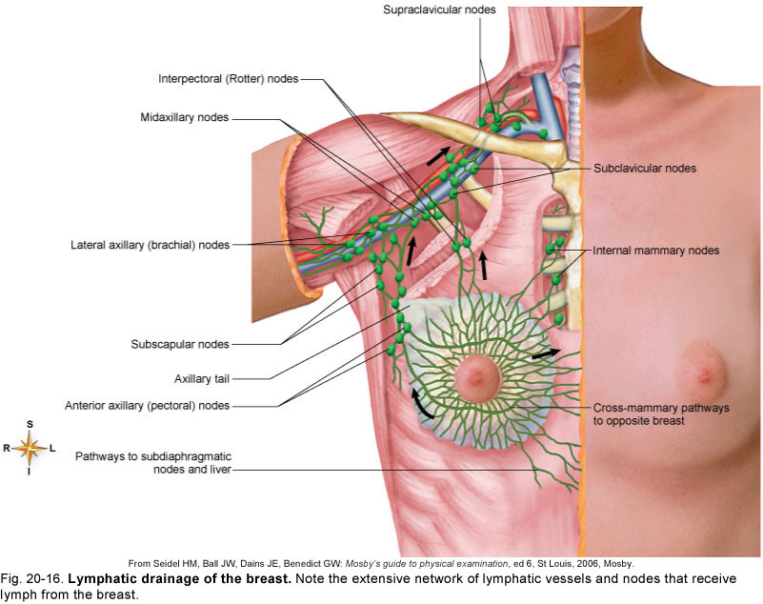
Spleen
- Largest lymphoid organ, located on the left side of the abdominal cavity beneath the diaphragm
- It extends to curl around the anterior aspect of the stomach
- Functions
  - Site of lymphocyte proliferation
  - Immune surveillance and response
  - Contains macrophages
  - Cleanses the blood
  - Produces antibodies
  - Stores platelets
    - Destroys them when they are no longer useful

Spleen Trauma
- Because the spleen capsule is very thin, a direct blow or infection may cause it to rupture. This rupture spills blood into the peritoneal cavity
- In the past, a splenectomy was performed
- Now, the tendency is to let the spleen regenerate
- If the spleen is removed, the liver and bone marrow will attempt to take over most of it’s functions

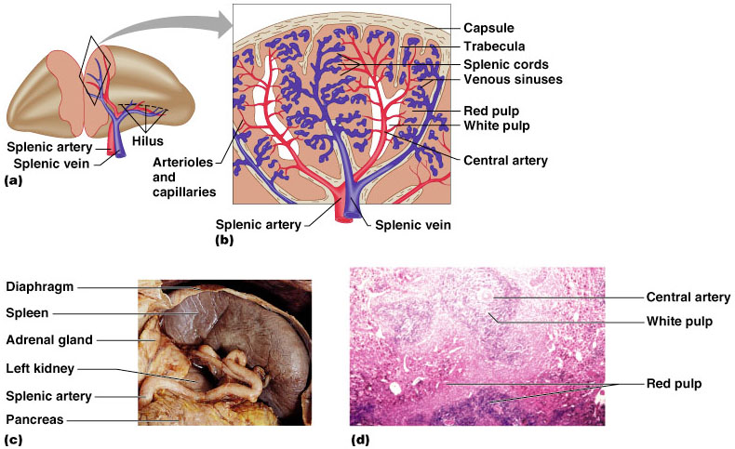

Thymus
- A organ that secrets hormones that cause T lymphocytes to become immunocompetent
- The size of the thymus varies with age
  - In infants, it is found in the inferior neck and extends into the mediastinum where it partially overlies the heart
  - It increases in size and is most active during childhood
  - It stops growing during adolescence and then gradually atrophies

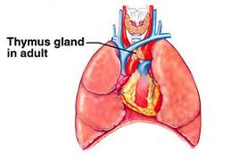

Tonsils
- Simplest lymphoid organs; form a ring of lymphatic tissue around the pharynx
- Location of the tonsils
  - Palatine tonsils – either side of the posterior end of the oral cavity
  - Lingual tonsils – lie at the base of the tongue
  - Pharyngeal tonsil – posterior wall of the nasopharynx
  - Tubal tonsils – surround the openings of the auditory tubes into the pharynx

The Immune System: Innate and Adaptive Body Defenses
Dr. Gary Mumaugh

Immunity: Two Intrinsic Defense Systems
- Nonspecific system responds quickly and consists of:
  - First line of defense – intact skin and mucosae prevent entry of
microorganisms
  - Second line of defense – antimicrobial proteins, phagocytes, and other cells
    - Inhibit spread of invaders throughout the body
    - Inflammation is its hallmark and most important mechanism
- Immunity: Two Intrinsic Defense Systems
- Specific defense system
  - Third line of defense – mounts attack against particular foreign substances
    - Takes longer to react than the innate system
    - Works in conjunction with the innate system

Surface Barriers
- Skin, mucous membranes, and their secretions make up the first line of defense
- Keratin in the skin:
  - Presents a formidable physical barrier to most microorganisms
  - Is resistant to weak acids and bases, bacterial enzymes, and toxins
- Mucosa provide similar mechanical barriers

Epithelial Chemical Barriers
- Epithelial membranes produce protective chemicals that destroy microorganisms
  - Skin acidity (pH of 3 to 5) inhibits bacterial growth
  - Sebum contains chemicals toxic to bacteria
  - Stomach mucosae secrete concentrated HCl and protein-digesting enzymes
  - Saliva and lacrimal fluid contain lysozyme
  - Mucus traps microorganisms that enter the digestive and respiratory systems

Respiratory Tract Mucosae
- Mucus-coated hairs in the nose trap inhaled particles
- Mucosa of the upper respiratory tract is ciliated
  - Cilia sweep dust- and bacteria-laden mucus away from lower respiratory passages

Internal Defenses: Cells and Chemicals
- The body uses nonspecific cellular and chemical devices to protect itself
  - Phagocytes and natural killer (NK) cells
  - Antimicrobial proteins in blood and tissue fluid
  - Inflammatory response enlists macrophages, mast cells, WBCs, and chemicals
- Harmful substances are identified by surface carbohydrates unique to infectious organisms

Phagocytes
- Macrophages are the chief phagocytic cells
- Free macrophages wander throughout a region in search of cellular debris
- Neutrophils become phagocytic when encountering infectious material
- Eosinophils are weakly phagocytic against parasitic worms
- Microbes adhere to the phagocyte

Natural Killer (NK) Cells
- Cells that can lyse and kill cancer cells and virus-infected cells
- Natural killer cells:
  - Are a small, distinct group of large granular lymphocytes
  - React nonspecifically and eliminate cancerous and virus-infected cells
  - Kill their target cells by releasing perforins and other cytolytic chemicals
  - They “police” the blood and lymph and are the “pits bulls” of the defense system

Inflammation: Tissue Response to Injury
- The inflammatory response is triggered whenever body tissues are injured
  - Prevents the spread of damaging agents to nearby tissues
  - Disposes of cell debris and pathogens
  - Sets the stage for repair processes
- The four cardinal signs of acute inflammation are redness, heat, swelling, and pain

Antimicrobial Proteins
- Enhance the innate defenses by:
  - Attacking microorganisms directly
  - Hindering microorganisms’ ability to reproduce
- The most important antimicrobial proteins are:
  - Interferon
    - blocks viral reproduction
  - Complement proteins
    - Amplifies all aspects of the inflammatory response
    - Kills bacteria and certain other cell types

C-reactive Protein (CRP)
- CRP is produced by the liver in response to inflammatory molecules
- CRP is a clinical marker used to assess for:
  - The presence of an acute infection
  - An inflammatory condition and its response to treatment
- Plays a surveillance role in targeting damaged cells for disposal

Fever
- Abnormally high body temperature in response to invading microorganisms
- The body’s thermostat is reset upwards in response to pyrogens, chemicals secreted by leukocytes and macrophages exposed to bacteria and other foreign substance
- High fevers are dangerous as they can denature enzymes
- Moderate fever can be beneficial, as it causes:
  - The liver and spleen to sequester iron and zinc (needed by microorganisms)
  - An increase in the metabolic rate, which speeds up tissue repair

Specific Defenses
- The adaptive immune system is a functional system that:
  - Recognizes specific foreign substances
  - Acts to immobilize, neutralize, or destroy foreign substances
  - Amplifies inflammatory response and activates complement

Adaptive Immune Defenses
- This is the third line of defense called immune response
- It is based on the ability that to distinguish molecules that are part of the body (“self” from “non-self”)
- Antigens are molecules that can elicit an immune response
- The adaptive immune system is:
  - Specific
  - Systemic
  - Has memory

Immunological Memory
- Primary immune response – cellular differentiation and proliferation, which occurs on the first exposure to a specific antigen
  - Lag period: 3 to 6 days after antigen challenge
  - Peak levels of plasma antibody are achieved in 10 days
  - Antibody levels then decline
- Secondary immune response – re-exposure to the same antigen
  - Sensitized memory cells respond within hours
  - Antibody levels peak in 2 to 3 days at much higher levels than in the primary response
  - Antibodies bind with greater affinity, and their levels in the blood can remain high for weeks to months

Cells of the Adaptive Immune System
- Two types of lymphocytes
  - B lymphocytes – oversee humoral immunity
  - T lymphocytes – non-antibody-producing cells that constitute the cell-mediated arm of immunity

Lymphocytes
- Whether a lymphocyte matures into a B cell or a T cell depends on where in the body it becomes immunocompetent
  - B cells mature in the bone marrow
  - T cells mature in the thymus

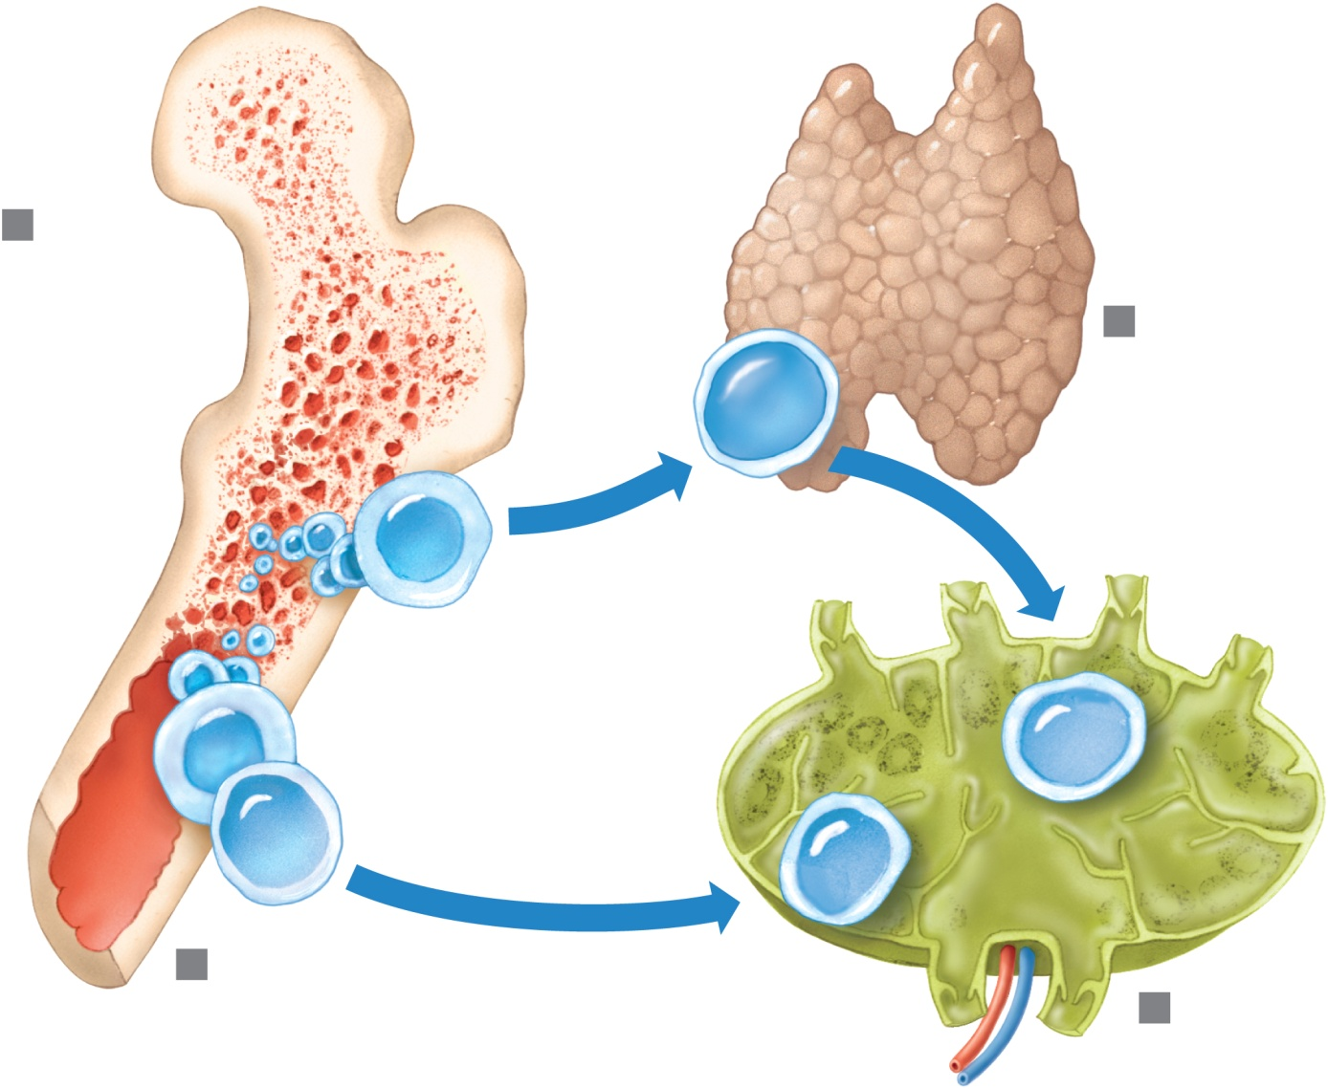
Active Humoral Immunity
- B cells encounter antigens and produce antibodies against them
  - Naturally acquired – response to a bacterial or viral infection
  - Artificially acquired – response to a vaccine of dead or attenuated pathogens
- Vaccines – spare us the symptoms of disease, and their weakened antigens provide antigenic determinants that are immunogenic and reactive

Passive Humoral Immunity
- Differs from active immunity in the antibody source and the degree of protection
- Naturally acquired – from the mother to her fetus via the placenta
- Artificially acquired – from the injection of serum, such as gamma globulin

Types of Acquired Immunity

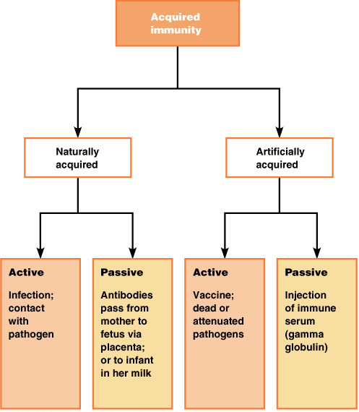

T Cell Summary
- T cells are best suited for cell-to-cell interactions, and target:
  - Cells infected with viruses, bacteria, or intracellular parasites
  - Abnormal or cancerous cells
  - Cells of infused or transplanted foreign tissue
- Each T cell has unique roles to play in the immune response
- Each T cell is heavily involved in interactions with other immune cells and elements
- Without helper T cells, there would be no adaptive immune response
- The helper T cells direct and help complete the activation of other cells
- Their role is evident when they are destroyed in AIDS

Organ Transplants
- The four major types of grafts are:
  - Autografts – graft transplanted from one site on the body to another in the same person
  - Isografts – grafts between identical twins
  - Allografts – transplants between individuals that are not identical twins, but belong to same species
  - Xenografts – grafts taken from another animal species

Prevention of Rejection
- Prevention of tissue rejection is accomplished by using immunosuppressive drugs
- However, these drugs depress patient’s immune system so it cannot fight off foreign agents

Immunodeficiencies
- Congenital and acquired conditions in which the function or production of immune cells, phagocytes, or complement is abnormal

Acquired Immunodeficiencies
- Hodgkin’s disease – cancer of the lymph nodes leads to immunodeficiency by depressing lymph node cells
- Acquired immune deficiency syndrome (AIDS) – cripples the immune system by interfering with the activity of helper T (CD4) cells
  - Characterized by severe weight loss, night sweats, and swollen lymph nodes
  - Opportunistic infections occur

AIDS
- Caused by human immunodeficiency virus (HIV) transmitted via body fluids – blood, semen, and vaginal secretions
- HIV enters the body via:
  - Blood transfusions
  - Contaminated needles
  - Intimate sexual contact, including oral sex
- HIV:
  - Destroys T_{H} cells
  - Depresses cell-mediated immunity
- HIV multiplies in lymph nodes throughout the asymptomatic period
- Symptoms appear in a few months to 10 years
- Treatments include:
  - Reverse transcriptase inhibitors (AZT)
  - Protease inhibitors (saquinavir and ritonavir)
  - New drugs currently being developed that block HIV’s entry to helper T cells

Hypersensitivity
- Immune responses that cause tissue damage
- Different types of hypersensitivity reactions are distinguished by:
  - Their time course
  - Whether antibodies or T cells are the principle immune elements involved
- Antibody-mediated allergies are immediate and subacute hypersensitivities
- The most important cell-mediated allergic condition is delayed hypersensitivity

Anaphylaxis
- Reactions include runny nose, itching reddened skin, and watery eyes
- If allergen is inhaled, asthmatic symptoms appear – constriction of bronchioles and restricted airflow
- If allergen is ingested, cramping, vomiting, or diarrhea occur
- Antihistamines counteract these effects

Anaphylactic Shock
- Response to allergen that directly enters the blood (e.g., insect bite, injection)
- Basophils and mast cells are enlisted throughout the body
- Systemic histamine releases may result in:
  - Constriction of bronchioles
  - Sudden vasodilation and fluid loss from the bloodstream
  - Hypotensive shock and death
- Treatment – epinephrine is the drug of choice

Delayed Hypersensitivities
- Onset is slow (1–3 days)
- Antihistamines are ineffective and corticosteroid drugs are used to provide relief
- Example: allergic contact dermatitis (e.g., poison ivy)
- Involved in protective reactions against viruses, bacteria, fungi, protozoa, cancer, and rejection of foreign grafts or transplants

Lifespan Changes
- The immune system declines early in life as the thymus gland shrinks
- There is a higher risk of infection
- Antibody response to antigens become slower
- Elderly may not be candidates for certain medical treatments that suppresses immunity

Developmental Aspects
- Immune system stem cells develop in the liver and spleen by the ninth week
- Later, bone marrow becomes the primary source of stem cells
- Lymphocyte development continues in the bone marrow and thymus system begins to wane
- The immune system is impaired by stress and depression
- With age, the immune system begins to wane

