The Respiratory System
Dr. Gary Mumaugh

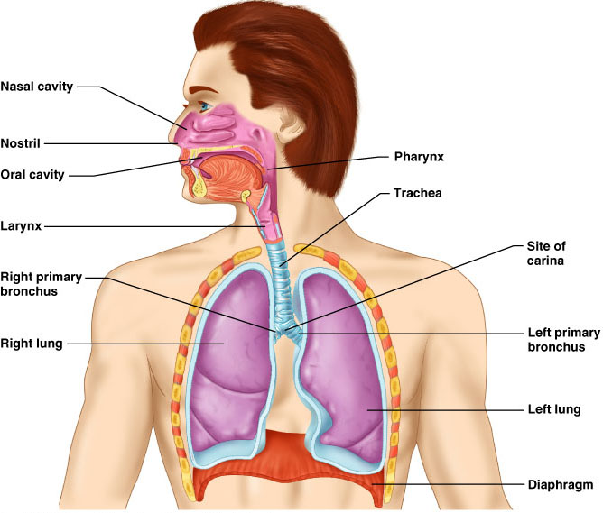

Major Functions of the Respiratory System
- To supply the body with oxygen and dispose of CO2
- Respiration – four distinct processes must happen
  - Pulmonary ventilation – moving air into and out of the lungs
  - External respiration – gas exchange between the lungs and the blood
  - Transport – transport of oxygen and carbon dioxide between the lungs and tissues
  - Internal respiration – gas exchange between systemic blood vessels and tissues

Respiratory System
- Consists of the respiratory and conducting zones
- Respiratory zone
  - Site of gas exchange
  - Consists of bronchioles, alveolar ducts, and alveoli
- Conducting zone
  - Provides rigid conduits for air to reach the sites of gas exchange
  - Includes all other respiratory structures (e.g., nose, nasal cavity, pharynx, trachea)
- Respiratory muscles – diaphragm and other muscles that promote ventilation

Function of the Nose
- The only externally visible part of the respiratory system that functions by:
  - Providing an airway for respiration
  - Moistening and warming the entering air
  - Filtering inspired air and cleaning it of foreign matter
  - Serving as a resonating chamber for speech
  - Housing the olfactory receptors

Structure of the Nose
- The nose is divided into two regions
  - The external nose
  - The internal nasal cavity

Nasal Cavity
- Lies in and posterior to the external nose
- Is divided by a midline nasal septum
- Vestibule – nasal cavity superior to the nares
  - Vibrissae – hairs that filter coarse particles from inspired air
- Olfactory mucosa
  - Lines the superior nasal cavity
  - Contains smell receptors
- Respiratory mucosa
  - Lines the balance of the nasal cavity
  - Glands secrete mucus containing lysozyme and defensins to help destroy bacteria

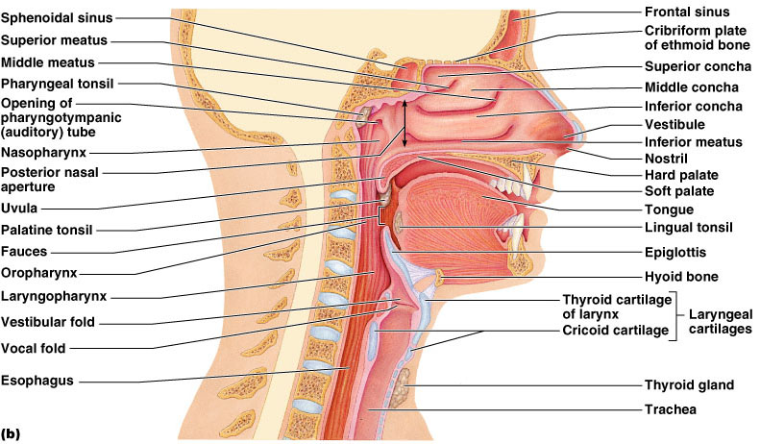
Nasal Cavity
- Inspired air is:
  - Humidified by the high water content in the nasal cavity
  - Warmed by rich plexuses of capillaries
- Ciliated mucosal cells remove contaminated mucus
- Superior, medial, and inferior conchae:
  - Increase mucosal area
  - Enhance air turbulence and help filter air
  - Sensitive mucosa triggers sneezing when stimulated by irritating particles

Functions of the Nasal Mucosa and Conchae
- During inhalation the conchae and nasal mucosa:
  - Filter, heat, and moisten air
- During exhalation these structures:
  - Reclaim heat and moisture
  - Minimize heat and moisture loss

Paranasal Sinuses
- Sinuses in bones that surround the nasal cavity
- Sinuses lighten the skull and help to warm and moisten the air
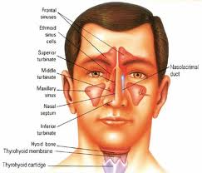
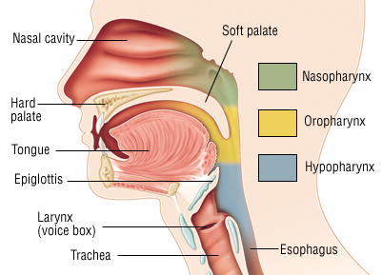

Pharynx
- Funnel-shaped tube of skeletal muscle that connects to the:
  - Nasal cavity and mouth superiorly
  - Larynx and esophagus inferiorly
- Extends from the base of the skull to the level of the sixth cervical vertebra

Pharynx – Divided Into Three Regions
- Nasopharynx
  - Strictly an air passageway
  - Closes during swallowing to prevent food from entering the nasal cavity
- Oropharynx
  - Opens to the oral cavity via an archway called the fauces
  - Serves as a common passageway for food and air
- Laryngopharynx
  - Serves as a common passageway for food and air
  - Extends to the larynx, where the respiratory and digestive pathways diverge

Larynx (Voice Box)
- Superiorly attaches to the hyoid bone. Inferiorly attaches to the trachea
- The three functions of the larynx are:
  - To provide a patent airway
  - To act as a switching mechanism to route air and food into the proper channels
  - To function in voice production
- Epiglottis – elastic cartilage that covers the laryngeal inlet during swallowing

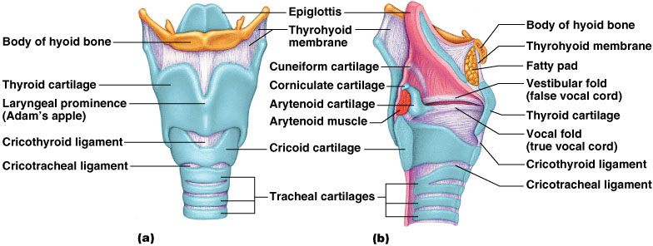

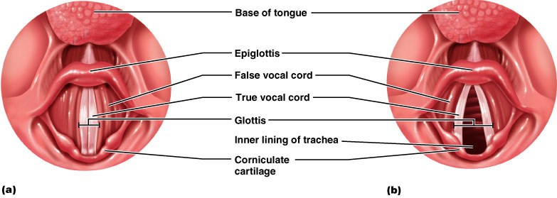

Trachea
- Flexible and mobile tube extending from the larynx into the mediastinum
- Composed of three layers
  - Mucosa – made up of goblet cells and ciliated epithelium
  - Submucosa – connective tissue deep to the mucosa
  - Adventitia – outermost layer made of C-shaped rings of hyaline cartilage

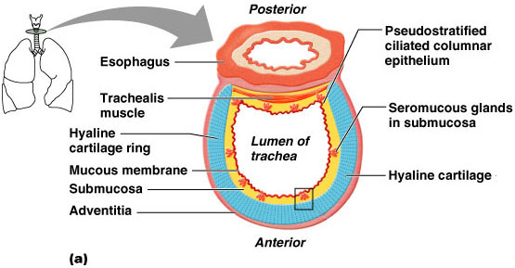

Conducting Zone: Bronchi
- The carina of the last tracheal cartilage marks the end of the trachea and the beginning of the right and left bronchi
- Air reaching the bronchi is:
  - Warm and cleansed of impurities
  - Saturated with water vapor
- Bronchi subdivide into secondary bronchi, each supplying a lobe of the lungs
- Air passages undergo 23 orders of branching in the lungs

Respiratory Zone
- Defined by the presence of alveoli; begins as terminal bronchioles feed into respiratory bronchioles
- Respiratory bronchioles lead to alveolar ducts, then to terminal clusters of alveolar sacs composed of alveoli
- Approximately 300 million alveoli:
  - Account for most of the lungs’ volume
  - Provide tremendous surface area for gas exchange

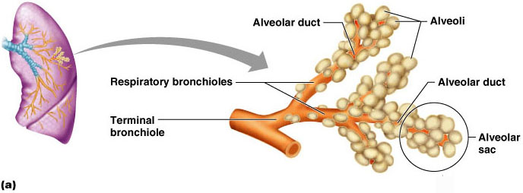
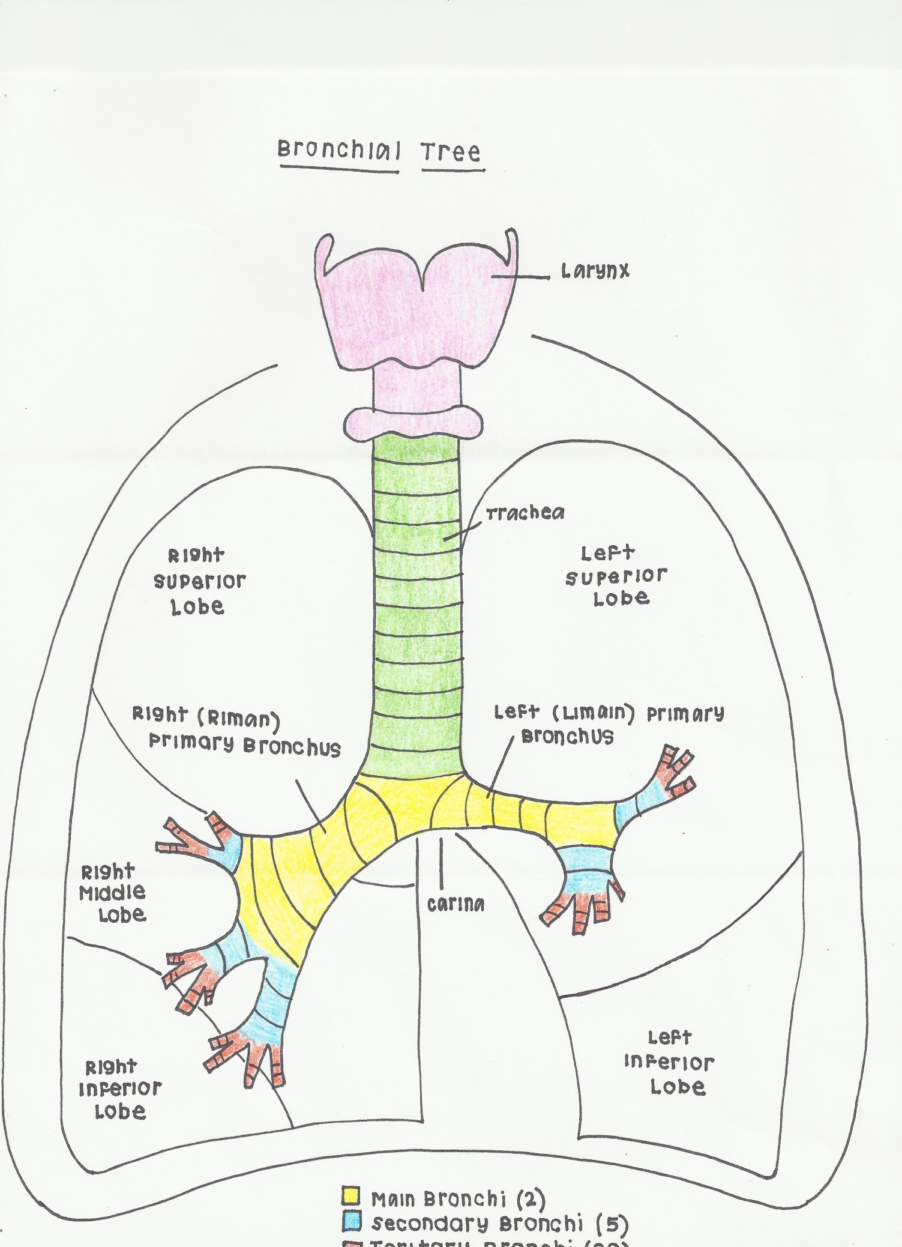

By Kayla Kern – OT Student
Gross Anatomy of the Lungs
- Lungs occupy all of the thoracic cavity except the mediastinum
  - Root – site of vascular and bronchial attachments
  - Costal surface – anterior, lateral, and posterior surfaces in contact with the ribs
  - Apex – narrow superior tip
  - Base – inferior surface that rests on the diaphragm
  - Hilus – indentation that contains pulmonary and systemic blood vessel
  - Cardiac notch (impression) – cavity that accommodates the heart
  - Left lung – separated into upper and lower lobes by the oblique fissure
  - Right lung – separated into three lobes by the oblique and horizontal fissures
  - There are 10 bronchopulmonary segments in each lung

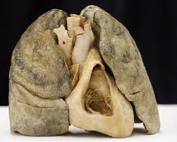
Pleurae
- Thin, double-layered serosa
- Parietal pleura
  - Covers the thoracic wall and superior face of the diaphragm
  - Continues around heart and between lungs
- Visceral, or pulmonary, pleura
  - Covers the external lung surface
  - Divides the thoracic cavity into three chambers
    - The central mediastinum
    - Two lateral compartments, each containing a lung

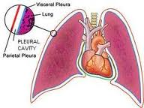
Breathing
- Breathing, or pulmonary ventilation, consists of two phases
  - Inspiration – air flows into the lungs
  - Expiration – gases exit the lungs

Pressure Relationships in the Thoracic Cavity
- Respiratory pressure is always described relative to atmospheric pressure
- Atmospheric pressure
  - Pressure exerted by the air surrounding the body
- Intrapulmonary pressure – pressure within the alveoli
- Intrapleural pressure – pressure within the pleural cavity
- Two forces act to pull the lungs away from the thoracic wall, promoting lung collapse
  - Elasticity of lungs causes them to assume smallest possible size
  - Surface tension of alveolar fluid draws alveoli to their smallest possible size
- Opposing force – elasticity of the chest wall pulls the thorax outward to enlarge the lungs

Inspiration
- The diaphragm and intercostal muscles (inspiratory muscles) contract and the rib cage rises
- The lungs are stretched and intrapulmonary volume increases
- Air flows into the lungs

Expiration
- Intercostal muscles relax and the rib cage descends due to gravity
- Thoracic cavity volume decreases
- Elastic lungs recoil passively and intrapulmonary volume decreases
- Gases flow out of the lungs

Inspiration Expiration
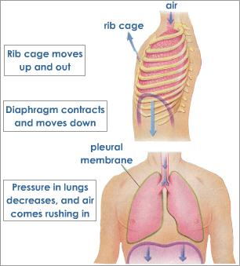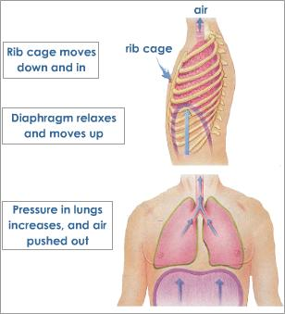
Airway Resistance
- As airway resistance rises, breathing movements become more strenuous
- Severely constricted or obstructed bronchioles:
  - Can prevent life-sustaining ventilation
  - Can occur during acute asthma attacks which stops ventilation
- Epinephrine release via the sympathetic nervous system dilates bronchioles and reduces air resistance

Alveolar Surface Tension
- Surface tension – the attraction of liquid molecules to one another at a liquid-gas interface
- The liquid coating the alveolar surface is always acting to reduce the alveoli to the smallest possible size
- Surfactant, a detergent-like complex, reduces surface tension and helps keep the alveoli from collapsing

Lung Compliance
- The ease with which lungs can be expanded
- Determined by two main factors
  - Distensibility of the lung tissue and surrounding thoracic cage
  - Surface tension of the alveoli

Factors That Diminish Lung Compliance
- Scar tissue or fibrosis that reduces the natural resilience of the lungs
- Blockage of the smaller respiratory passages with mucus or fluid
- Reduced production of surfactant
- Decreased flexibility of the thoracic cage or its decreased ability to expand
- Examples include:
  - Deformities of thorax
  - Ossification of the costal cartilage
  - Paralysis of intercostal muscles

Respiratory Volumes
- Tidal volume - Air that moves into and out of the lungs with each breath (approximately 500 ml)
- Inspiratory reserve volume - Air that can be inspired forcibly beyond the tidal volume (2100–3200 ml)
- Expiratory reserve volume - Air that can be evacuated from the lungs after a tidal expiration (1000–1200 ml)
- Residual volume - Air left in the lungs after strenuous expiration (1200 ml)

Respiratory Capacities
- Inspiratory capacity - Total amount of air that can be inspired after a tidal expiration
- Functional residual capacity - Amount of air remaining in the lungs after a tidal expiration
- Vital capacity - The total amount of exchangeable air
- Total lung capacity - Sum of all lung volumes

Surface Area and Thickness of the Respiratory Membrane
- Respiratory membranes:
  - Thicken if lungs become waterlogged and edematous, whereby gas exchange is inadequate and oxygen deprivation results
  - Decrease in surface area with emphysema, when walls of adjacent alveoli break through

Oxygen Transport
- Molecular oxygen is carried in the blood:
- Bound to hemoglobin (Hb) within red blood cells
- Dissolved in plasma

Hypoxia – Low Oxygen to the Tissues
- Anemic hypoxia
  - Poor oxygen delivery from too few RBCs
- Ischemic or stagnant hypoxia
  - Occurs when blood circulation is impaired or blocked
- Histotoxic hypoxia
  - Occurs when body cells are unable to use oxygen
Hypoxia – Low Oxygen to the Tissues - continued
- Hypoxemic hypoxia
  - Seen in reduced oxygen pressure

Carbon Dioxide Transport
- CO2 is transported in the blood in three forms
  - Dissolved in plasma – 7 to 10%
  - Chemically bound to hemoglobin – 20% is carried in RBCs
  - Bicarbonate ion in plasma – 70% is transported as bicarbonate

Control of Respiration: Medullary Respiratory Centers
- The dorsal respiratory group or inspiratory center
  - Appears to be the pacesetting respiratory center
  - Excites the inspiratory muscles and sets breath rates (12-15 breaths/minute)
  - Becomes dormant during expiration
- The ventral respiratory group is involved in forced inspiration and expiration

Depth and Rate of Breathing: Higher Brain Centers
- Hypothalamic controls act through the limbic system to modify rate and depth of respiration
  - Example: breath holding that occurs in anger
- A rise in body temperature acts to increase respiratory rate
- Cortical controls are direct signals from the cerebral motor cortex that bypass medullary controls
  - Examples: voluntary breath holding, taking a deep breath

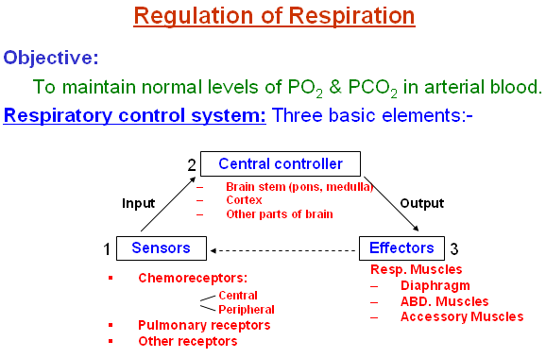

Hyperventilation
- Increase in the rate and depth of breathing that exceeds the bodies need to remove CO2
- Occurs when low CO2 levels in the blood cause cerebral blood vessels to constrict which produces cerebral ischemia

Hypoventilation
- Hypoventilation – slow and shallow breathing due to abnormally low P_{CO2} levels
  - Apnea (breathing cessation) may occur until P_{CO2} levels rise

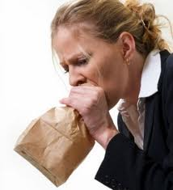

Respiratory Adjustments: Exercise
- Respiratory adjustments are geared to both the intensity and duration of exercise
- During vigorous exercise:
  - Ventilation can increase 20 fold
  - Breathing becomes deeper and more vigorous, but respiratory rate may not be significantly changed (hyperpnea)
- As exercise begins
  - Ventilation increases abruptly, rises slowly, and reaches a steady state
- When exercise stops
  - Ventilation declines suddenly, then gradually decreases to normal
- Neural factors bring about the above changes, including:
  - Psychic stimuli
  - Cortical motor activation
  - Excitatory impulses from proprioceptors in muscles

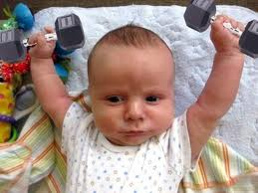

Respiratory Adjustments: High Altitude
- The body responds to quick movement to high altitude (above 8000 ft) with symptoms of acute mountain sickness – headache, shortness of breath, nausea, and dizziness
- Acclimatization – respiratory and hematopoietic adjustments to altitude

Chronic Obstructive Pulmonary Disease (COPD)
- Exemplified by chronic bronchitis and obstructive emphysema
- Patients have a history of:
  - Smoking
  - Dyspnea, where labored breathing occurs and gets progressively worse
  - Coughing and frequent pulmonary infections
- COPD victims develop respiratory failure accompanied by hypoxemia, carbon dioxide retention, and respiratory acidosis

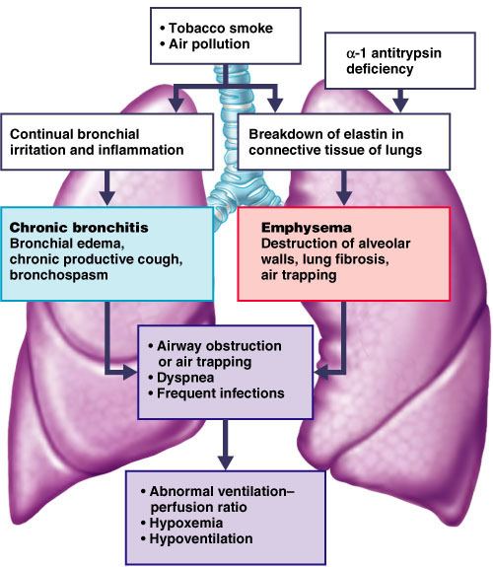
Asthma
- Characterized by dyspnea, wheezing, and chest tightness
- Active inflammation of the airways precedes bronchospasms
- Airway inflammation is an immune response caused by release of IL-4 and IL-5, which stimulate IgE and recruit inflammatory cells
- Airways thickened with inflammatory exudates magnify the effect of bronchospasms
- Asthma is a process that affects the airways with excessive mucus production, bronchial muscle contraction, and swelling causing obstruction.
- During an asthma attack, spasms in the muscles and bronchi constrict, impeding the outward passage of stale air. Sufferers can get starved for air with coughing, wheezing and chest tightness.
- Recently, asthma has been found to be a chronic inflammatory process with the prior symptoms.
- Most of the research has been aimed at determining what might trigger asthma responses and what to avoid.
- Incidence
  - In the last decade the incidence of asthma has increased by 1/3
  - 20 million people in the US
  - 6 million children and 14 million adults
  - Children under 16 and adults over 65 are more prone

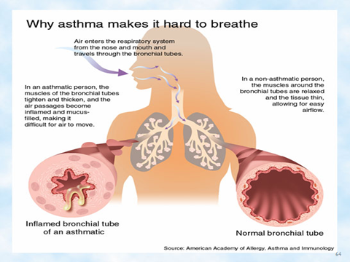

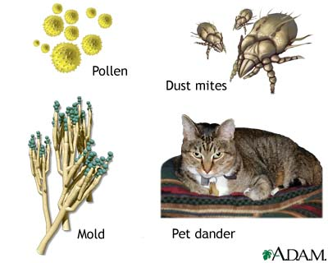

Lung Cancer
- Accounts for 1/3 of all cancer deaths in the U.S.
- 90% of all patients with lung cancer were smokers
- The three most common types are:
  - Squamous cell carcinoma (20-40% of cases) arises in bronchial epithelium
  - Adenocarcinoma (25-35% of cases) originates in peripheral lung area
  - Small cell carcinoma (20-25% of cases) contains lymphocyte-like cells that originate in the primary bronchi and subsequently metastasize

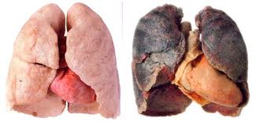

Lifespan Changes
- By the 28th week, a baby born prematurely can breathe on its own
- During fetal life, the lungs are filled with fluid and blood bypasses the lungs
- Gas exchange takes place via the placenta
- At birth, respiratory centers are activated, alveoli inflate, and lungs begin to function
- Respiratory rate is highest in newborns and slows until adulthood
- Lungs continue to mature and more alveoli are formed until young adulthood
- Respiratory efficiency decreases in old age
- Lifespan changes reflect an accumulation of environmental influences and the effects of aging in other organ systems, and may include:
  - The cilia become less active
  - Mucous thickening
  - Swallowing, gagging, and coughing reflexes slowing
  - Macrophages in the lungs lose efficiency
  - An increased susceptibility to respiratory infections
  - A “barrel chest” may develop
  - Bronchial walls thin and collapse
  - Dead space increasing

