**The Digestive System**

**Dr. Gary Mumaugh**

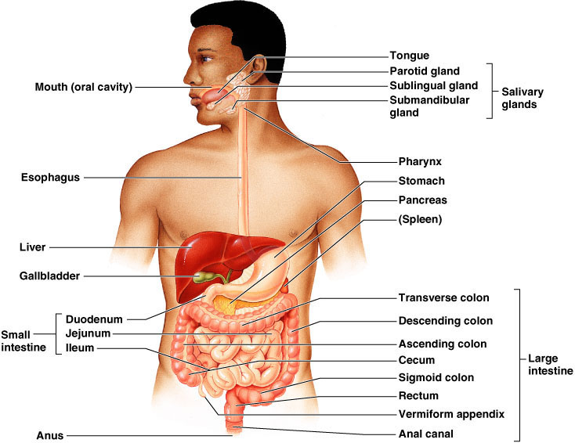

**Digestive System: Overview**

* The alimentary canal or gastrointestinal (GI) tract digests and absorbs food
* Alimentary canal – mouth, pharynx, esophagus, stomach, small intestine, and large intestine
* Accessory digestive organs – teeth, tongue, gallbladder, salivary glands, liver, and pancreas

**Digestive Process**

* The GI tract is a “disassembly” line
  + Nutrients become more available to the body in each step
* There are six essential activities:
  + Ingestion, propulsion, and mechanical digestion
  + Chemical digestion, absorption, and defecation

**Gastrointestinal Tract Activities**

* Ingestion – taking food into the digestive tract
* Propulsion – swallowing and peristalsis
  + Peristalsis – waves of contraction and relaxation of muscles in the organ walls
* Mechanical digestion – chewing, mixing, and churning food
* Chemical digestion – catabolic breakdown of food
* Absorption – movement of nutrients from the GI tract to the blood or lymph
* Defecation – elimination of indigestible solid wastes

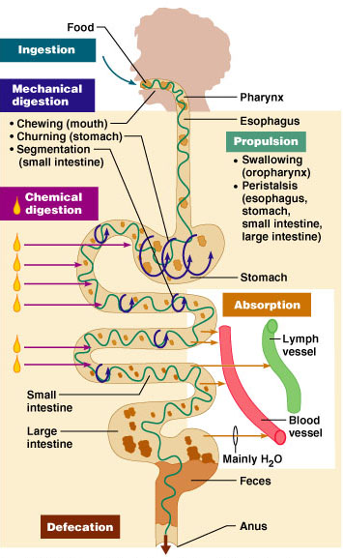

**Regulation of digestion involves:**

* Mechanical and chemical stimuli, stretch receptors, osmolarity, and presence of substrate in the lumen
* Extrinsic control by CNS centers
* Intrinsic control by local centers

**Receptors of the GI Tract**

* Mechano- and chemoreceptors respond to:
  + Stretch by the presence of food
  + Osmolarity – solute concentration
  + pH of contents
  + Presence of end products of digestion
* They initiate reflexes that:
  + Activate or inhibit digestive glands to secrete digestive juices
  + Mix lumen contents and move them along

**Nervous Control of the GI Tract**

* Intrinsic controls
  + Nerve plexuses near the GI tract initiate short reflexes
  + Short reflexes are mediated by local enteric plexuses (gut brain)
* Extrinsic controls
  + Long reflexes arising within or outside the GI tract
  + Involve CNS centers and extrinsic autonomic nerves

**Peritoneum and Peritoneal Cavity**

* Peritoneum – serous membrane of the abdominal cavity
  + Visceral – covers external surface of most digestive organs
  + Parietal – lines the body wall
* Peritoneal cavity
  + Lubricates digestive organs
  + Allows them to slide across one another
* Mesentery – double layer of peritoneum that provides:
  + Vascular and nerve supplies to the viscera
  + A means to hold digestive organs in place and store fat

**Layers of the Alimentary Canal**

* Mucosa
  + Secretes mucus, enzymes and hormones
  + Absorption of end products of digestion into blood
  + Protection against disease
* Submucosa
  + Dense connective tissue with blood, lymph and nerves
* Muscularis externa or muscularis
  + Responsible for peristalsis and segmentation
* Serosa
  + Actually the visceral peritoneum

**Mouth**

* Oral or buccal cavity:
  + Is bounded by lips, cheeks, palate, and tongue
  + Has the oral orifice as its anterior opening
  + Is continuous with the oropharynx posteriorly
* To withstand abrasions:
  + The mouth is lined with stratified squamous epithelium
  + The gums, hard palate, and dorsum of the tongue are slightly keratinized

**Histology of the Alimentary Canal**

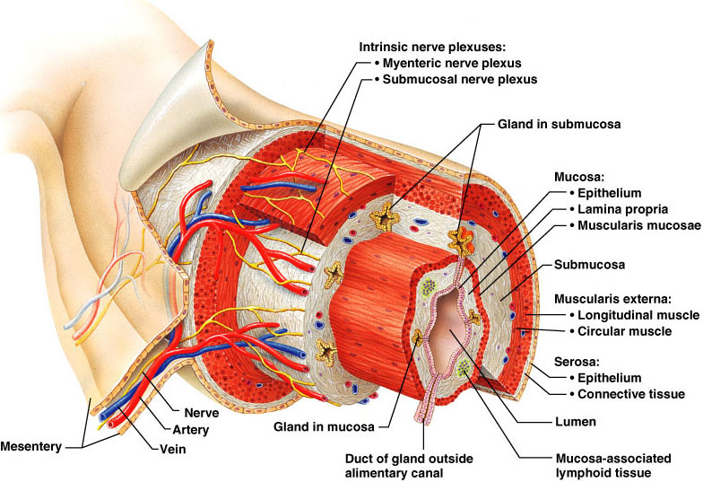

**Mouth**

* Oral or buccal cavity:
  + Is bounded by lips, cheeks, palate, and tongue
  + Has the oral orifice as its anterior opening
  + Is continuous with the oropharynx posteriorly
* To withstand abrasions:
  + The mouth is lined with stratified squamous epithelium
  + The gums, hard palate, and dorsum of the tongue are slightly keratinized

**Lips and Cheeks**

* Have a core of skeletal muscles
  + Lips: orbicularis oris
  + Cheeks: buccinators
* Vestibule – bounded by the lips and cheeks externally, and teeth and gums internally
* Oral cavity proper – area that lies within the teeth and gums
* Labial frenulum – median fold that joins the internal aspect of each lip to the gum

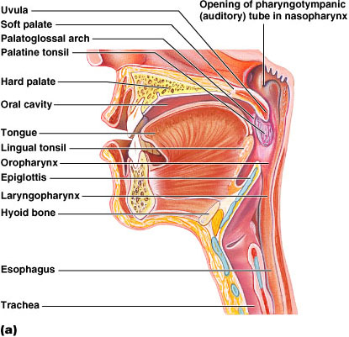

**Palate**

* Hard palate
  + Assists the tongue in chewing
  + Slightly corrugated on either side of the raphe (midline ridge) which helps to create friction
* Soft palate – mobile fold formed mostly of skeletal muscle
  + Closes off the nasopharynx during swallowing

**Tongue**

* Occupies the floor of the mouth and fills the oral cavity when mouth is closed
* Functions include:
  + Gripping and repositioning food during chewing
  + Mixing food with saliva and forming the bolus
  + Initiation of swallowing, and speech
* Intrinsic muscles change the shape of the tongue
* Extrinsic muscles alter the tongue’s position
* Lingual frenulum secures the tongue to the floor of the mouth

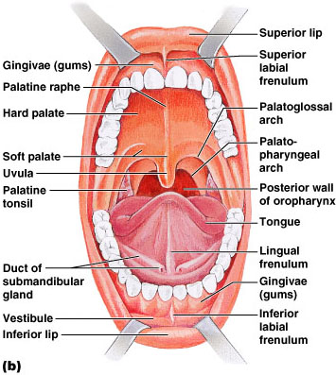

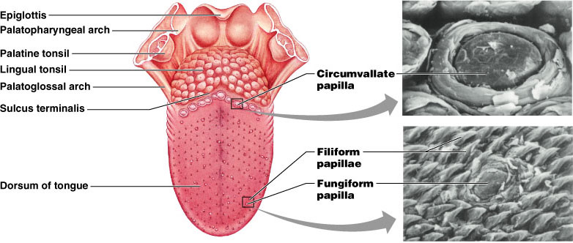

**Salivary Glands**

* Produce and secrete saliva that:
  + Cleanses the mouth
  + Moistens and dissolves food chemicals
  + Aids in bolus formation
  + Contains enzymes that break down starch
* Three pairs of extrinsic glands – parotid, submandibular, and sublingual
* Intrinsic salivary glands (buccal glands) – scattered throughout the oral mucosa
* Parotid – lies anterior to the ear between the masseter muscle and skin
  + Parotid duct – opens into the vestibule next to the second upper molar
* Submandibular – lies along the medial aspect of the mandibular body
  + Its ducts open at the base of the lingual frenulum
* Sublingual – lies anterior to the submandibular gland under the tongue
  + It opens via 10-12 ducts into the floor of the mouth

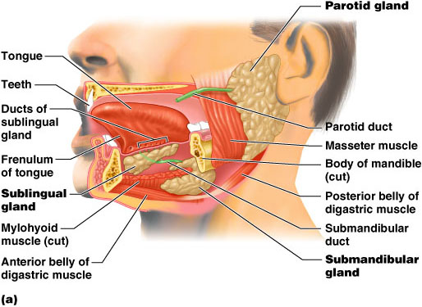

**Saliva**

* Secreted from serous and mucous cells of salivary glands
* A 97-99.5% water, hypo-osmotic, slightly acidic solution containing
  + Electrolytes
  + Digestive enzyme – salivary amylase
  + Proteins – mucin, lysozyme, defensins
  + Metabolic wastes – urea and uric acid
* Control of Salivation
  + Intrinsic glands keep the mouth moist
  + Extrinsic salivary glands secrete serous, enzyme-rich saliva in response to:
    - Ingested food which stimulates chemoreceptors and pressoreceptors
    - The thought of food
* Strong sympathetic stimulation inhibits salivation and results in dry mouth

**Teeth**

* Primary and permanent dentitions have formed by age 21
* Primary – 20 deciduous teeth that erupt at intervals between 6 and 24 months
* Permanent – enlarge and develop causing the root of deciduous teeth to be resorbed and fall out between the ages of 6 and 12 years
  + All but the third molars have erupted by the end of adolescence
  + There are usually 32 permanent teeth
* Teeth are classified according to their shape and function
  + Incisors – chisel-shaped teeth adapted for cutting or nipping
  + Canines – conical or fanglike teeth that tear or pierce
  + Premolars (bicuspids) and molars – have broad crowns with rounded tips and are best suited for grinding or crushing
* During chewing, upper and lower molars lock together generating crushing force
* Tooth Structure
  + Two main regions – crown and the root
    - Crown – exposed part of the tooth above the gingiva (gum)
    - Enamel – acellular, brittle material composed of calcium salts and hydroxyapatite crystals is the hardest substance in the body
      * Encapsules the crown of the tooth
    - Root – portion of the tooth embedded in the jawbone

**Tooth and Gum Disease: Periodontitis**

* Dental caries – gradual demineralization of enamel and dentin by bacterial action
  + Dental plaque, a film of sugar, bacteria, and mouth debris, adheres to teeth
  + Acid produced by the bacteria in the plaque dissolves calcium salts
  + Without these salts, organic matter is digested by proteolytic enzymes
  + Daily flossing and brushing help prevent caries by removing forming plaque

**Tooth and Gum Disease: Periodontitis - continued**

* Gingivitis – as plaque accumulates, it calcifies and forms calculus, or tartar
* Accumulation of calculus:
  + Disrupts the seal between the gingivae and the teeth
  + Puts the gums at risk for infection
* Periodontitis – serious gum disease resulting from an immune response
  + Risk factors include smoking, diabetes, and oral or tongue or lip piercing

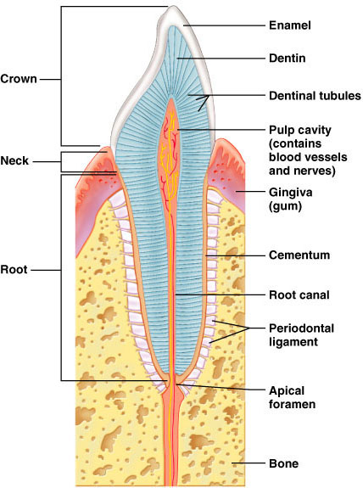

**Pharynx**

* From the mouth, the oro- and laryngopharynx allow passage of:
  + Food and fluids to the esophagus
  + Air to the trachea
* Lined with stratified squamous epithelium and mucus glands
* Has two skeletal muscle layers
  + Inner longitudinal
  + Outer pharyngeal constrictors

**Esophagus**

* Muscular tube going from the laryngopharynx to the stomach
* Travels through the mediastinum and pierces the diaphragm
* Joins the stomach at the cardiac orifice
* Glands secrete mucus as a bolus moves through the esophagus

**Digestive Processes in the Mouth**

* Food is ingested
* Mechanical digestion begins (chewing)
* Propulsion is initiated by swallowing
* Salivary amylase begins chemical breakdown of starch
* The pharynx and esophagus serve as conduits to pass food from the mouth to the stomach

**Deglutition (Swallowing)**

* Involves the coordinated activity of the tongue, soft palate, pharynx, esophagus and 22 separate muscle groups
* Buccal phase – bolus is forced into the oropharynx
* Pharyngeal-esophageal phase – controlled by the medulla and lower pons
  + All routes except into the digestive tract are sealed off
* Peristalsis moves food through the pharynx to the esophagus

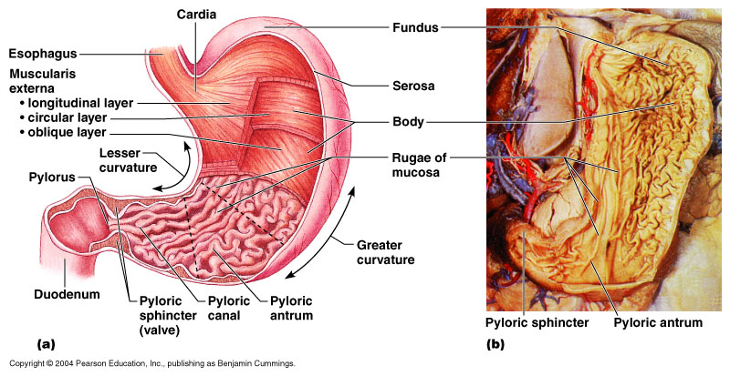

**Stomach – Gross Anatomy**

* Chemical breakdown of proteins begins and food is converted to chyme
* Cardiac region – surrounds the cardiac orifice
* Fundus – dome-shaped region beneath the diaphragm
* Body – midportion of the stomach
* Pyloric region – made up of the antrum and canal which terminates at the pylorus
* The pylorus is continuous with the duodenum through the pyloric sphincter

**Stomach – Gross Anatomy**

* Greater curvature – entire extent of the convex lateral surface
* Lesser curvature – concave medial surface
* Lesser omentum – runs from the liver to the lesser curvature
* Greater omentum – drapes inferiorly from the greater curvature to the small intestine

**Microscopic Anatomy of the Stomach**

* Muscularis – has an additional oblique layer that:
  + Allows the stomach to churn, mix, and pummel food physically
  + Breaks down food into smaller fragments
* Gastric pits contain gastric glands that secrete gastric juice, mucus, and gastrin

**Glands of the Stomach**

* Gastric glands of the fundus and body have a variety of secretory cells
  + Mucous neck cells – secrete acid mucus
  + Parietal cells – secrete HCl and intrinsic factor

**Stomach Lining**

* The stomach is exposed to the harshest conditions in the digestive tract
* To keep from digesting itself, the stomach has a mucosal barrier with:
  + A thick coat of bicarbonate-rich mucus on the stomach wall
  + Epithelial cells that are joined by tight junctions
  + Gastric glands that have cells impermeable to HCl
* Damaged epithelial cells are quickly replaced

**Digestion in the Stomach - The stomach:**

* Holds ingested food
* Degrades this food both physically and chemically
* Delivers chyme to the small intestine
* Enzymatically digests proteins with pepsin
* Secretes intrinsic factor required for absorption of vitamin B12

**Regulation of Gastric Secretion**

* Neural and hormonal mechanisms regulate the release of gastric juice
* Stimulatory and inhibitory events occur in three phases
  + Cephalic (reflex) phase: prior to food entry
  + Gastric phase: once food enters the stomach
  + Intestinal phase: as partially digested food enters the duodenum
* Cephalic Phase
  + Excitatory events include:
    - Sight or thought of food
    - Stimulation of taste or smell receptors
  + Inhibitory events include:
    - Loss of appetite or depression
    - Decrease in stimulation of the parasympathetic division

**Regulation of Gastric Secretion - continued**

* Gastric Phase
  + Excitatory events include:
    - Stomach distension
    - Activation of stretch receptors (neural activation)
    - Activation of chemoreceptors
    - Release of gastrin to the blood
  + Inhibitory events include:
    - A pH lower than 2
    - Emotional upset that overrides the parasympathetic division
* Intestinal Phase
  + Excitatory phase – low pH; partially digested food enters the duodenum and encourages gastric gland activity
  + Inhibitory phase – distension of duodenum, presence of fatty, acidic, or hypertonic chyme, and/or irritants in the duodenum
    - Initiates inhibition of local reflexes and vagal nuclei
    - Closes the pyloric sphincter
    - Releases enterogastrones that inhibit gastric secretion

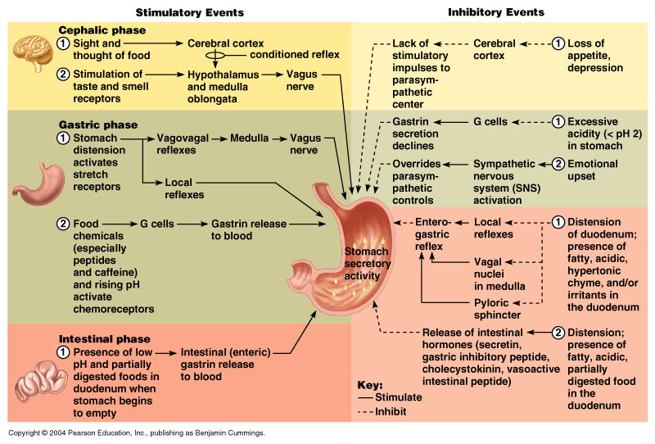

**Gastric Contractile Activity**

* Peristaltic waves move toward the pylorus at the rate of 3 per minute
* Most vigorous peristalsis and mixing occurs near the pylorus
* Chyme is either:
  + Delivered in small amounts to the duodenum or
  + Forced backward into the stomach for further mixing

**Regulation of Gastric Emptying**

* Gastric emptying is regulated by:
  + The neural enterogastric reflex
  + Hormonal (enterogastrone) mechanisms
* These mechanisms inhibit gastric secretion and duodenal filling
* Carbohydrate-rich chyme quickly moves through the duodenum
* Fat-laden chyme is digested more slowly causing food to remain in the stomach longer

**Small Intestine**

* Gross Anatomy
  + Runs from pyloric sphincter to the ileocecal valve
  + Has three subdivisions: duodenum, jejunum, and ileum
  + The jejunum extends from the duodenum to the ileum
  + The ileum joins the large intestine at the ileocecal valve
* Microscopic Anatomy
  + Structural modifications of the small intestine wall increase surface area
    - Plicae circulares: deep circular folds of the mucosa and submucosa
    - Villi – fingerlike extensions of the mucosa
    - Microvilli – tiny projections of absorptive mucosal cells’ plasma membranes

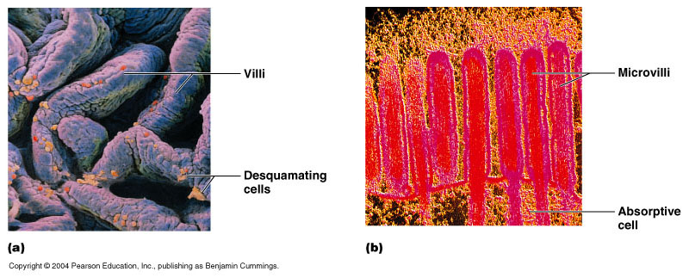

**Intestinal Juice**

* Secreted by intestinal glands in response to distension or irritation of the mucosa
* Slightly alkaline and isotonic with blood plasma
* Largely water, enzyme-poor, but contains mucus

**Liver**

* The largest gland in the body
* Superficially has four lobes – right, left, caudate, and quadrate
* The falciform ligament:
  + Separates the right and left lobes anteriorly
  + Suspends the liver from the diaphragm and anterior abdominal wall
* Liver: Associated Structures
  + Bile leaves the liver via:
    - Bile ducts, which fuse into the common hepatic duct
    - The common hepatic duct, which fuses with the cystic duct
      * These two ducts form the bile duct
* Liver: Microscopic Anatomy
  + Hexagonal-shaped liver lobules are the structural and functional units of the liver
    - Composed of hepatocyte (liver cell) plates radiating outward from a central vein
    - Portal triads are found at each of the six corners of each liver lobule
  + Portal triads consist of a bile duct and
    - Hepatic artery – supplies oxygen-rich blood to the liver
    - Hepatic portal vein – carries venous blood with nutrients from digestive viscera
  + Hepatocytes’ functions include:
    - Production of bile
    - Processing bloodborne nutrients
    - Storage of fat-soluble vitamins
    - Detoxification

**Composition of Bile**

* A yellow-green, alkaline solution containing bile salts, bile pigments, cholesterol, neutral fats, phospholipids, and electrolytes
* Bile salts are cholesterol derivatives that:
  + Emulsify fat
  + Facilitate fat and cholesterol absorption
  + Help solubilize cholesterol
* The chief bile pigment is bilirubin, a waste product of heme

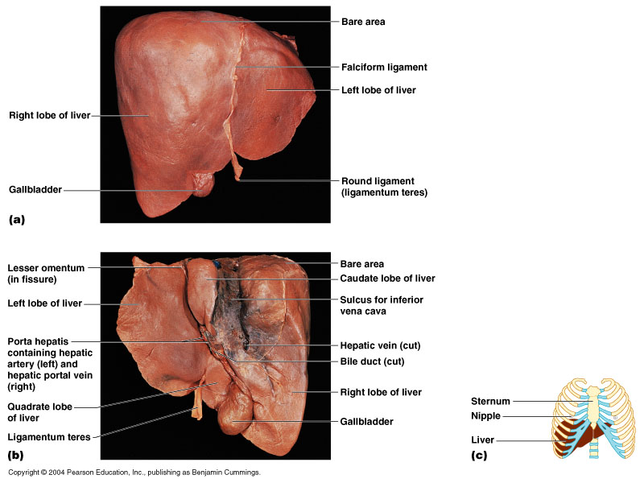

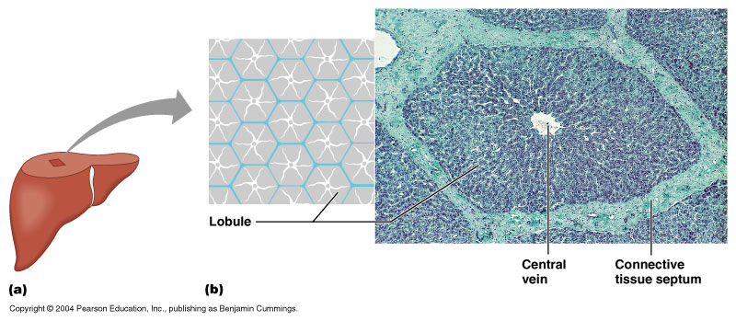

**The Gallbladder**

* Thin-walled, green muscular sac on the ventral surface of the liver
* Stores and concentrates bile by absorbing its water and ions
* Releases bile via the cystic duct, which flows into the bile duct

**Regulation of Bile Release**

* Acidic, fatty chyme causes the duodenum to release:
  + Cholecystokinin (CCK) and secretin into the bloodstream
* Bile salts and secretin transported in blood stimulate the liver to produce bile
* Cholecystokinin causes:
  + The gallbladder to contract
  + The hepatopancreatic sphincter to relax
* As a result, bile enters the duodenum

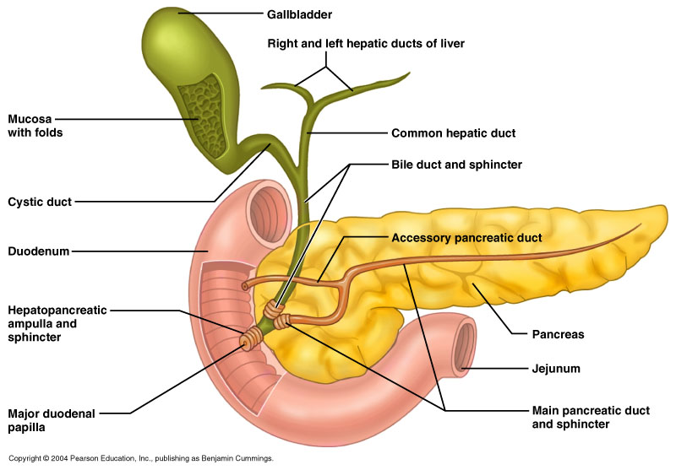

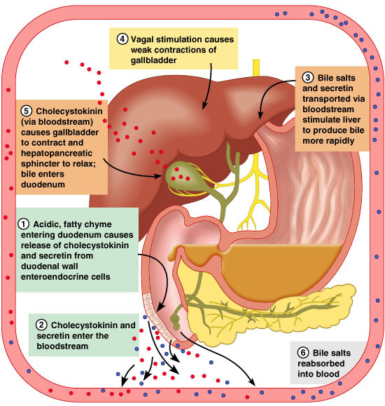

**Pancreas**

* Location
  + Lies deep to the greater curvature of the stomach
  + Encircled by the duodenum and the tail abuts the spleen
* Exocrine function
  + Secretes pancreatic juice which breaks down food
  + Acini (clusters of secretory cells) contain zymogen granules with digestive enzymes
* Endocrine function
  + Release of insulin and glucagon

**Pancreatic Juice**

* Water solution of enzymes and electrolytes
  + Neutralizes acid chyme
  + Provides environment for pancreatic enzymes
* Enzymes are released in inactive form and activated in the duodenum
* Active enzymes secreted
  + Amylase, lipases, and nucleases
  + These enzymes require ions or bile for optimal activity

**Regulation of Pancreatic Secretion**

* Secretin and CCK are released when fatty or acidic chyme enters the duodenum
* CCK and secretin enter the bloodstream
* Upon reaching the pancreas:
  + CCK induces the secretion of enzyme-rich pancreatic juice
* Vagal stimulation also causes release of pancreatic juice

**Digestion in the Small Intestine**

* As chyme enters the duodenum:
  + Carbohydrates and proteins are partially digested
  + No fat digestion has taken place
  + Chyme is released slowly into the duodenum
  + Mixing is required for proper digestion
  + Virtually all nutrient absorption takes place in the small intestine

**Motility in the Small Intestine**

* The most common motion of the small intestine is segmentation
  + Initiated by intrinsic pacemaker cells
  + Moves contents steadily toward the ileocecal valve
* After nutrients have been absorbed:
  + Peristalsis begins with each wave starting distal to the previous
  + Meal remnants, bacteria, mucosal cells, and debris are moved into the large intestine
* Control of Motility
  + Local enteric neurons of the GI tract coordinate intestinal motility
  + Cholinergic neurons cause:
    - Contraction and shortening of muscle layer
    - Distension of the intestine
  + The gastroileal reflex and gastrin:
    - Relax the ileocecal sphincter
    - Allow chyme to pass into the large intestine

**Large Intestine**

* Has three unique features:
  + Teniae coli – three bands of smooth muscle
  + Haustra – pocketlike sacs caused by muscle tone
  + Epiploic appendages – fat-filled pouches of visceral peritoneum
* Is subdivided into the cecum, appendix, colon, rectum, and anal canal
* The saclike cecum:
  + Lies below the ileocecal valve in the right iliac fossa
  + Contains a wormlike vermiform appendix

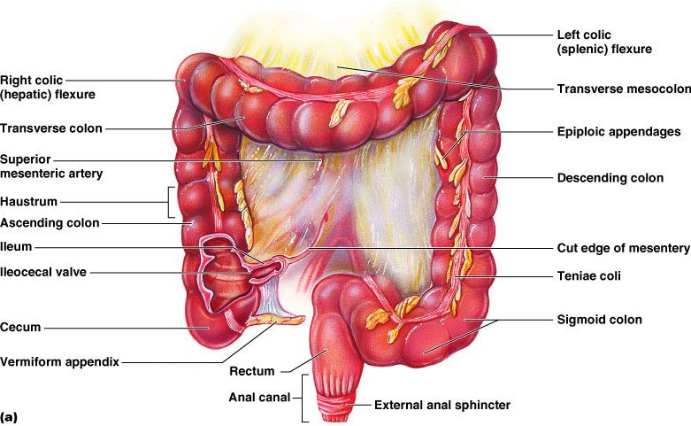

**Colon**

* Has distinct regions: ascending colon, hepatic flexure, transverse colon, splenic flexure, descending colon, and sigmoid colon
* The sigmoid colon joins the rectum
* The anal canal, the last segment of the large intestine, opens to the exterior at the anus

**Valves & Sphincters of the Rectum and Anus**

* Three valves of the rectum stop feces from being passed with gas
* The anus has two sphincters:
  + Internal anal sphincter of smooth muscle
  + External anal sphincter of skeletal muscle
* These sphincters are closed except during defecation

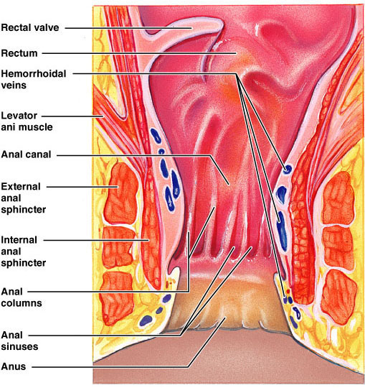

**Bacterial Flora**

* The bacterial flora of the large intestine consist of:
  + Bacteria surviving the small intestine that enter the cecum and
  + Those entering via the anus
* These bacteria:
  + Colonize the colon
  + Ferment indigestible carbohydrates
  + Release irritating acids and gases (flatus)
  + Synthesize B complex vitamins and vitamin K

**Functions of the Large Intestine**

* Other than digestion of enteric bacteria, no further digestion takes place
* Vitamins, water, and electrolytes are reclaimed
* Its major function is propulsion of fecal material toward the anus
* Though essential for comfort, the colon is not essential for life

**Motility of the Large Intestine**

* Haustral contractions
  + Slow segmenting movements that move the contents of the colon
  + Haustra sequentially contract as they are stimulated by distension
* Presence of food in the stomach:
  + Activates the gastrocolic reflex
  + Initiates peristalsis that forces contents toward the rectum

**Defecation**

* Distension of rectal walls caused by feces
  + Stimulates contraction of the rectal walls
  + Relaxes the internal anal sphincter
* Voluntary signals stimulate relaxation of the external anal sphincter and defecation occurs

**Absorption**

* Up to 10 L of food, drink, and GI secretions enter the GI tract daily
* Only 1 L or less reaches the large intestine
* Virtually all food, 80% of electrolytes and water absorb in the small intestine
* It is nearly impossible to exceed the absorptive capacity if the GI tract
* At the end of the ileum, all that remains is some water, indigestible food materials, and millions of bacteria
* The debris is passed on into the large intestine

**Water Absorption**

* Approximately 9 L of water, mostly derived from GI tract secretions, enter the small intestine daily
* Water is the most abundant substance in chyme
* 95% of water is absorbed in the small intestines by osmosis
* Normal rate of water absorption is 300-400 ml/hour
* Water moves in both directions across intestinal mucosa

**Malabsorption of Nutrients**

* Results from anything that interferes with delivery of bile or pancreatic juice
* Factors that damage the intestinal mucosa (e.g., bacterial infection)
* Gluten enteropathy (adult celiac disease) – gluten damages the intestinal villi and reduces the length of microvilli
  + Treated by eliminating gluten from the diet (all grains but rice and corn)

**Developmental Aspects and Lifespan Changes**

* During fetal life, nutrition is via the placenta, but the GI tract is stimulated toward maturity by amniotic fluid swallowed in utero
* At birth, feeding is an infant’s most important function and is enhanced by
  + Rooting reflex (helps infant find the nipple) and sucking reflex (aids in swallowing)
* Digestive system has few problems until the onset of old age
* During old age the GI tract activity declines, absorption is less efficient, and peristalsis is slowed
* Changes to the digestive system are slow and slight, and eventually include:
* Teeth may become sensitive
* Gums may recede
* Teeth may loosen, break or fall out
* Heartburn may become more frequent
* Constipation may become more frequent
* Nutrient absorption decreases
* Accessory organs age but typically not necessarily in ways that effect health

**Cancer**

* GI cancers rarely have early signs or symptoms
* Metastasized colon cancers frequently cause secondary liver cancer
* Prevention is by regular dental and medical examinations
* Colon cancer is the 2nd largest cause of cancer deaths in males (lung cancer is 1st)
* Regular colon examination should be done for all those over 50
* Colon cancer is the 2nd largest cause of cancer deaths in males (lung cancer is 1st)
* Forms from benign mucosal tumors called polyps whose formation increases with age
* Regular colon examination should be done for all those over 50