Fluid and Electrolyte Balance
Dr. Gary Mumaugh

Interrelation of Fluid and Electrolyte Balance
- Fluid and electrolyte balance: implies homeostasis
- Electrolytes have chemical bonds that allow dissociation into ions, which carry an electrical charge; of critical importance in fluid balance
- Fluid balance and electrolyte balance are interdependent

Body Water Content
- Infants have low body fat, low bone mass, and are 73% or more water
- Total water content declines throughout life
- Healthy males are about 60% water; healthy females are around 50%
- This difference reflects females:
  - Higher body fat
  - Smaller amount of skeletal muscle
- In old age, only about 45% of body weight is water

Body Fluid Compartments
- Two major fluid compartments
- Extracellular fluid (ECF) makes up the internal environment of the body
  - Consists mainly of plasma and interstitial fluid (IF)
  - Lymph, cerebrospinal fluid, and joint fluids are considered ECF
  - Functions of ECF are to provide a relatively constant environment for cells and transport substances to and from the cells
- Intracellular fluid (ICF): water inside the cells
  - Function is to facilitate intracellular chemical reactions that maintain life
  - By volume, ICF is the largest body fluid compartment

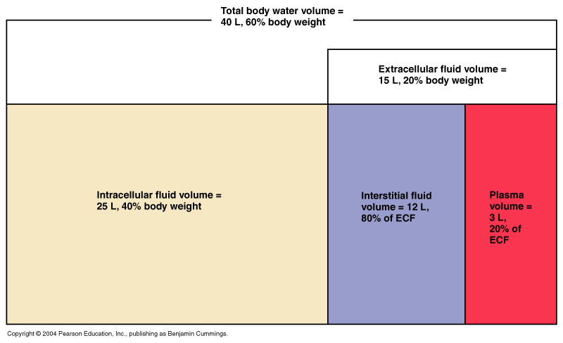
Water Compartments
- The fluid sites of the body where water is stored is called water compartments
  - Heart and circulatory system is an example of one compartment and the fluid is plasma
  - Joint capsules is an example and the water is synovial fluid
- Although water and ions are constantly moving, their proportion in the compartments remain constant
- This balance is called fluid-electrolyte homeostasis and it is essential for life

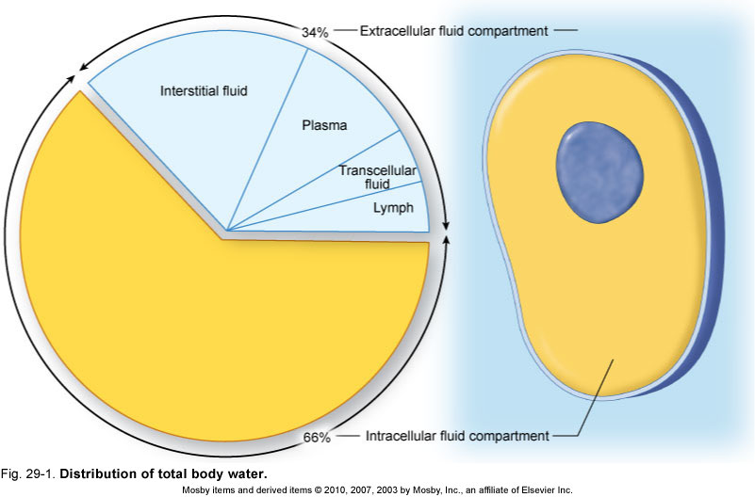

How Water Enters & Leaves the Body
- Water enters the body in the digestive tract; also added to the total fluid volume from each cell as it catabolizes food, with the resulting water entering the bloodstream
- Water leaves the body by four exits
  - As urine through the kidney
  - As water in expired air through the lungs
  - As sweat through the skin
  - As feces from the intestine

Water Intake and Output
- The total intake of daily water is about 2.5 liters
  - 1600 mL from drinking liquids
  - 700 mL from food
  - 200 mL from cell respiration
- The total water output is about 2.5 liters
  - 1500 mL from the urine
  - 500 mL from sweat
  - 300 mL from exhaled water vapor
  - 200 mL from feces

Regulation of Water Intake
- The hypothalamic thirst center contains osmoreceptors that detect changes in the osmolarity of body fluids
- Osmolarity is the concentration of dissolved materials in fluid
- Dehydration raises osmolarity
  - There is less water in proportion to the dissloved materials
- Thirst is quenched as soon as we begin to drink water
- Feedback signals that inhibit the thirst centers include:
  - Moistening of the mucosa of the mouth and throat
  - Activation of stomach and intestinal stretch receptors

Influence and Regulation of ADH
- Water reabsorption in collecting ducts is proportional to ADH release
- Low ADH levels produce dilute urine and reduced volume of body fluids
- High ADH levels produce concentrated urine
- Hypothalamic osmoreceptors trigger or inhibit ADH release
- Factors that specifically trigger ADH release include prolonged fever; excessive sweating, vomiting, or diarrhea; severe blood loss; and traumatic burns

Disorders of Water Balance: Dehydration
- Water loss exceeds water intake and the body is in negative fluid balance
- Causes include: hemorrhage, severe burns, prolonged vomiting or diarrhea, profuse sweating, water deprivation, and diuretic abuse
- Signs and symptoms: cottonmouth, thirst, dry flushed skin, and oliguria
- Prolonged dehydration may lead to weight loss, fever, and mental confusion
- Other consequences include hypovolemic shock and loss of electrolytes

Disorders of Water Balance: Edema
- Atypical accumulation of fluid in the interstitial space, leading to tissue swelling
- Caused by anything that increases flow of fluids out of the bloodstream or hinders their return
- Factors that accelerate fluid loss include:
  - Increased blood pressure, capillary permeability
  - Incompetent venous valves, localized blood vessel blockage
  - Congestive heart failure, hypertension, high blood volume
- May be localized or systemic
- Localized edema follows injury and inflammation
- Systemic edema is the result of an imbalance between the movement of water out of and into capillaries
- Edema is a symptom and not a disease
- Treatment is aimed at correcting the specific cause
  - If this is not possible then the volume of tissue fluid can be reduced my a low salt diet and the use of diuretics

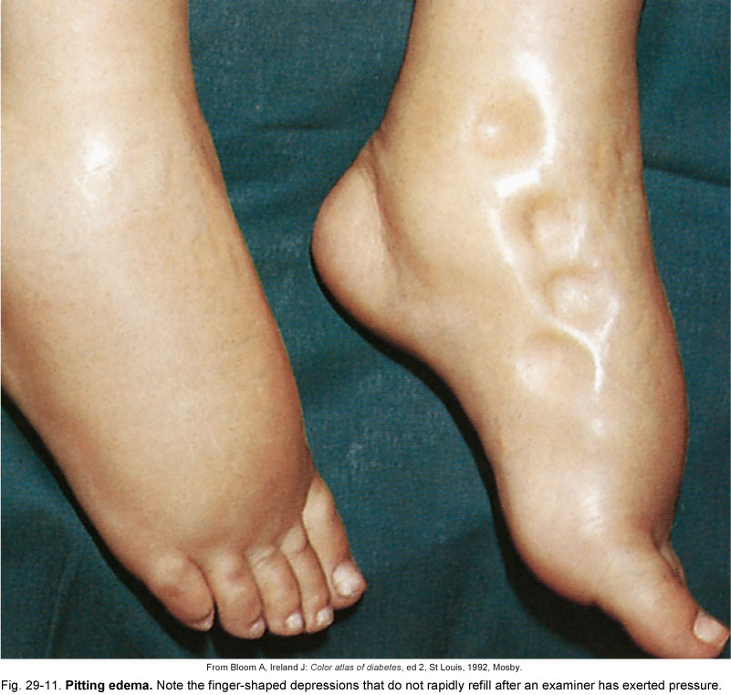

Mechanisms That Maintain Homeostasis of Total Fluid Volume
- Under normal conditions, homeostasis of total volume of water is maintained or restored primarily by adjusting urine volume and secondarily by fluid intake
- Regulation of fluid intake: decrease in fluid intake causes osmoreceptors in “thirst center” of hypothalamus to increase secretion of antidiuretic hormone
- Regulation: two factors determine urine volume
  - Glomerular filtration rate, except under abnormal conditions, remains fairly constant
  - Rate of tubular reabsorption of water fluctuates considerably; normally adjusts urine volume to fluid intake; influenced by amount of antidiuretic hormone and aldosterone

- Factors that alter fluid loss under abnormal conditions: rate of respiration and volume of sweat secreted may alter fluid output under certain abnormal conditions
  - Vomiting, diarrhea, or intestinal drainage can produce fluid and electrolyte imbalances
  - Symptoms range from simple thirst to muscle weakness and kidney failure

Electrolyte Balance
- Electrolytes are salts, acids, and bases, but electrolyte balance usually refers only to salt balance
- Salts are important for:
  - Neuromuscular excitability
  - Secretory activity
  - Membrane permeability
  - Controlling fluid movements
- Salts enter the body by ingestion and are lost via perspiration, feces, and urine

Regulation of Sodium and Potassium Levels in Body Fluids
- Normal sodium concentration in IF and potassium concentration in ICF depend on various factors, especially the amount of ADH and aldosterone secreted
  - ADH regulates ECF electrolyte concentration and colloid osmotic pressure by regulating amount of water reabsorbed into blood by renal tubules
  - Aldosterone regulates ECF volume by regulating the amount of sodium reabsorbed into blood by renal tubules
- Regulation of Sodium and Potassium Levels in Body Fluids
- When conservation of body sodium is required, the kidneys excrete essentially sodium-free urine; kidneys are considered the chief regulator of sodium levels
- Chloride: most important extracellular anion and almost always linked to sodium; chloride ions are generally excreted in urine in association with potassium; thus hypochloremia is often associated with cases of potassium loss
- Hypokalemia occurs in cell breakdown; as cells disintegrate, potassium enters the ECF and is rapidly excreted because it is not reabsorbed efficiently by the kidney

