Acid-Base Balance
Dr. Gary Mumaugh

Introduction
- Acid-base balance is one of the most important of the body’s homeostatic mechanisms
- Acid-base balance refers to regulation of hydrogen ion (H⁺) concentration in body fluids
- Precise regulation of pH at the cellular level is necessary for survival
- Slight pH changes have dramatic effects on cellular metabolism

Mechanisms That Control pH of Body Fluids
- Review of pH concept
  - pH indicates degree of acidity or alkalinity of a solution - range is from 0 - 14
  - If [H⁺] is high, solution is acidic; pH < 7
  - If [H⁺] is low, solution is basic or alkaline ; pH > 7
  - Acidosis describes arterial blood pH of less than 7.35
  - Alkalosis describes arterial blood pH greater than 7.45

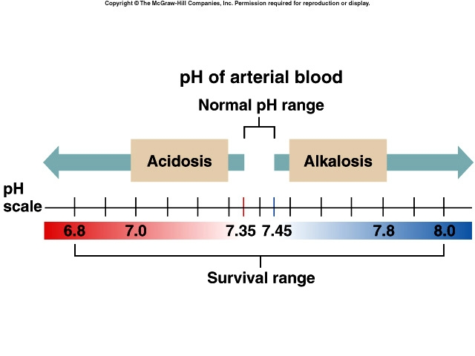Small changes in pH can produce major disturbances
- Most enzymes function only with narrow pH ranges
- Acid-base balance can also affect electrolytes (Na⁺, K⁺, Cl⁻)
- Can also affect hormones

The body produces more acids than bases
- Acids take in with foods
- Acids produced by metabolism of lipids and proteins
- Cellular metabolism produces CO₂
  - CO₂ + H₂0 ↔ H₂CO₃ ↔ H⁺ + HCO₃

Mechanisms That Control pH of Body Fluids
- Types of pH control mechanisms
- Chemical: rapid-action buffers
  - Bicarbonate buffer system
  - Phosphate buffer system
  - Protein buffer system
- Physiological: delayed-action buffers
  - Respiratory response
  - Renal response
- Summary of pH control mechanisms
  - Buffers
  - Respiration
  - Kidney excretion of acids and bases

Buffer Mechanisms for Controlling pH of Body Fluids
- Buffers
  - Substances that prevent a marked change in pH of a solution when an acid or base is added to it
  - Buffer pairs present in body fluids: mainly carbonic acid, proteins, hemoglobin, acid phosphate, and sodium and potassium salts of these weak acids
- Buffer systems
  - Take up H+ or release H+ as conditions change
    - Buffer pairs – weak acid and a base
    - Exchange a strong acid or base for a weak one
    - Results in a much smaller pH change
  - Types of buffer systems
    - Bicarbonate buffers
      - Sodium Bicarbonate (NaHCO₃) and carbonic acid (H₂CO₃)
      - Maintain a 20:1 ratio : HCO₃⁻ : H₂CO₃
      - HCl + NaHCO₃ ↔ H₂CO₃ + NaCl
      - NaOH + H₂CO₃ ↔ NaHCO₃ + H₂O
    - Phosphate buffers
      - Major intracellular buffer
      - H⁺ + HPO₄²⁻ ↔ H₂PO4⁻
      - OH⁻ + H₂PO₄⁻ ↔ H₂O + H₂PO₄²⁻
    - Protein Buffers
      - Includes hemoglobin, work in blood and ISF
      - Carboxyl group gives up H⁺
      - Amino Group accepts H⁺
      - Side chains that can buffer H⁺ are present on 27 amino acids.

Respiratory mechanisms
- Respiratory mechanism – limited to adjustments of CO₂.
  - With every exhalation CO₂ and H₂O leaves the body
  - Hypoventilation causes respiratory acidosis, and hyperventilation cause respiratory alkalosis
  - Respiratory control centers “sense” and regulate RR and depth
  - Changes in respiratory rate and depth also can partially correct metabolic disturbances
- Respiratory Mechanisms of pH Control
  - Explanation of respiratory mechanisms
    - Amount of blood carbon dioxide (CO₂) directly relates to the amount of carbonic acid and therefore to the concentration of H⁺
    - With increased respirations, less CO₂ remains in blood, hence less carbonic acid and fewer H⁺; with decreased respirations, more CO₂ remains in blood, hence more carbonic acid and more H⁺
  - Respirations adjustment to counter pH imbalance of arterial blood
- Principles that relate respirations to pH value
  - Prolonged hyperventilation, by decreasing blood H⁺ excessively, may produce alkalosis
  - Alkalosis causes hypoventilation, which tends to correct alkalosis by increasing blood CO₂ and therefore blood H₂CO₃ and H⁺
  - Prolonged hypoventilation, by eliminating too little CO₂, causes an increase in blood H₂CO₃ and consequently in blood H⁺, thereby possibly producing acidosis

Kidney Excretion
- Urinary mechanism - greatest capacity to adjust pH changes
- Slow to begin but long-lasting
  - The kidneys are the most effective regulators of blood pH
  - Eliminates much larger amounts of acid than the lungs, and if necessary can excrete excess base which the lungs cannot do
  - Renal Failure – acid base control fails

Urinary Mechanisms That Control pH
- General principles concerning urinary mechanisms
  - Play vital role in acid-base balance because kidneys can eliminate more H⁺ from the body while reabsorbing more base when pH lowers
- Mechanisms that control urine pH
  - Secretion of H⁺ into urine: when blood CO₂, H₂CO₃, and H⁺ increase above normal
  - Secretion of NH₃: when blood H⁺ concentration increases, distal tubules secrete more NH₃

Rates of correction
- Buffers function almost instantaneously
- Respiratory mechanisms take several minutes to hours
- Renal mechanisms may take several hours to days
- Evaluation of the role of buffers in pH control: cannot maintain normal pH without adequate functioning of the respiratory and urinary pH control mechanisms

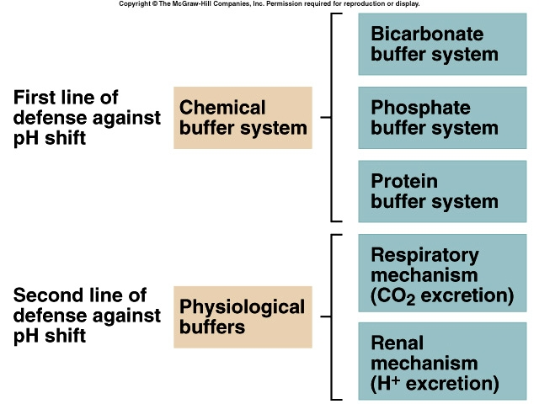
Acid Base Disturbances
- Metabolic Acidosis – to little bicarbonate
  - Acidosis – may be related to kidney disease, uncontrolled diabetes mellitus, excessive diarrhea, vomiting or use of diuretics.
    - Increased H⁺ stimulate respiratory centers and RR increases
    - Effects/symptoms of acidosis – depresses CNS, confusion, coma, and perhaps death
- Metabolic Ketoacidosis
  - Occurs in diabetic patients ( and those on the Atkin’s diet) when fats and proteins are used for energy instead of glucose
  - The use of fats without some glucose is inefficient and ketones accumulate in the blood making it acid
- Metabolic Alkalosis - to much bicarbonate
  - Alkalosis – rare but can occur with ingestion of too many antacids, vomiting of stomach contents only
    - Effects/symptoms – affects the PNS, irritability, muscle spasms, convulsions

Respiratory Disturbances
- Acidosis – to much carbonic acid
  - Seen in pneumonia and emphysema which retains CO2 in blood
  - Also seen in drug abuse and decreased breathing
- Alkalosis – to little carbonic acid
  - Seen in hyperventilation

Language of Medicine – Ch. 30
- Bicarbonate loading
- Emesis
- Hyperkalemia
- Lactic acidosis
- Metabolic acidosis
- Metabolic alkalosis
- Pernicious vomiting
- Respiratory acidosis
- Respiratory alkalosis

