Male Reproductive System
Dr. Gary Mumaugh

Reproductive System Basics
- Primary sex organs (gonads) – testes in males, ovaries in females
- Gonads produce sex cells called gametes (gametes means spouses) and secrete sex hormones
- Accessory reproductive organs – ducts, glands, and external genitalia
- Sex hormones – androgens (males), and estrogens and progesterone (females)
  - Sex hormones play roles in:
    - The development and function of the reproductive organs
    - Sexual behavior and drives
    - The growth and development of many other organs and tissues
- Functioning of the reproductive system ensures the survival of the genetic characteristics of a species
- Male reproductive system consists of organs whose functions are to produce, transfer, and introduce mature sperm into the female reproductive tract, where fertilization can occur

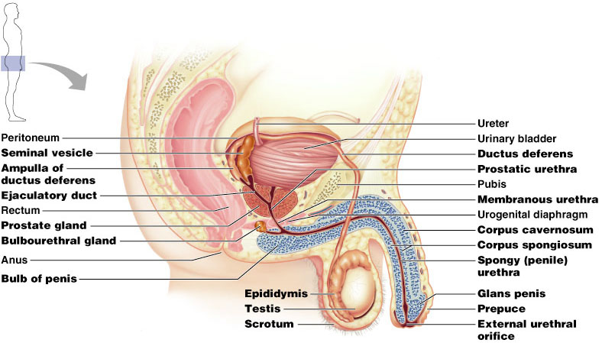

Male Reproductive System
- The male gonads (testes) produce sperm and lie within the scrotum
- Sperm are delivered to the exterior through a system of ducts: epididymis, vas deferens, ejaculatory duct, and the urethra
- Accessory sex glands:
  - Empty their secretions into the ducts during ejaculation
  - Include the seminal vesicles, prostate gland, and bulbourethral glands

Male Reproductive Organs
- Essential organs
  - For production of gametes
  - Gonads of male – testes
- Accessory organs
  - Support the reproductive process
  - Genital ducts convey sperm outside the body
    - pair of epididymides
    - paired vasa deferentia,
    - pair of ejaculatory ducts, and the
    - urethra
  - Accessory glands
    - produce secretions that nourish, transport, and mature sperm
    - pair of seminal vesicles, the prostate, and pair of bulbourethral glands
  - Supporting structures
    - Scrotum
    - Penis
    - Pair of spermatic cords
- Male – Perineum
  - Roughly diamond-shaped area between thighs
  - Extends from pubic symphysis to coccyx
  - Lateral boundary is the ischial tuberosity bilateral Divided into the urogenital triangle and the anal triangle

The Scrotum
- Sac of skin (scrotum = “pouch”) and superficial fascia that hangs outside the abdominopelvic cavity at the root of the penis
- Divided into two compartments - contains paired testicles separated by a midline septum
- Contains testis, epididymis, and lower part of a spermatic cord
- Dartos and cremaster muscles elevate the scrotal pouch
- Its external positioning keeps the testes 3°C lower than core body temperature (needed for sperm production)

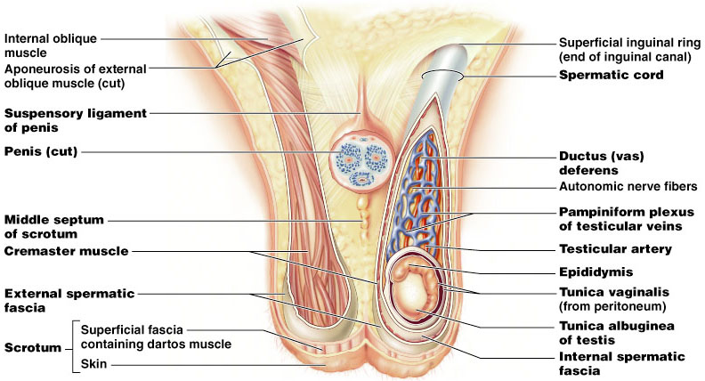

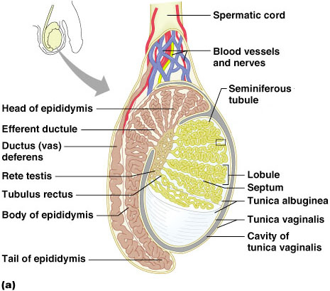

The Testes
- Located in scrotum, one testis in each of two scrotal compartments
- Each testis is surrounded by two tunics or layers
- Septa (walls) divide the testis into 250-300 lobules, each containing 1-4 seminiferous tubules
  - Produce and carry the sperm
- The microscopic structure of the seminiferous tubules contains interstitial cells called Leydig cells
  - The interstitial cells produce androgens
- The seminiferous tubules are encased in fibrous capsule called the tunica albuginea
- Seminiferous tubules in testis open into a plexus called rete testis
- From the rete testis, the sperm:
  - Leave the testis via efferent ductules
  - Enter the epididymis

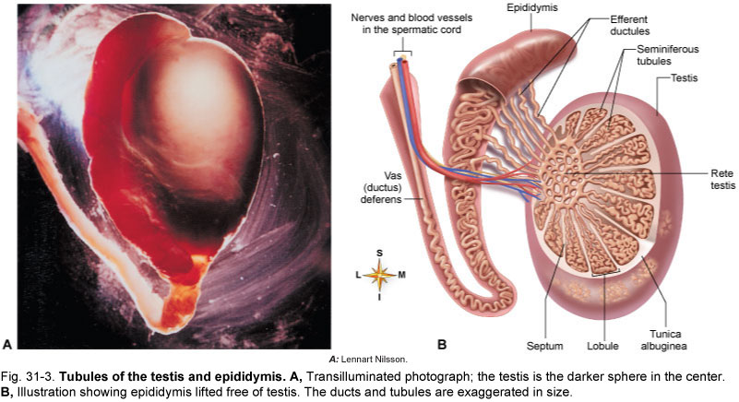

Functions of Testes
- Spermatogenesis - formation of mature male gametes (spermatozoa) by seminiferous tubules
  - stimulated by FSH from the anterior pituitary
- Secretion of hormones by interstitial cells
  - Testosterone
    - Type of androgen: maleness hormone
    - Secondary male sexual characteristics
    - Regulated by LH from anterior pituitary

Functions of Testes - comtinued
  - Inhibin
    - Inhibits release of FSH by anterior pituitary
    - Allows the testis some control over spermatogenesis
  - Estrogen
    - Small amounts secreted by interstitial cells, liver, and other organs
    - Role in males uncertain but may influence spermatogenesis and other functions

Testicular cancer
- Very rare cancer (<1% of all cancers), but most common cancer of young men
- Most common risk factor – cryptorchidism (undesended testicle)
- 7000 cases per year with 300 death per year
- 90% success rate with orchidectomy

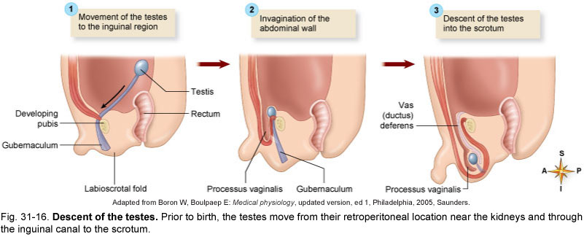

Spermatogenesis
- The sequence of events that produces sperm in the seminiferous tubules of the testes – takes 64 to 72 days
- Each cell has two sets of chromosomes (one maternal, one paternal)
- Humans have 23 pairs of chromosomes
- Spermatogenesis begins at puberty and continues throughout life
- Healthy adult male produces 400 million sperm per day
- Sperm have three major regions
  - Head – contains DNA and has a helmetlike acrosome containing hydrolytic enzymes that allow the sperm to penetrate and enter the egg
  - Midpiece – contains mitochondria spiraled around the tail filaments
  - Tail – a typical flagellum produced by a centriole

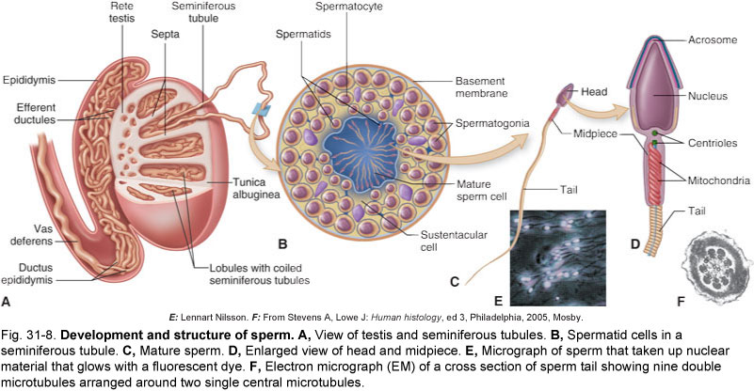

Male Secondary Sex Characteristics
- Male hormones make their appearance at puberty and induce changes in nonreproductive organs, including
  - Appearance of pubic, axillary, and facial hair
  - Enhanced growth of the chest and deepening of the voice
  - Skin thickens and becomes oily
  - Bones grow and increase in density
  - Skeletal muscles increase in size and mass
- Testosterone is the basis of libido in both males and females

The Penis
- Composed of three cylindrical masses of erectile tissue, one of which contains urethra
- Functions
  - Contains the urethra, the terminal duct for both urinary and reproductive tracts
  - Penetrating copulatory organ during sexual intercourse
- Consists of an attached root and a free body that ends in the glans penis or head
- Prepuce, or foreskin – cuff of skin covering the distal end of the penis
- Internal penis – the urethra and three cylindrical bodies of erectile tissue
- Erectile tissue – spongy network of connective tissue and smooth muscle riddled with vascular spaces
- Corpus spongiosum – surrounds the urethra and expands to form the glans and bulb of the penis

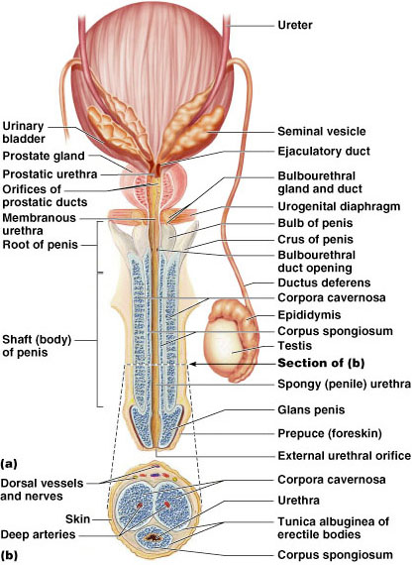

Epididymis
- Structure and location
  - Single tightly coiled tube enclosed in fibrous casing
  - Lies along top and side of each testis
  - Anatomical divisions include head, body, and tail
- Functions
  - Duct for seminal fluid
  - Also secretes part of seminal fluid
  - Sperm become capable of motility while they are passing through the epididymis
- Its head joins the efferent ductules and caps the superior aspect of the testis
- Nonmotile sperm enter, pass through its tubes and become motile (it takes about 20 days)
- If the epididymus ducts were uncoiled, it would be about 20 feet long
- Upon ejaculation the epididymis contracts, expelling sperm into the vas deferens

Vas Deferens (ductus deferens)
- Runs from the epididymis through the inguinal canal into the pelvic cavity then joins the duct of the seminal vesicle to form the ejaculatory duct
- Is approximately 18 inches long
- Propels sperm from the epididymis to the urethra
- Vasectomy – cutting and ligating the ductus deferens, which is a nearly 100% effective form of birth control
- Vasovasotomy – vasectomy reversal

Vas Deferens (ductus deferens) - continued
- Structure and location
  - Tube, extension of epididymis
  - Extends through inguinal canal, into abdominal cavity, over top and down posterior surface of bladder
  - Enlarged terminal portion called ampulla; joins duct of seminal vesicle
- Function
  - Excretory duct for seminal fluid
  - Connects epididymis with ejaculatory duct

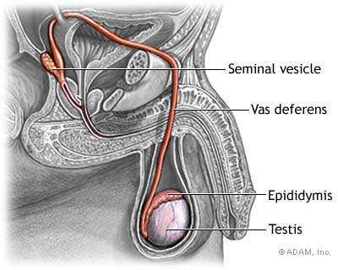

Urethra
- Conveys both urine and semen
- Consists of three regions
  - Prostatic – portion surrounded by the prostate
  - Membranous – lies in the urogenital diaphragm
  - Spongy, or penile – runs through the penis and opens to the outside at the external urethral orifice

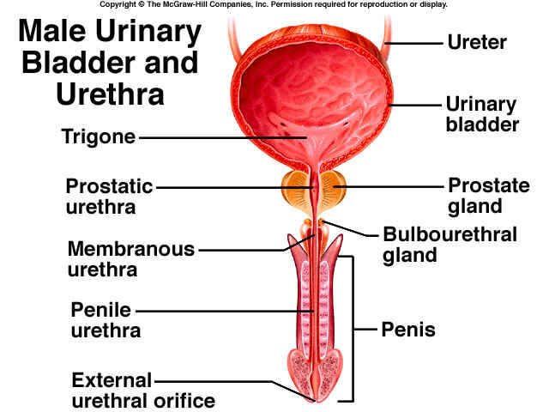

Accessory Glands
- Seminal Vesicles
  - Secrete 60% of the volume of semen
  - Join the vas deferens to form the ejaculatory duct
  - Sperm and seminal fluid mix in the ejaculatory duct and enter the prostatic urethra during ejaculation
- Prostate Gland
  - Encircles part of the urethra inferior to the bladder
  - Doughnut shaped
  - Plays a role in the activation of sperm
  - Function: adds slightly acidic, watery, milky-looking secretion to seminal fluid (30% of semen volume)
- Bulbourethral Glands (Cowper’s Glands)
  - Structure and location
    - Small, pea-shaped structures with approximately 2.5-cm long (1 inch) ducts leading into urethra
    - Lie below prostate gland
  - Function
    - Secrete alkaline fluid that is part of semen (5% of semen volume)
    - Produce thick, clear mucus prior to ejaculation that neutralizes traces of acidic urine in the urethra
Semen
- Provides a transport medium and nutrients, protects and activates sperm, and facilitates their movement
- Prostaglandins in semen:
  - Decrease the viscosity of mucus guarding the cervix
  - Stimulate reverse peristalsis in the uterus
  - Facilitate the movement of sperm through the female reproductive tract
  - The relative alkalinity of semen neutralizes the acid environment found in the male urethra and female vagina
- Only 2-5 ml of semen are ejaculated, but it contains 50-130 million sperm/ml

Erection
- Engorgement of spongy erectile bodies with blood during stimulation
- Under the control of parasympathetic control which releases nitrous oxide (NO2), which relaxes vascular smooth muscle causing the arterioles to dilate
  - Cavernous bodies fills with 50 cc blood
  - The erection blocks the venous flow from the penis after the cavernous bodies engorge

Ejaculation
- The propulsion of semen from the male duct system
- At ejaculation, sympathetic nerves serving the genital organs cause:
  - Reproductive ducts and accessory organs to contract and empty their contents
  - The bladder sphincter muscle to constrict, preventing the expulsion of urine
  - Bulbospongiosus muscles to undergo a rapid series of contractions
  - Propulsion of semen from the urethra

Composition and Course of Seminal Fluid
- Consists of secretions from testes, epididymides, seminal vesicles, prostate, and bulbourethral glands
- Each milliliter contains millions of sperm
- Passes from testes through epididymis, vas deferens, ejaculatory duct, and urethra

Male Fertility
- Relates to many factors: number, size, shape, and motility of sperm
- Infertility may be caused by antibodies some men make against their own sperm
- Male fertility begins at puberty and extends into old age

Cycle of Life: Male Reproductive
- Reproductive functions begin at time of puberty
- Development of organs begins before birth; immature testes descend into scrotum before or shortly after birth
- Puberty: high levels of hormones stimulate final stages of development
- System operates to permit reproduction until advanced old age
- Late adulthood: gradual decline in hormone production may decrease sexual appetite and fertility

