Female Reproductive System
Dr. Gary Mumaugh

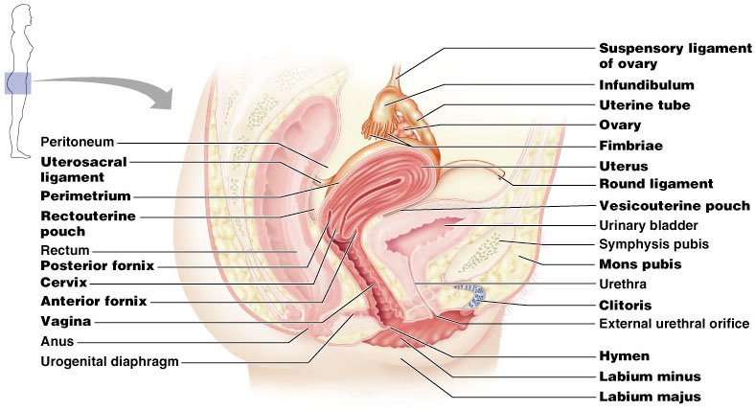

Overview - Function
- To produce offspring and thereby ensure continuity of the genetic code
- To produce eggs, or female gametes, each of which has the potential to unite with a male gamete to form the first cell of an offspring
- To provide nutrition and protection to the offspring for up to several years after conception

Structural plan of the female reproduction system
- Reproductive organs are classified as essential or accessory
  - Essential organs: gonads are the paired ovaries; gametes are ova produced by the ovaries; ovaries are also internal genitals
  - Accessory organs
    - Internal genitals: uterine tubes, uterus, and vagina—ducts or duct structures that extend from the ovaries to the exterior
    - External genitals: the vulva
    - Additional sex glands such as the mammary glands

Perineum
- The skin-covered region between the vaginal orifice and the rectum
- Area that may be torn during childbirth

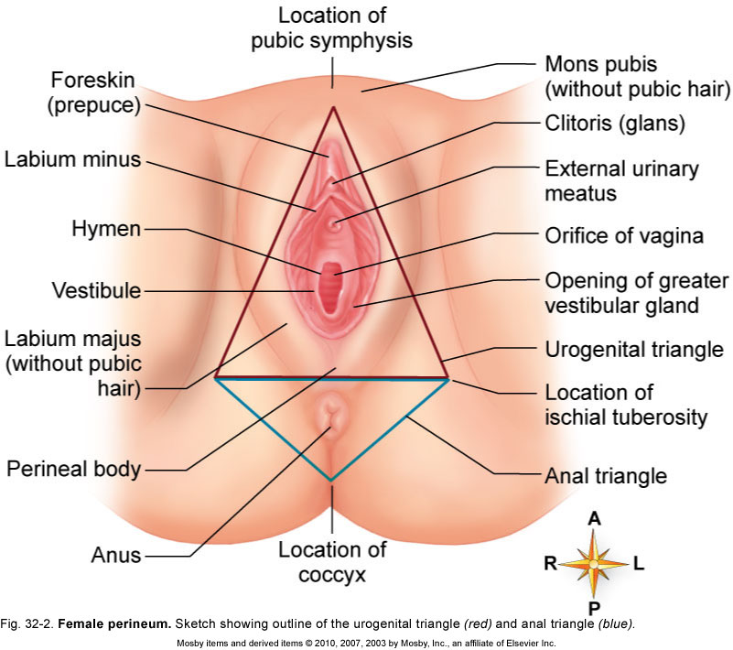
The Ovaries
- Functions
  - Ovaries produce ova, the female gametes
  - Oogenesis: process that results in formation of a mature egg
  - Ovaries are endocrine organs that secrete the female sex hormones (estrogens and progesterone)
- Paired organs on each side of the uterus held in place by several ligaments
  - Ovarian and Suspensory – anchors the ovary to the pelvic wall
  - Mesovarium – suspends the ovary in between
  - Broad ligament – contains the suspensory ligament and the mesovarium
- Deep in the ovaries is a highly vascular connective tissue with many saclike structures called ovarian follicles
  - Each follicle consists of an immature egg called an oocyte
- The follicles are at different stages of maturity
Primordial follicle  Primary follicle  Secondary follicle 
Graafian follicle  Ovulation  Corpus luteum
  - Graafian follicle – secondary follicle at its most mature stage that bulges from the surface of the ovary
  - Ovulation – ejection of the oocyte from the ripening follicle
  - Corpus luteum – ruptured follicle after ovulation

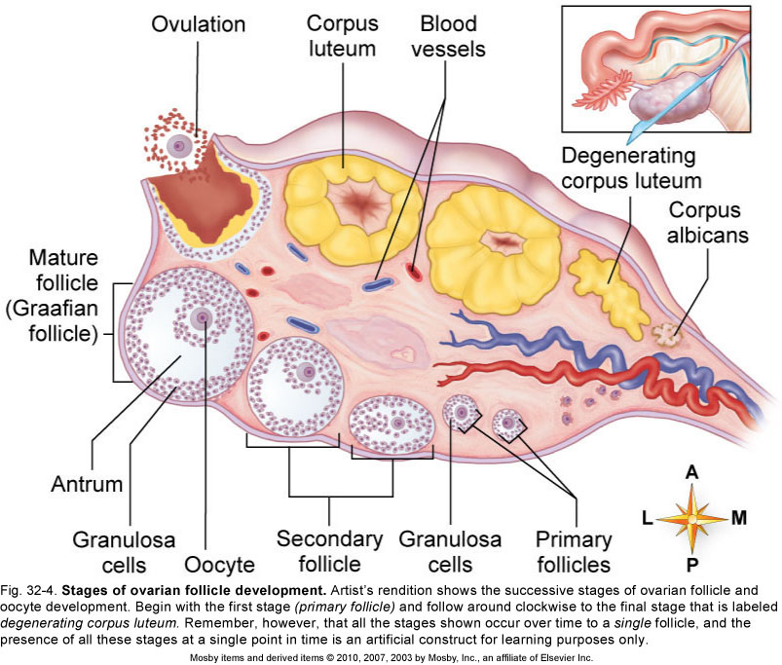

The Ovaries
- The female fetus, by the 7th month, has all the ova that she will ever have during her lifetime - There are 400,000 ova by the 7th month
- Ova were formed in yolk sac (not the ovary) and migrated to the ovaries
- The ova start discharging – ovulation – from 10 years to 50 years
  - 480 ovulations for reproductive life
- At ovulation, the fimbria engorge with blood to grasp the ovary
- Takes 3-4 days to go down the tube so fertilization can occur in the tube
    - Tubal pregnancy vs. ectopic pregnancy

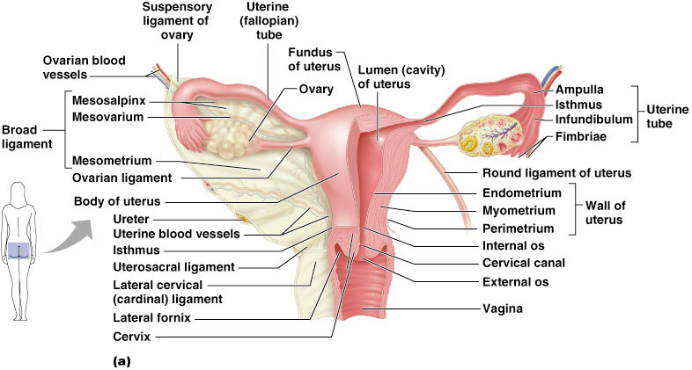

Uterus
Structure of the uterus
- Size and shape of the uterus
  - The uterus is pear shaped and has two main parts: the cervix and the body
- Wall of the uterus is composed of three layers: the inner endometrium (mucous membrane), the middle myometrium (smooth muscle), and the perimetrium (outer incomplete layer of parietal peritoneum)
- Cavities of the uterus are small because of the thickness of the uterine walls
  - The body cavity’s apex constitutes the internal os and opens into the cervical canal, which is constricted at its lower end and forms the external os that opens into the vagina
- Uterine arteries supply blood to the uterus

Location of the uterus
- Located in the pelvic cavity between the urinary bladder and the rectum
- Position of the uterus is altered by age, pregnancy, and distention of related pelvic viscera
- The uterus descends, between birth and puberty, from the lower abdomen to the true pelvis
- The uterus begins to decrease in size at menopause
- Body lies flexed over the bladder
- Cervix points downward and backward, joining the vagina at a right angle
- Several ligaments hold the uterus in place but allow some movement

Functions of the uterus
- The uterus is part of the reproductive tract and permits sperm to ascend toward the uterine tubes
- If conception occurs, an offspring develops in the uterus
  - The embryo is supplied with nutrients by endometrial glands until the production of the placenta
  - The placenta is an organ that permits the exchange of materials between the mother’s blood and the fetal blood but keeps the two circulations separate
  - Myometrial contractions occur during labor and help push the offspring out of the mother’s body
- If conception does not occur, outer layers of endometrium are shed during menstruation—a cyclical event that allows the endometrium to renew itself

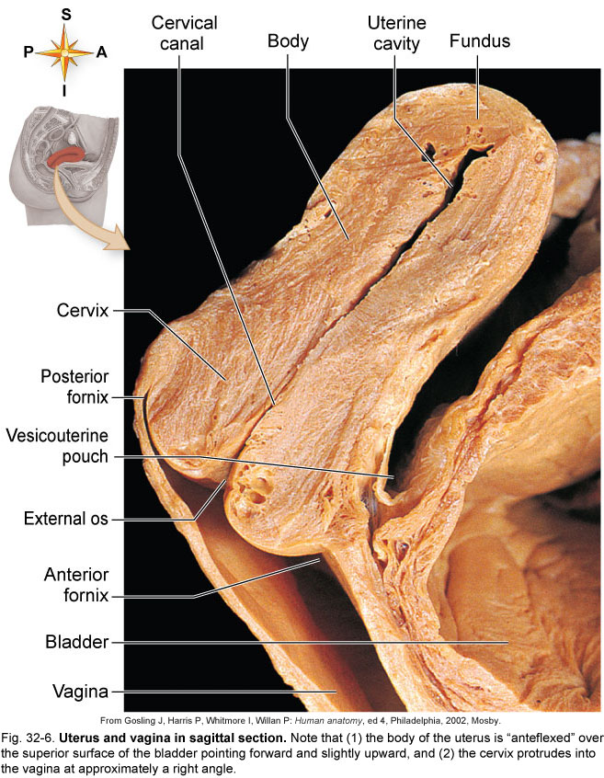

Uterine Tubes
- Also called fallopian tubes, or oviducts
- Uterine tubes are attached to the uterus at its upper outer angles and extend upward and outward toward the sides of the pelvis
- Structure
  - Uterine tubes consist of mucous lining, smooth muscle, and serous lining
  - Mucosal lining is directly continuous with the peritoneum lining the pelvic cavity
  - Tubal mucosa is continuous with that of the vagina and uterus, which means it may become infected with organisms introduced into the vagina
  - Each uterine tube has three divisions: isthmus, ampulla, and infundibulum
- Function: serve as transport channels for ova and as the site of fertilization

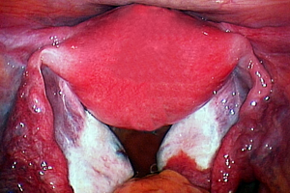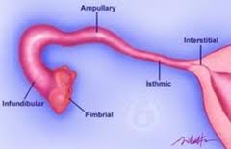

Vagina
- A tubular organ located between the rectum, urethra, and bladder
- Functions of the vagina
  - The lining of the vagina lubricates and stimulates the penis during sexual intercourse and acts as a receptacle for semen
  - The vagina is the lower portion of the birth canal
  - The vagina transports tissue and blood sheds during menstruation outside the body
- Structure of the vagina
  - The vagina is a collapsible tube capable of distention, composed of smooth muscle, and lined with mucous membrane arranged in rugae
  - The anterior wall is shorter than the posterior wall because the cervix protrudes into its uppermost portion
  - Hymen: a mucous membrane that typically forms a border around the vagina in young premenstrual girls

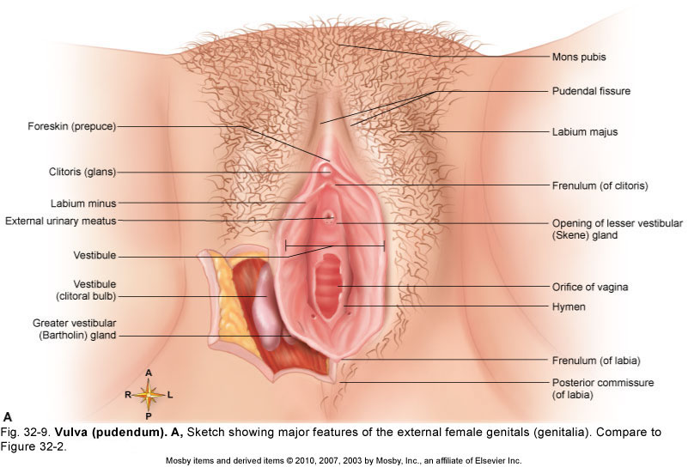
Vulva – External Genitalia
- Mons pubis - superficial fat pad over symphasis pubis
- Labia majora - folds of skin with glands that protect vestibule
- Labia minora
  - Folds of skin with glands that protects clitoris, urethra and vagina
- Clitoris
  - Erectile tissue with exposed glans
  - Clitoris contains sensory receptors that send information to the sexual response area of the brain
- Perineum
  - Area between pubic arch and cocyx
  - Episiotomy
- Greater vestibular glands – Bartholin’s Glands
  - Small pea-sized glands inside vagina
  - Keep the vestibule moist and lubricated
- Bulbospongiosus muscle
  - Deep in the vestibule the engorges with blood during stimulation which squeezes the urethra shut
- Lesser vestibular glands – Skene’s Glands
  - Also called paraurethral glands in anterior vaginal wall
  - Composed of erectile tissue
    - When stimulated, it prevents unrination and increases the orgasmic potential
    - Female ejaculation

Female Reproductive Cycles
- The female reproductive system has many cyclical, recurring changes that start with the beginning of menses
- Ovarian cycle
  - Ovaries from birth contain oocytes in primary follicles in which the meiotic process has been suspended
  - At the beginning of menstruation each month, several oocytes resume meiosis; meiosis stops again just before the cell is released during ovulation
- Menstrual cycle (endometrial cycle) is divided into four phases
  - Menses
  - Postmenstrual phase
  - Ovulation
  - Premenstrual phase
- Control of female reproductive cycles
  - Hormones control cyclical changes
  - Cyclical changes in the ovaries result from changes in the gonadotropins secreted by the pituitary gland
  - Cyclical changes in the uterus are caused by changes in estrogens and progesterone

Female Reproductive Cycles - continued
- Importance of the female reproductive cycles
  - Ovarian cycle’s primary function is to produce ova at regular intervals
  - Secondary function is to regulate the endometrial cycle through estrogen and progesterone
  - Function of the endometrial cycle is to make the uterus suitable for implantation of a new offspring
  - Cyclical nature of the reproductive system and the fact that fertilization occurs within 24 hours after ovulation mean that a woman is fertile only a few days of each month
- Infertility: failure to conceive after 1 year of regular unprotected intercourse
  - Causes are varied and can involve either or both partners
  - Fertility drugs and other assisted reproductive procedures such as in vitro fertilization are available
- Menstrual flow begins at puberty; menstrual cycle continues for about 3 decades

Breasts
- Location and size
  - The breasts lie over the pectoral muscles
  - Estrogens and progesterone control breast development
  - Breast size is determined by the amount of fat around glandular tissue
  - Alveoli of the mammary gland produce milk, and a system of ducts carries it to the nipple, surrounded by an areola
- Function of the breasts
  - The function of mammary glands is lactation
  - Mechanism of lactation
    - The ovarian hormones make the breasts structurally ready to produce milk
    - Shedding of the placenta results in a decrease of estrogens and thus stimulates prolactin
    - Prolactin stimulates lactation
    - Additional hormones also support lactation
  - Lactation can provide nutrient-rich milk to offspring for up to several years from birth; advantages include:
    - Nutrients
    - Passive immunity from antibodies present in the colostrum and milk
    - Emotional bonding between mother and child
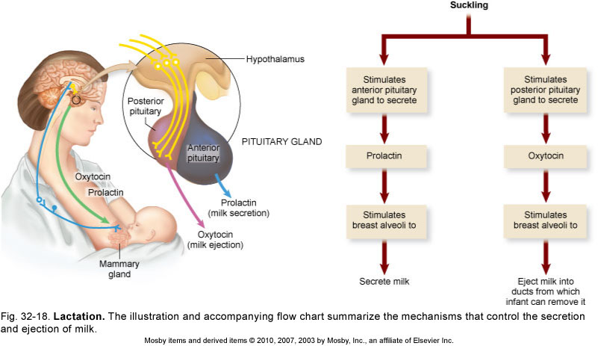

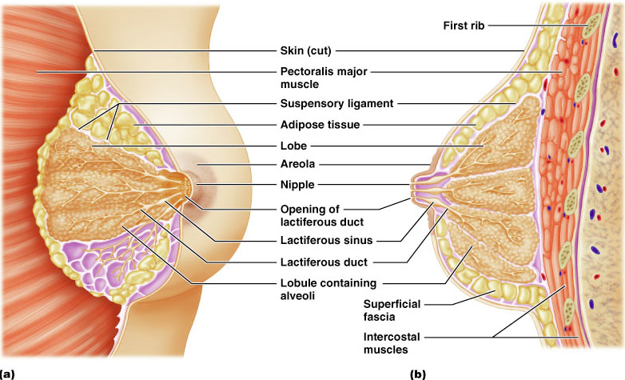

Physiological Benefits of Orgasm
- Reduces Stress
- Lowered blood pressure
- Increased Oxytocin and endorphins
- Increases Immunity
  - Increased antibodies and immunoglobulins
- Sex Burns Calories (Approximately 5/minute)
- Weight Reduction
  - Not from exercise
  - Release of phenylethyline (appetite suppressant)
  - Release of serotonin
- Improves Heart Health
  - Can increase HR to 125 & BP to 165
    - Equivalent to climbing stairs
  - Release DHEA – arterial dilator
  - British study
    - Decreased risk of heart attack by 50%
- Boosts Self Esteem
- Reduces Pain
  - Increased endorphins
- Improves Sleep
  - Due to lowered stress & relaxation
  - Increased Oxytocin & lowered Dopamin levels
- Sex Reduces Cancer Risk
  - Prostate and breast cancer
- Sex Strengthens Pelvic Floor Muscles
  - Kegel muscles
    - Has a favorable effect of incontinence latter in life
- Helps Decrease Aging by Increasing DHEA
  - Improves brain function
  - Improves fat metabolism
  - Improves immune function
  - Improves cardiovascular function
  - Duke study
  - BMJ study
- Sex Improves Intimacy
  - Due to Increased Oxytocin Levels
    - “Bonding, Love, Cuddling Hormone”
    - Decreases cravings
    - Calms
    - Increases sexual receptivity
    - Counteracts effects of cortisol
      - Increases immunity and faster recovery time
    - Improves mental health
    - Helps with depression
      - Similar effect to SSRI (Prozac)
The Big Picture: The Female Reproductive System and the Whole Body
- Reproductive system imparts immortality to genes and ensures survival of the species
- Relation of the female reproductive system with other body systems
- Close proximity to the urinary system; share a common structure: the vulva
- Anatomical relation with the skeletal muscles in the perineum
- Breasts are modifications of the skin in the integumentary system

Birth Control Methods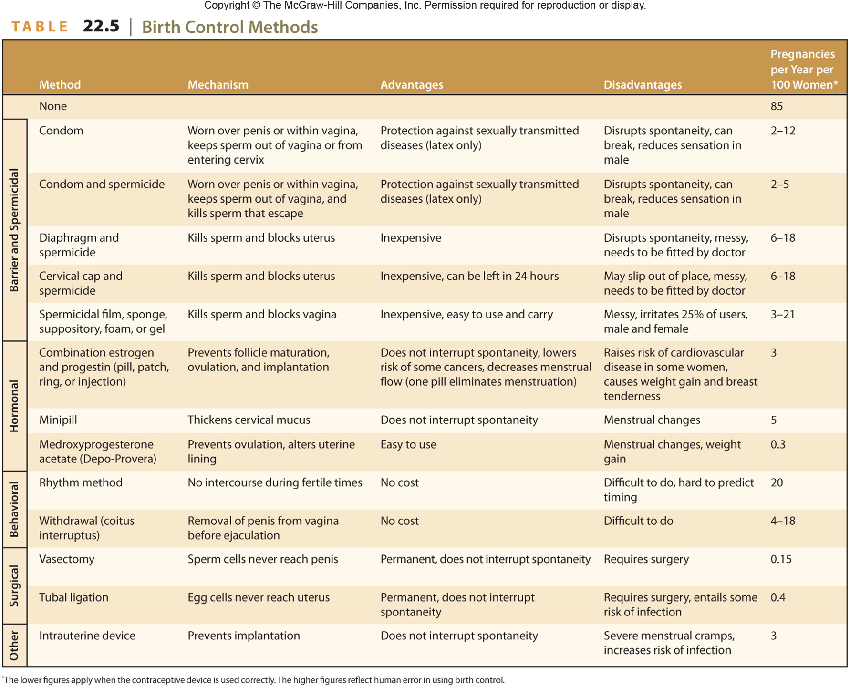
Some Sexually Transmitted Infections