Pregnancy and Human Development
Dr. Gary Mumaugh

From Egg to Embryo
- Pregnancy – events that occur from fertilization until the infant is born
- Conceptus – the developing offspring
- Gestation period – from the last menstrual period until birth
- Preembryo – conceptus from fertilization until it is two weeks old
- Embryo – conceptus during the third through the eighth week
- Fetus – conceptus from the ninth week through birth

Relative Size of Human Conceptus
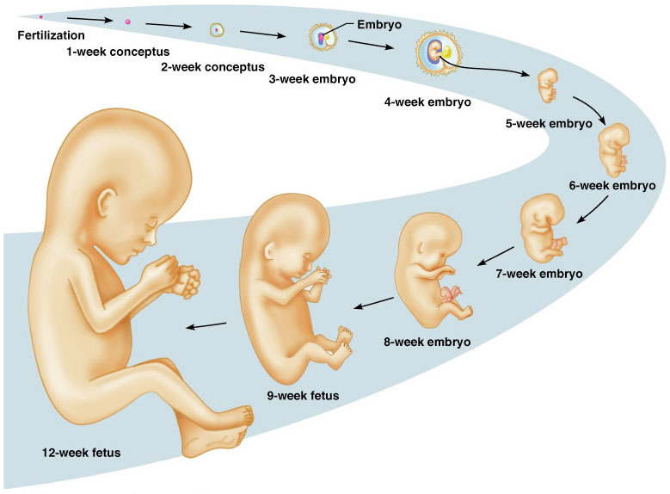

Accomplishing Fertilization
- The oocyte is viable for 12 to 24 hours
- Sperm is viable 24 to 72 hours
- For fertilization to occur, coitus must occur no more than:
- Three days before ovulation
- 24 hours after ovulation
- Fertilization – when a sperm fuses with an egg to form a zygote

Sperm Transport
- Fates of ejaculated sperm
  - Leak out of the vagina immediately after deposition
  - Destroyed by the acidic vaginal environment
  - Fail to make it through the cervix
  - Dispersed in the uterine cavity or destroyed by phagocytic leukocytes
  - Reach the uterine tubes

Polyspermy
- Polyspermy – multiple sperm penetrations
- Only one sperm is allowed to penetrate oocyte
- Blocks to polyspermy
  - Egg membrane depolarizes to prevent sperm from fusing
  - Proteins destroy sperm receptors
  - Proteins cause already attached sperm to death

Implantation
- Begins six to seven days after ovulation when the trophoblasts adhere to a properly prepared endometrium
- The trophoblasts then proliferate and form two distinct layers
- Implantation is completed by the fourteenth day after ovulation

Placentation
- The placenta is fully formed and functional by the end of the third month
- The placenta also secretes other hormones
  - Human placental lactogen, human chorionic thyrotropin, and relaxin

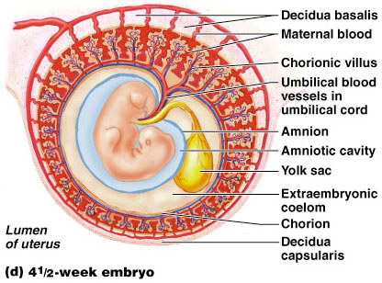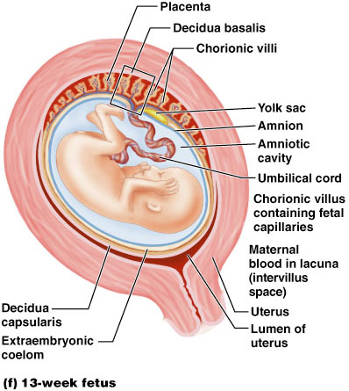

Pregnancy Testing
- Human chorionic gonadotropin, or hCG

Primary Germ Layers
- Serve as primitive tissues from which all body organs will derive
- Ectoderm – forms structures of the nervous system and skin epidermis
- Endoderm – forms epithelial linings of the digestive, respiratory, and urogenital systems
- Mesoderm – forms all other tissues
- Endoderm and ectoderm are securely joined and are considered epithelia
Specialization of Ectoderm
- Neuralization
  - First event of organogenesis giving rise to the brain and spinal cord.
  - Ectoderm thickens and forms neural plate which folds into neural tube.
  - By the 22nd day, neural folds fuse into a neural tube, which pinches off into the body.
  - The anterior end becomes the brain; the rest becomes the spinal cord.

Specialization of Endoderm
- Embryonic folding begins with lateral folds.
- Next, head and tail folds appear.
- An endoderm tube forms the epithelial lining of the GI tract.
- Organs of the GI tract become apparent, and oral and anal openings perforate.
- Endoderm forms epithelium linings of the hollow organs of the digestive and respiratory tracts.

Specialization of the Mesoderm
- The 40 pairs of somites have three functional parts:
  - Sclerotome – produce the vertebrae and ribs
  - Dermatome – help form the dermis of the skin on the dorsal part of the body
  - Myotome – form the skeletal muscles of the neck, trunk, and limbs
- Intermediate mesoderm forms the gonads and the kidneys
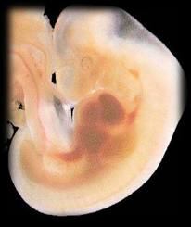
- Somatic mesoderm forms the:
  - Dermis of the skin in the ventral region
  - Parietal serosa of the ventral body cavity
  - Bones, ligaments, and dermis of the limbs
- Splanchnic mesoderm forms:
  - The heart and blood vessels
  - Most connective tissues of the body

Organogenesis
- By the 8th week all organ systems are recognizable

Development of Fetal Circulation
- By the end of the 3rd week:
  - The embryo has a system of paired vessels
  - The vessels forming the heart have fused
- Unique vascular modifications seen in prenatal development include umbilical arteries and veins, and three vascular shunts (occluded at birth)
  - Ductus venosus – venous shunt that bypasses the liver
  - Foramen ovale – opening in the interatrial septa to bypass pulmonary circulation
  - Ductus arteriosus – transfers blood from the right ventricle to the aorta

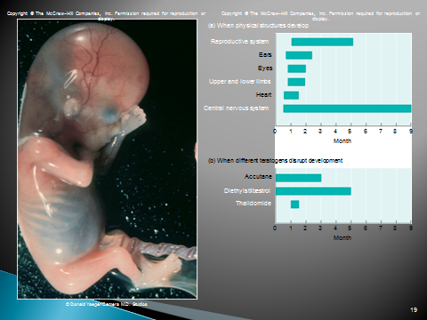

Effects of Pregnancy: Anatomical Changes
- Chadwick’s sign – the vagina develops a purplish hue
- Breasts enlarge and their areolae darken
- The uterus expands, occupying most of the abdominal cavity
- Lordosis is common due to the change of the body’s center of gravity
- Relaxin causes pelvic ligaments and the pubic symphysis to relax
- Typical weight gain is about 29 pounds
- Relative Uterus Size During Pregnancy

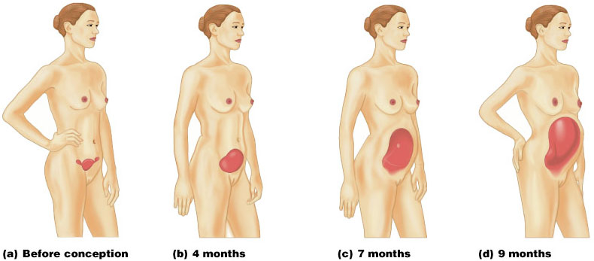

Effects of Pregnancy: Metabolic Changes
- The placenta secretes human placental lactogen (hPL), also called human chorionic somatomammotropin (hCS), which stimulates the maturation of the breasts
- hPL promotes growth of the fetus and exerts a maternal glucose-sparing effect
- Human chorionic thyrotropin (hCT) increases maternal metabolism
- Parathyroid hormone levels are high, ensuring a positive calcium balance

Effects of Pregnancy: Physiological Changes
- GI tract – morning sickness occurs due to elevated levels of estrogen and progesterone
- Urinary system – urine production increases to handle the additional fetal wastes
- Respiratory system – edematous and nasal congestion may occur
- Dyspnea (difficult breathing) may develop late in pregnancy
- Cardiovascular system – blood volume increases
25-40%
  - Venous pressure from lower limbs is impaired, resulting in varicose veins

Parturition: Initiation of Labor
- Estrogen reaches a peak during the last weeks of pregnancy causing myometrial weakness and irritability
- Weak Braxton Hicks contractions may take place
- As birth nears, oxytocin and prostaglandins cause uterine contractions
- Emotional and physical stress:
  - Activates the hypothalamus
  - Sets up a positive feedback mechanism, releasing more oxytocin

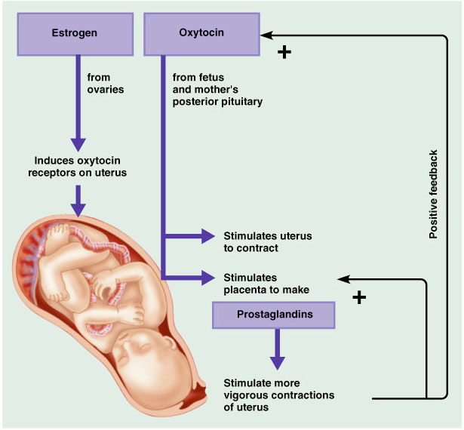

Stages of Labor: Dilation Stage
- From the onset of labor until the cervix is fully dilated (10 cm)
- Initial contractions are 15–30 minutes apart and 10–30 seconds in duration
- The cervix effaces and dilates
- The amnion ruptures, releasing amniotic fluid (breaking of the water)
- Engagement occurs as the infant’s head enters the true pelvis

Stages of Labor: Expulsion Stage
- From full dilation to delivery of the infant
- Strong contractions occur every 2–3 minutes and last about 1 minute
- The urge to push increases in labor without local anesthesia
- Crowning occurs when the largest dimension of the head is distending the vulva
- The delivery of the placenta is accomplished within 30 minutes of birth
- Afterbirth – the placenta and its attached fetal membranes
- All placenta fragments must be removed to prevent postpartum bleeding

Extrauterine Life
- At 1-5 minutes after birth, the infant’s physical status is assessed based on five signs: heart rate, respiration, color, muscle tone, and reflexes
- Each observation is given a score of 0 to 2
- Apgar score – the total score of the above assessments
  - 8-10 indicates a healthy baby - Lower scores reveal problems
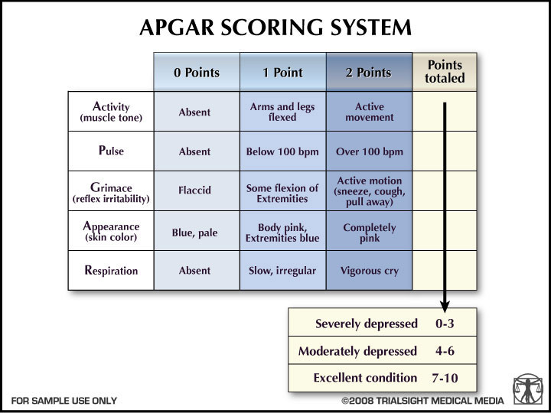

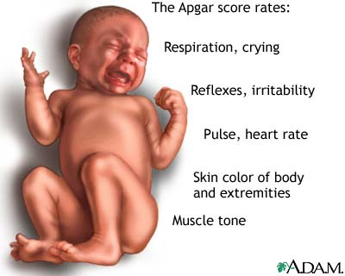

First Breath
- Once carbon dioxide is no longer removed by the placenta, central acidosis occurs
- This excites the respiratory centers to trigger the first inspiration
- This requires tremendous effort – airways are tiny and the lungs are collapsed
- Once the lungs inflate, surfactant in alveolar fluid helps reduce surface tension

Transitional Period
- Unstable period lasting 6-8 hours after birth
- The first 30 minutes the baby is alert and active
  - Heart rate increases (120-160 beats/min.)
  - Respiration is rapid and irregular
  - Temperature falls
- Activity then diminishes and the infant sleeps about three hours
- A second active stage follows in which the baby regurgitates mucus and debris
- After this, the infant sleeps, with waking periods occurring every 3-4 hours

Lactation
- The production of milk by the mammary glands
- Estrogens, progesterone, and lactogen stimulate the hypothalamus to release prolactin-releasing hormone (PRH)
- The anterior pituitary responds by releasing prolactin
- Colostrum
  - Solution rich in vitamin A, protein, minerals, and IgA antibodies
  - Is released the first 2–3 days
  - Is followed by true milk production

Lactation and Milk Let-down Reflex
- After birth, milk production is stimulated by the sucking infant

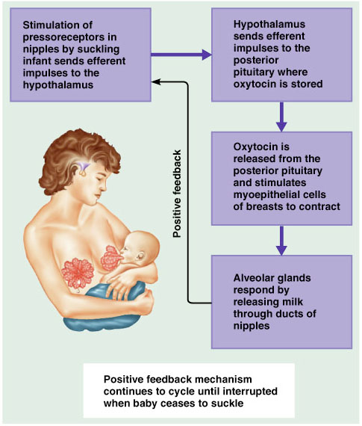

Breast Milk
- Advantages of breast milk for the infant
  - Fats and iron are better absorbed
  - Its amino acids are metabolized more efficiently than those of cow’s milk
  - Beneficial chemicals are present – IgA, other immunoglobulins, complement, lysozyme, interferon, and lactoperoxidase
  - Interleukins and prostaglandins are present, which prevent overzealous inflammatory responses
  - Its natural laxatives help cleanse the bowels of meconium

Prenatal Stages
- Germinal period: Days 1-14
  - Implantation: One-half are successful
  - Miscarriage: 15% to 50%
- Embryonic period: 3rd to 8th week
  - Organogenesis, Sexual differentiation
  - Brain development starts at 3-4 weeks
- Fetal period: 9th week – birth
  - Proliferation, Migration
  - Ends in tremendous brain development
  - Age of viability at 23 weeks (5 ½ months)

Stages of Life
Infancy
- From the end of the 4th week to one year
- The growth rate is high
- The teeth begin to erupt
- The muscular and nervous systems mature
- Communication begins
Childhood
- From one year to puberty
- The growth rate is high
- Permanent teeth appear
- Muscular control is achieved
- Bladder and bowel controls are established
- Intellectual abilities mature

Adolescence
- From puberty to adulthood
- The person becomes reproductively functional and emotionally more mature
- Growth spurts occur
- Motor skills continue to develop
- Intellectual abilities continue to mature
Adulthood
- Adolescence to old age
- The person remains relatively unchanged anatomically and physiologically
- Degenerative changes begin
Senescence
- Old age to death
- Degenerative changes continue
- The body becomes less able to cope with the demands placed on it
- Death results from various conditions and diseases

Age Related Changes
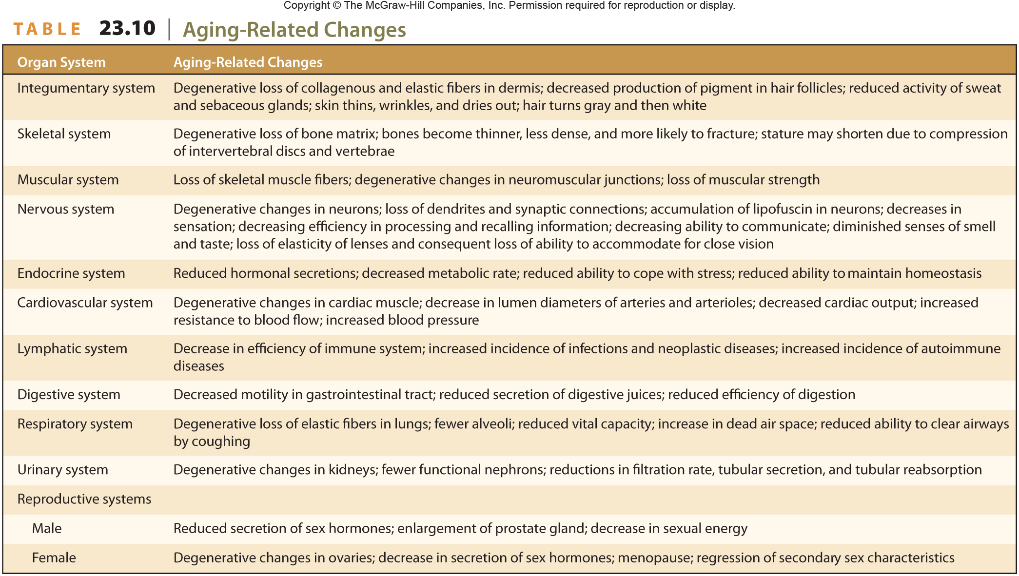

Ten Leading Causes of Death in USA 2004

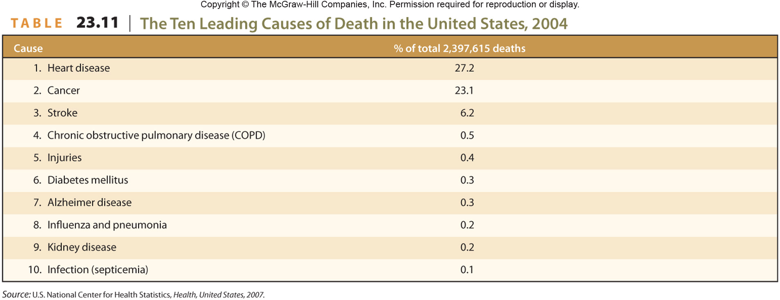

Teratogen
- Any disease, drug or environmental agent that can harm a developing fetus
- 15% of newborns have minor problems
- 5% of newborns have significant problems
- Generalizations about the effects of teratogens
  - Critical period is worse in organogenesis
  - Dosage and duration
  - Genetic make-up of mom determines susceptibility

Teratogens: Drugs
- Thalidomide
  - For morning sickness in the 1950s
  - All or parts of limbs missing
- Tobacco
  - Miscarriage, low birth weight, SIDS, slows fetal growth
- Alcohol: FAS
  - Small, facial deformities, retardation
- Cocaine
  - Processing difficulties

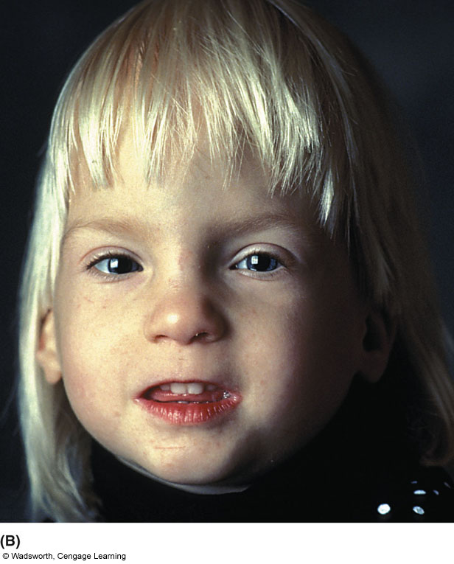

Teratogens - Diseases
- Rubella (German Measles)
  - Blind, deaf, heart, brain
- Syphilis
  - Miscarriage, blind, deaf, heart, brain
- AIDS: Mothers transmit to babies
  - Without treatment 15%-35% of infected babies will become HIV positive
  - Even those infected, 75% are alive at age 5

Teratogens: Environmental Hazards
- Radiation
  - MR, leukemia, cancer, mutations, spontaneous abortions, etc.
  - Avoid X-rays when pregnant
- Pollutants
  - In air and water
  - Lead: MR (also postnatally)
    - 1 in 4 children live in homes with lead paint
- One estimate is that there are 70,000 synthetic chemicals are available for exposure, and only 20% have been tested for toxity

