Bone Tissue
Dr. Gary Mumaugh

Function of Bones
- Support – form the framework that supports the body and cradles soft organs
- Protection – provide a protective case for the brain, spinal cord, and vital organs
- Movement – provide levers for muscles
- Mineral storage – reservoir for minerals, especially calcium and phosphorus
- Blood cell formation – hematopoiesis occurs within the marrow cavities of bones

Gross Anatomy of Bone

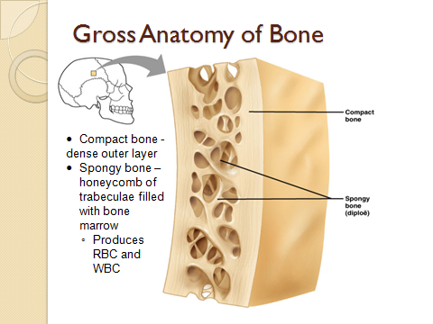
Classification of Bones
- Axial skeleton – bones of the skull, vertebral column, and rib cage
- Appendicular skeleton – bones of the upper and lower limbs, shoulder, and hip
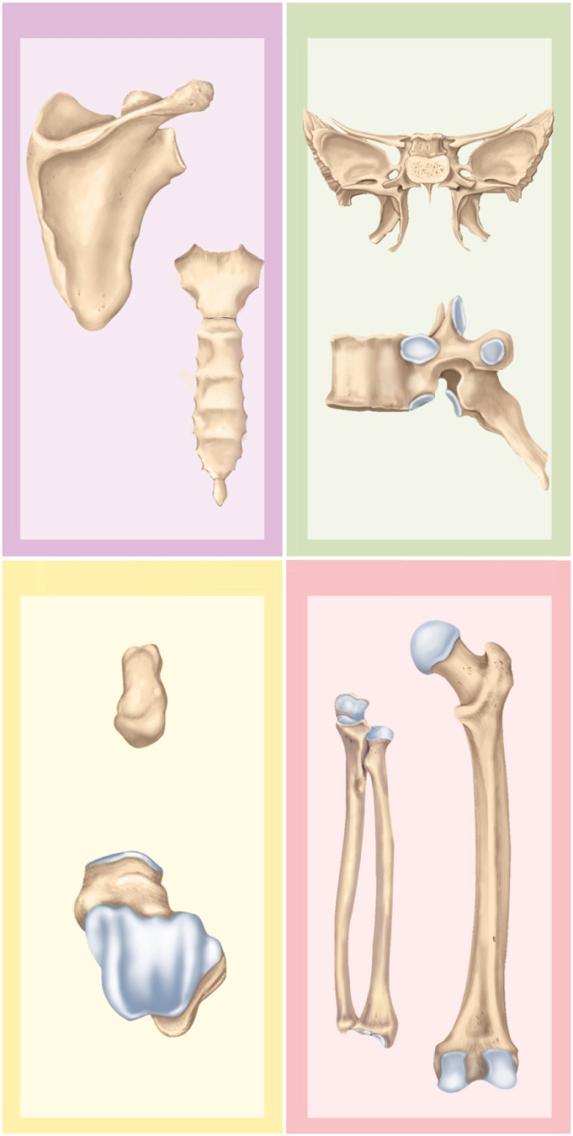
Shape of Bones
- Long bones
- Short bones
- Flat bones
- Irregular bones

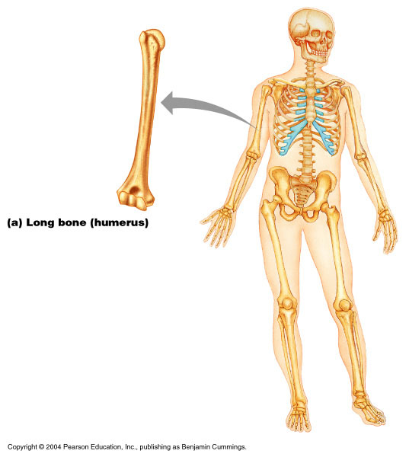
Long Bones
- Long bones – longer than they are wide
- Humerus, radius, ulna
- Femur, tibia, fibula

Structure of Long Bones
- Diaphysis
  - Tubular shaft that forms the axis of long bones
- Epiphyses
  - Expanded ends of long bones
  - Joint surface is covered with articular (hyaline) cartilage
  - Epiphyseal line separates the diaphysis from the epiphyses

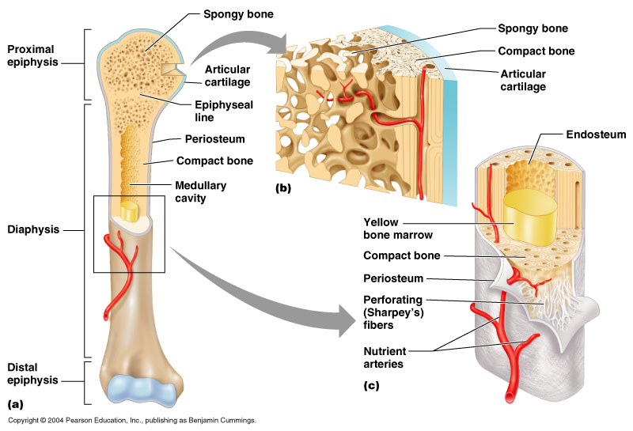

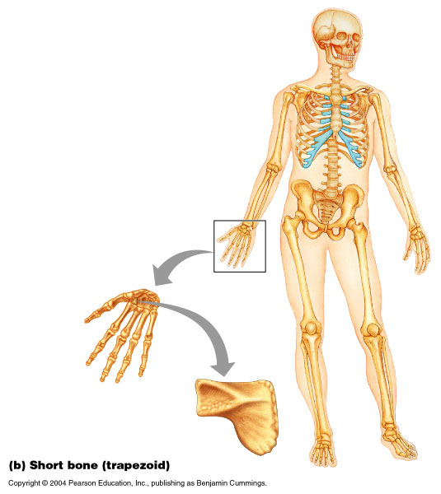
Short Bones
- Short bones
  - Bones of the wrist and ankle
  - Bones that form within tendons (e.g., patella)

Flat Bones
- Flat bones – thin, flattened, and a bit curved (e.g., sternum, and most skull bones)

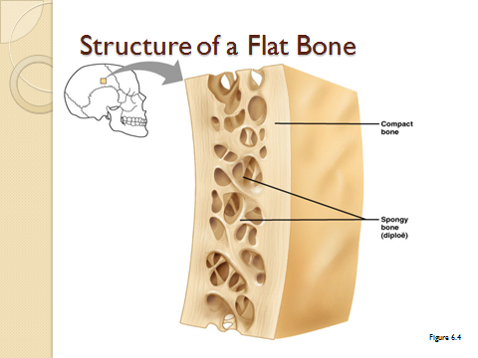
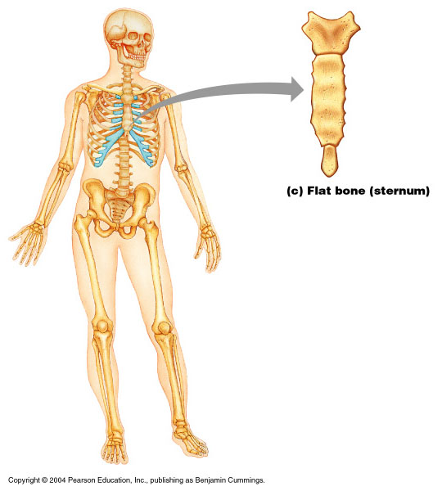
Irregular Bones
- Irregular bones – bones with complicated shapes (e.g., vertebrae and hip bones)

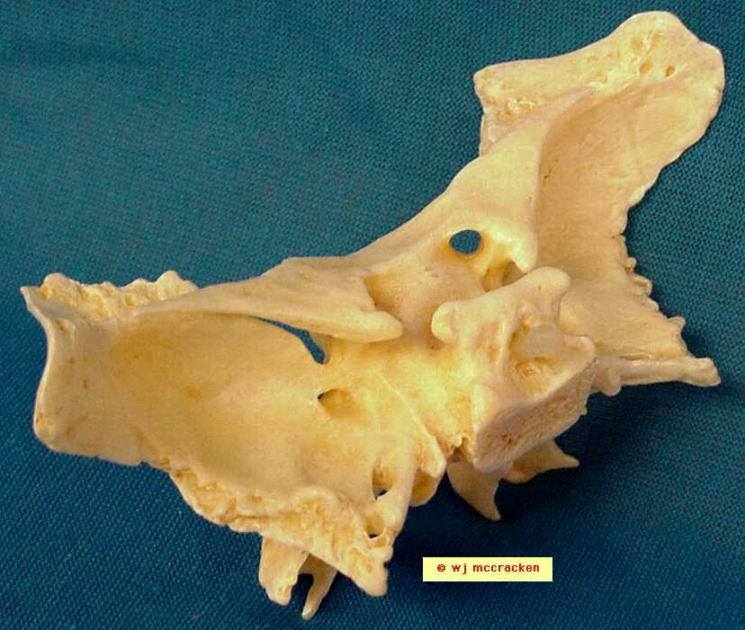
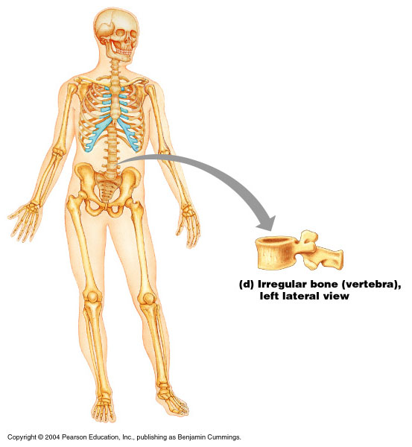

Bone Membranes
- Periosteum – double-layered protective membrane
  - Outer fibrous layer is dense regular connective tissue
  - Richly supplied with nerve fibers, blood, and lymphatic vessels, which enter the bone via nutrient foramina
- Endosteum – delicate membrane covering internal surfaces of bone

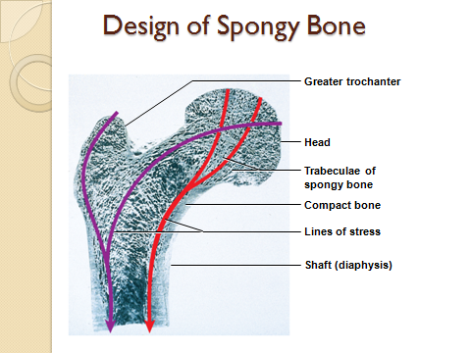
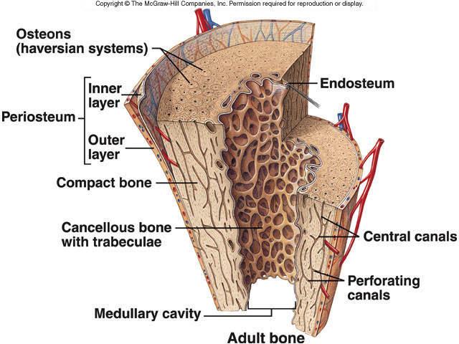

Bone Marrow
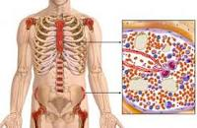
- bone marrow – general term for soft tissue that occupies the marrow cavity of a long bone and small spaces amid the trabeculae of spongy bone
- red marrow
  - in nearly every bone in a child
  - hemopoietic tissue - produces blood cells
  - in adults, found in skull, vertebrae, ribs, sternum, part of pelvic girdle, and proximal heads of humerus and femur
- yellow marrow found in adults
  - most red marrow turns into fatty yellow marrow
  - no longer produces blood

Bone Development
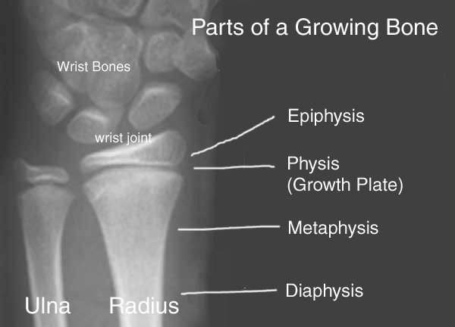
- ossification or osteogenesis – the formation of bone
- in the human fetus and infant, bone develops by two methods:
- intramembranous ossification
- endochondral ossification

Bone Growth and Remodeling
- ossification continues throughout life with the growth and remodeling of bones
- bones grow in two directions: length and width
- bone elongation
  - epiphyseal plate – a region of transition from cartilage to bone
    - functions as growth zone where the bones elongate
    - consists of typical hyaline cartilage in the middle
    - with a transition zone on each side where cartilage is being replaced by bone

Factors Affecting Bone Growth
- Heredity
- Nutrition
  - Calcium, phosphorus, protein, Vitamin D, A, C
- Hormones
- Exercise or “stress”
Without bones becoming weight bearing, they lose calcium

Hormonal Regulation of Bone Growth During Youth
- During infancy and childhood, epiphyseal plate activity is stimulated by growth hormone
- During puberty, testosterone and estrogens:
  - Initially promote adolescent growth spurts
  - Cause masculinization and feminization of specific parts of the skeleton
  - Later induce epiphyseal plate closure, ending longitudinal bone growth

Importance of Ionic Calcium in the Body
- Calcium is necessary for:
  - Transmission of nerve impulses
  - Muscle contraction
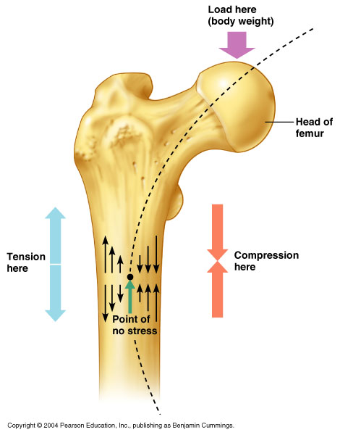
  - Blood coagulation
  - Secretion by glands and nerve cells
  - Cell division

Response to Mechanical Stress
- Wolff’s law – a bone grows or remodels in response to the forces or demands placed upon it
- Observations supporting Wolff’s law include
  - Long bones are thickest midway along the shaft (where bending stress is greatest)
  - Curved bones are thickest where they are most likely to buckle
Bone Fractures (Breaks)
- Bone fractures are classified by:
  - The position of the bone ends after fracture
  - The completeness of the break
  - The orientation of the bone to the long axis
  - Whether or not the bones ends penetrate the skin
- Types of Bone Fractures
  - Compound (open) – bone ends penetrate the skin
  - Simple (closed) – bone ends do not penetrate the skin
  - Greenstick – incomplete fracture where one side of the bone breaks and the other side bends; common in children
  - Comminuted – bone fragments into three or more pieces; common in the elderly
  - Compression – bone is crushed; common in porous bones

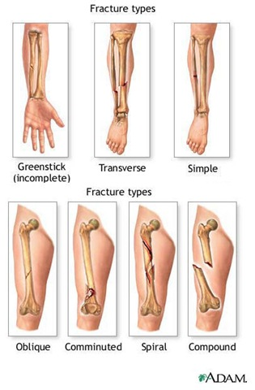

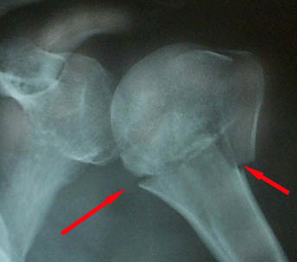
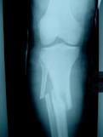

Stages in the Healing of a Bone Fracture
- Hematoma formation A
  - Torn blood vessels hemorrhage
  - A mass of clotted blood (hematoma) forms at the fracture site
  - Site becomes swollen, painful, and inflamed
- Fibrocartilaginous callus forms B
- Bony callus formation C
  - Bone callus begins 3-4 weeks after injury, and continues until firm union is formed 2-3 months later
- Bone remodeling D
  - Excess material on the bone shaft exterior and in the medullary canal is removed
  - Compact bone is laid down to reconstruct shaft walls

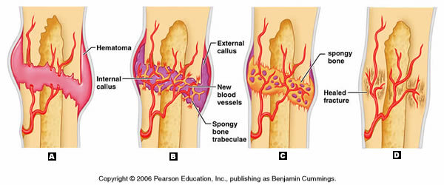

Homeostatic Imbalances
- Osteomalacia
  - Bones are inadequately mineralized causing softened, weakened bones
  - Main symptom is pain when weight is put on the affected bone
  - Caused by insufficient calcium in the diet, or by vitamin D deficiency
- Rickets
  - Bones of children are inadequately mineralized causing softened, weakened bones
  - Bowed legs and deformities of the pelvis, skull, and rib cage are common
  - Caused by insufficient calcium in the diet, or by vitamin D deficiency
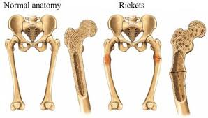
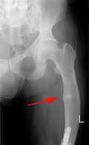

- Osteopenia
  - Normal bone demineralization seen after 35-40 years old
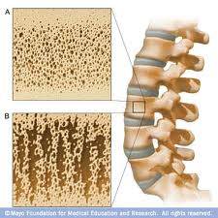
- Osteoporosis
  - Spongy bone of the spine is most vulnerable
  - Occurs most often in postmenopausal women
  - Bones become so fragile that sneezing or stepping off a curb can cause fractures
  - Osteoporosis Treatment
    - Calcium and vitamin D supplements
      - 1200 mg. of calcium per day
      - Increased weight-bearing exercise
      - Hormone (estrogen) replacement therapy (HRT) slows bone loss
      - Natural progesterone cream prompts new bone growth

