The Axial Skeleton
Dr. Gary Mumaugh

The Axial Skeleton
- Eighty bones segregated into three regions
  - Skull
  - Vertebral column
  - Bony thorax

The Skull
- The skull, the body’s most complex bony structure, is formed by the cranium and facial bones
- Cranium – protects the brain and is the site of attachment for head and neck muscle
- Facial bones
  - Supply the framework of the face, the sense organs, and the teeth
  - Provide openings for the passage of air and food
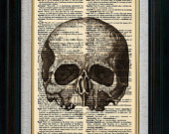
  - Anchor the facial muscles of expression

Anatomy of the Cranium
- Eight cranial bones
  - two parietal
  - two temporal,
  - one frontal, one occipital, one sphenoid, and one ethmoid
  - Cranial bones are thin and remarkably strong for their weight

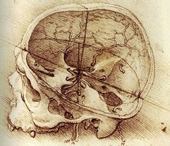

Anterior Skull

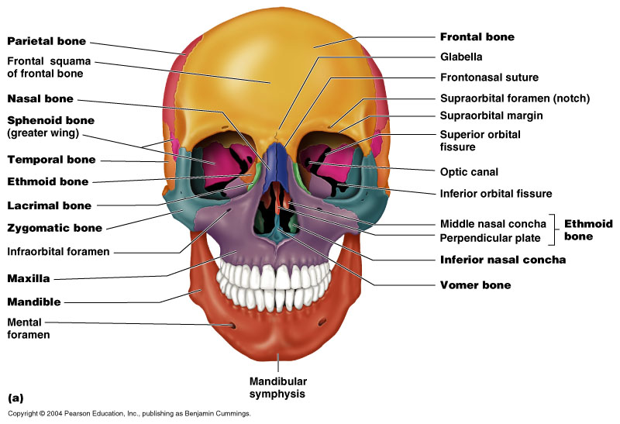

Posterior Skull
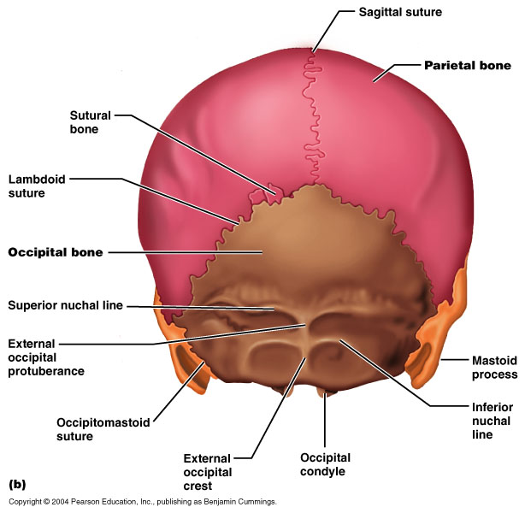

Lateral Skull

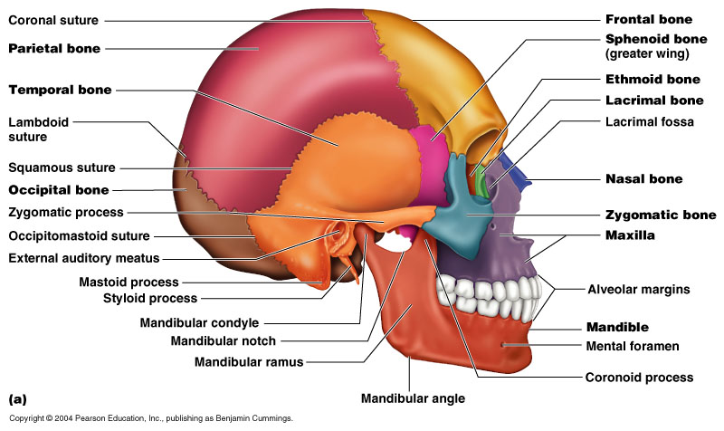

Inferior Skull
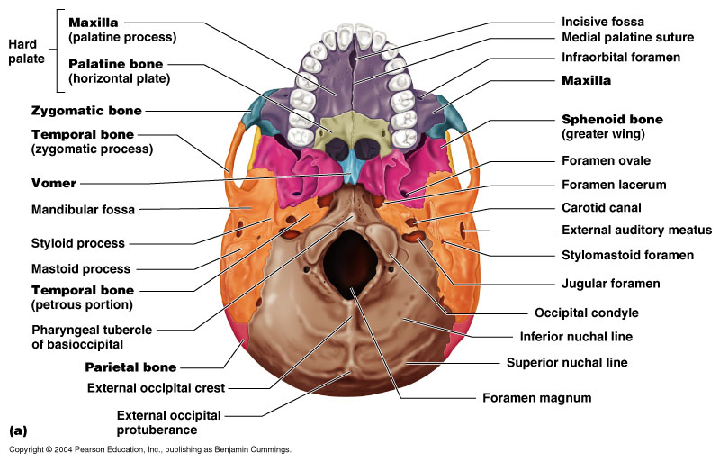
Mandible
- The mandible (lower jawbone) is the largest, strongest bone of the face

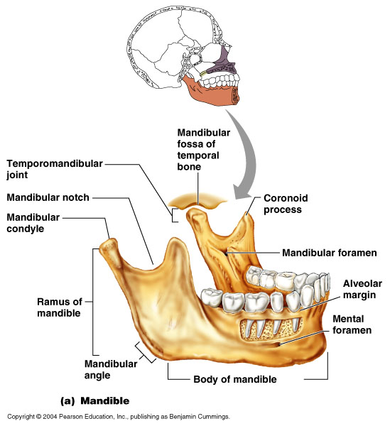

Maxillary Bones
- Medially fused bones that make up the upper jaw and the central portion of the facial skeleton
- Facial keystone bones that articulate with all other facial bones except the mandible

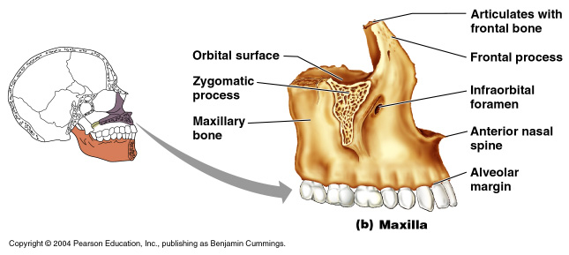

Paranasal Sinuses

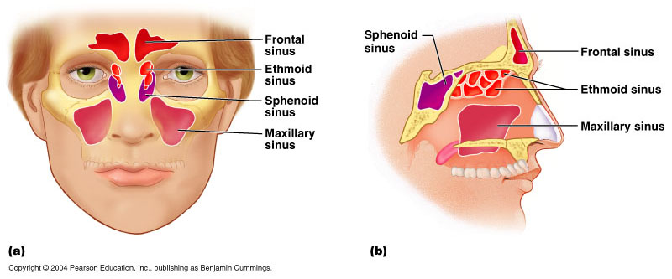

Vertebral Column
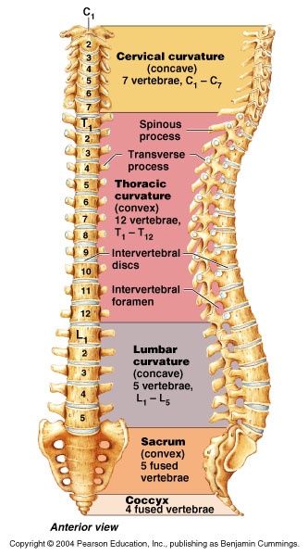
- Formed from 26 irregular bones (vertebrae) connected in such a way that a flexible curved structure results
- Cervical vertebrae – 7 bones of the neck
- Thoracic vertebrae – 12 bones of the torso
- Lumbar vertebrae – 5 bones of the lower back
- Sacrum – bone inferior to the lumbar vertebrae that articulates with the hip bones

Vertebral Column: Curvatures
- Posteriorly concave curvature
  - cervical and lumbar
- Posteriorly convex curvatures
  - thoracic and sacral
- Abnormal spine curvatures
  - scoliosis (abnormal lateral curve)
  - kyphosis (hunchback),
  - lordosis (swayback)

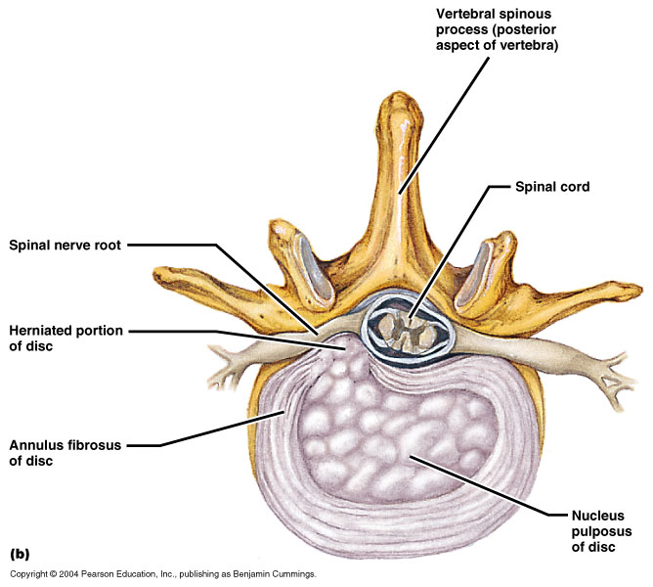

Vertebral Column: Intervertebral Discs
- Cushionlike pad composed of two parts
- Nucleus pulposus – inner gelatinous nucleus that gives the disc its elasticity and compressibility
- Annulus fibrosus – surrounds the nucleus pulposus with a collar composed of collagen and fibrocartilage

General Structure of Vertebrae

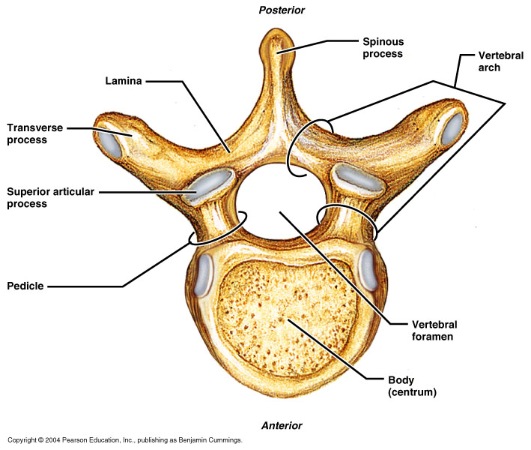
Vertebral Column
- Formed from 26 irregular bones (vertebrae) connected in such a way that a flexible curved structure results
- Cervical vertebrae – 7 bones of the neck
- Thoracic vertebrae – 12 bones of the torso
- Lumbar vertebrae – 5 bones of the lower back
- Sacrum – bone inferior to the lumbar vertebrae that articulates with the hip bones

Cervical Vertebrae
- Seven vertebrae (C₁-C₇) are the smallest, lightest vertebrae
- C₃-C₇ are distinguished with an oval body, short spinous processes, and large, triangular vertebral foramina
- Each transverse process contains a transverse foramen
- Cervical Vertebrae: The Atlas (C₁)
  - The atlas has no body and no spinous process
  - It consists of anterior and posterior arches, and two lateral masses
  - The superior surfaces of lateral masses articulate with the occipital condyles
- Cervical Vertebrae: The Axis (C₂)
  - The axis has a body, spine, and vertebral arches as do other cervical vertebrae
  - Unique to the axis is the dens, or odontoid process, which projects superiorly from the body and is cradled in the anterior arch of the atlas
  - The dens is a pivot for the rotation of the atlas

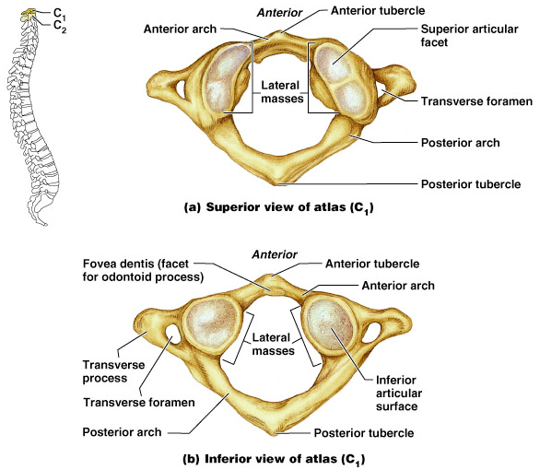

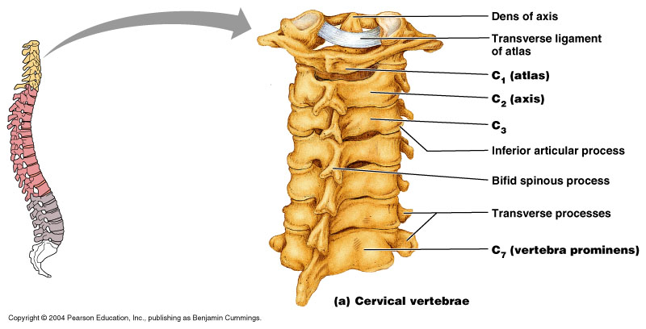

Thoracic Vertebrae
- There are twelve vertebrae (T₁-T₁₂) all of which articulate with ribs

Lumbar Vertebrae
- The five lumbar vertebrae (L₁-L₅) are located in the small of the back and have an enhanced weight-bearing function
- They have short, thick pedicles and laminae, flat hatchet-shaped spinous processes, and a triangular-shaped vertebral foramen
- Orientation of articular facets locks the lumbar vertebrae together to provide stability

Sacrum
- Consists of five fused vertebrae (S₁-S₅), which shape the posterior wall of the pelvis
- It articulates with L₅ superiorly, and with the auricular surfaces of the hip bones

Coccyx (Tailbone)
- The coccyx is made up of four (in some cases three to five) fused vertebrae that articulate superiorly with the sacrum

Posterior Sacrum
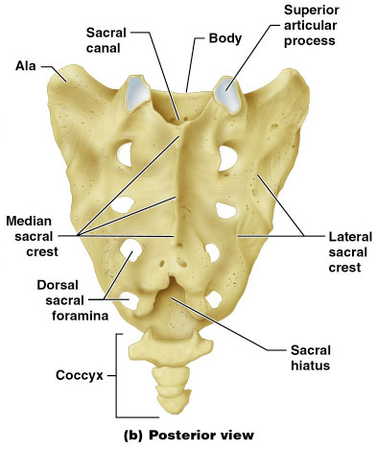

Anterior Sacrum

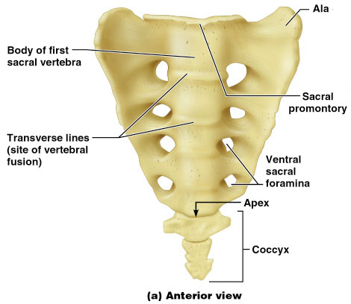

Bony Thorax (Thoracic Cage)
- The thoracic cage is composed of the thoracic vertebrae dorsally, the ribs laterally, and the sternum and costal cartilages anteriorly
- Functions
  - Forms a protective cage around the heart, lungs, and great blood vessels
  - Supports the shoulder girdles and upper limbs
  - Provides attachment for many neck, back, chest, and shoulder muscles
  - Uses intercostal muscles to lift and depress the thorax during breathing

Sternum (Breastbone)
- A dagger-shaped, flat bone that lies in the anterior midline of the thorax
- Anatomical landmarks include the jugular (suprasternal) notch, the sternal angle, and the xiphisternal joint

Ribs
- There are twelve pair of ribs forming the flaring sides of the thoracic cage
- All ribs attach posteriorly to the thoracic vertebrae
- The superior 7 pair (true, or vertebrosternal ribs) attach directly to the sternum via costal cartilages
- Ribs 8-10 (false, or vertebrocondral ribs) attach indirectly to the sternum via costal cartilage
- Ribs 11-12 (floating, or vertebral ribs) have no anterior attachment
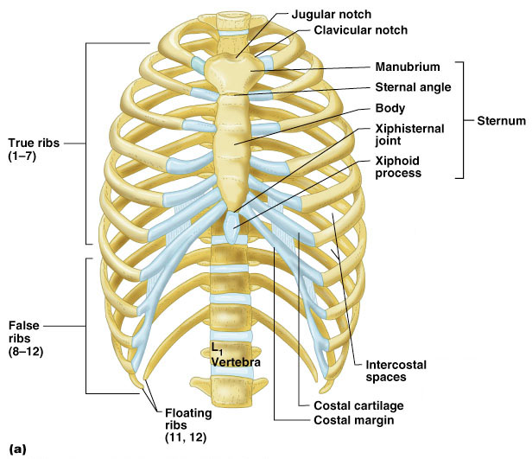

The Appendicular Skeleton

Appendicular Skeleton
- The appendicular skeleton is made up of the bones of the limbs and their girdles
- Pectoral girdles attach the upper limbs to the body trunk
- Pelvic girdle secures the lower limbs

Pectoral Girdles (Shoulder Girdles)
- The pectoral girdles consist of the anterior clavicles and the posterior scapulae
- They attach the upper limbs to the axial skeleton in a manner that allows for maximum movement
- They provide attachment points for muscles that move the upper limbs

Clavicles (Collarbones)
- The clavicles are slender, doubly curved long bones lying across the superior thorax
- The acromial (lateral) end articulates with the scapula, and the sternal (medial) end articulates with the sternum
- They provide attachment points for numerous muscles, and act as braces to hold the scapulae and arms out laterally away from the body

Scapulae (Shoulder Blades)
- The scapulae are triangular, flat bones lying on the dorsal surface of the rib cage, between the second and seventh ribs
- Scapulae have three borders and three angles
- Major markings include the suprascapular notch, the supraspinous and infraspinous fossae, the spine, the acromion, and the coracoid process

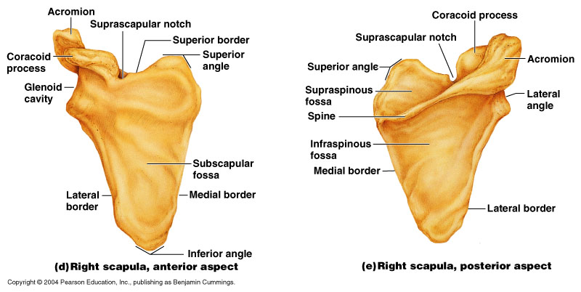

The Upper Limb
- The upper limb consists of the arm (brachium), forearm (antebrachium), and hand (manus)
- Thirty-seven bones form the skeletal framework of each upper limb
- Arm - Brachium
  - The humerus is the sole bone of the arm
  - It articulates with the scapula at the shoulder, and the radius and ulna at the elbow
- Forearm - Antebrachium
  - The bones of the forearm are the radius and ulna
  - They articulate proximally with the humerus and distally with the wrist bones
  - They also articulate with each other proximally and distally at small radioulnar joints
  - Interosseous membrane connects the two bones along their entire length
  - Bones of the Forearm
    - Ulna
      - The ulna lies medially in the forearm and is slightly longer than the radius (non thumb side)
      - Forms the major portion of the elbow joint with the humerus
    - Radius
      - The radius lies opposite the ulna and is thin at its proximal end, widened distally (thumb side)
      - The superior surface of the head articulates with the humerus
- Hand - Manus
  - Carpals - Wrist bones
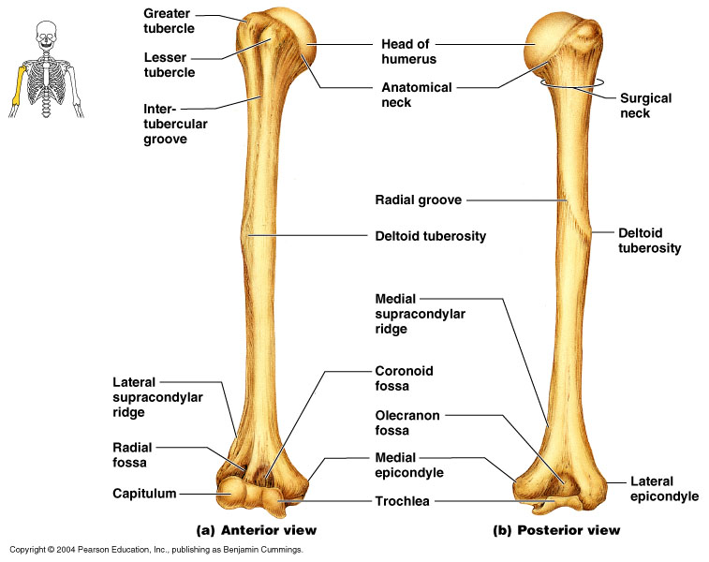
  - Metacarpals - Palm
  - Phalanges - Fingers

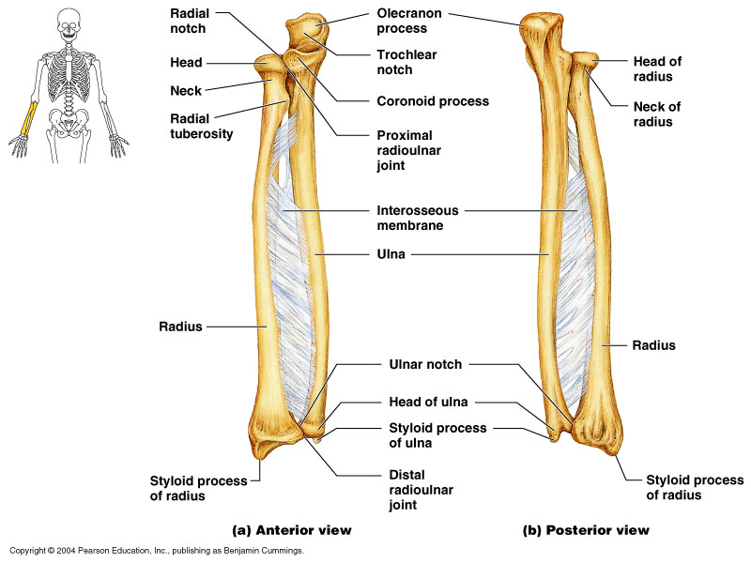

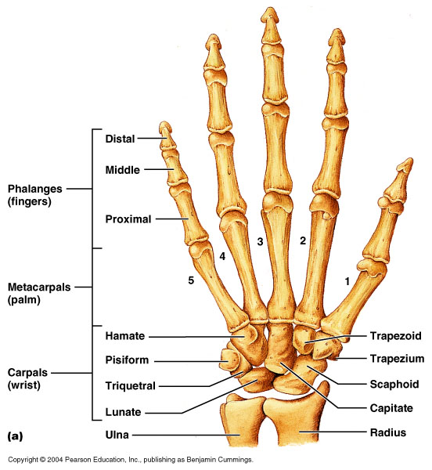
Pelvic Girdle (Hip)
- The hip is formed by a pair of hip bones
- Together with the sacrum and the coccyx, these bones form the bony pelvis
- The pelvis
  - Attaches the lower limbs to the axial skeleton with the strongest ligaments of the body
  - Transmits weight of the upper body to the lower limbs
  - Supports the visceral organs of the pelvis

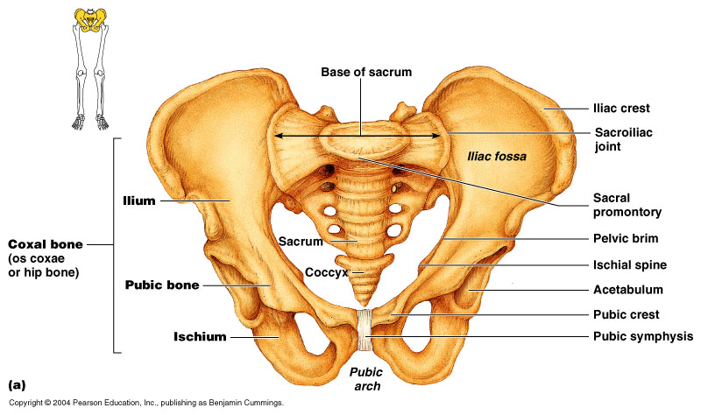

Pelvic Girdle (Hip)
- Ilium
  - The ilium is a large flaring bone that forms the superior region of the hip bone
    - It consists of a body and a superior winglike portion called the ala
    - The broad posterolateral surface is called the gluteal surface
  - The auricular surface articulates with the sacrum (sacroiliac joint)
- Ischium
  - The ischium forms the posteroinferior part of the hip bone

Comparison of Male and Female Pelvic Structure
- Female
  - For childbearing
- Male
  - For support of heavier male build and stronger muscles

Female Male

The Lower Limb
- The three segments of the lower limb are the thigh, leg, and foot
- They carry the weight of the erect body, and are subjected to exceptional forces when one jumps or runs

Femur
- The sole bone of the thigh is the femur
- The largest and strongest bone in the body
- It articulates proximally with the hip and distally with the tibia and fibula

Leg
- The tibia and fibula form the skeleton of the leg
- They are connected to each other by the interosseous membrane
- They articulate with the femur proximally and with the ankle bones distally

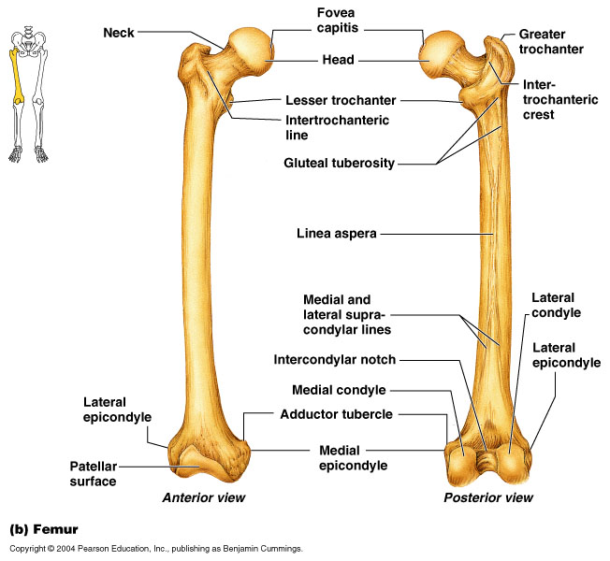
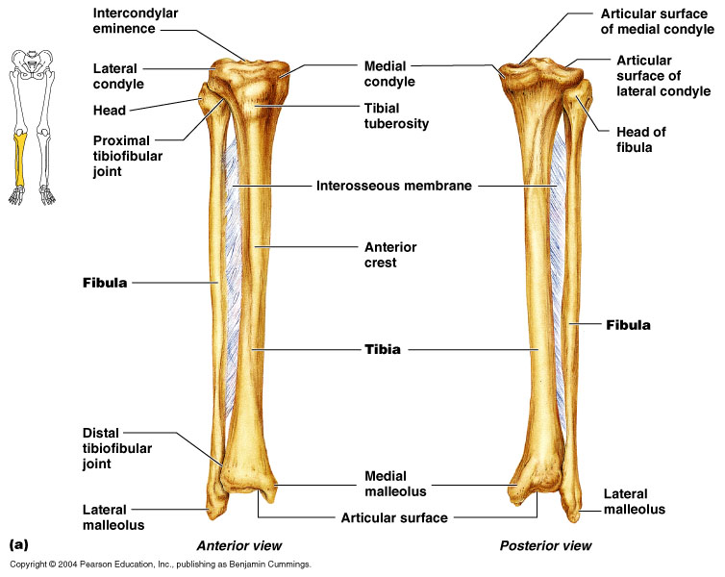

Skeletal Anatomy Mnemonics
Facial Bones
- Virgil Can Not Make My Pet Zebra Laugh!
  - Vomer, Conchae, Nasal, Maxilla, Mandible, Palatine, Zygomatic, Lacrimal
Carpal Bones
- Some Lovers Try Positions That They Cannot Handle or
- Stop Letting Those People Touch The Cadaver's Hand or
- She Looks Too Pretty, Try To Catch Her or
- She Like To Play, Try To Catch Her or
  - Proximal row, lateral-to-medial: Scaphoid Lunate Triquetrum Pisiform
  - Distal row, lateral-to-medial: Trapezium Trapezoid Capitate Hamate
Tarsal Bones
- Tall Californian Navy Medcial Interns Lay Cuties or
- Tiger Cubs Need MILC
  - In order (right foot, superior to inferior, medial to lateral):
    - Talus, Calcaneus, Navicular, Medial cuneiform, Intermediate cuneiform, Lateral cuneifrom, Cuboid

Tibia vs. Fibula – which is lateral?
- FibuLA is LAteral.
Recognizing and Thoracic vs. Lumbar Vertebra
- Examine vertebral body shape:
  - Thoracic is heart-shaped body since your heart is in your thorax.
  - Lumbar is kidney-bean shaped since kidneys are in lumbar area.

