Autonomic Nervous System Dr. Gary Mumaugh – Campbellsville University

Peripheral Nervous System
- The peripheral nervous system is divided into two systems:
- SENSORY SYSTEM
- MOTOR SYSTEM - The motor system is further divided into:
  - Somatic Nervous System
    - Under voluntary control
    - Example: contraction of the biceps brachii
  - Visceral Nervous System – aka Autonomic Nervous System
    - Under involuntary control
    - Example: contraction of visceral organs
    - Divided into three branches:
      - Sympathetic Nervous System
      - Parasympathetic Nervous System
      - Enteric Nervous System

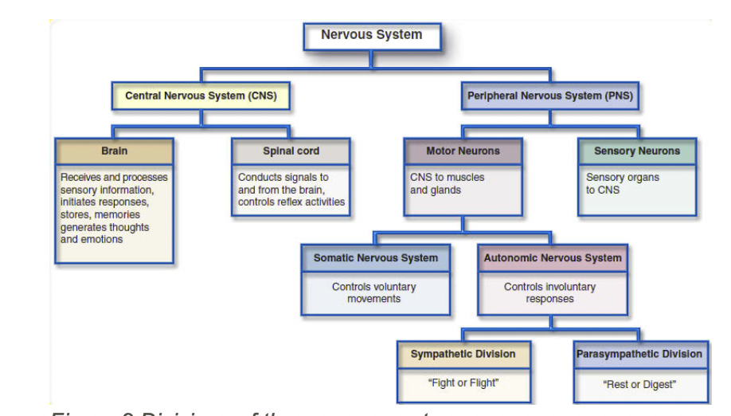

Somatic Nervous System Fibers/Neurons
- It only takes one motor neuron (a.k.a. somatic motor fibers, alpha motor neurons) to reach its target/effector organ
- Origin: anterior horn of the spinal cord
- Target: skeletal muscles
- At the synaptic level, the neuron releases acetylcholine, which binds to the nicotinic receptors on muscles to stimulate contraction

Visceral Nervous System (ANS) Fibers/Neurons
- It takes two motor neurons to reach its target/effector organ
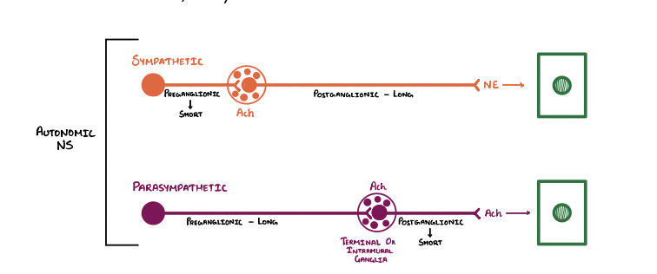
  - Pre-ganglionic neuron
    - Origin: brainstem/spinal cord
    - Target: synapses with a ganglion
  - Post-ganglionic neuron
    - Origin: ganglion
    - Target: effector organ (e.g., skeletal muscle, viscera, etc.

Remember Key Neuron Terms
- Synapse
  - Site of transmission of electrical/chemical; signals between two neurons
- Ganglion
  - A group of neuron cell bodies in the PNS
- Pre-ganglionic nerve fibers
  - Fibers which originate from the brain/spinal cord and synapses with a ganglion
- Post-ganglionic nerve fibers
  - Fibers which originate from the ganglion and travels to the target/effector organ
- Splanchnic nerve fibers
  - Any of several nerves of the sympathetic part of the ANS that innervates viscera and blood vessels

Autonomic Nervous System
- Sympathetic Nervous System
  - “Fight, Flight, or Fright stage”
  - Activated in stressful situations
  - Location: Spinal Cord, T1 – L2 (thoracolumbar)
  - Action potentials/signals from the sympathetic nervous system pass through this thoracolumbar outflow

- Parasympathetic Nervous System
  - “Rest and Digest stage”
  - Location: Brainstem (CN III, VII, IX, X) and Spinal Cord, S2-S4 (craniosacral)
  - These cranial nerves have parasympathetic activity
  - Action potentials/signals from the parasympathetic nervous system pass through this craniosacral outflow

Remember Main Divisions
- Sympathetic Nervous System
  - Thoracolumbar outflow
  - Spinal cord, T1 – L2
- Parasympathetic Nervous System
  - Craniosacral outflow
  - Brainstem and spinal cord, S2-S4

Ganglionic Neurons/Fibers
- Sympathetic Nervous System Pathway:
  - Short pre-ganglionic neurons
    - Cholinergic fibers
      - Releases Ach at the synaptic junction to stimulate post-ganglionic neuron
    - Sympathetic ganglia
      - Are located far from the target organs.
  - Long post-ganglionic neurons
    - Adrenergic fibers - release norepinephrine at the synaptic junction

Ganglionic Neurons/Fibers
- Parasympathetic Nervous System Pathway:
  - Long pre-ganglionic neurons
    - Cholinergic fibers
      - Travel until they reach the target organ
    - Terminal / Intramural ganglia
    - The only type of parasympathetic ganglia
    - Located at or inside the target organ
  - Short post-ganglionic neurons

Key Points to Remember
- Sympathetic Nervous System
  - Short pre-ganglionic neurons: cholinergic
  - Long post-ganglionic neurons: adrenergic
- Parasympathetic Nervous System
  - Long pre-ganglionic neurons: cholinergic
  - Short post-ganglionic neurons: cholinergic

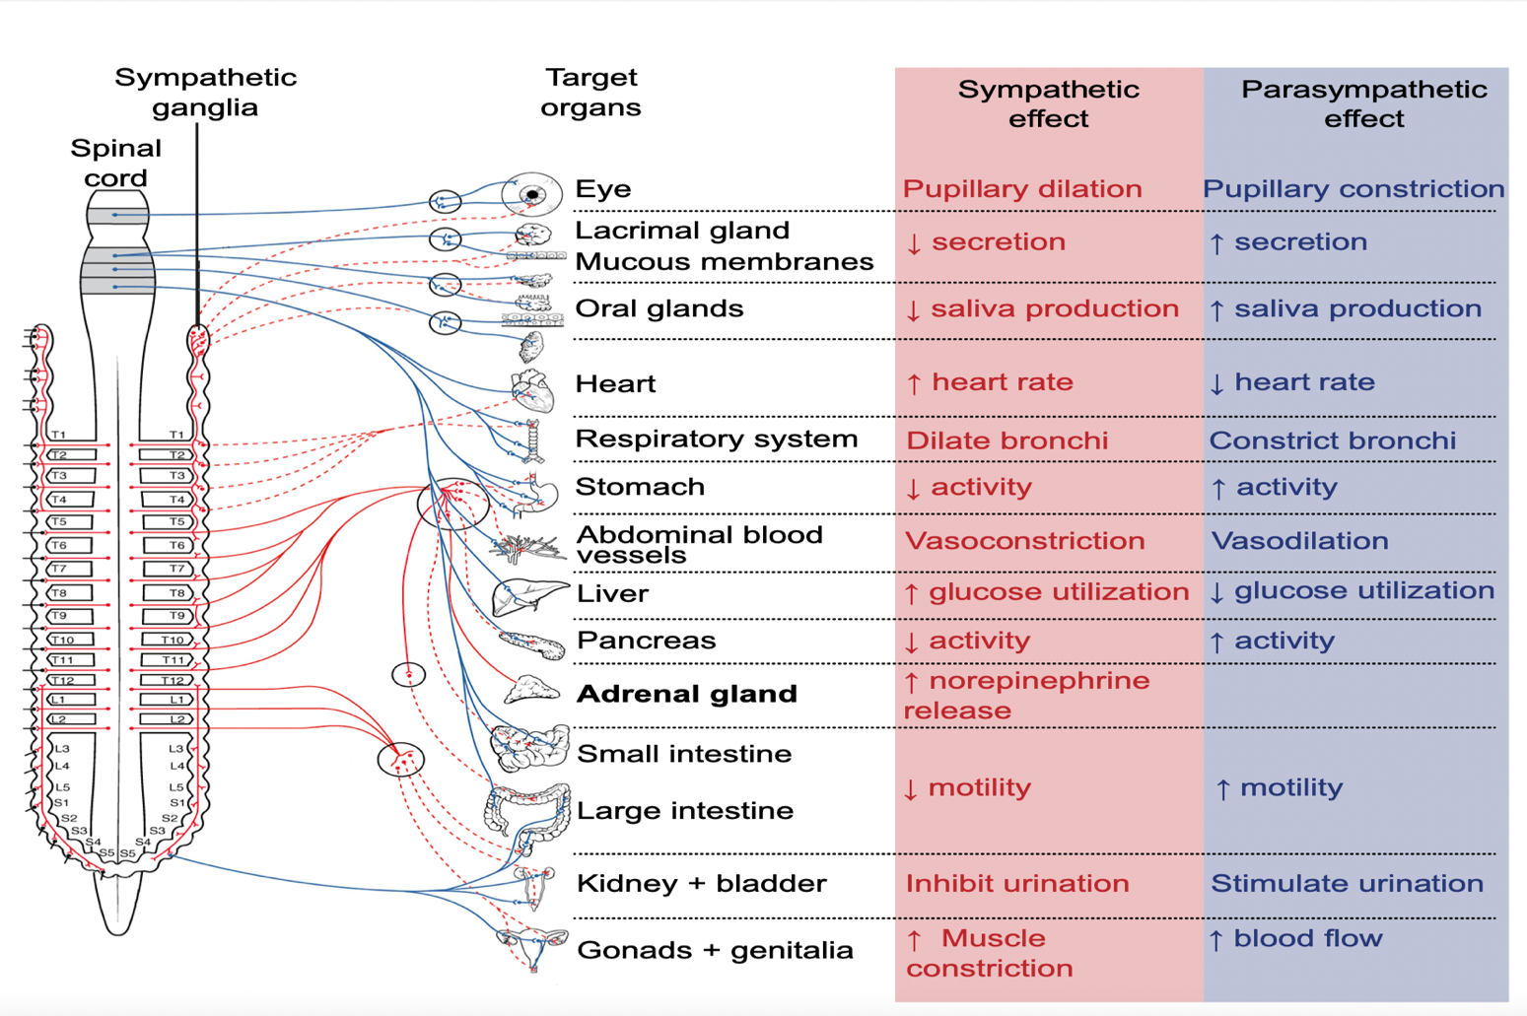

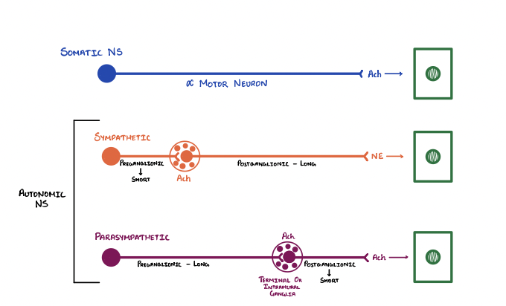

- Differences Between the Somatic and Autonomic Nervous Systems
  - Somatic is voluntary and part of the peripheral nervous system
  - ANS is involuntary and is divided into sympathetic and parasympathetic

- Divisions of the Autonomic Nervous System
  - Sympathetic division speeds things up
    - Fight or flight mechanism
  - Parasympathetic slows things down
    - Rest and repose
  - The enteric nervous system
    - Controls the gastrointestinal system

- Cholinergic and Adrenergic Neurons
  - Cholinergic neurons
    - What fires in the parasympathetic nervous system
    - Ach (acetylcholine) as the neurotransmitter
  - Adrenergic
    - What fires in the sympathetic nervous system
    - Adrenaline as the neurotransmitter

- Two Types of Cholinergic Receptors
  - Nicotinic receptors
    - Part of the cholinergic receptors
    - Respond faster than muscarinic receptors
  - Muscarinic receptors
    - Part of the cholinergic receptors
    - Respond slower than nicotinic receptors

- Two Types of Adrenergic Receptors
  - Also called sympathetic or adrenergic receptors
  - Alpha receptors
    - Alpha 1 - Stimulatory
      - Found in all smooth muscle, glands and tissues of the sympathetic nervous system
      - Stimulates peripheral blood vessels to constrict, muscles to contract and glands to constrict and release
    - Alpha 2 – Inhibitory
      - Found in all presynaptic terminals

- Two Types of Adrenergic Receptors - continued
  - Beta receptors
    - Beta 1 – Stimulatory
      - Found in heart and kidney
      - Stimulate heart to increase cardiac output and stimulates kidneys to raise blood pressure via the renin complex
    - Beta 2 – Inhibitory
      - Found in all smooth muscle, glands and tissues of the sympathetic nervous system
      - Stimulates peripheral blood vessels to dilate, muscles to relax and glands to relax and not release

- Effects of the Sympathetic Nervous System on the Body
  - Sympathetic Effects “Stress” on the Visceral Organs
    - Generally increases the activity of most visceral organs to meet the increased energy demands associated with stress
    - Stimulates catabolic biochemical processes to increase the availability of O2 and glucose to active tissues, and to increase the generation of ATP (cell respiration)
  - “ E SITUATIONS”
    - Exercise
    - Excitement
    - Emergency
    - Embarrassment

- Effects of the Parasympathetic Nervous System on the Body
  - Parasympathetic Effects “Rest and Digest” on the Visceral Organs
    - Generally inhibits the activity of of most visceral organs to conserve energy
- Stimulates anabolic biochemical processes for growth and repair of body tissues
- Visualize: The body’s internal state after leisurely enjoying a large dinner and then relaxing with a movie.
- “S L U D D”
        - Salivation
        - Lacrimation
        - Urination
        - Digestion
        - Defecation

Parasympathetic Sympathetic
“Rest & Digest” “Stress”
ACh | Epinephrine & Norepinephrine
(Muscarinic Cholinergic) | (Adrenergic, Catecholamines)
Purpose Decreased Energy Demands | Purpose Increased Energy Demands
Liver glycogenesis >> hypoglycemia | Liver glycogenolysis >> hyperglycemia
Lipogenesis in fat cells | Lipolysis in fat cells
Decreased rate & depth of breathing | Increased rate & depth of breathing  (Diaphragm is a skeletal muscle)
Bronchoconstriction | Bronchodilation
Increased bronchial secretions | Decreased bronchial secretions
Decreased rate & force of cardiac contraction  Bradycardia Decreased contractility | Increased rate & force of cardiac contraction  Tachycardia Increased contractility
Vasoconstriction to heart and skeletal muscle  Causing decreased blood flow | Vasodilation to heart and skeletal muscle  Causing increased blood flow
Generalized vasodilation to the other blood vessels of the body causing increased blood flow to the GI tract and kidneys | Generalized vasoconstriction to the other blood vessels of the body causing decreased blood flow to the GI tract and kidneys
Decreased blood pressure | Increased blood pressure
Pupillary constriction | Pupillary dilation(Mydriasis)
Increased salivation | Decreased salivation
Emptying of urinary bladder | Inhibits emptying of urinary bladder (retention)
Decreased CNS alertness | Increased CNS alertness
Sexual arousal (penile erection) | Orgasm (ejaculation)
Increased sweating causing heat loss
(From Increased Cell Respiration)

