Brain Overview
Dr. Gary Mumaugh – Campbellsville University

Coverings of the Brain and Spinal Cord
- Two protective coverings
  - Outer covering is bone; cranial bones encase the brain and vertebrae encase the spinal cord
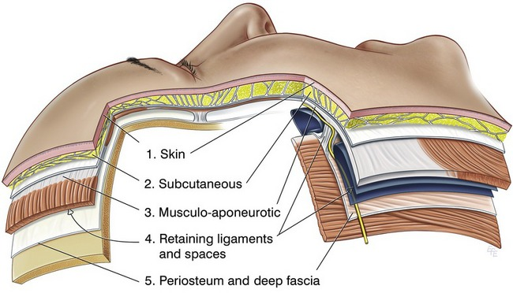
  - Inner covering is the meninges; the meninges of the cord continue inside the spinal cavity beyond the end of the spinal cord

Protection of the Brain
- Scalp - 5 layers
- Skull - Encloses and protects the brain and special senses
- Meningeal Protection - CSF provides cushion for brain and is a shock absorber
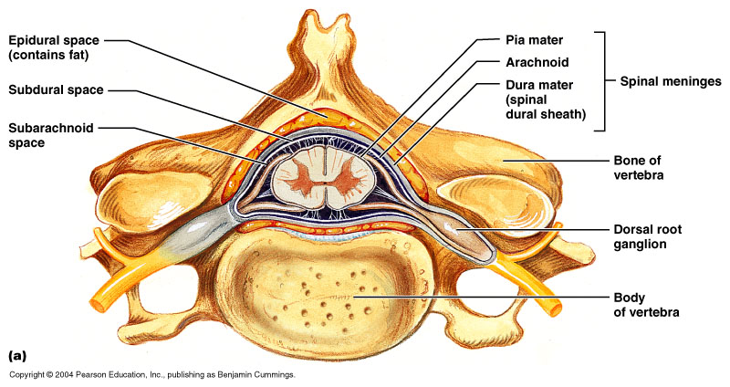
Protection of the Spinal Cord - Vertebral Column
    - Protects spinal cord
    - Articulates with the head, rib, pectoral and pelvic girdles
    - Points of attachment for muscles
    - Avenue for vertebral arteries

Meninges of Vertebra and Spinal Cord – Dura Mater
- The outermost layer of the meninges, directly underneath the bones of the skull
- Thick, tough and does not stretch
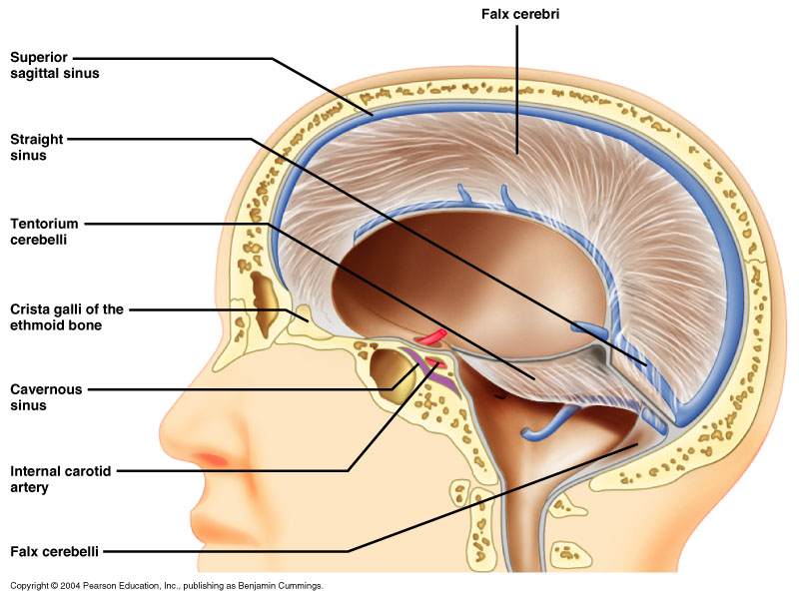
- Dura has two connective tissue sheets:
- Periosteal layer – lines the inner surface of the bones of the cranium.
- Meningeal layer – deep to the periosteal layer inside the cranial cavity. It is the only layer present in the vertebral column.
- Between the two layers are dural venous sinuses which will drain the blood from the brain into the jugular veins.
- In some areas within the skull, the dura mater folds inwards as separates the parts of the brain and anchors it.
  - Falx cerebri separates the two hemispheres and anchors to the crista galli
  - Falx cerebelli separates the two parts of cerebellum
  - Tentorium cerebelli separates the cerebellum from the cerebrum.

Meninges of Vertebra and Spinal Cord – Arachnoid Membrane
- Delicate, cobweblike layer between the dura mater and pia mater and is avascular
- Underneath the arachnoid is a space known as the sub-arachnoid space.
- It contains cerebral spinal fluid, which acts to cushion the brain.
- Small projections of arachnoid mater into the dura (known as arachnoid granulations) allow CSF to re-enter the circulation via the dural venous sinuses

Meninges of Vertebra and Spinal Cord – Pia Mater
- Innermost, transparent layer; adheres to the outer surface of the brain and spinal cord
- It is very thin, and tightly adhered to the surface of the brain and spinal cord. It is the only covering to follow the contours of the brain (the gyri and fissures).
- Like the dura mater, it is highly vascularized, with blood vessels perforating through the membrane to supply the underlying neural tissue.
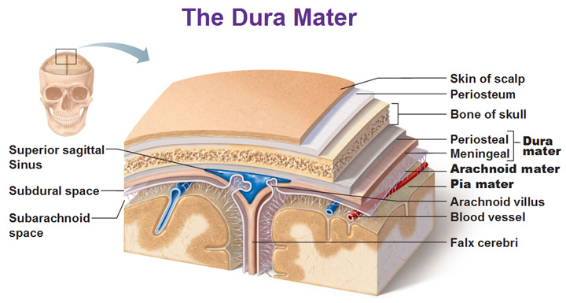
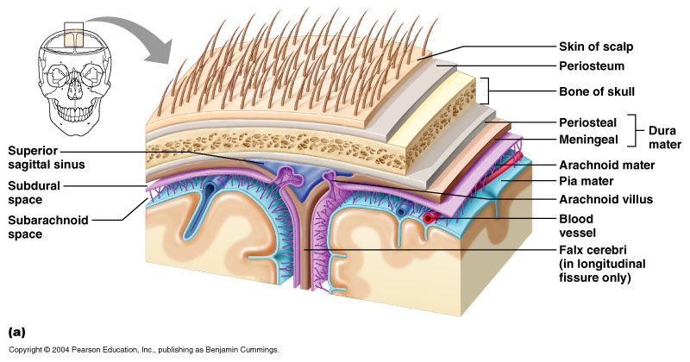

Spaces between the meninges
- Epidural space
  - Between the dura mater and inside the bony covering of the spinal cord; contains a supporting cushion of fat and other connective tissues
- Subdural space
  - Between the dura and arachnoid; contains lubricating serous fluid
- Subarachnoid space
  - Between the arachnoid and pia mater; contains a significant amount of cerebrospinal fluid (CSF)

Cerebral Spinal Fluid
- CSF continually flows through and around the CNS
  - driven by its own pressure, beating of ependymal cilia, and pulsations of the brain produced by each heartbeat
- cerebrospinal fluid (CSF) – clear, colorless liquid that fills the ventricles and canals of CNS - small amount of CSF fills the central canal of the spinal cord
- brain produces and absorbs 500 mL/day
  - 100 – 160 mL normally present at one time
- production begins with the filtration of blood plasma through brain capillaries
- Functions of CSF
  - buoyancy
    - allows brain to attain considerable size without being impaired by its own weight
    - if it rested heavily on floor of cranium, the pressure would kill the nervous tissue
  - protection
    - protects the brain from striking the cranium when the head is jolted
    - shaken child syndrome and concussions do occur from severe jolting
  - chemical stability
    - flow of CSF rinses away metabolic wastes from nervous tissue and homeostatically regulates its chemical environment
  - nutrition to the cord

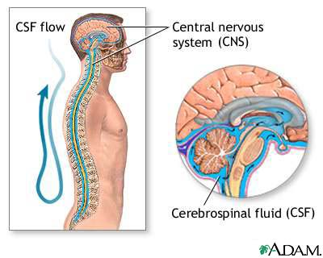
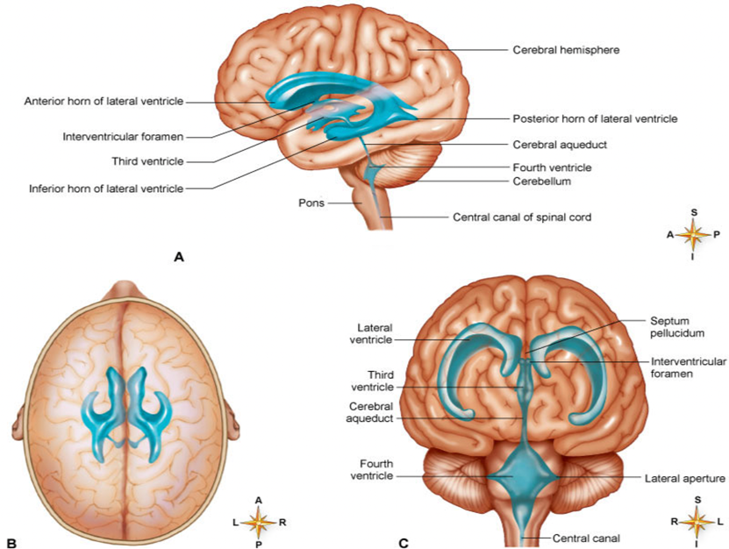

Hydrocephalus
- Excess fluid within the cranial vault, subarachnoid space, or both
- 3 mechanisms for hydrocephalus
  - Over secretion of CSF: rare
  - Impaired absorption of CSF: many ways, anything that raises venous pressure
  - Obstruction of CSF pathways: due to tumor of fibrosis

Brain Directional Terms and Landmarks
- rostral - toward the forehead
- caudal - toward the spinal cord
- brain weighs about 1600 g (3.5 lb) in men, and 1450 g in women
- three major portions of the brain - cerebrum, cerebellum, brainstem

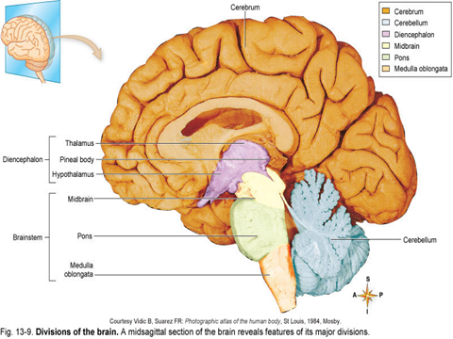
Brain Functions
- Interprets sensations
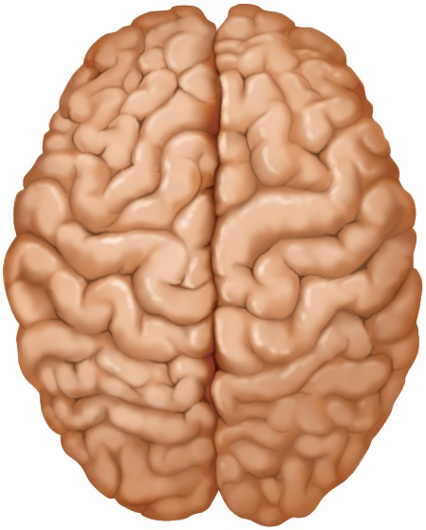
- Determines perception
- Stores memory
- Reasoning
- Makes decisions
- Coordinates muscular movements
- Regulates visceral activities
- Determines personalities

Cerebrum
- 80-85% of brain volume
- longitudinal fissure – deep groove that separates cerebral hemispheres
- gyri - thick folds
- sulci - shallow grooves
- corpus callosum – thick nerve bundle at bottom of longitudinal fissure that connects hemispheres
- Two cerebral hemispheres divided by longitudinal fissure
  - connected by white fibrous tract the corpus callosum
  - gyri and sulci – increases amount of cortex in the cranial cavity
  - gyri increases surface area for information processing capability
  - some sulci divide each hemisphere into lobes named for the cranial bones that overly them

General Functions of the Cerebrum
- Interpreting impulses
- Initiating voluntary movements
- Storing information as memory
- Retrieving stored information
- Reasoning
- Seat of intelligence and personality

Functions of Cerebrum - Lobes
- frontal lobe
  - voluntary motor functions
  - motivation, foresight, planning, memory, mood, emotion, social judgment, and aggression
- parietal lobe
  - receives and integrates general sensory information, taste and some visual processing
- occipital lobe
  - primary visual center of brain
- temporal lobe
  - areas for hearing, smell, learning, memory, and some aspects of vision and emotion
- insula (hidden by other regions)
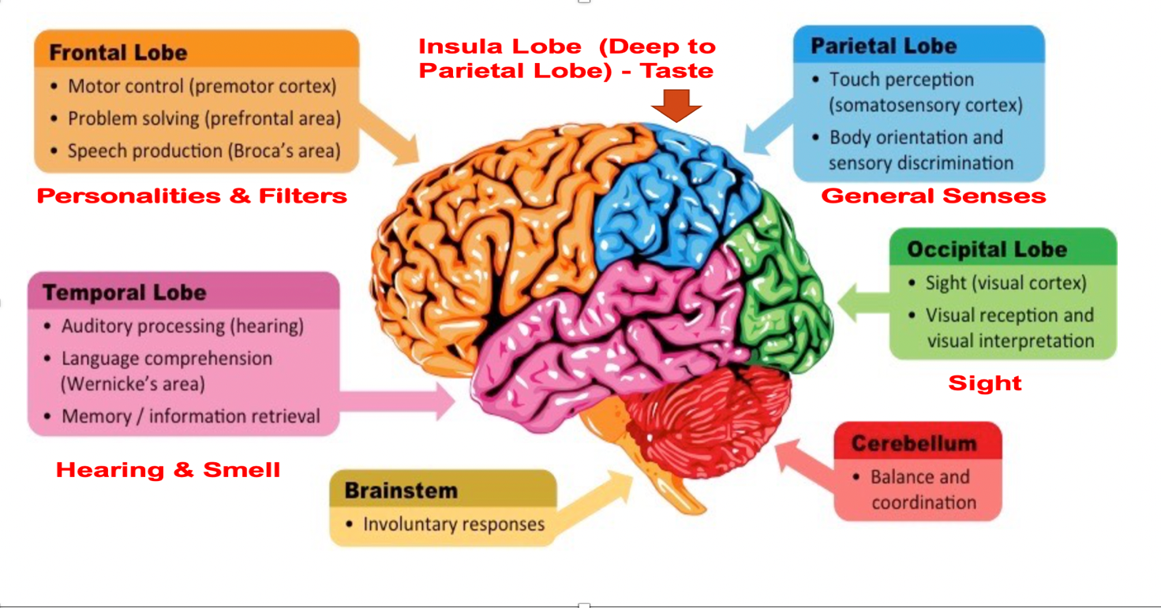
  - understanding spoken language, taste and sensory information from visceral receptors

Brain – Cerebral Cortex
- Sensory functions of the cortex
  - Somatic senses: sensations of touch, pressure, temperature, proprioception, and similar perceptions that require complex sensory organs
  - Cortex contains a somatic sensory map of the body
  - Information sent to primary sensory areas is relayed to sensory association areas and other parts of the brain
  - The sensory information is compared and evaluated, and the cortex integrates separate bits of information into whole perceptions
- Motor functions of the cortex
  - For normal movements to occur, many parts of the nervous system must function
  - Is the region of the cerebral cortex involved in the planning, control, and execution of voluntary movements.
  - Classically, the motor cortex is an area of the frontal lobe located in the posterior precentral gyrus immediately anterior to the central sulcus.

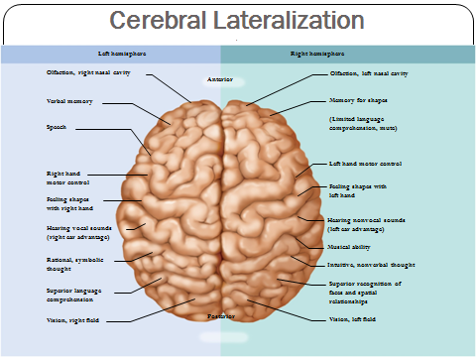
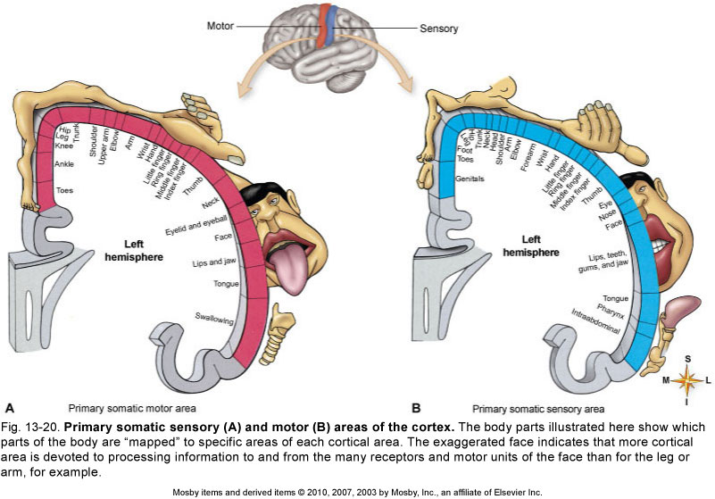
Cerebral Lateralization
- cerebral lateralization – the difference in the structure and function of the cerebral hemispheres
- left hemisphere - categorical hemisphere
  - specialized for spoken and written language
  - sequential and analytical reasoning (math and science)
- right hemisphere - representational hemisphere
  - perceives information in a more integrated holistic way
  - musical and artistic skill
  - comparison of sights, sounds, smells, and taste
- lateralization develops with age
  - males exhibit more lateralization than females and suffer more functional loss when one hemisphere is damaged

Male Brain | Female Brain
Better at single tasks | Better at multitasking
Shorter attention span | Better attention span
Better at spatial processing and sensorimotor speed | Better with word memory and verbal abilities
Better memory of things | Better memory of faces
When getting lost, tends to use N,S,E, W | When getting lost, tends to use landmarks

Consciousness
- State of awareness of one’s self, one’s environment, and other human beings
- Depends on excitation of cortical neurons by impulses conducted to them by the reticular activating system
- Two current concepts about the reticular activating system
  - Functions as arousal system for the cerebral cortex
  - Functioning is crucial for maintaining consciousness

Cognition
- cognition – the range of mental processes by which we acquire and use knowledge
  - such as sensory perception, thought, reasoning, judgment, memory, imagination, and intuition
- association areas of cerebral cortex constitutes about 75% of all brain tissue
- studies of patients with brain lesions, cancer, stroke, and trauma yield information on cognition
  - parietal lobe association area – perceiving stimuli
  - temporal lobe association area – identifying stimuli
    - agnosia – inability to recognize, identify, and name familiar objects
    - prosopagnosia – person cannot remember familiar faces

Memory
- information management requires
  - learning – acquiring new information
  - memory – information storage and retrieval
  - forgetting – eliminating trivial information; as important as remembering
- amnesia – defects in declarative memory – inability to describe past events
  - procedural memory – ability to tie your shoes
  - anterograde amnesia – unable to store new information
  - retrograde amnesia – cannot recall things they knew before the injury
- hippocampus – important memory-forming center
  - does not store memories
  - memory consolidation – the process of “teaching the cerebral cortex” until a long-term memory is established
  - long-term memories are stored in various areas of the cerebral cortex
- cerebellum – helps learn motor skills
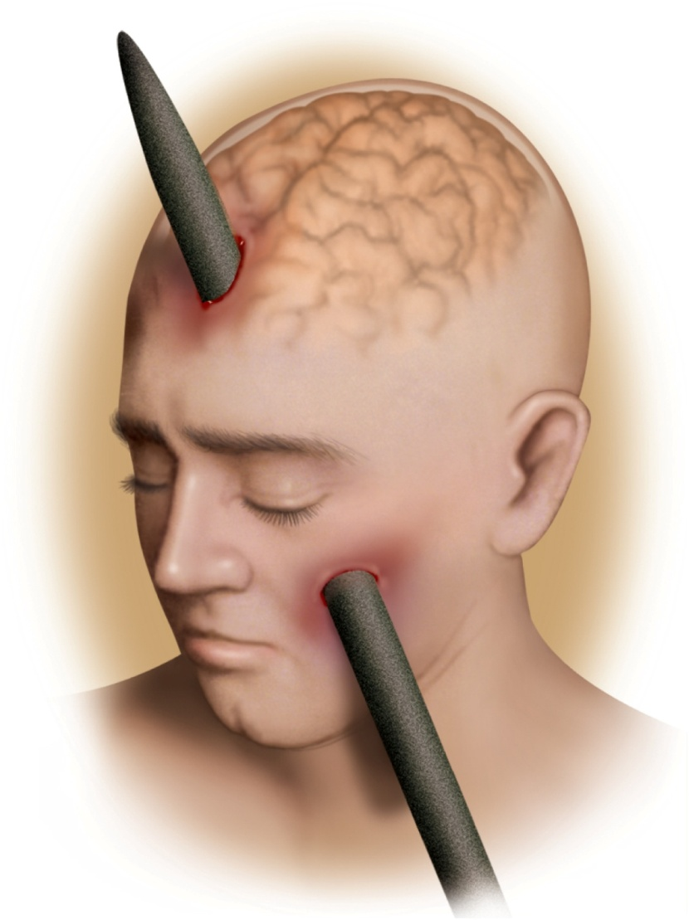
- amygdala - emotional memory

Lobotomy of Phineas Gage
- severe injury with metal rod
- injury to the ventromedial region of both frontal lobes
- extreme personality change
  - fitful, irreverent, grossly profane, opposite of previous personality
- prefrontal cortex functions
  - planning, moral judgment, and emotional control
Emotion
- prefrontal cortex - seat of judgment, intent, and control over expression of emotions
- feelings come from hypothalamus and amygdala
- amygdala receives input from sensory systems
  - role in food intake, sexual behavior, and drawing attention to stimuli
  - one output goes to hypothalamus influencing somatic and visceral motor systems
  - other output to prefrontal cortex important in controlling expression of emotions
- behavior shaped by learned associations between stimuli, our responses to them, and the reward or punishment that results

Cerebellum
- marked by gyri, sulci, and fissures
- about 10% of brain volume
- contains over 50% of brain neurons
Structure of the Cerebellum
- Second largest part of the brain; contains more neurons than the rest of the nervous system
- Located just below the posterior portion of the cerebrum
- Gray matter makes in cortex & white matter interior
- Internal white matter: composed of short and long tracts
  - Shorter tracts conduct impulses from cerebellar cortex to interior of the cerebellum
  - Longer tracts conduct impulses to and from the cerebellum
- Dentate nuclei
  - Important pair of cerebellar nuclei, one in each hemisphere
  - Nuclei connected with thalamus and motor areas of the cerebral cortex by tracts

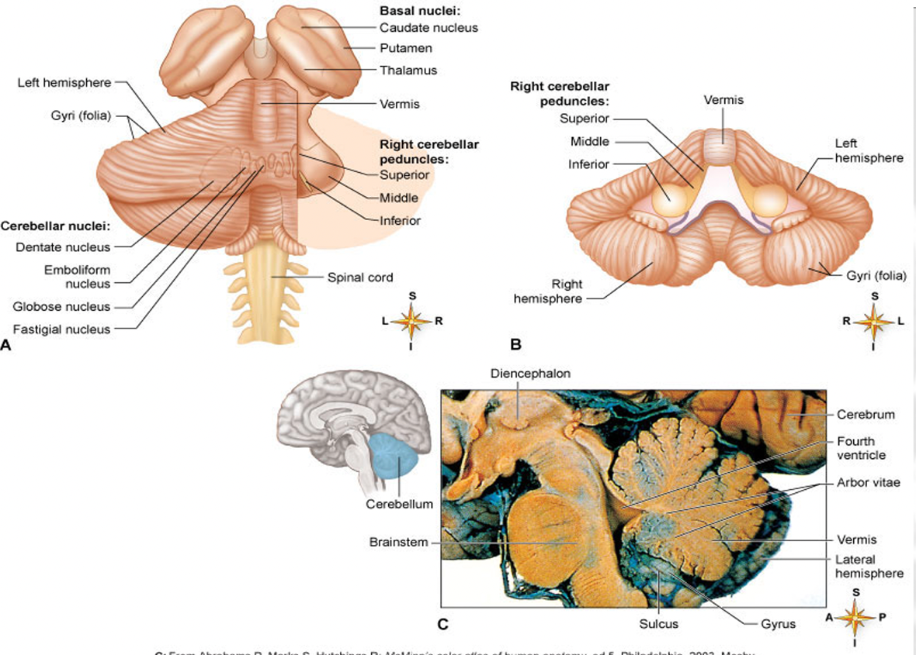

Brainstem
- major components
  - diencephalon
  - midbrain
  - pons
  - medulla oblongata

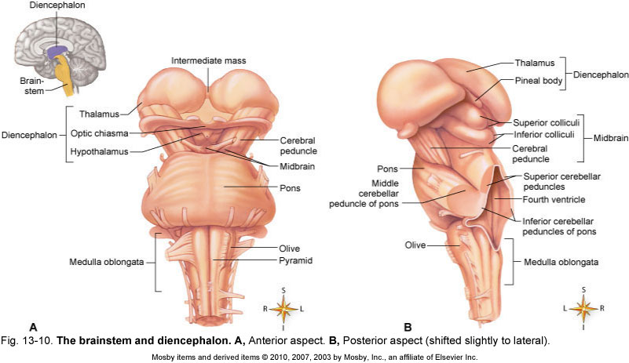
Structures of the Brainstem
- Medulla oblongata
  - Lowest part of the brainstem
  - Part of the brain that attaches to spinal cord; located just above the foramen magnum
  - Composed of white matter and a network of gray and white matter called the reticular formation network
- Pons
  - Located above the medulla and below the midbrain
  - Composed of white matter and reticular formation
- Midbrain
  - Located above the pons and below the cerebrum
  - Composed of white tracts and reticular formation

Functions of the Brainstem
- Performs sensory, motor, and reflex functions
- Important sensory tracts that pass through the brainstem
- Sensory tracts terminate in the brainstem
- Nuclei in medulla contain reflex centers
  - Vital importance: cardiac, vasomotor, and respiratory centers
  - Nonvital reflexes: vomiting, coughing, sneezing, etc.
- Pons contains reflexes mediated by fifth, sixth, seventh, and eighth cranial nerves and pneumotaxic centers that help regulate respiration

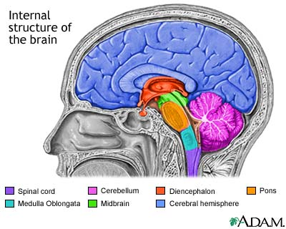

Thalamus
- ovoid mass on each side of the brain perched at the superior end of the brainstem beneath the cerebral hemisphere
- composed of at least 23 nuclei
- the “gateway to the cerebral cortex” – nearly all input to the cerebrum passes by way of synapses in the thalamic nuclei, filters information on its way to cerebral cortex
- plays key role in motor control by relaying signals from cerebellum to cerebrum
- involved in the memory and emotional functions of the limbic system

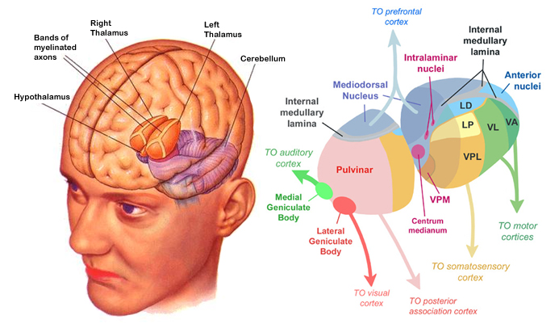
Hypothalamus
- extends anteriorly to optic chiasm and posteriorly to the paired mammillary bodies
- infundibulum – a stalk that attaches the pituitary gland to the hypothalamus
- major control center of autonomic nervous system and endocrine system
  - plays essential roll in homeostatic regulation of all body systems
- Functions of Hypothalamic Nuclei
  - hormone secretion
    - controls anterior pituitary
    - regulates growth, metabolism, reproduction ,and stress responses
  - autonomic effects
    - major integrating center for the autonomic nervous system
    - influences heart rate, blood pressure, gastrointestinal secretions and motility, and others

Hypothalamus
- Functions of Hypothalamic Nuclei
  - thermoregulation
    - hypothalamic thermostat monitors body temperature
    - activates heat-loss center when temp is too high
    - activates heat-promoting center when temp is too low
  - food and water intake
    - hunger and satiety centers monitor blood glucose and amino acid levels
      - produce sensations of hunger and satiety
    - thirst center monitors osmolarity of the blood
  - rhythm of sleep and waking
    - controls 24 hour circadian rhythm of activity
  - memory
  - emotional behavior
    - anger, aggression, fear, pleasure, and contentment

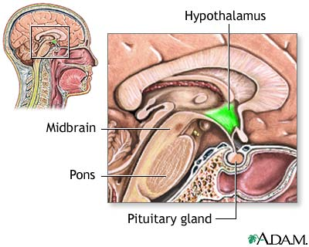
Pineal gland
- Located just above the corpora quadrigemina of the midbrain
- Involved in regulating the body’s biological clock
- Produces melatonin as a “timekeeping” hormone
  - Melatonin is made from the neurotransmitter serotonin
  - Levels increase when sunlight is absent and decrease when sunlight is present, thus regulating the circadian (daily) biologic clock
  - Melatonin is the “sleep hormone”

