Childhood Cancer
Dr. Gary Mumaugh – Bethel University

Childhood Cancer
- Incidence
  - Second leading cause of death in children
  - 9500 children up to age 15 are diagnosed annually
  - 1 in every 900 people between the ages of 15 and 45 will be a survivor of childhood cancer

What is Childhood Cancer
- Childhood Cancer is the leading cause of death in children under 18 and is actually a collection of diseases.
- Children are diagnosed with many different forms of cancer. There are 12 major types of cancer that can affect the bones, muscle, blood, liver, kidney, brain, or even the eyes.
- Common adult cancers (lung, breast, colon, etc.) rarely occur in children or adolescents.
- Among the 12 major types, Leukemias (cancer in the blood) and brain tumors account for more than half of all cases.
- The median age at diagnosis is six years old.
- Some forms of pediatric cancer have a 5 year survival rate of more than 90%, while others have a 5 year survival rate of less than 2%.
- Every day in America, 46 children are diagnosed with cancer.
- Each year in the U.S. approx. 12,400 children between the ages of birth and 19 years of age are diagnosed with cancer.
- There is no known cause of childhood cancer, and it occurs regularly and randomly across all ethnic groups.
- Some children are even born with cancer.

Childhood Cancer
- Most originate from the mesodermal germ layer
  - The mesodermal layer gives rise to connective tissue, bone, cartilage, muscle, blood, blood vessels, gonads, kidneys, and the lymphatic system
- Most common childhood cancers are leukemias, sarcomas, and embryonic tumors
  - Embryonic tumors
    - Originate during uterine life
    - Immature embryonic tissue unable to mature or differentiate into fully developed cells
    - Diagnosed early in life

Leukemia
- Most common malignancy in children
- Children with Down syndrome have a 10 to 20 times greater risk for developing

Brain tumors
- Second leading cause of death from childhood cancer.
- Most are cerebellar and brain stem tumors

Lymphomas
- Non-Hodgkins lymphomas—one-third present with a mass in the neck or mediastinal area
- Also have dyspnea, wheezing, abdominal mass or pain and lymphadenopathy
- Hodgkin’s disease – arises in single lymph node with painless nodal enlargement, followed by extension to adjacent nodes and into spleen, liver, lungs, bone marrow

Neuroblastoma
- Malignant tumor arising from NS ganglion cells outside the cranium
- Can arise from anywhere along the sympathetic nervous system chain
- Can also occur in retroperitoneal area, pelvis, neck

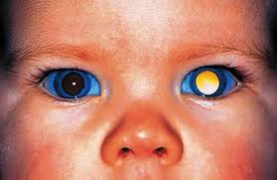
Wilms Tumor - Solid tumor of kidney

Retinoblastoma
- Intraocular malignancy of the retina of eye
- Usually unilateral
- If bilateral , hereditary
- First sign is white pupil

Rhabdomyosarcoma
- Malignant tumor of the striated muscle cells
- Occur in muscles around eye, head, neck, extremities, GU system

Others
- Osteogenic sarcoma/ Ewings sarcoma – tumor of bones of the trunk
- Often seen in adolescence growth spurt
- Found in distal femur, proximal tibia

Theories of Etiology
- Intrauterine carcinogens
- Physical carcinogens
- Viruses
- Immune defects
- Genetics - Discovered gene for leukemia on chromosome 22

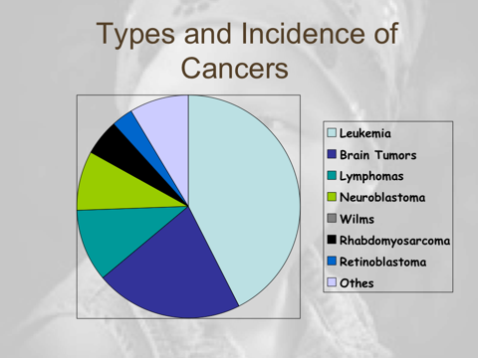

Warning Signs of Childhood Cancer
- C = continual unexplained weight loss
- H = headaches with vomiting (early morning)
- I = increased swelling of pain in joints
- L = lump or mass
- D = development of whitish appearance in pupil
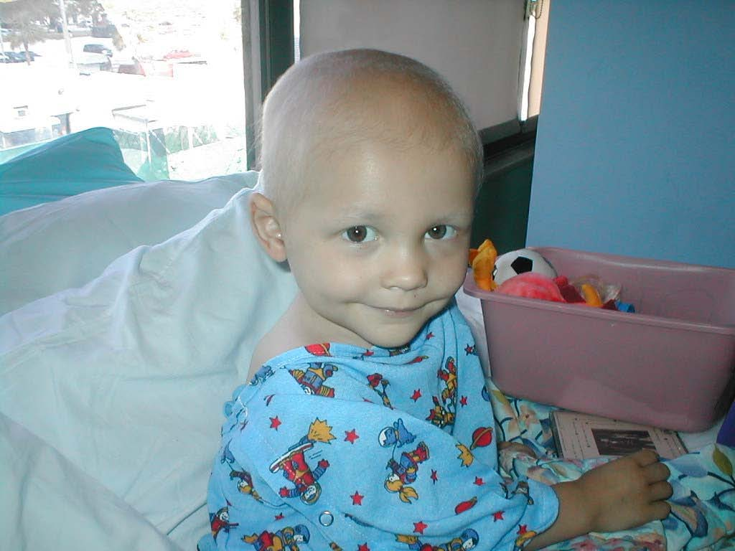
- R = recurrent or persistent fevers, night sweats
- E = excessive bruising or bleeding
- N = noticeable paleness or tiredness

Effects of Childhood Cancer
- Many adult cancer patients endure no more than a year of treatment.
- On the other hand, the average length of treatment for children, from initial diagnosis to cure or remission, is three years.
- If the child experiences a relapse, the treatment time could possibly be extended over many years with a potentially lowered prognosis.

The Need for Progress
- In 80% of cases, a child’s cancer diagnosis is delayed until the disease is very advanced and has spread to other parts of the body. As a stark comparison, this only occurs in 20% of adult cancer cases.
- Childhood cancers tend to be more aggressive than adult cancers, so this late diagnosis can significantly affect the 5-year survival probability of the child.
- Today’s pediatric cancer patients are still being treated with drugs that were developed in the 1950’s, 1960’s and 1970’s.

The Need for Progress

- Why? Because childhood cancer is rare, often called an ‘orphan disease.’ Therefore, drug development for this group of patients is not considered ‘cost effective.’
- Some forms of pediatric cancer have seen an increase in survival over the past few decades but one in four children will still die. If formerly incurable types of cancer are being treated successfully with “old drugs,” imagine what progress could be made with new drugs!
- In the past 20 years, the FDA has only approved ONE new drug exclusively for pediatric patients.
- In the past 20 years, the prevalence of pediatric cancer has risen by 29%.
The Battle After Treatment
- Out of every 4 children diagnosed, one will not survive past 5 years and three will have life-long complications due to aggressive treatments for their cancer.
- When treatment stops, an entirely different battle begins…
  - Because children’s bodies are still developing, toxic therapies damage more than just the cancer cells. Young cancer survivors live the remainder of their lives with the side-effects of their initial treatments.
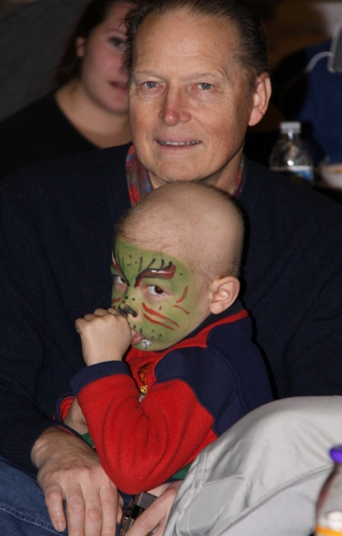
- A few of these side effects are:
  - Delayed/ Disrupted cognitive development
  - Stunted Growth
  - Damaged speech and/or hearing
  - Infertility and Endocrine Dysfunction
  - Learning Disabilities
  - Physical Handicaps due to nerve damage or amputation
- As many as 2/3rds of survivors have at least one chronic health effect.
- 25% of survivors have severe or life-threatening effects.
- 10% will develop a secondary cancer.

Follow-up Care is CRUCIAL.
- However, only 20% of children receive follow-up care. This is in stark contrast to the 90% adults who receive follow-up care.
- Chemo and radiation make children feel sick and weak.
- They may lose their hair. This can be scary and makes children with cancer feel as though they are different from their classmates.
- Often, these children are also coping with major trust issues, since the world no longer feels safe to them.
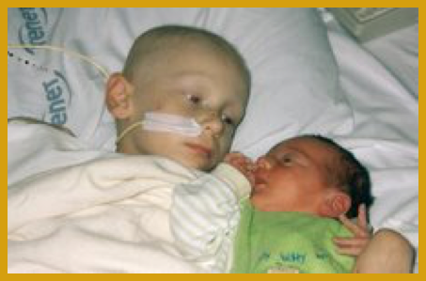
- They often feel that their parents and other adults can no longer protect them, since each new adult is usually bringing them a painful procedure.
The Child’s Entire Family is Affected.
- Siblings are often put to the wayside. Some may be constantly shuttled around and may have problems maintaining a normal schedule. They are worried, resentful, and feel abandoned.
- These children may develop behavioral problems, anxiety, or depression.
- They may also begin to have trouble in school.
- Counseling specifically for siblings is often necessary.
- Parents can spend over 40 hours per week caring for their sick child.
- Studies have even shown that mothers of a child with cancer may exhibit symptoms similar to those of Post Traumatic Stress Disorder.
- The effects on parents are almost always long term. If the child dies, parents deal with difficult and long-lasting grief. If the child lives, parents may still have to care for a child who has mild, moderate or severe physical or emotional late effects. They may spend the rest of their lives helping their child deal with those issues.
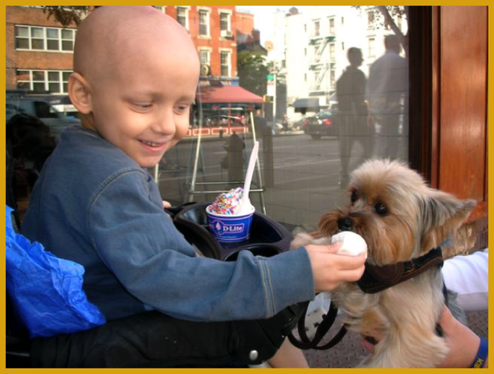
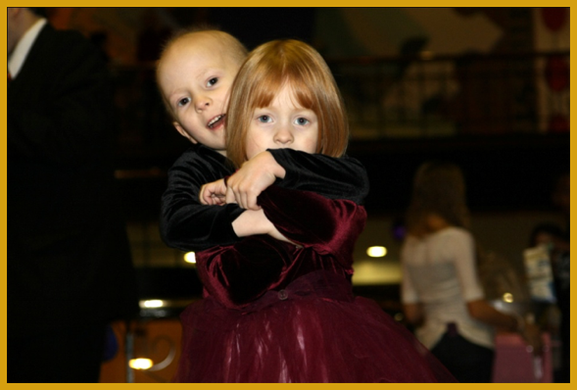

Effects of Childhood Cancer
- Children with cancer can best be helped by doctors who have specialized in treating pediatric cancer patients.
- These specialized treatment centers are spread across the country, so families must travel to get the best treatment for their children.
- This puts a financial, emotional, and social strain on the parents.
Diagnostic Tests
- Biopsy
- Blood Tests
  - CBC, Uric Acid
- Bone Marrow Aspiration
- PET, MRI, CT, ultrasound

Interventions
- Radiation therapy
- Chemotherapy
- Surgery
- Bone Marrow and Stem cell transplantation
- Radiation Therapy

Effects of Radiation Therapy
- Radiation sickness- anorexia, nausea, vomiting
  - Treated with antiemetics (Zofran or Anzimet) Cool cloth to forehead, provide distraction
- Fatigue
  - Allow for naps an rest periods (coordinate care), encourage parent to cuddle in bed with child, pillow, blankets, favorite toys
- Skin reactions
  - Erythema, tenderness
- Bone marrow suppression
  - Anemia, neutropenia thrombocytopenia
- Mucositis
  - Inflammation of mucus membranes mainly the mouth
  - Offer soft foods, and cold foods
  - Frequent mouth care. Lidocaine oral to swish in mouth (older child)
- Long term
  - Depends on part of body receiving radiation

Chemotherapy
- There are several categories of antineoplastic drugs used in treating childhood cancers.
- Scheduled at set times and days and by different predetermined routes.
- May remain in hospital for few days at first, then later report on specific day for therapy.
- Children and Parents must be taught about what to do and not to do during therapy.
- Review of Common Side Effects of Chemotherapy and Radiation
  - Chemotherapy
    - Bone marrow suppression, Alopecia, Malaise/fatigue
    - Nausea, Vomiting
    - Anorexia, Stomatitis
  - Radiation side effects
    - Skin reactions, Fatigue, Bone marrow suppression
    - Nausea, Vomiting
    - Anorexia, Mucositis

Side effects and Toxic Reactions to Chemotherapy
- Bone Marrow Suppression
  - Neutropenia, anemia, thrombocytopenia
  - Place in reverse isolation, keep anyone exposed to a virus away from patient.
  - Monitor temperature
  - Should not receive live-virus vaccines
- Bleeding Tendency
  - Apply pressure to puncture site
  - No contact sports
  - Check urine and stool for blood
  - Give stool softeners.
- Malaise and fatigue
  - Encourage video games, movies, etc
  - Allow visits from friends
- Nausea, vomiting, diarrhea, anorexia
  - Give anti-emetics
  - Small frequent meals
  - Monitor for dehydration
- Altered mucous membranes
  - Stomatitis
  - Rectal ulcerations
- Renal involvement
  - Uric acid levels rise as a result of breakdown of cells. The renal tubules causing renal failure.
  - If kidney affected/damaged- chemo drugs will not be excreted as usual and may limit drugs given.
- Body Image changes
  - Alopecia
- Pain Management

Etiology
- Ecogenetics
- Genetic factors
  - Chromosome abnormalities
    - Aneuploidy, amplifications, deletions, translocations, and fragility
  - Oncogenes and tumor-suppressor genes
    - Fanconi’s anemia, Bloom’s syndrome
  - High recurrence risk
- Environmental factors
  - Prenatal exposure
    - Drugs and ionizing radiation
  - Nutrition and diet
  - Childhood exposure
    - Drugs, secondhand smoke, ionizing radiation, viruses
      - Anabolic androgenic steroids, cytotoxic agents, immunosuppressive agents, Epstein-Barr virus, and AIDS

Prognosis
- 5-year survival rate nearly 80%
- Children are more responsive and are better able to tolerate treatments
- More likely to be enrolled in clinical trials
- Residual and long-term effects of treatment
- Psychologic sequelae

