Childhood Leukemia
Dr. Gary Mumaugh - Bethel University
Leukemia Basics
- Leukemia is cancer of the blood and bone marrow
- In the U.S. there are approximately 3,250 children diagnosed each year with leukemia and 2,400 with acute lymphoblastic leukemia (ALL).
- Leukemia is the most common cancer of childhood.
- There has been a steady increase of 1% per year in the incidence of ALL in the past 25 years.
- Etiology is not well understood

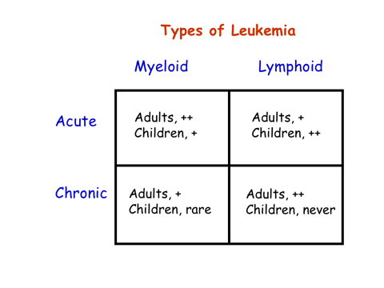

Leukemogenesis
- Multistep process
- Involves one renegade cell - a hematopoietic stem cell or early myeloid cell
- Disregulation of cell growth and differentiation (associated with mutations)
- Proliferation of the leukemic clone

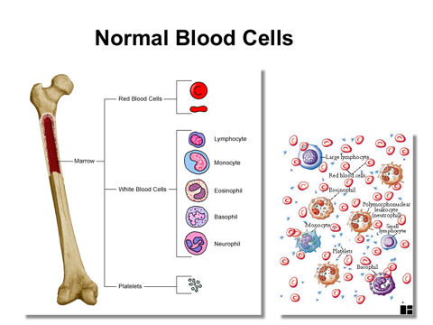

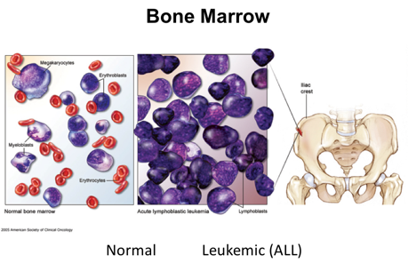
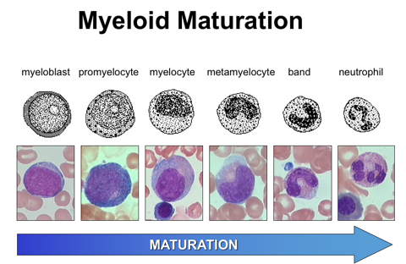

In leukemia, the growth signal protein is switched on

What are the known causes in adults?
- Radiation causes leukemia
- Scientists studying radioactive substances developed leukemia
- Uranium miners
- Atomic bomb survivors
- Down winders now receiving compensation

Above ground nuclear testing
- From 1945 to 1962, the US conducted 235 above ground nuclear weapons tests, primarily in Nevada and the Pacific
- 200,000 Department of Defense (DoD) military and civilian participants.

Benzene
- Known leukemogen in occupational settings
- Clusters of leukemia in shoemakers, rubber workers, refinery workers

What are the known causes in children?
- Prenatal Exposure to X-Rays
  - 1954 British researcher Alice Stewarts finds 50% higher risk of childhood leukemia following maternal x-ray
  - Findings repeated in multiple studies
  - Almost no pregnant women have abdominal radiography now
- Postnatal Exposure to Radiation
  - Previously used for conditions such as tinea capitis and thymus enlargement
  - From 1924 to 1946, 1131 newborns in a Boston hospital irradiated for enlarged thymus
  - Atomic bomb survivors
- Cancer treatments cause leukemia
  - AML is a common secondary cancer, caused by chemotherapy and radiation
  - Antibiotic chloramphenicol and analgesic phenylbutazone

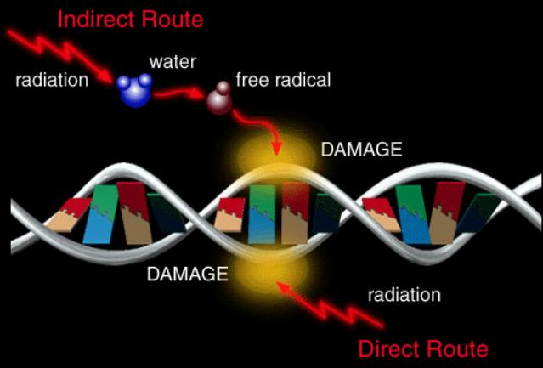
What are the known causal mechanisms?
- DNA Damage
- Molecular Epidemiology
  - Benzene exposure causes chromosome damage
  - Chromosomes are cellular structures that contain DNA
  - Chromosome damage is a known precursor to cancer
- Double Strand DNA Break

- Chromosomal Translocations
  - A translocation is a condition where a fragment of one chromosome is broken off and is then attached to another.
- DNA Repair
  - Think of DNA as a zipper, and picture our cells as having tiny scavenger proteins that spend all of their time searching for and eliminating stray threads and foreign matter and broken teeth that have made their way into our DNA zippers.
  - There is a high incidence of leukemia in children with inherited defects in DNA repair mechanisms

Topoisomerase II
- Topo II is an enzyme that allows the double helix of DNA to untangle during cell division so the chromosomes can replicate and segregate properly.
- Inhibiting topo II can cause cell cycle blocks and DNA breakage. And these DNA disruptions can lead to cancer.
- Benzene is a suspected topo II inhibitor
- Topo II Inhibitors
  - Many common chemotherapies are topo II inhibitors
  - 2-12% of patients who take topo II inhibitors go on to develop AML

In Utero Beginning
- Newborn heel stick cards show leukemic chromosomal translocations present at birth
- About 60-70% of diagnosed childhood ALL had the clone at birth
- These chromosomal translocations are DNA damage probably caused by chemical, infectious or pesticide exposure

Two-Hit Theory
- Approximately 1% of all umbilical cord blood studied have ETV6-AML1 (translocation common with ALL)
- Only some of these children develop leukemia
- Another “hit,” or damage to the gene, is needed to develop full blown leukemia

Second hit a virus?
- Many leukemia researchers suspect the second “hit” may be a virus
- Human T-cell Leukemia Virus (HTLV)
- Suspicions on common viruses

What are the theories of causation?
- ALL peaks at age 2-4 years
  - Age peak absent in non-industrialized countries
  - Higher incidence in middle and high income families

Does modern living give 2 year-olds leukemia?
- Electromagnetic frequency?
- Automotive exhaust?
- Jet planes?
- Rise of chemical industry?
- Radiation from power plants?
- Nuclear testing?

Population Mixing Theory?
- In the 1980’s England had two childhood leukemia clusters near nuclear power plants
- It was proposed this was due to the influx of workers to build the plants, bringing new exposures to the local rural population
- They had increased from 20,000 to 50,000 trainees during the cluster period

TCE and Solvents
- Childhood leukemia clusters were associated with wells with TCE
  - Woburn, MA. and Toms River, NJ

Pesticides
- 12+ studies found elevated rates of leukemia among children whose parents were occupationally exposed to pesticides or who used pesticides in their home or garden.
- Children 5-6x more likely to develop brain cancer or leukemia if pesticides used at home

Low level exposure to benzene?
- Benzene is a known leukemogen given large exposures in an occupational setting. But are current exposures safe?
- Benzene is ubiquitous in low levels, from sources such as automotive exhaust, cigarettes smoke, gasoline vapors, paints and dyes and glues.
- There are leukemia clusters near active airfields.

Non ionizing radiation?
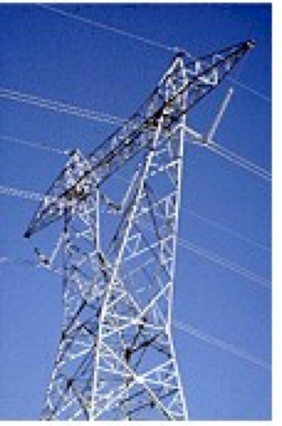
- Many studies on EMF exposure and leukemia
- Conflicting results
- Recent ~12 studies have shown positive association with childhood leukemia

