Enteric Nervous System
Dr. Gary Mumaugh – Campbellsville University

Histology of the GI Tract
- Awesome Fact - All the neurons that are involved in the enteric nervous
system is equal to the amount in the entire spinal cord.

There are 4 layers of the Alimentary Canal
- Mucosa
  - Epithelium
  - Lamina Propria
  - Muscularis mucosa
- Submucosa
  - Areolar connective tissue & dense connective tissue
  - Contains glands
  - Contains Submucosal Plexus (or Meissner’s plexus)
- Muscularis Externa
  - Inner circular layer
  - Outer longitudinal layer
  - Stomach has an additional layer called the inner oblique layer
  - In between there is the Myenteric plexus (Auerbach plexus)
- Serosa
  - This is basically the mesothelium
  - If a structure has a serosa it is intraperitoneal (that means it has a mesentery)
  - If it doesn’t have serosa, it is retroperitoneal they are anchored to posterior abdominal wall and called adventitia
  - So in the gut there is serosa or adventitia

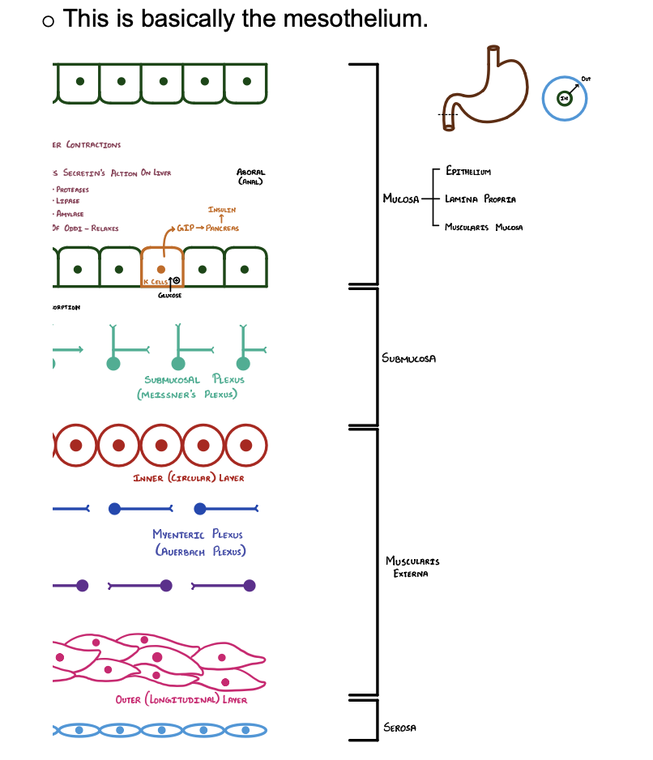
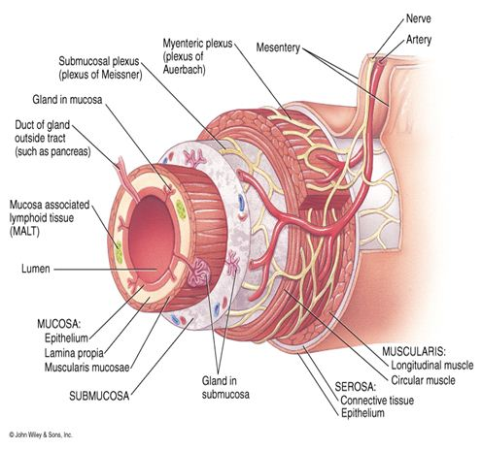

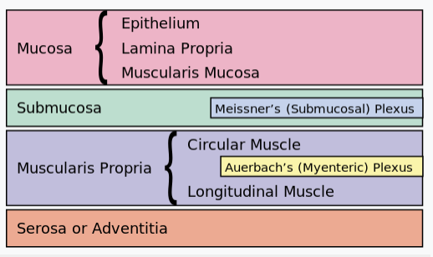
 | Meissner’s Plexus | Auerbach’s Plexus
Definition | Meissner’s Plexus is an inner nerve plexus located in the submucosal tissue of the intestinal wall | Auerbach’s plexus is an outer plexus between the circular and longitudinal layer of the intestine
Location | In the submucosal tissue of intestinal wall | Between the circular and longitudinal muscle layers in the lower esophagus, stomach and small and large intestines
Nerve Bundles | The nerve bundles of the submucous plexus are the finer than those of the myenteric plexus | The nerve bundles of the Auerbach’s plexus are larger than the fibers of the Meisner’s plexus
Function | Controls GI secretions and local blood flow | Controls GI movements
Plexus | An inner plexus | An outer plexus

GI Motility of Muscularis Externa
- Course of Ingested Food
  - Food enters the mouth which becomes a bulus, then chyme
  - Stretches the wall of alimentary wall
  - Stretch Receptors in the muscular layer are activated:
  - Circular layer:
    - Contracts and produces a constriction ring and pushes behind the bolus and pushes it forward
  - Longitudinal layer:
    - When it contracts it opens the lumen in front of the food
    - For the food to move down the gut, the circular muscles need to contract and longitudinal muscles need to relax.
- Function of Ascending Fibers
  - The ascending fibers work on the oral side of the bolus to push it forward.
  - The stretch receptors will stimulate the ascending fibers.
  - Axons travel to the longitudinal muscle layer and the circular muscle layer
  - Circular Muscle Layer
    - The fibers from the stretch receptors release acetylcholine + substance P to the circular muscle layer.
    - This causes it to contract

GI Motility of Muscularis Externa
- Function of Ascending Fibers
  - Longitudinal Muscle Layer
    - The fibers release vasoactive intestinal peptide (VIP) + Nitric Oxide
    - This causes a hyperpolarization which causes the muscle to RELAX
- Function of Descending Fibers
- The descending fibers work on the anal side of the bolus.
- When propelling the food down the gut tract, the area that is after the bolus needs to be open/relax to accept the food.
- Circular Muscle Layer
  - The fibers release VIP + NO, which causes potassium ions to leave the cell, causing hyperpolarization RELAX
  - Descending fibers give fibers to the circular muscles downstream / anal side of the bolus. This area needs to relax to allow the bolus to move downstream.
- Longitudinal Muscle Layer
  - The fibers release acetylcholine + substance P to the longitudinal layer which causes CONTRACTION, which opens up the lumen to accept the bolus

Stimulation of Submucosal Plexus
- Submucosal Plexus
- Stretch Receptors can stimulate the submucosal plexus as well. But the more powerful stimulators for the submucosal plexus are the chemoreceptors.
- Function of Chemoreceptors:
  - Chemoreceptors release chemicals depending on the food eaten.
  - Certain chemical substances can stimulate chemoreceptors and stimulates the submucosal plexus.
- How are the chemoreceptors stimulated?
  - Chemical substances from food stimulates chemoreceptors, which activate submucosal plexus which stimulates glands to secrete secretions to the lumen to help with digestion.
  - If blood vessels are stimulated by chemoreceptors, it causes the blood vessels to dilate which increases more blood flow to the area which increases absorption of substances into circulation.

Examples of the Effects of Chemoreceptors
- Fatty Rich and H+ Rich Foods
  - Food rich in fatty acids and H+ ingested stimulates the chemoreceptors, which activates the submucosal plexus. This stimulates entero-endocrine cells to release secretin.
  - Secretin has 2 functions:
    - Stimulates hepatocytes to produce more bile which emulsifies fats
    - Duct cells in acini in pancreas releases bicarbonate rich pancreatic juice which neutralizes the acid

Examples of the Effects of Chemoreceptors
- Protein Rich Food
  - Food rich in protein ingested stimulates submucosal plexus is via the chemoreceptors. This stimulates I cells to secrete CCK.
  - Functions of CCK (Cholecystokinin):
    - Gall bladder contractions
    - Potentiate secretions action on liver
    - Pancreas stimulates ductal cells which produces proteases, lipases and amylase
    - Relaxes the sphincter of Oddi, which releases more bile and pancreatic juices into the duodenum
- Glucose Rich Food
  - Food rich in glucose ingested activates K cells in the duodenum to release Glucose Insulinotropic Peptide (GIP).
    - This stimulates the pancreas to produce insulin.

Autonomic Nervous System Effect

Sympathetic Nervous System:
- Remember: Sympathetic Stimulation inhibits the effect of the GI tract. (Dr. M quote – “You can’t run away from the bear unless you pooped your pants.”
- Overall results:
  - ↓ Motility
  - ↓ Blood Flow
  - ↓ Secretions
  - ↓ Absorption
- Exception: constricts sphincters (pyloric sphincter, internal anal sphincter for example)

Parasympathetic Nervous System:
- Most fibers come from the Vagus nerve. The dorsal nucleus of Vagus synapse DIRECTLY on to the submucosal plexus or the myenteric plexus.
- This means the submucosal and myenteric plexus are the post ganglionic cell bodies (intramural ganglion).
- Overall results:
  - ↑ Motility
  - ↑ Secretions
  - ↑ Absorption
- Exception: Relaxes Sphincters

Autonomic Reflexes of the GI Tract
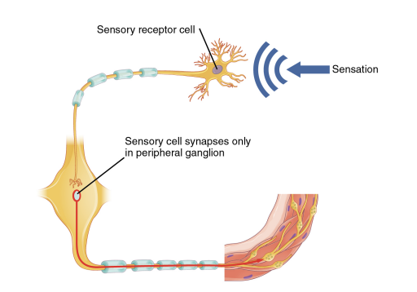
- Short Reflexes
  - Short reflexes are completely peripheral and only involve the local integration of sensory input with motor output. [lumen learning]
  - Recall: reflexes consists of receptor (afferent), integration center and the effect (produced by efferent pathway).
  - In this case:
    - Afferent: chemo/stretch receptor
    - Integration center: plexus
    - Effect: dilation, secretion, motility, etc.
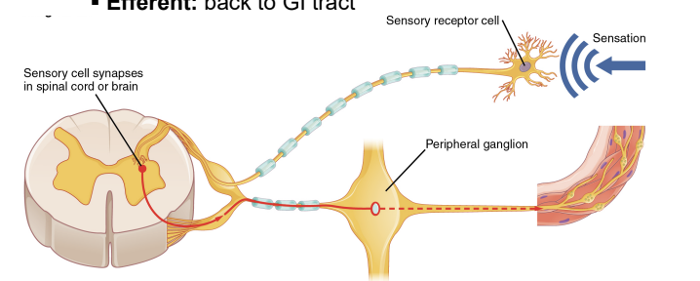
Autonomic Reflexes of the GI Tract
- Long Reflexes
  - Long reflexes have afferent branches that enter the spinal
cord or brain and involve the efferent branches. [lumen learning]
- Therefore:
  - Afferent fibers: from GI tract
  - Integration center: CNS
  - Efferent: back to GI tract

Examples of Long Reflexes
- Vagovagal Reflex
  - Function:
    - This reflex is activated when food stretches the stomach, and so it reduces the tone in the muscular wall of the body of the stomach allowing the wall to bulge progressively outward, accommodating greater and greater quantities of food up to a certain limit.
  - Do not confuse this with a Vasovagal Response or Vasovagal Syncope
    - Occurs when you faint because your body overreacts to certain triggers, such as the sight of blood or extreme emotional distress.
    - It may also be called neurocardiogenic syncope.
    - The vasovagal syncope trigger causes your heart rate and blood pressure to drop suddenly
- Entero-gastric reflex
  - Function:
    - This is an inhibitory reflex which is initiated by increased acid in the intestines and increased distention of stomach.
    - Signals from the colon and small intestine inhibit stomach motility and stomach secretion.
    - Since the rate of stomach emptying is slower, sufficient time is ensured for adequate digestion in the duodenum and small intestine.
- Defecation reflex
  - This reflex is initiated by feces entering the descending colon and allows defecation.

