Cerebral Cortex – Frontal Lobe Anatomy and Function
Outline
- Frontal Lobe Anatomy
- Primary Motor Cortex
- Motor Association Cortex
- Pre-Frontal Cortex
- Frontal Eye Fields
- Broca’s Area
- Review Questions
- References

FRONTAL LOBE ANATOMY
Boundaries of Frontal Lobe
- Anterior to the central sulcus and the parietal lobe.
- Anterior and superior to the lateral sulcus (Sylvian Fissure) of Temporal Lobe.
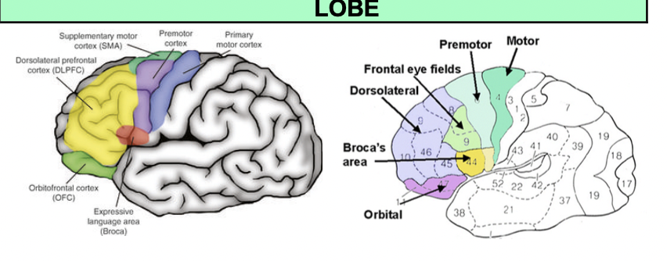

Divisions and Functions of Frontal Lobe
- Primary Motor Cortex – this is the functional name
  - The anatomical name is the Pre Central Gyrus
  - Anterior to the central sulcus
  - Involved in voluntary movement, particularly skeletal muscles
- Motor Association Cortex
  - Two specific areas: Premotor Cortex and the Supplementary Motor Area
  - Located anterior to the primary motor cortex Involved in planning, sequence, and execution of movement
- Frontal Eye Fields
  - Anterior to the motor association cortex Involved in voluntary rapid eye movements, which is also called saccadic eye movement
- Pre-Frontal Cortex
  - Anterior to the frontal eye fields
  - Involved in the following: memory, learning, motor planning, personality and behavior
- Broca’s Area
  - Superior to temporal lobe, anterior to primary motor cortex
  - Predominantly in the dominant hemisphere
    - e.g. right-handed people in the left frontal lobe and left handed people in the right front lobe
  - Involved in the muscles of speech

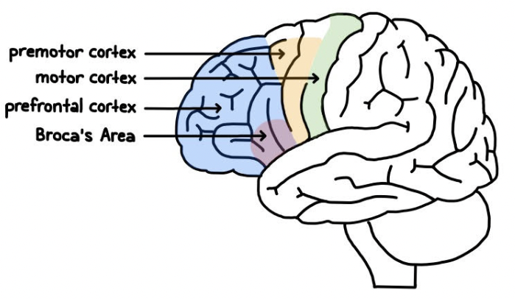

Primary Motor Cortex
- Anatomical term is the pre-central gyrus or the Brodmann Area 4
- Functions
  - Sends motor information from the cortex to the brainstem and to the spinal cord the final motor plan.
  - Sent either to the brainstem areas, or through the brainstem to the spine.
  - The tracts from the motor cortex are all involved in voluntary motor movement.
  - It sends the information through two separate tracts
- Corticospinal Tracts
  - Tracts to the anterior gray horn from the ventral and lateral corticospinal tracts
  - Activate the neurons that come out of the grey horn to the muscles.
- Corticobulbar Tract
  - Innervates several nuclei located in the brainstem
  - Particularly the cranial nerves that supply motor innervation to the skeletal muscles of the head and neck
- Cranial Nerves Involved with the Corticospinal and Corticobulbar Tracts:
  - CN V - Trigeminal nerve - muscles of mastication
  - CN VII - Facial nerve - muscles of facial expression
  - Combination of CN IX - Glossopharyngeal nerve, CN X - Vagus nerve, and the CN XI - Spinal Accessory nerve
    - CN IX and CNX - supply the pharynx, larynx, uvula and the soft palate
    - CN XI - supply the same region + sternocleidomastoid and trapezius muscles; also supplies the tongue
    - CN XII - Hypoglossal nerve - innervates the tongue
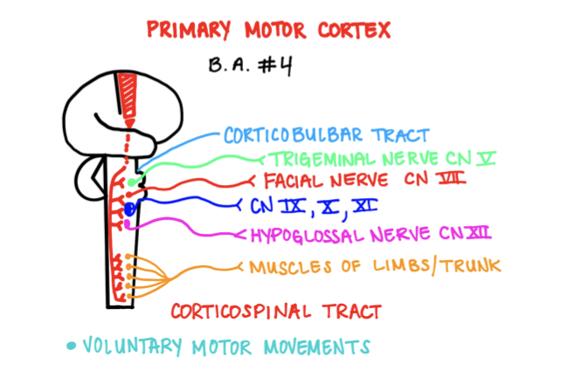

Somatotopy Arrangement and the Primary Motor Cortex
- The homunculus of the primary motor cortex wraps the human body around the outer margin of the cerebrum in both hemispheres
- When reviewing the location of various body areas that create movement, the locations can be in specific areas

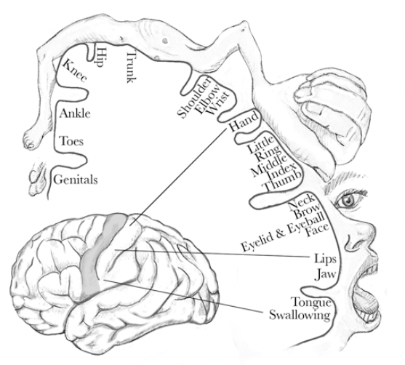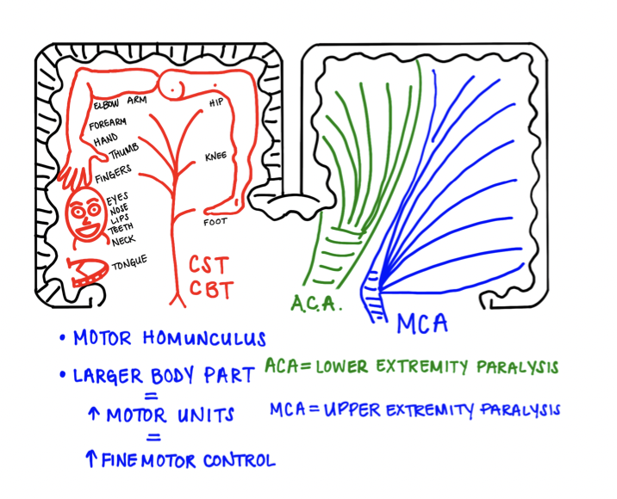

Somatotopy and the Primary Motor Cortex
- In general, it can be thought of as such:
  - Most medially relates to the foot, leg and hip area (lower extremities)
  - Most laterally relates to trunk, shoulders, and arms (upper extremities)
  - Most laterally and inferiorly relates to the face and neck
- The sizing of the body sections indicated on the homunculus, represents the greater number of motor units.
- This is due to more fine motor skill requirements in that section of body, (e.g. hand uses highly skilled fine motor movements therefore the homunculus representing hand would be larger than that of the arm)
- If a person were to sustain an occlusion in the brain in the anterior cerebral artery, the leg hip and truck area would be impacted
- If the occlusion were in the middle cerebral artery, the arm, hand, face and neck would be impacted

Clinical Application of Primary Motor Cortex
- An occlusion (stroke) of Anterior Cerebral Artery – lower extremity paralysis
- An occlusion (stroke of Middle Cerebral Artery – upper extremity paralysis

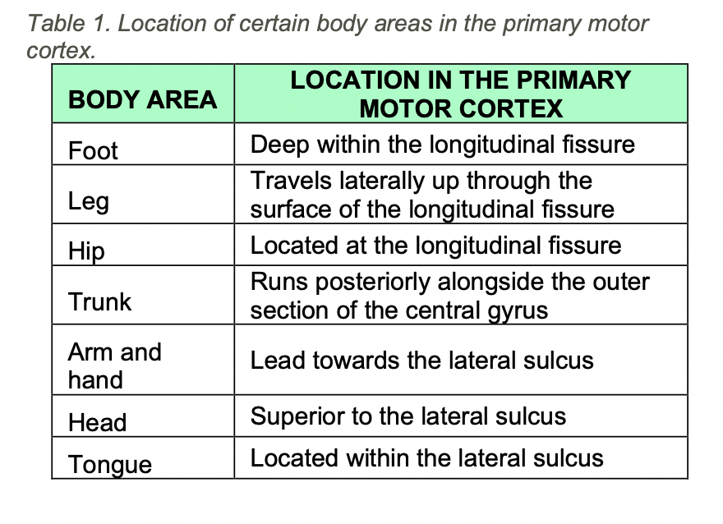

Motor Association Cortex
- The Motor Association Cortex is divided into a Pre Motor Cortex and a Supplementary Motor Area
- The Motor Association Cortex is also referred to as Brodmann’s Area 6
- The Premotor Cortex is located laterally beside the primary motor cortex, finishes in the superior region
- The Supplementary Motor Area is located most superiorly and leads down into the
longitudinal fissure
- Functions of Motor Association Cortex
  - We will study the combined functions of both areas because the work together
  - Both involved in the fine motor movement
  - Has a 15% contribution to the corticospinal tract
  - Supplies the axial muscles and the proximal limb muscles, thus the trunk, hips, and shoulders.
- Communicates with the Basal Ganglia
  - Plays a significant role by:
    - Initiating movements
    - Preventing unwanted movement
    - Modifying incorrect movements
- Communicates with Cerebellum
  - Plays a role by processing the following:
    - Equilibrium of the inner ear
    - Sensations experienced by the body
    - Planning for future movement by the motor association cortex
- All the information is considered and modifications to the expected movement is sent back to the motor association complex for further planning
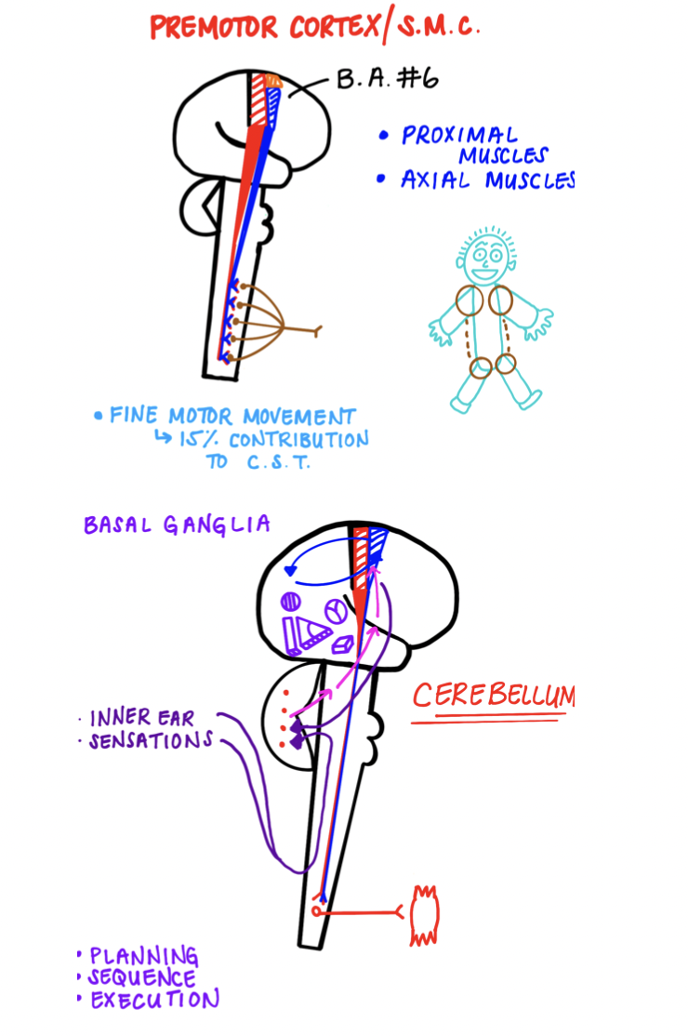

Pre Frontal Cortex
- Has numerous Brodmann’s areas - 8 to 14, 24, 25, 32, 45 to 47
- Involved with the following:
  - Personality and behaviors (connections with hippocampus and limbic brain)
  - Working memory (connections with hippocampus)
  - Cognition & learning
  - Decision-making, reasoning and judgment
(connections with the V.A.A. – Ventral Tegmental Area, and limbic brain through the Basal Ganglia)
  - Motor planning (through the Basal Ganglia)
    - Communicates by gathering information in the occipital area (vision), temporal area (auditory), and prefrontal area (sensation)
  - All of this information is sent back to the Pre Frontal Cortex for motor planning to modify anything

Clinical Application of Pre Frontal Cortex
Fronto-Temporal Dementia
- Characterized by the following:
  - Personality changes - aggressive/hostile/agitated
  - Working memory loss - aphasia and difficulty learning or storing new tasks
  - Decision-making
  - Behavioral changes
    - Perform behavior that they would not normally perform
    - Increased inappropriate behavior such as sexual activity or gambling
  - Parkinsonian symptoms = motor symptoms

Frontal Eye Fields
- Also known as Brodmann’s Area 8
- Involved with saccadid eye movement, or alternatively rapid eye movement
- Driven through communication with CN III - Oculomotor nerve, CN VI - Abducens nerve, and the PPRF - paramedian pontine reticular formation.
- These three areas the frontal eye fields (right) will send contralateral signals to the left PPRF → left CN VI → crosses and then to right CN III
  - Left CN VI can send innervation to the left lateral rectus muscle → abduction
  - Right CN III can then send innervation to the right medial rectus → adduction
  - Therefore, causing contralateral conjugate movement of the eyes

Clinical Application of Frontal Eye Fields
- Damage to the area of the frontal eye field:
  - PPRF is not innervated → contralateral eye will NOT abduct and ipsilateral eye will NOT adduct
  - Eyes cannot pull towards one direction → causes deviation on the alternate side - ipsilateral conjugate gaze deviation

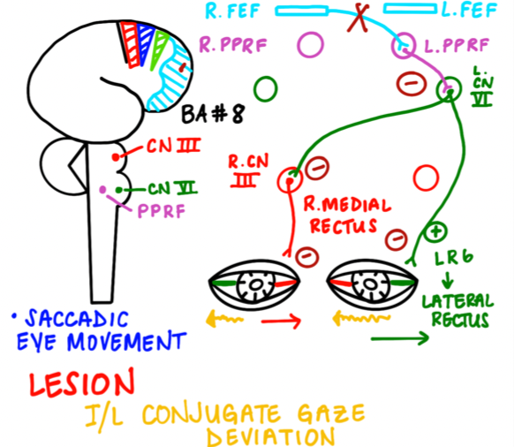
Broca’s Area
- Involved with the muscles of speech
- It is generally located on the non-dominant side of the individual
- Communicates with Wernicke’s Area by the arcuate vesiculas
- Takes the information about the words that should be spoken
- It sends nerves via the brain stem and connects with a number of nerves:
  - CN VII - Facial nerve
Works with orbicularis oris to changes the shape of the mouth
    - This changes the way that language can be heard and interpreted

Broca’s Area - continued
- Nucleus ambiguous
  - Comes out via a couple nerves (CN IX, CN X and CN XI)
  - The combination of these nerves is called the pharyngeal plexus
  - Supplies the soft palate, uvula, pharynx, larynx
    - All of these organs are important for voice modulation
  - Hypoglossal nerve (CN XII)
    - Stimulates the muscle of the tongue.
- Stimulation to all these areas is important:
  - Voice comes out via the larynx
  - Tension of the small vocal cords is stimulated by CN X and a small amount of the CN XI
  - Could change the pharynx, uvula, or soft palate in a particular way
  - The sound will be so dependent on how the nerves interact with it
  - Tongue is moved in a particular way to articulate speech
  - As the speech moves past the throat area and the tongue it is impacted by the orbicularis oris, which changes the shape of the lips to assist in pronunciation
Clinical Application of Broca’s Area – Broca’s Aphasia
- Damage to the Broca’s area (e.g. Middle Cerebral Artery)
- Broca’s Aphasia is sometimes called Expressive Aphasia
- Characterized by loss of ability to speak properly:
  - Non-fluent speech
  - Grammatically incorrect
  - Intact comprehension of language
  - Expressive aphasia
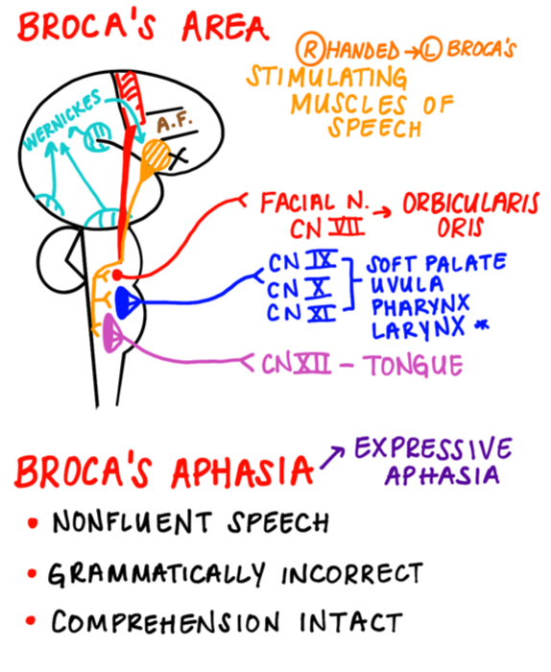

Review Questions
- In Broca’s area, what cranial nerves travel out with the nucleus ambiguous to cause sound?
  - III, VI and VII
  - VI only
  - X only
  - IX, X and XI
- What nerve stimulates the movement of the tongue?
  - III
  - VII
  - XI
  - XII
- What does the prefrontal cortex area NOT control?
  - Motor planning
  - Working memory
  - Personality and behaviors
  - Intelligence
- What is not in the Frontal Lobe area
  - Wernicke’s area
  - Frontal eye fields
  - Primary motor cortex
  - Pre-frontal cortex
- The motor association cortex is not involved in Planning, sequencing and execution of movement.
  - True
  - False
References
- Helmstaedter, C., & Witt, J. (2011). Behavioral and neuropsychological aspects of frontal and temporal lobe epilepsy. In M. Trimble, & B. Schmitz, The Neuropsychiatry of Epilepsy. Cambridge
- Purves, Dale. Neuroscience. Available from: VitalSource Bookshelf, (6th Edition). Oxford University Press Academic US, 2017. University Press (Chapter 32, 33)
- Siegel, Allan, and Hreday N. Sapru. Essential Neuroscience. Available from: VitalSource Bookshelf, (4th Edition). Wolters Kluwer Health, 2018. (Chapter 1, 12)
- Waxman, Stephen G. Clinical Neuroanatomy. Available from: VitalSource Bookshelf, (29th Edition). McGraw-Hill Professional, 2020. (Chapter 21)

Frontal Lobe Anatomy and Function Wrap-up
