Functional Nervous System Dr. Gary Mumaugh – Campbellsville University

Meninges
- Membranes that cover the brain and spinal cord
- Dura Mater
  - Dense connective tissue that provides a tough barrier against foreign agents
  - Outer layer of meninges and inner periosteum of the cranial bones; has three important extensions
    - Falx cerebri
      - Projects downward into the longitudinal fissure between the two cerebral hemispheres
      - Dural sinuses: function as veins, collecting blood from brain tissues for return to the heart
      - Superior sagittal sinus—one of several dural sinuses
    - Falx cerebelli: separates the two hemispheres of the cerebellum
    - Tentorium cerebelli: separates the cerebellum from the cerebrum
- Arachnoid Membrane
  - Subarachnoid space is filled with CSF – cerebrospinal fluid
- Pia Mater
  - Delicate membrane that touches the surface of the brains and spinal cord
  - Innermost, transparent layer; adheres to the outer surface of the brain and spinal cord; contains blood vessels; beyond the spinal cord, forms a slender filament called filum terminale; at level of sacrum, blends with dura mater to form a fibrous cord that disappears into the periosteum of the coccyx
- Spaces between the meninges
  - Epidural space
    - Between the dura mater and inside the bony covering of the spinal cord; contains a supporting cushion of fat and other connective tissues
  - Subdural space
    - Located between the dura mater and arachnoid mater; contains lubricating serous fluid
  - Subarachnoid space
    - Between the arachnoid and pia mater; contains a significant amount of cerebrospinal fluid (CSF)
- Meningitis – inflammation of the meninges

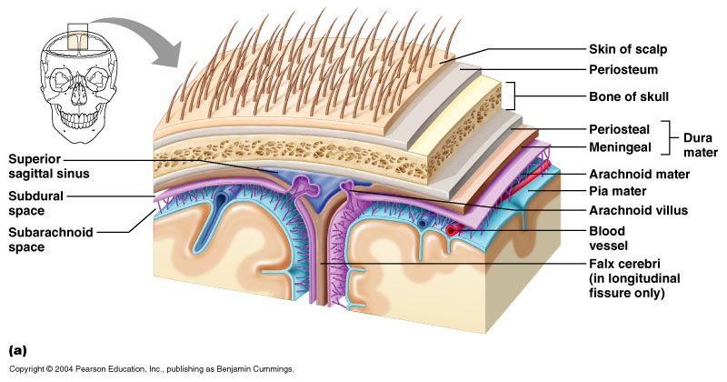
Cerebral Spinal Fluid
- CSF continually flows through and around the CNS
  - driven by its own pressure, beating of ependymal cilia, and pulsations of the brain produced by each heartbeat
- Brain produces and absorbs 500 mL/day
  - 100 – 160 mL normally present at one time
- Formation of the CSF
  - Produced by the Choroid Plexus (vascularized membrane) within the ventricles of the brain
  - Has a chemical composition similar to that of tissue fluid
    - The one major difference between tissue fluid and plasma is that there are proteins in plasma but they are to big to get into tissue fluid.
  - Cerebrospinal fluid (CSF) – clear, colorless liquid that fills the ventricles and canals of CNS - small amount of CSF fills the central canal of the spinal cord
- Functions of CSF
  - buoyancy
    - allows brain to attain considerable size without being impaired by its own weight
    - if it rested heavily on floor of cranium, the pressure would kill the nervous tissue
  - protection
    - protects the brain from striking the cranium when the head is jolted
    - shaken child syndrome and concussions do occur from severe jolting
  - chemical stability
    - flow of CSF rinses away metabolic wastes from nervous tissue and Homeostatically regulates its chemical environment
  - nutrition to the cord
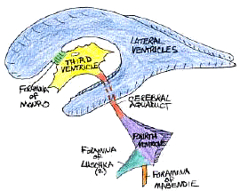
Cerebral Spinal Fluid - continued
- Circulation of CSF
  - The CSF starts in the bloodstream and returns to the bloodstream
  - Starts in the ventricles of the brain
    - 10% goes into the central canal of the spinal cord and travels down the spine before ending in the subarachnoid space at the bottom of the spine.
    - 90% goes through the Foramen of Magendje (Median Aperature) and flows directly into the subarachnoid space.
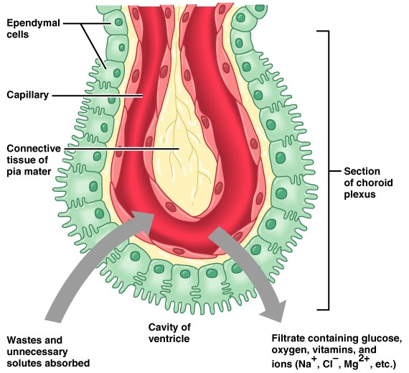
- Reabsorption of CSF
  - Reabsorbed through the arachnoid villa
  - Reabsorb about 20 ml/hour = rate of production

Excess Fluid
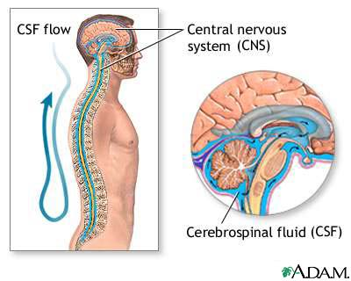
Subarachnoid space >>>>>>>>>>>>>>>>>>>>>>>>Cranial Venous Sinuses
Clinical Considerations of CSF
- Hydrocephaly
  - Rate of reabsorption is less than the rate of production of the CSF
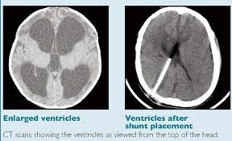
  - Creates increased ICP – Intra cranial pressure
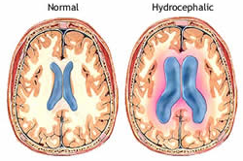
- Lumbar Puncture (“Spinal Tap”)
  - Puncture is made into the subarachnoid space between L3-L4
    - Remember the cord ends at L2
  - Uses:
    - Sampling of CSF – to DD (differentially diagnose) spinal conditions
    - Myelography – injection of x-ray dye into the subarachnoid space to identify the size of IVDS vs. trauma, etc. This is rarely done anymore because and MRI will give the same information.
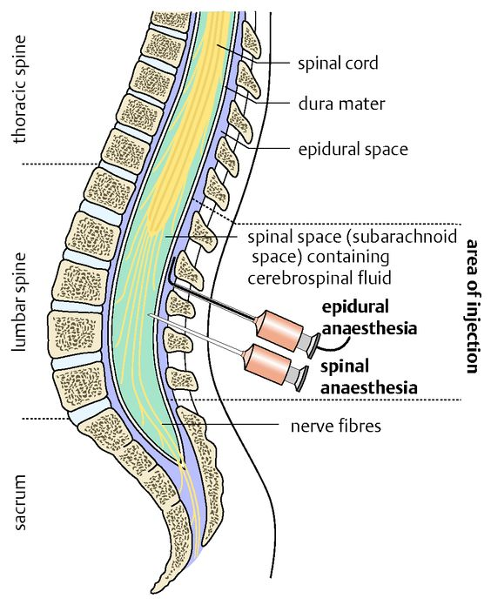
    - Regional Anesthesia – Epidural Nerve Block

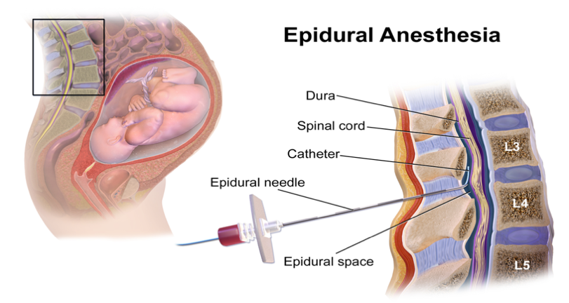
    - The Epidural is injected into the subarachnoid space
    - The Spinal Block is injected into the spinal space

Medications Used in Regional Anesthetics
- The drugs used are the same as what is used by Dentists
- The drugs temporarily block the action potentials in excitable cells (nerve cells and muscle cells)
- Lidocaine (Xylocaine)
  - In Dentistry, it is used to block the AP of facial nerves for dental procedures
  - In Medicine, it is used as a cardiac anti-arrhythmic (slows down the heart) for PVC – Premature Ventricular Contraction. This is how cardiologists treat cardiac electrical arrhythmias.
- Procaine (Narcaine)
- Benzocaine - OTC medication
  - This is what is used in Solarcaine for sunburn pain
  - Anbesol and campho-phenique for cold sores
  - Before the Dentist gives you a Lidocaine injection, they first numb the area with topical benzocaine.
- Cocaine – has local anesthetic qualities and is also a powerful brain stimulate
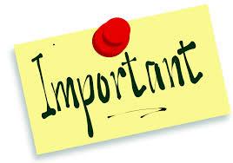
- Novacaine – hasn’t been used for 35 years
- Major Point – Any drug that can effect the action potential of nerves will also affect the action potential of muscles. (Both are excitable cells)

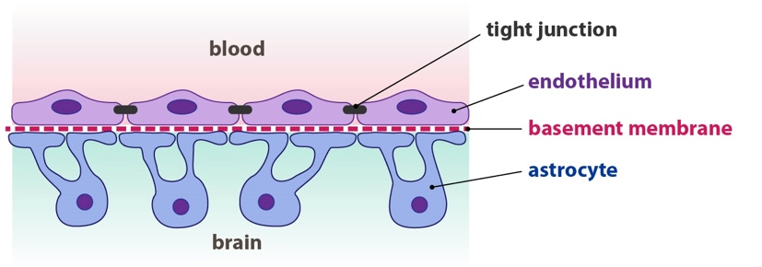
Blood Brain Barrier
- A filtering mechanism of the capillaries that carry blood to the brain and spinal cord tissue, blocking the passage of certain substances.
- The brain is the only organ known to have its own security system, a network of blood vessels that allows the entry of essential nutrients while blocking other substances.
- Unfortunately, this barrier is so effective at protecting against the passage of foreign substances that it often prevents life-saving drugs from being able to repair the injured or diseased brain.

Nerve Impulses
- Membrane potentials
  - All living cells maintain a difference in the concentration of ions across their membranes
  - Membrane potential: slight excess of positively charged ions on the outside of the membrane and slight deficiency of positively charged ions on the inside of the membrane
  - Difference in electrical charge is called potential because it is a type of stored energy

- Resting membrane potential
  - Membrane potential maintained by a non-conducting neuron’s plasma membrane; typically −70 mV
  - The membrane’s selective permeability characteristics help maintain a slight excess of positive ions on the outer surface of the membrane
  - Sodium-potassium pump
    - Active transport mechanism in plasma membrane that transports sodium (Na⁺) and potassium (K⁺) ions in opposite directions and at different rates
    - Maintains an imbalance in the distribution of positive ions, resulting in the inside surface becoming slightly negative compared with its outer surface

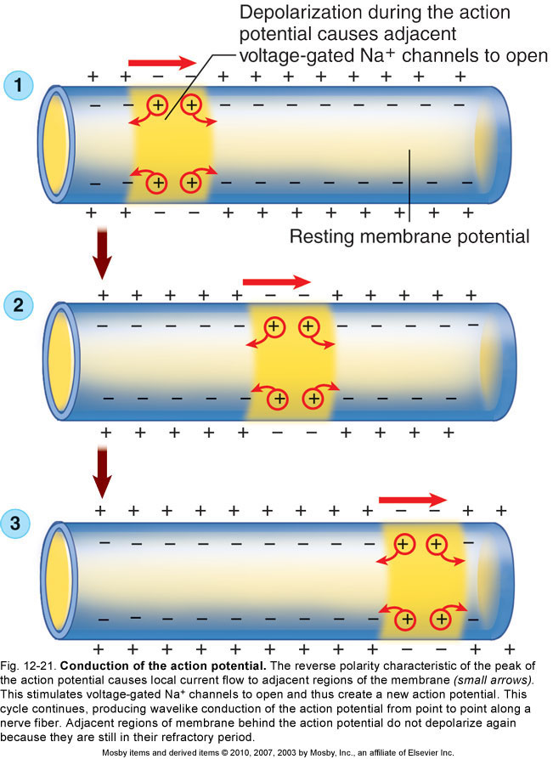

Action Potential
- Action potential: the membrane potential of a neuron conducting an impulse; also known as a nerve impulse
- Mechanism that produces the action potential
  - When an adequate stimulus triggers stimulus-gated Na⁺ channels to open, allowing Na⁺ to diffuse rapidly into the cell, which produces a local depolarization
  - The action potential is an all-or-none response
  - After action potential peaks, membrane begins to move back toward the resting membrane potential, a process is known as repolarization
- Refractory period
  - Absolute refractory period: brief period (lasting approximately 0.5 ms) during which a local area of a neuron’s membrane resists restimulation and will not respond to a stimulus, no matter how strong
  - Relative refractory period: time when the membrane is repolarized and restoring the resting membrane potential; the few milliseconds after the absolute refractory period; will respond only to a very strong stimulus
- Conduction of the action potential
  - At the peak of the action potential, the plasma membrane’s polarity is now the reverse of the resting membrane potential
  - This cycle continues to repeat
  - The action potential never moves backward
  - In myelinated fibers, action potentials in the membrane only occur at the nodes of Ranvier; this type of impulse conduction is called saltatory conduction
  - Speed of nerve conduction depends on diameter and on the presence or absence of a myelin sheath

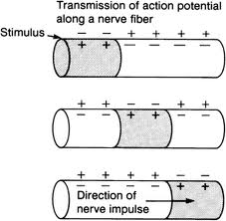

Action Potential – Starting at the Axon Hillock
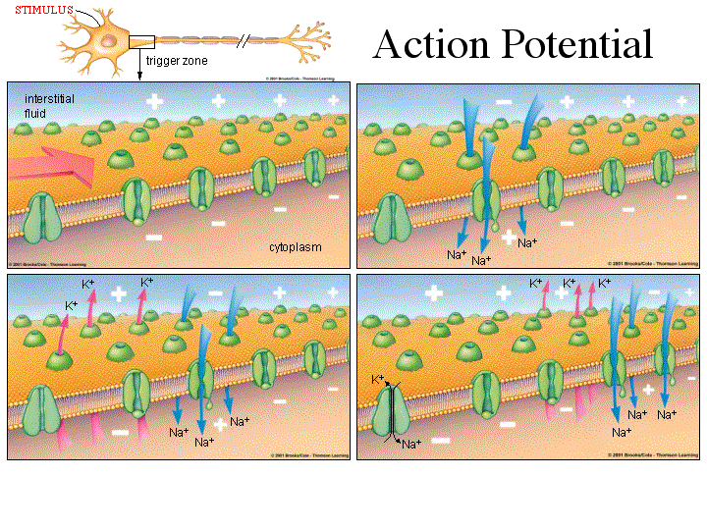

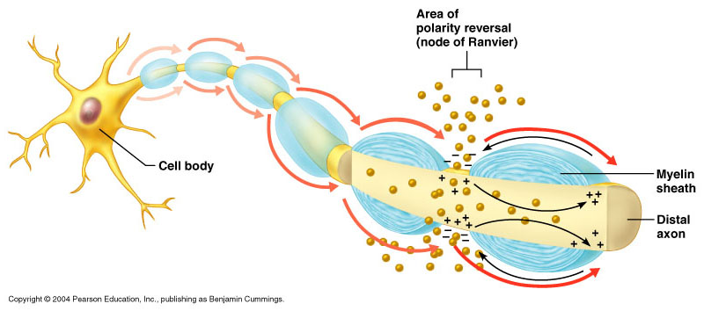

Synaptic Transmission
- Two types of synapses (junctions)
  - Electrical synapses occur where cells joined by gap junctions allow an action potential to simply continue along postsynaptic membrane
  - Chemical synapses occur where presynaptic cells release chemical transmitters (neurotransmitters) across a tiny gap
    - Structure of the chemical synapse
      - Synaptic knob: tiny bulge at the end of a terminal branch of a presynaptic neuron’s axon that contains vesicles housing neurotransmitters
      - Synaptic cleft: space between a synaptic knob and the plasma membrane of a postsynaptic neuron
      - Plasma membrane of a postsynaptic neuron has protein molecules that serve as receptors for the neurotransmitters
- Synapses and memory
  - Memories are stored by facilitating (or inhibiting) synaptic transmission
  - Short-term memories (seconds or minutes)
  - Intermediate long-term memory (minutes to weeks)
  - Long-term memories (months or years)
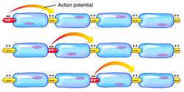

Speed of the Action Potential
- The speed of the action potential (or nerve transmission) is directly related to:
  - diameter of the nerve
  - amount of myelination
- Clinical Considerations:
  - Tested with NCV Nerve Conduction Velocity Studies
  - Guillian- Barre’ Syndrome
  - Multiple Sclerosis - demylination
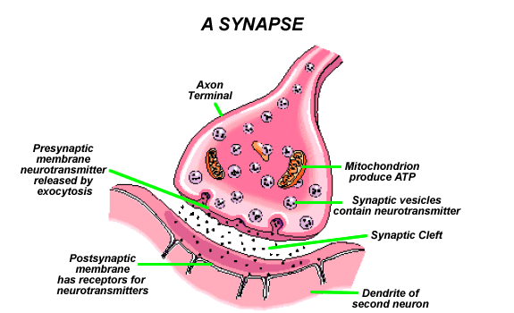

Repair of Nerve Fibers – Wallerian Degeneration
- Mature neurons are incapable of cell division; therefore damage to nervous tissue can be permanent
- Neurons have limited capacity to repair themselves
- If the damage is not extensive, the cell body and neurilemma are intact, and scarring has not occurred, nerve fibers can be repaired
- Stages of repair of an axon in a peripheral motor neuron
  - After injury, distal portion of axon and myelin sheath degenerates
  - Macrophages remove the debris
  - Remaining neurilemma and endoneurium form a tunnel from the point of injury to the effector
  - New Schwann cells grow in tunnel to maintain a path for axon regrowth
  - Cell body reorganizes its Nissl bodies to provide the needed proteins to extend the remaining healthy portion of the axon
  - Axon “sprouts” appear
  - When sprout reaches tunnel, its growth rate increases
  - Skeletal muscle cell atrophies until nervous connection is reestablished
- In CNS, similar repair of damaged nerve fibers is unlikely

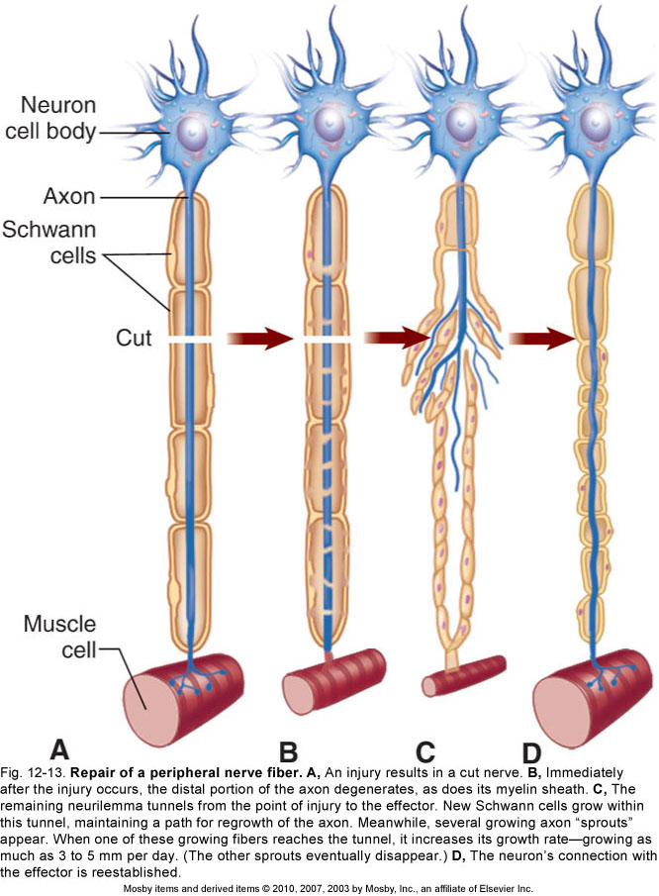

Neurotransmitters
- Neurotransmitters: means by which neurons communicate with one another; more than 100 compounds are known to be neurotransmitters, and more are be discovered.
- Common classification of neurotransmitters:
  - Two major functional classifications are excitatory neurotransmitters and inhibitory neurotransmitters
  - Chemical structure: the mechanism by which neurotransmitters cause a change; four main classes; because the functions of specific neurotransmitters vary by location, usually classified by chemical structure
- Function is determined by the postsynaptic receptor.
  - Given advances in pharmacology, genetics, and chemical neuroanatomy, the term "neurotransmitter" can be applied to chemicals that:
    - Carry messages between neurons via influence on the postsynaptic membrane.
    - Have little or no effect on membrane voltage, but have a common carrying function such as changing the structure of the synapse.
    - Communicate by sending reverse-direction messages that affect the release or reuptake of transmitters.

Release of Neurotransmitters
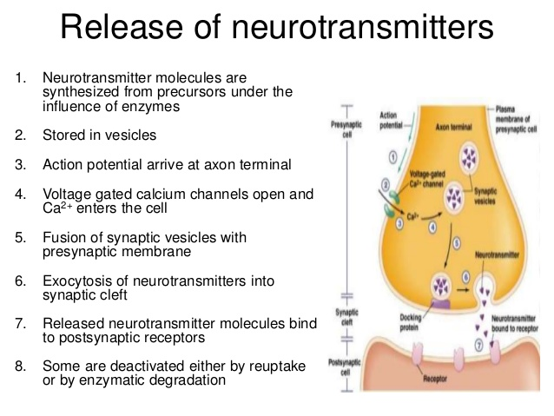

Examples of Clinically Significant Neurotransmitter Actions
- Glutamate is used at the great majority of fast excitatory synapses in the brain and spinal cord.
  - Excessive glutamate release can overstimulate the brain and lead to excitotoxicity causing cell death resulting in seizures or strokes.
  - Excitotoxicity has been implicated in certain chronic diseases including ischemic stroke, epilepsy, Amyotrophic lateral sclerosis, Alzheimer's disease, Huntington disease, and Parkinson's disease.
- GABA is used at the great majority of fast inhibitory synapses in virtually every part of the brain.
  - Many sedative/tranquilizing drugs act by enhancing the effects of GABA.
- Acetylcholine is the transmitter at the neuromuscular junction connecting motor nerves to muscles.
- Dopamine has a number of important functions in the brain.
  - This includes regulation of motor behavior, pleasures related to motivation and also emotional arousal.
  - It plays a critical role in the reward system.
  - Parkinson's disease have been linked to low levels of dopamine and people with schizophrenia have been linked to high levels of dopamine.
- Serotonin is produced by and found in the intestine (approximately 90%), and the remainder in central nervous system neurons.
  - It functions to regulate appetite, sleep, memory and learning, temperature, mood, behavior, muscle contraction, and function of the cardiovascular system and endocrine system.
- Epinephrine plays a role in sleep, with ones ability to stay become alert, and the fight-or-flight response.
- Norepinephrine focuses on the central nervous system, based on patients sleep patterns, focus and alertness.
- Histamine works with the CNS and CNS mast cells.

Action Potentials Travel Long Distances

Conduction is the high-speed movement of a action potential along an axon.

All-or-none

Wave of electrical signal at constant amplitude

Receptors

Cholinergic receptors

Nicotinic on skeletal muscle, in autonomic division of PNS and CNS

Muscarinic in CNS and autonomic parasympathetic division of the PNS

Synaptic Transmissions
Summary of Synaptic Transmission at Neuromuscular Junction
- Action Potential moves down the motor neuron to the synaptic knob
- The change in electrical polarity at the synaptic knob opens the voltage-gated Calcium channels.
- The entry of Calcium into the synaptic knob causes exocytosis (secretion) of the neurotransmitter Ach – Acetlycholine.
- The Ach diffuses across the synaptic cleft and binds to Nicotinic Ach Receptor site proteins on the membrane of skeletal muscle cell (fiber).
- Activation of the Ach Receptor sites causes an opening of the ligand-gated Sodium Channels.
- As Sodium flows into the skeletal muscle cell, it depolarizes to the Threshold Potential triggering (causing) an Action Potential.
- As the Action Potential spreads along the skeletal muscle cell, it causes the muscle cell to contract
- The Ach at the receptor site is split into Acetate and Choline by AChase – Acetylcholinesterase – and enzyme of the skeletal muscle cell membrane.
- The ligand-gated Sodium channels close off, permitting the skeletal muscle to relax.
- The Acetate and Choline are actively transported back up into the synaptic knob (Active Re-Uptake) to be re-synthesized.
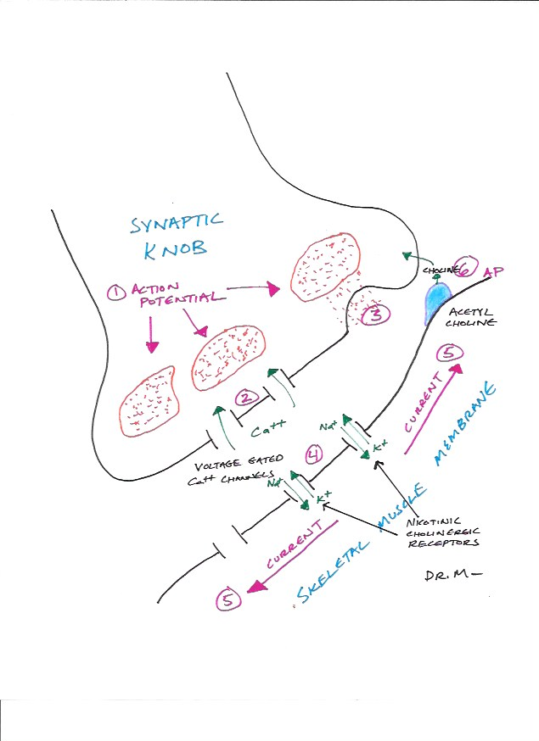

Pharmacological Applications of Neuromuscular Junctions
- Neuromuscular Blocking Agents
  - Attaches at Ach receptor sites, preventing Ach from exiting the muscles to contract
  - Causes flaccid paralysis of skeletal muscles
  - Examples:
    - Curare
      - Used as a skeletal muscle relaxant during surgical incisions
      - Used to relax the diaphragm muscle during general anesthesia so the patient doesn’t “fight” the respirator.
    - Cobra toxin

- Acetylcholinesterase Inhibitors
  - Prevents the AChase enzyme from breaking down ACh
  - The Ach remains attached to the receptor sites, so Sodium continues to flow into the muscle and the muscle remains contracted.
  - Causes spastic paralysis of voluntary muscles
  - Examples:
    - Organophosphate insecticides
      - Parathion, Malathion, Diazinon, Fenthion
    - Nerve gases
      - Soman, Sarin, Tabun,
    - Ophthalmic agents
      - Echothiophate, Isoflurophate

Clinical Considerations of Neuromuscular Junction
- Poliomyelitis
  - Viral infection of somatic motor neurons
  - Results in irreversible flaccid paralysis of voluntary muscles (including diaphragm)
- Botulism
  - A toxin (produced by Clostridium botulism) prevents the release of ACh by somatic motor neurons
  - Results in flaccid paralysis of voluntary muscles
- Myasthenia Gravis
  - Progressive weakening of voluntary muscles
  - An auto-immune disease, associated with an antibody cross-reaction with ACh receptor site proteins.
  - Treatment – immunosuppressants (corticosteroids)

Synaptic Transmission by Sensory Neurons
- Each sensory neuron typically synapses onto hundreds of other neurons.
  - They usually synapse onto interneurons, but they may synapse directly onto motor neurons.
- Sensory neurons always act to excite (depolarize) the post-synaptic neuron

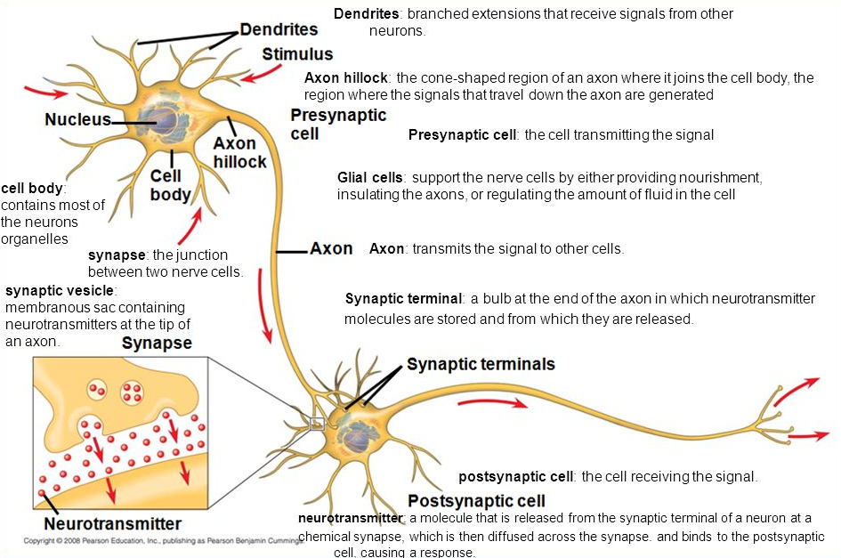

Synaptic Transmission by Interneurons
- Each interneuron typically influences over 100 other neurons
- The conduction of the Action Potential along a neuron trigger the release of a neurotransmitter from the synaptic knobs.
- Each interneuron releases one specific type of neurotransmitter

Excitatory Neurotransmitter
Increased Stimulus >>>>>>>> Local Increased >>>>>>>>>>>> Local Neurotransmitter Membrane Permeability Depolarization Receptor Site Sodium

Inhibitory Neurotransmitter
Increased Stimulus >>>>>>>> Local Increased >>>>>>>>>>>> Local Neurotransmitter Membrane Permeability Hyperpolarization Receptor Site Potassium

- There are specific enzymes to inactivate each type of neurotransmitter
- Summation of post-synaptic potentials
  - Temporal Summation
    - Summation of EPSP or IPSP due to repeated stimulation by one neuron
  - Spatial Summation
    - Summation of EPSP or IPSP due to stimulation by more than one neuron simultaneously
- Whether a neuron generates an Action Potential or not, depends on the overall sum of EPSP and IPSP occurring in the neuron at any moment of time.

Examples of Excitatory Neurotransmitters
- ACh – acetylcholine
- Glutamic Acid (an amino acid – note: most neurotransmitters are amino acids)
- NO – Nitric Acid
  - Causes blood vessel vasodilation – Example: Viagra
- Catecholamines
  - Examples: EPI – Epinephrine, NOREPI – Norepinephrine, Dopamine
  - All of the catecholamines are made from the amino acid tyrosine and they are chemically very similar. They activate receptor sites that form cyclic AMP.
  - They are very complicated, but are releasing enzymes that are forming more Cyclic-AMP which increases activity levels.
  - Caffeine is very similar in structure and function to EPI, just not as strong.
  - Tea has no caffeine, but has an additional theophylline, which is also a stimulant. Theophylline is used in some patients with breathing problems.

Examples of Inhibitory Neurotransmitters
- Glycine
- GABA (gamma-aminobutyric acid)
- Serotonin
  - Made from the amino acid tryptophan
  - Slows down action potentials
- Endorphin
  - From two-word endogenous morphine
  - Narcotic analgesics have the same effect
    - Morphine, codeine, dermerol, vicodine

Functional Role of Inhibitory Neurotransmitters
  - Sleep
  - All the sensory signals are still working, but the brain is ignoring these signals.
    - This involves activating inhibitory neurotransmitters, especially serotonin.
  - Permits sensory discrimination and attention
    - Allows us to focus our attention
    - Example: right now we are trying to listen and concentrate on the lecture. So you must tune out all the other stimuli around you. We
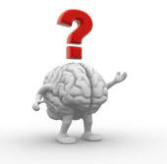
are able to do this by releasing Inhibitory Neurotransmitters.
What happens if you don’t produce enough Inhibitory Neurotransmitters?

- The production of inhibitory neurotransmitters increases as we age.
- This is why we are able to pay attention more as we age.
- Most children outgrow ADD because of this.
- ADD is more common in boys because girls nervous systems mature faster.
  - Rx for ADD – Ritalin and Alderol
    - These are actually stimulants like amphetamine, but they do increase the release of inhibitory neurotransmitters.

What happens if you had no Inhibitory Neurotransmitters?

Sensory Overload SEIZURES From Increased Sensory Input Overstimulation of Brain
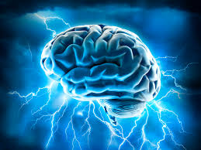

Neurotransmitters - continued
- Permits fine motor controls of muscles and effectors
  - Young children have gross motor skills.
  - The normal hand position of a baby is a clenched fist.
  - As the nervous system grows, they release more inhibitory neurotransmitters that can exert fine motor control.
  - Fine motor control means that we activate some motor neurons to some muscles and at the same time inhibit some motor neurons to other muscles.
What happens if we don’t have enough inhibitory neurotransmitters?

Overstimulation of Convulsions Somatic Motor Neurons
(Increased Motor Output)
Seizure = To Much Sensory Input to Brain
Convulsion = To Much Motor Output to Muscles

Clinical Consideration of Inhibitory Neurotransmitters
- Strychnine
  - A poison that blocks inhibitory neurotransmitters on the brain
  - Has both seizures and convulsions
- Tetanus (Lock Jaw)
  - Toxin produced by bacteria clostridium tetani.
  - Produces an exotoxin that blocks inhibitory neurotransmitters.

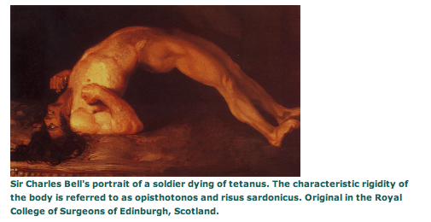

1809 Portrait of a British Soldier dying of tetanus

Functional Organization of the Nervous System

General Terms
- Gray Matter
  - Collection of neuron cell bodies in the CNS
- White Matter
  - Consists of bundles of myelinated nerve fibers that conduct impulses within the CNS
- Commissures
  - Bundles of nerve fibers that cross (“Decussate”) the midline from one side of the CNS to the other side.
- Ganglia
  - Collections of nerve cell bodies outside the CNS.
  - Singular is ganglion.

Organization of the Spinal Cord
- Spinal Nerves
  - Contains both sensory and motor nerve fibers (“mixed nerves”)
- Dorsal Root (Posterior)
  - Sensory branch of spinal nerve
  - Dorsal Root Ganglion –located of sensory (somatic & visceral) nerve fiber cell bodies
- Ventral Root (Anterior)
  - Motor branch of the spinal nerve

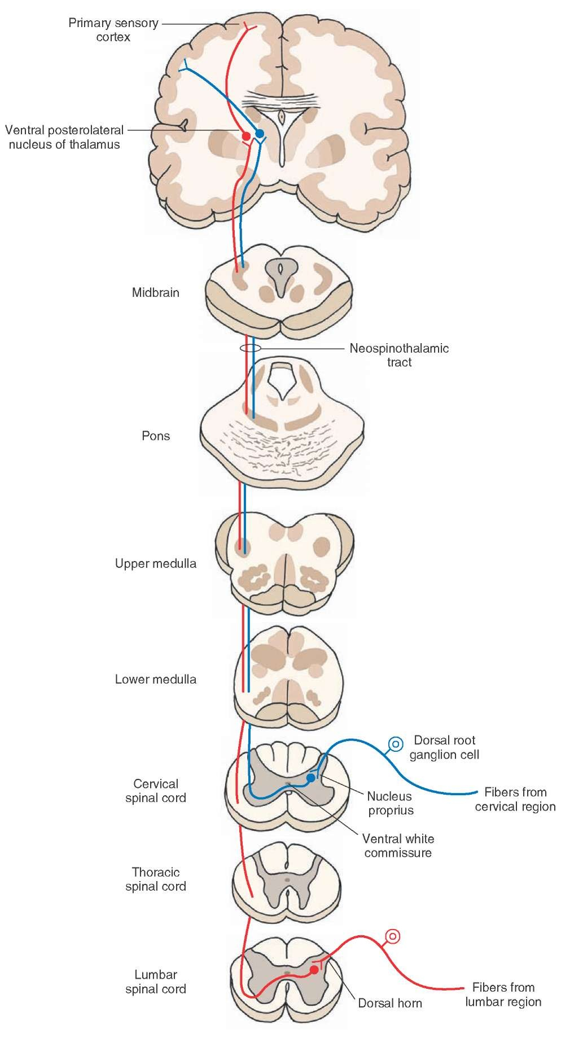

Organization of the Spinal Cord – continued

- Dorsal Grey Horn
  - Location – where sensory nerve fibers synapse onto interneurons
- Ventral Gray Horn
  - Location of somatic motor cell bodies
- Lateral Grey Horn
  - Location of autonomic motor neuron cell bodies (sympathetic preganglionic)
  - Only present at the thoracic and lumbar levels of the spinal cord

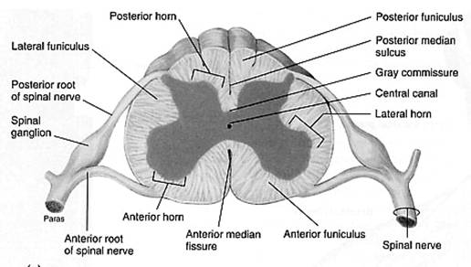

Somatic Sensory Neuron

- Brings information from the skin and skeletal muscles and reaches consciousness.
- It then synapses with an interneuron.
- After synapsing with the interneuron, it goes from the back of the cord to the front of the cord and synapses in the ventral grey horn with the somatic motor neuron.
- Patellar Tendon Reflex – most famous somatic reflex
  - Tapping on the patellar tendon starts and AP (action potential) in the somatic sensory neuron which releases and excitatory neurotransmitter.
  - The neurotransmitter activates an AP in the interneuron. The Interneuron sends an AP which releases and excitatory neurotransmitter to the somatic motor neuron.
  - The somatic motor neuron sends an AP which causes the skeletal muscles to contract.

Somatic Motor Neuron
- Originates in the ventral grey horn and is always myelinated.
- It travels through the ventral root and travels out through a spinal nerve before it innervates skeletal muscle cells.
Visceral Sensory Neuron
- Neuron is stimulated and sends an AP into the cord.
- The cell body of all the sensory neurons are located in the dorsal root ganglion.
- The AP releases an excitatory neurotransmitter at the synapse in the lateral gray horn.
- This excitatory neurotransmitter activates an AP in the autonomic motor neuron.
- This sends an AP via the autonomic motor neuron which synapses onto the organ.
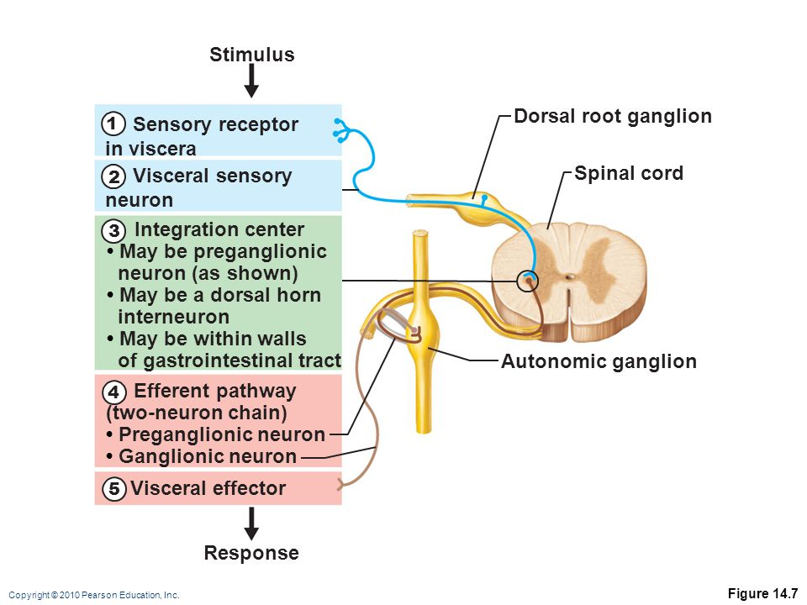
Clinical considerations of spinal cord injuries
- Causes
  - Physical trauma
  - Spinal meningitis
  - Herniated IVD
- Symptoms
  - Loss of sensation (anesthesia) and voluntary motion (flaccid paralysis)
occurring below the level of the injury. Z

Note: Up to now we have been considering how the nervous system send signals horizontally from the body to the spine and back to the body. This has all had connections in the Grey Matter. Now we need to focus on how the signals are sent vertically up to the brain and back. This is all happening in the White Matter.

The White Matter of the Spinal Cord
- Organized into bundles of Sensory (Ascending) Tracts and Motor (Descending) Tracts.
- The Tracts are also called Fasciculi because the have thousands of fascicles.
- Visualize: Think of the tracts a lot like the ranks in the military. When signals are traveling from the lower ranked enlisted to the officers, those signals are always INFORMATION, never commands. When signals are traveling from the officers to the enlisted, those signals are always COMMANDS, and not information.
- The Ascending Tracts are providing INFORMATION and the Descending Tracts are providing COMMANDS.
- Many of the tracts are named by where they start and where they finish.
Origen Destination
Spino (spinal cord) thalamic (thalamus)

- Examples of Sensory Fiber Tracts
  - Spinothalamic Tract
    - Conducts impulse from the spinal cord to the thalamus of the brain
    - Conveys sensory information about pain and temperature to the cerebral cortex which is the commander of conscious awareness.
  - Spinocerebellar Tract
    - Conducts information from the spinal cord to the cerebellum of the brain.
    - Conveys sensory information about proprioception.
  - The Dorsal White Columns
    - Fasciculis Gracilis and Fasciculus Cuneatus
    - Conducts impulses from the spinal cord to the thalamus
    - Conveys information about touch, pressure, and proprioception or kinesthesia.

- Examples of Motor Fiber Tracts
  - Corticospinal Tract – Pyramidal Tract
    - Conducts impulses from the cortex of the brain to the spinal cord
    - Permits voluntary control of skeletal muscles
  - Extracorticospinal Tract – Extrapyramidal Tract
    - Conducts impulses from the midbrain to spinal cord.
    - Provides involuntary control of skeletal muscles
    - Examples: unconscious maintenance of posture and balance; voluntary shivering

