Nervous System Development Dr. Gary Mumaugh – Campbellsville University

Nervous System Development
- A study of development of nervous system helps to understand its complex organization and the occurrence of various congenital anomalies.
- The whole of nervous system is derived from ectoderm.
- The specific cell population of the early ectoderm, which gives rise to entire nervous system is termed as neural ectoderm.
- The neural ectoderm later differentiates into three structures:
  - neural tube neural will become the CNS
  - crests cells will become most of the PNS
  - ectodermal placodes will become hypophysis, inner ear,
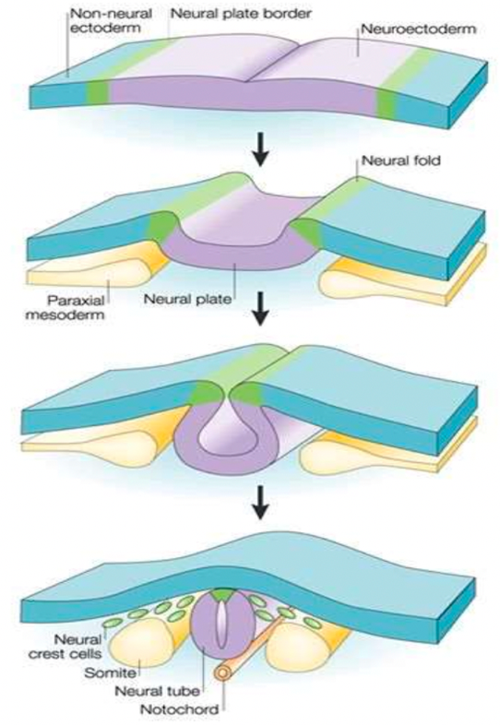
cranial sensory ganglia

Formation of Neural Tube
- In early embryonic disc (16th day ) ectoderm overlying the newly formed notochord thickens in the mid line forming the neural plate.
- The margins of neural plate elevated as neural folds.
- Center of plates sinks, creating the neural groove.
- The neural folds move towards the mid line and fuse to form a cylindrical structure called neural tube that loses its connection with the surface ectoderm.
- This whole process is called neurulation.
- The fusion of the neural folds begin in the midline (day 20) and it proceeds in cranial and caudal direction.
Formation of Neural Tube
- Fusion is delayed at cranial and caudal ends forming small openings called anterior and posterior neuropores.
- The anterior neuropore closes in the mid of 4th week and posterior neuropore closes at the end of 4th week.
- By the time neural tube is completely closed it is divisible into an enlarged cranial part and an elongated caudal part.
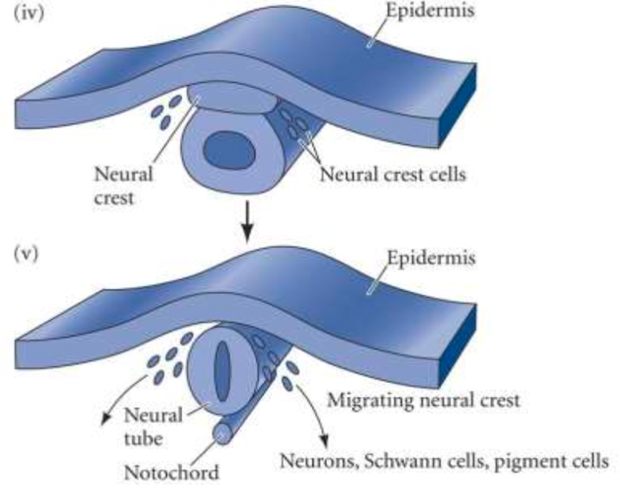
Formation of Neural Crests
- As the neural folds comes together and fuse, cells at the tips of neural folds breakaway from the neuroectoderm to form neural crests cells.
- The surface ectoderms becomes continuous over the neural tube.
- The neural crests cells then form two-cell clusters dorso laterally, one on either side of neural tube.
- These cells differentiate to form the cells of dorsal root ganglia, sensory cranial ganglia, autonomic ganglia, adrenal medulla, melanocytes, and Schwan cells.
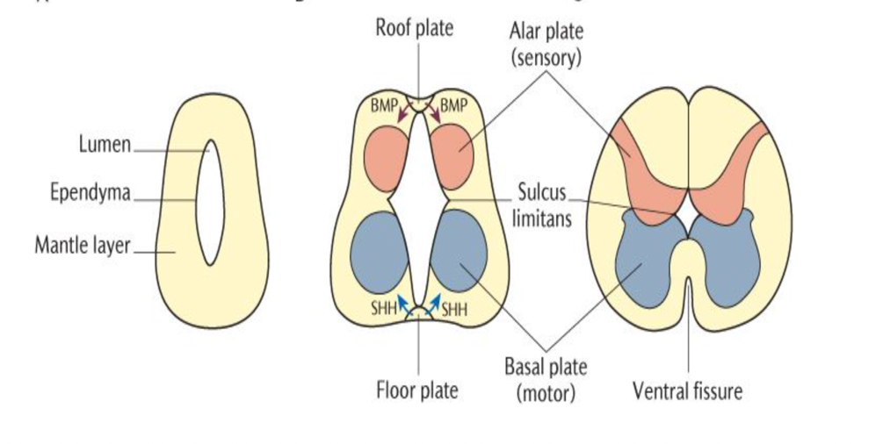
Development of the Spinal Cord
- It develop from caudal elongated part of the neural tube.
- The neural tube increases in thickness due to repeated mitosis of its epithelial lining.
- By the mid of 5th week the wall of recently closed neural tube consists of only one type of cell, the pluripotent neuroepithelial cells.
- As the development proceeds, these neuroepithelial cells give rise to another cell type called nerve cells or neuroblasts.

Remember these terms from anatomy
- Cells termed blast cells create a matrix in connective tissues.
- Cyte cells are cells that maintain a matrix of connective tissues.
- Clast cells destroy it in order to remodel it.
  - Osteoblasts (cells that form bone tissue)
  - Osteoclasts (cells that degrade bone to initiate normal bone remodeling)
  - Neuroblasts (undifferentiated precursors of the CNS)

Development of the Spinal Cord
- The neuroblast cells forms a zone which surround the neuroepithelial layer.
- It is called the mantle zone.
- Latter it will form to become the gray matter of the spinal cord.
- The outermost layer of spinal cord contains the fibers emerging from neuroblasts in the mantle layer and is known as marginal layer (white matter of spinal cord).
- The dorsal and ventral walls of neural tube remain thin and called roof and floor plates.
- Neural plates are demarcated into dorsal and ventral regions by inner longitudinal sulcus called sulcus limitans.
- The cells of dorsal region or alar lamina are functionally afferent/sensory while those of basal lamina are efferent/motor.
- The axons of cells of basal lamina leaving the cord as ventral roots join with the dorsal root ganglia, to form the spinal nerves.
- Two afferent columns of alar lamina receive axons from dorsal root ganglia. These are:
  - General Somatic Afferent Column: present in whole cords and receive impulses from superficial cutaneous and deep proprioceptive receptors.
  - General Visceral Afferent Column: confined to thoracolumbar and sacral viscera and blood vessels.

Development of the Spinal Cord
- Two efferent columns of basal lamina give rise to motor fibers. These are:
  - General Visceral Efferent Column: confined to thoracolumbar and sacral regions only provides preganglionic fibers to viscera, glands and blood vessels.
  - General Somatic Efferent Column: extends throughout the cord and provides fibers which innervate the skeletal muscles
Development of the Brain
- Develops from enlarged part of neural tube
- At the end of the 4th week the cephalic part shows three different dilations called primary brain vesicles.
- Craniocaudally these are
  - Prosencephalon (will become the forebrain)
  - Mesencephalon (will become midbrain)
  - Rhomboencephalon (will become hindbrain)
- Their cavities form the ventricular system of the adult brain.
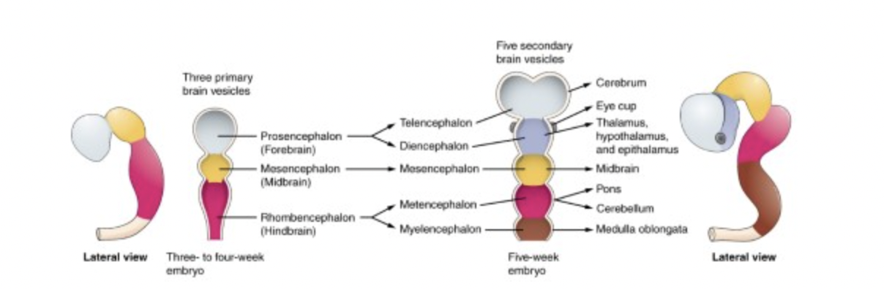
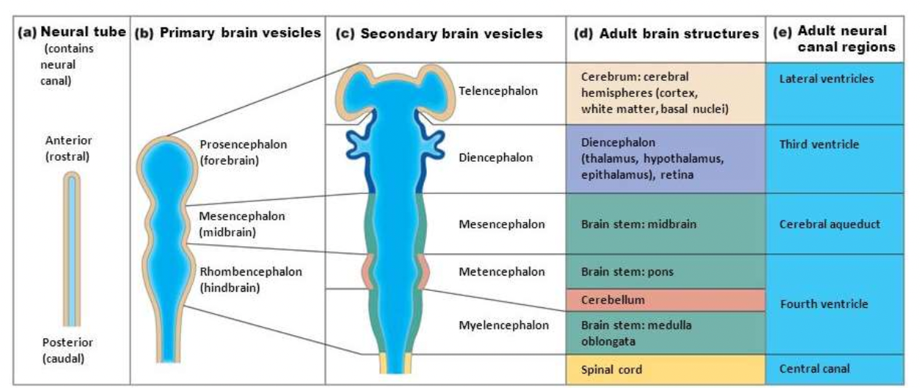
- During the 5th week both the prosencephalon and the rhombencephalon subdivide into two vesicles producing the five secondary brain vesicles.
Flexure of Brain
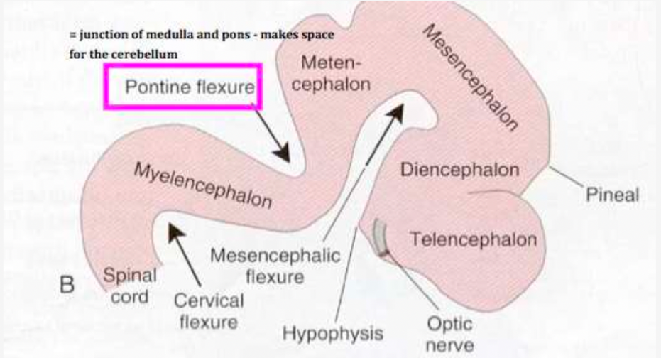
- Between the 4th and 8th weeks, the brain tube folds sharply in three different locations.
- The first of these folds will develop at the mesencephalic flexure (cranial or cephalic flexure) centered at the midbrain region.
- The second fold is the cervical flexure, located at the junction of the myelencephalon and the spinal cord.
- Both of these flexures involve a ventral folding of the brain tube.
- The third fold goes in the reverse direction.
- It is dorsally positioned and is called the pontine flexure.
- This is the location of the developing pons.
- By the 8th week, the deepening of the pontine flexure has folded the metencephalon (which will include the developing cerebellum) back into the myelencephalon.
Development of the Ventricular System
- Within each of the brain vesicles, the neural canal is expanded into a cavity called the primitive ventricle.
- The rhombencephalon cavity will become the fourth ventricle.
- The mesencephalon cavity will become the cerebral aqueduct (of Sylvius.)
- The diencephalon will become the third ventricle.
- The telencephalon cavity become the paired lateral ventricles of the cerebral hemispheres.
- After then closure of the caudal neuropore, the developing brain vesicles and the central canal of the more caudal spinal cord are now filled with cerebral spinal fluid.

Hind Brain Development
- The caudal part of myelencephalon enclosed central canal form closed part of medulla oblongata.
- The rostral part is expanded form open part of medulla oblongata.
- 4TH ventricle is derived from medulla and pons.
- The floor of Medulla Oblongata consists of basal and alar lamina separated from each other by sulcus limitans.
- In brainstem to supply the derivatives of branchial arches an extra columns appear btw somatic and visceral columns of each lamina.
- A special column is added to receive impulses of special sensations of hearing and balance.
- Thus basal contains three and alar lamina contain four columns.
- The stretched roof plate roof of the 4th ventricle which is made of pia matter.
- This single layer of pia with ependymal cells called tela chordia, with invaginating tuft of capillaries form the choroid plexus.
- The dorsolateral parts of alar laminae of metencephalon extend medially and dorsally to form the rhombic lip, and grow dorsally to form cerebellum.
- The marginal layer of basal plates of metencephalon expands considerably to form bridge for nerve fibers called pons which connect cerebral cortex and cerebellar cortex.

Midbrain Development
- It is most primitive of brain vesicles, with narrow cavity called cerebral aqueduct.
- Anterior to cerebral aqueduct basal layer give rise to tegmentum and substantia nigra. The marginal layer of basal lamina enlarges and forms crus cerebri.
- The cells of alar lamina invade the roof plate to form bilateral elevations called superior and inferior colliculi collectively called tectum.
- Basal plate generate 4 motor tracts
  - Somatic efferent – motor output to extraocular muscle CN III, IV
  - Visceral efferent – motor output to ciliary ganglion of eye and CN III
  - Red nucleus – motor relay to flexor muscles of arms
  - Substantia nigra – dopaminergic output to the basal ganglia
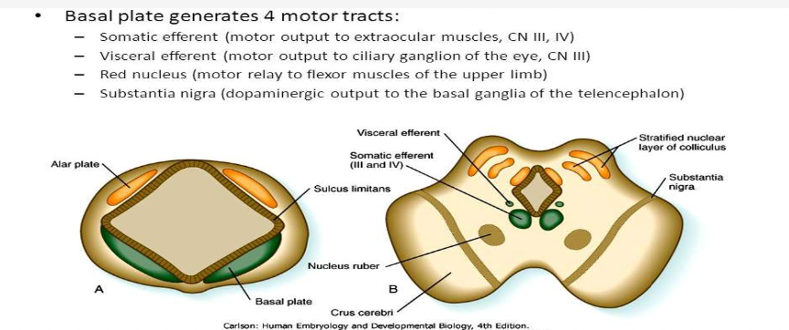

Forebrain Development - Telencephalon
- Is subdivided into a dorsal pallium and ventral subpallium
- The latter forms the large neuronal nuclei of the basal ganglia (corpus striatum, globus pallidus) that are crucial to executing commands from the cerebral hemispheres.
- The cortical structures arise as lateral outpouchings of the pallium and grow rapidly to cover the diencephalon and mesencephalon
- The hemispheres are joined by the cranial lamina terminalis (representing the zone of closure of the cranial neuropore) and by axon tracts called commissures, particularly the massive corpus callosum.
- The olfactory bulbs and olfactory tracts arise from the cranial telencephalon and receive input from the primary olfactory neurosensory cells, which differentiate from the nasal placodes and line the roof of the nasal cavity.
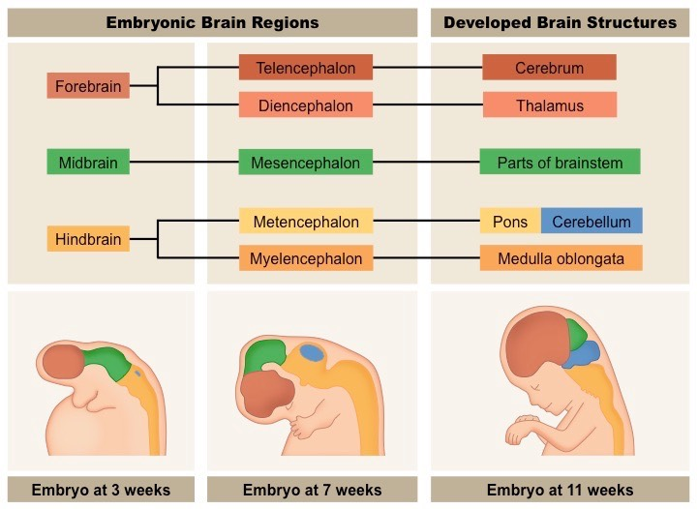

Forebrain Development - Diencephalon
- The alar plate of the diencephalon is divided into a dorsal portion and a ventral portion by a deep groove called the hypothalamic sulcus.
- The hypothalamic swelling ventral to this groove differentiates into the nuclei collectively known as the hypothalamus.
- Dorsal to the hypothalamic sulcus, the large thalamus swelling gives rise to the thalamus.
- Finally, a dorsal swelling becomes the epithalamus, which will give rise to smaller structures, including the pineal gland.
- A ventral outpouching of the diencephalic midline, called the infundibulum, differentiates to form the posterior pituitary.
- A matching diverticulum, called Roethke’s pouch, grows to meet the infundibulum and becomes the anterior pituitary.
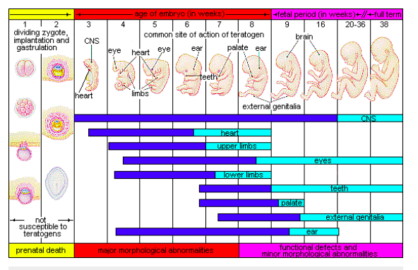
What does knowing the exact time the brain develops important?
Organogenesis and Teratogens

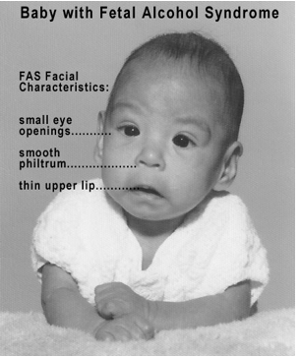
F.A.S. – Fetal Alcohol Syndrome
- Characterized by defect in growth and development
- Clinical features
  - Microcephaly
  - Short palpebral fissure
  - Maxillary hypoplasia
  - Mental and growth retardation
- The MOST COMMON type of preventable mental retardation in the U.S.
- Mechanism of pathophysiology
  - Acetaldehyde crosses the placenta and damages the fetal brain

Nuclei of Cranial Nerves
- The nuclei of the 3rd to 12th cranial nerves are located in the brain stem (mesencephalon, metencephalon, and myelencephalon)
- The cranial nerve motor nuclei develop from the brain stem basal plates
- Sensory nuclei develop from the brain stem alar plates
- The brain stem cranial nerve nuclei are organized into seven longitudinal columns, which correspond closely to the types of function they will do.
- From ventromedial to dorsolateral, there are three basal columns and four alar columns.

Neural Crest Cells
- Three basal columns contain
  - somatic efferent
  - branchial (or special visceral) efferent
  - visceral efferent motoneurons
- The four alar columns
  - general visceral afferent
  - special visceral afferent - sense of taste
  - general somatic afferent
  - special somatic afferent - hearing and balance
- During elevation of the neural plate, a group of cells appears along each edge or crest of the neural folds.
- These neural crests are ectodermal in origin and extend throughout the length of the neural tube.
- Crest cells migrate laterally and give rise to the sensory ganglia (dorsal root ganglia) of the spinal nerves and other cells types.
- During further development, neuroblasts of the sensory ganglia form two processes.
- The centrally growing processes penetrate the dorsal part of the neural tube.
- In the spinal cord, they either end in the dorsal horn or ascend through the marginal layer to one of the higher brain centers.
- These processes are known as the dorsal sensory root of the spinal nerve.
- The peripherally growing processes join the fibers of the ventral motor roots and participate in the formation of the trunk of the spinal nerve.

Neural Crest Cells
- Eventually these processes terminate in the sensory receptor organs.
- The neuroblasts of the sensory ganglion from the neural crest will give rise to the dorsal root neurons.
- In addition to forming sensory ganglia, cells of the neural crest differentiate into sympathetic neuroblasts, Schwan cells, pigment cells, odontoblasts, meninges, and mesenchyme of the cerebral arches.

Development of Spinal Nerves
- Motor nerve fibers start to appear in the fourth week, arising from the nerve cells of the basal plates (ventral horns) of the spinal cord.
- These fibers collect into bundles known as ventral nerve roots.
- Dorsal nerve roots form as collections of fibers originating from cells in the dorsal root ganglia (spinal ganglia).
- Central processes from these ganglia form bundles that grow into the spinal cord opposite the dorsal horns.
- Distal processes join the ventral nerve roots to form a spinal nerve.
- Immediately, the spinal nerves will divide into a dorsal and ventral primary rami.
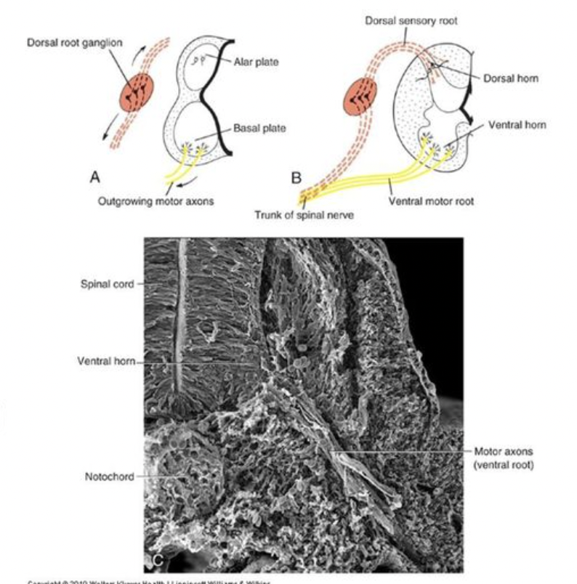
- The dorsal primary rami innervates the skin, muscles and joints of the back, including the vertebra!!!!

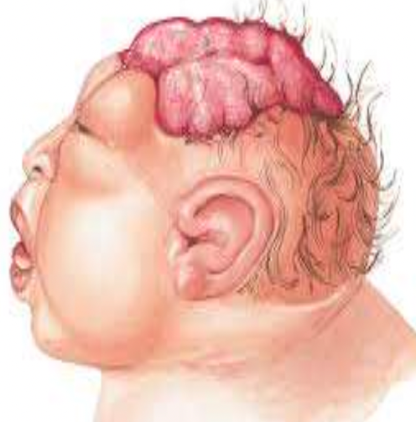
Clinical Applications - Anencephaly ( craniorachischisis)
- A failure of the cephalic part of neural tube to close and associated defective development of the vault of the skull produces a congenital anomaly called anencephaly.
- Characteristics
  - The vault is absent, and the brain is represented by a mass of degenerated tissues exposed to the surface.
  - The cord is open in the cervical region.
- Appearance of child
  - Prominent eyes bulging forward
  - Absence of neck causes the chin to be continuous with the chest.

Clinical Applications - Meningocele
- These are the congenital malformations of the nervous system which occur due to defective ossification of the skull bones, makes the meninges surrounding the brain to bulge out of cranial cavity .

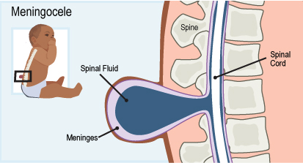

Clinical Applications - Meningoencephalocele
- If the defect is large, a part of brain tissue may also herniate producing meningoencephalocele.

Clinical Applications – Meningohydroencephalocele
- If the herniated part of the brain contains a part of ventricular cavity.
- Meningohydroencephalocele is a herniation of meninges, cerebrospinal fluid, brain parenchyma and a part of the ventricular system through a bony defect in the skull.
- This bone defect may be congenital, spontaneous or traumatic in origin.
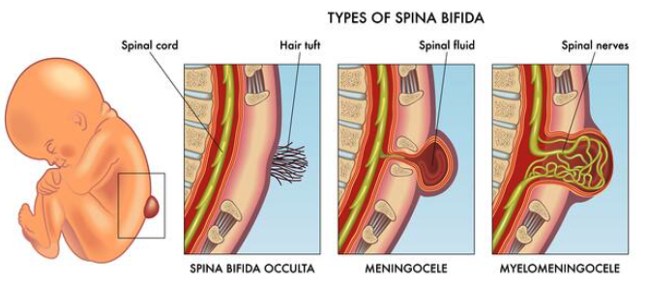

Clinical Applications
- Spina Bifida - Failure of fusion of vertebral arches, with vertebral canal remaining defective posteriorly.
- Spina Bifida Occulta - No herniation of structures of spinal canal, with a tuft of hair is often present over the skin at the site of defect.
- Meningocele - Meninges bulge out through defect forming a cystic swelling beneath the skin containing cerebral spinal fluid.
- Meningomyelocele - Spinal cord and spinal nerve roots also herniate along with meninges if the defect is large.

