Neuron Anatomy and Cell Physiology
Dr. Gary Mumaugh

Major Parts of Neurons
- Dendrites
- Cell Body or Soma
- Axons
- Axon Terminals

Dendrites
- Short (usually, about 100 microns in length) protoplasmic extensions that arise from body
- Primarily involved in receiving neural signals from other neurons
- Extensions of the cell body of the neuron that act as neurotransmitter receptors at a synapse
- Dendritic cell membranes contain different types of Channels and receptors:
  - Ligand-gated ion channels
    - Quick response
    - Neurotransmitter binds to allosteric site, opening up channel
- G-Protein Coupled Receptors (GPCR)
  - Slower response
  - Neurotransmitter binds to receptor
- These receptors work by allowing positive or negative ions to enter the cell:
  - Positive Ions
    - Excitatory Postsynaptic Potential (EPSP)
    - EPSPs cause depolarization
      - Negative on outside and positive on inside
  - Negative Ions
    - Inhibitory Postsynaptic Potential (IPSP)
    - IPSPs cause hyperpolarization
      - Positive on inside and negative on inside

Cell Body / Soma
- Also called a soma (= “body”; plural = somata)
- Contains nucleus, nucleic acids, and the usual organelles
- Typically, neurons are very active metabolically in order to support neural signaling and the synthetic requirements that are necessary to maintain the intricate protoplasmic processes that arise from the body
- The functions of the cell body include:
  - Receiving graded potentials through receptors on its membrane (same as dendrites)
  - Synthesizing the proteins necessary for cell function: DNA from the nucleus is transcribed into mRNA mRNA travels to the rough endoplasmic reticulum
- Proteins travel to the Golgi apparatus where they are packaged into vesicles
- Types of proteins synthesized in the cell body include:
  - Neurotransmitters
  - Enzymes
  - Membrane proteins
- Neurons constantly receive hundreds of both IPSPs and ESPs through dendrites and cell body receptors.
  - These are known as graded potentials.
  - In order for a neuron to be able to process action potentials, the sum of these voltages must reach a threshold of -55mV

Axons
- Long protoplasmic extension that arises from body
  - For some neurons, the axons are very short (<100 μm)
  - For others, axons can be very long (> 1 meter!)
- Involved in the transmission or sending of neural signals away from the cell body and toward other neurons or effector cells
  - Other Nerves, Muscles and Glands
- The main function of the axon is to conduct an Action Potential.

- EPSPs cause the membrane potential to reach the threshold of -55mV
- Voltage-gated Sodium Channels open, allowing Na+ ions into the cell and further depolarizing it
- This depolarization wave is transmitted down the axon to the axon terminal where it causes release of neurotransmitters
- When the voltage inside the cell reaches +30mV, Voltage-gated Potassium channels open, allowing K+ to leave the cell and repolarizing it
- This repolarization wave also travels down the axon
- The other major function of the axon is to perform Axonal Transport
  - The movement of molecules between the cell body and the axon terminal via microtubules

Axons
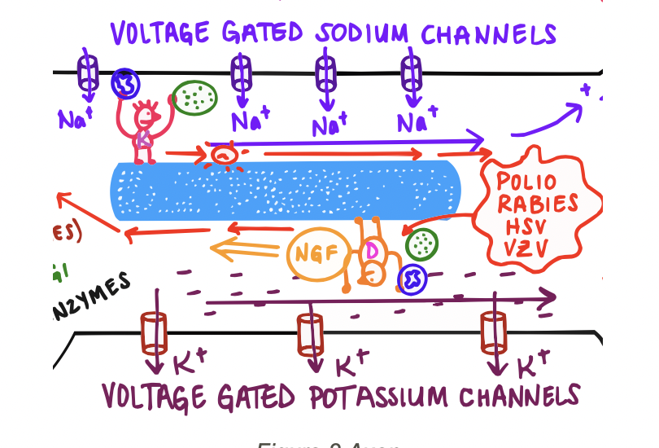

Anterograde Axonal Transport
- From cell body to axon terminal
- Transports:
- Proteins in vesicles
- Neurotransmitters, enzymes, membrane proteins
- Mitochondria
- Dormant pathogens that have been activated (Example shingles)

Retrograde Axonal Transport
- From axon terminal to cell body
- Transports:
  - Vesicles + mitochondria to be degraded/recycled
  - Nerve Growth Factors (produced at damaged parts of a neuron to stimulate repair/growth)
  - Pathogens
    - Polio, Rabies, Herpes simplex, Herpes Zooster

Axon Terminal
- Specialized contacts among neurons and between neurons and effector cells
- Synapses may be “electrical” (the small minority in the mature CNS)
- Synapses may be “chemical” (the vast majority in the mature CNS)
- Usually found at the end of axons, with an axon terminal contacting a dendrite of another neuron
- Axon terminals may contact cell bodies or even other axon terminals

Functions of Synapse
- Neurotransmitter release
  - When a depolarization wave from an action potential reaches the axon terminal, it activates Voltage-gated Calcium channels
  - Ca⁺⁺ enters the cell and allows the fusion of neurotransmitter-containing vesicles with the cell membrane
- Snare proteins in vesicles and snare proteins on the cell membrane connect and pull toward each other
- Neurotransmitters are released into the synapse

Function of Synapse
- Neurotransmitter reuptake
- After the neurotransmitters pass on the action potential to the next neuron, they need to be removed from the synapse
- This can be done through either:
  - Degradation - Enzyme on the cell membrane/synapse breaks neurotransmitters down
  - Reuptake - Reuptake protein on the cell membrane picks up neurotransmitters and brings them back into the cell to be recycled
- Neurotransmitter reuptake
- Some drugs (SSRIs - Selective Serotonin Reuptake Inhibiter) block these reuptake proteins resulting in more neurotransmitters available to stimulate post-synaptic neurons

